**EVENT MANAGING UNIT**

We propose to create an event management system that will handle all the large- and small-scale events of any university including the conferences, workshops, competitions, fests etc. The event managing unit we propose to create is a dynamic portal where a student simply has to login using an e-mail id and password and he will be directed to a dashboard where each and every ongoing events, competitions and workshops of the university will be posted. The student can easily register and pay via our portal. Hence the application is extremely handy. The student will also have access to each minute detail regarding the event like the school which is conducting the event, the event dates and deadline, study material and pre-requisites, result of the competition and also the live streaming of the result, the e-certificate and also the attendence management. Our application also provide provision to the university authority to organise the event. The faculty co-ordinator can ask for approval to the higher authorities. The higher authority can approve/decline the event based on the availability. Once the approval is granted the faculty member can ask for the requirements of the event like venue, staff or any kind of additional help. Once the event is live, the coordinators can mark attendance of the present students through our application and also provide the e-certificate. There is even a provision to distribute food coupons or necessary requisites. Hence our application is very useful in conducting any type of fully fledged event in any university with much ease and convenience, avoiding any kind of mis management and confusion.

**OBJECTIVE:** The purpose of this application is to automize the entire event management system, make it error free and provide both user and admin a smart platform to interact.

**MOTIVATION:** To minimize the hustle bustle that gets created in organising the entire event successfully.

|  |  |
| --- | --- |
| **EXISTING SYSTEM** | **PROPOSED SYSTEM** |
| * The existing manual system is very obsolete and time consuming which creates a lot of fuss and mis management. * According to the current system the organiser of the event gets approval from the higher authority. He further generates a mail and sends it to all the students. * A google form is attached with the mail for the registration process. * After submitting the form, the student pays the fees to the respective coordinator/ bank. He gets a receipt. | * As per our system the student will simply login to the portal using email id and a password. Then opens a dashboard with various options. The information regarding all the upcoming events is displayed in the dashboard with an available link to register. * After registration payment is given to the student coordinator who updates the portal and student receives a digital receipt. * On the day of the event; attendance, food coupon distribution etc is done online through the application. * The attendance data is further transferred to the DSW who updates the OD. * A digital certificate is given at the end of the event. |

**USER LEVELS:**

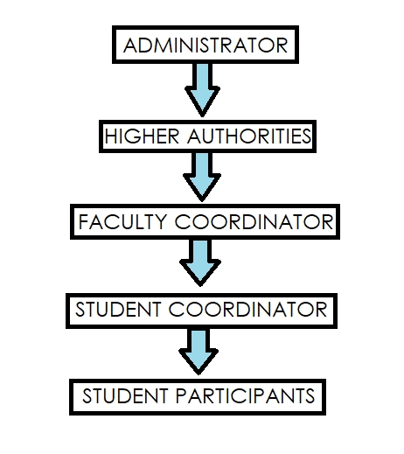

**FUNCTIONALITY PER USER LEVEL**

1. **ADMIN**
2. Details per user level
3. Add/modify/delete user level
4. Password management
5. Details of every school

* Add/delete schools
* School responsible for event

1. Event details

* Form generation: Event name

Event date

Event venue

Event description

Organised by

Pre-requisites

Brochure

1. Participant database
2. Budget database
3. Approval/Decline event
4. Report management
5. Attendance database
6. Per user access management
7. Certificate
8. Push notification generator
9. Password management

* Encrypted password database
* Reset password

1. Server management
2. Bug Report
3. Personalised dashboard
4. Per user data

* Clubs enrolled
* Events attended
* Hours of event participated
* Events Volunteered

1. Extra databases for outside participants
2. Number of active users
3. **HIGHER AUTHORITY**
4. Individual Login credentials
5. Database

* Budget
* Attendance
* Registration

1. Approve/decline event.
2. Certificate access
3. Event requirements

* Room requirement
* Volunteer requirements
* Food requirement
* Technical requirements
* Transport requirements

1. Participants Details

* Clubs involved in
* Hours spent in clubs
* Events and conferences attended
* Events coordinated
* Competitions participation
* Non club events attended

1. E-mail/ push notification
2. Each school and student history record
3. Track live record of every event happened or happening at the moment
4. Faculty details

* Club Involved in
* Event conducted
* Hours of each event
* Budget under each event
* Visits conducted outside university
* Events (competitions) participation outside universities
* Competitions conducted in universities
* Non club events and conferences

1. Industrial visits
2. **Faculty Coordinator**
   1. Club(s) involved in
   2. Request page (to apply for event permission)
   3. Room requirement
   4. Student coordinator requirement
   5. Food requirements
   6. Budget management
   7. Fee collected
   8. Event details page
   9. Form
   10. Certificate
   11. Feedback
   12. Payment receipt
   13. Digital attendance taker
   14. Chat window for queries
   15. Brochure
   16. Request form for kit and e study material
3. **STUDENT**
4. Login through email
5. Past events participated
6. Present events enrolled in
7. Future events
8. Personalised dashboard
9. Mail oriented notification
10. Event brochure
11. Registration page
12. Fee payment window
13. Receipt window
14. Chatroom for queries
15. Ai chat-bot for help
16. Feedback
17. E guide material
18. Digital certificate
19. Data of all the workshops and conferences
20. College competitions posted
21. Application for the competition
22. Apply for a teacher guide for a particular competition
23. Result evaluation portal
24. Apply for a club
25. Club payment receipt
26. Club activity recorder

**5. STUDENT COORDINATOR**

* + - 1. Special access on student profile
      2. Chatroom
      3. Fee collection
      4. List updating on basis of fee payment
      5. Receipt Generator
      6. Digital attendance manager
      7. Feedback management
      8. Food coupon management

**Future Enhancements:**

* Club integration
* Fest management
* Intercollegiate events
* Sports fest
* Secure payment window (online payment)
* Automatic event requirement setup

Proposed By:

JYOTSNA- 18BCE10128

TANAY SINGH-18BCE10276

VIPUL DEORA-18BCE10296

KARTIKEY NARAIYAN GARG- 18BCE10140