

CSE3004 Design Analysis of Algorithm

**Algorithm Design for Innovative Problem**

**_____________________________________________**

**M.VOLUNTEER**

*Turning ‘Spectators’ into ‘Volunteers’*

***_______________________________________________________***

*A report on finding the solution for reducing the likelihood of Road accidents while avoiding delay in assistance for the victims*

Submission Date: December 3, 2019

*Under the Guidance of* **Dr. R. Manikandan**

*By:*

**Jyotsna (18BCE10128)**

**Gursimar Singh Bedi (18BCE10105)**

SLOT: G11+G12+G13

PROBLEM STATEMENT

***Road accidents are one of the 12 most common causes of deaths in India, the ninth most common cause of premature deaths, and the 10th most common reason for disability,*** according to the 2017 WHO Global Health Estimates. In 2018 alone, India witnessed a staggering 4.61 lakh deaths related to traffic incidents pointing to a rise of over 3 points in the past two decades. According to the statistics from [Road Accidents in India](https://morth.nic.in/sites/default/files/Road%20Accidednts%20in%20India%20-%20201811.pdf) 2018, a report published by the Ministry of Road Transport and Highways, India’s young, productive population (aged 18-45 years) is involved in 70% of road accidents. These accidents costs India a [3-5% of gross domestic product](https://openknowledge.worldbank.org/bitstream/handle/10986/29129/HighTollofTrafficInjuries.pdf?sequence=5&isAllowed=y) every year.

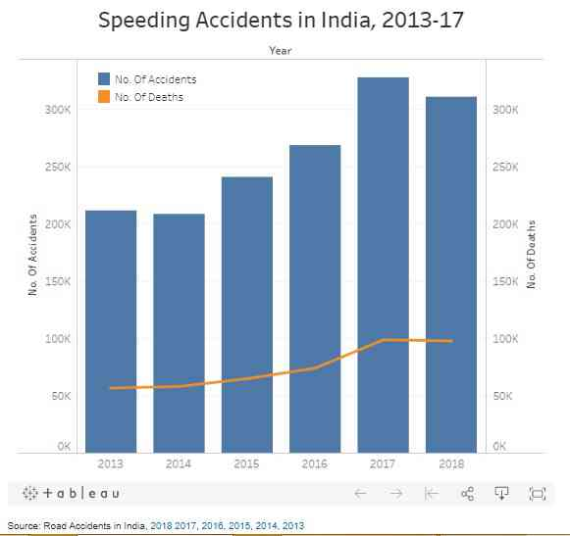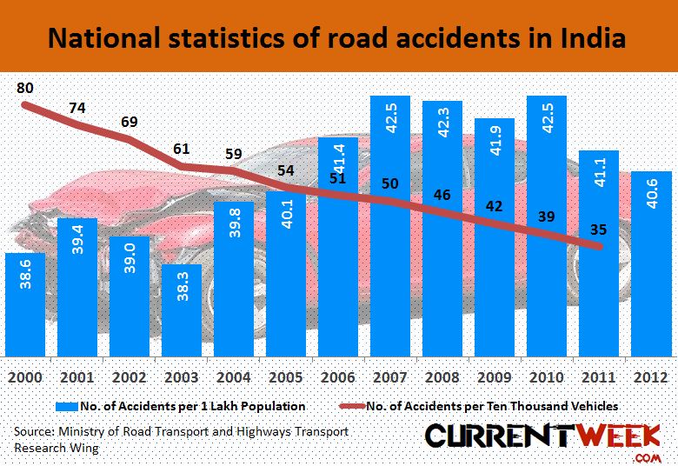In the year 2018, A world Bank Report suggested that over a period of 24 years (from 2014 to 2038), if India could halve the deaths and injuries due to road traffic, its GDP could increase by 7%. According to data from a 2018 World Health Organization [report](https://www.who.int/news-room/fact-sheets/detail/road-traffic-injuries), India while accounting for only 1% of the world’s vehicles accounts for 6% of the world’s road traffic accidents. The report also stated that as many as 73% of all deaths due to road traffic accidents in 2018 in the South and South-East Asia region happened in India. Though the government has formulated several strict laws but the enforcement is still puny. The fine for speeding has been increased from Rs 500 to Rs 5,000 since September, 2019 under the new [Motor Vehicles Act](http://egazette.nic.in/WriteReadData/2019/210413.pdf) of 2019. In addition, the law demands the imprisonment of drivers for a period of three months for speed racing – an illegal race– if it is their first offence, and for a period of one year if it is the second offence. We know human behaviour is conspicuously affected by enforcement but in India, enforcement loses its power to widespread corruption.

Over 30 percent of all road accidents in India are hit-and-run cases, but only 10 percent of hit-and-run accident drivers are reported. A lack of concern for the other person’s safety, coupled with rash driving and scarcity of time are major contributing factors.

CRUX OF THE ISSUE

While the rising intolerance and the lack of empathy amongst the current generation is often blamed for road accidents. ***The hidden crux behind the issue is scarcity of Time***. In the current times time is of the essence. It has turned into an entity that everyone desires for but what everyone is devoid of. This scarcity of time has driven humans to a point where they are obsessed to speed and this desire to reach quicker than anyone else causes the most number of accidents. Even after witnessing a gruesome accident, people just pass by blaming their prior commitments and the scarcity of time caused by their tight schedule. It’s ironical how people are losing precious years of their life just to save seconds off of it.

Target Audience

The problem affects a major section of the society providing us with a huge and a widely distinct target audience. In General, our target audience will be the lower to higher-middle class section of the society which resides in the developed/developing cities and depend on road transport for commuting.

Summary and Our Proposition

With the value of time rising every second and the intolerance in people sky rocketing the frequency of road accidents is bound to increase while the frequency of people stopping to help the victims is bound to drop. This unethical and diabolical approach has affected lakhs of families in India but not anymore.

With our solution we aim at building a collaborative platform built upon ideologies like Brotherhood and unanimity which are induced in our widely recognized culture while giving people a chance to partake in social services in their routine life to feel good about themselves. We aim to build a community of vigilant and emphatic citizens.