**M.VOLUNTEER**

*Turning ‘Spectators’ into ‘Volunteers’*

SOLUTION:

Our app provides a solution for these ‘deprived of time’ and ‘ruthless’ souls turning them from spectators to volunteers at a click of a button. Apart from helping people do their bit, the app will also prove to be pivotal in saving precious seconds in case of emergency.

Basically, the app will provide an interface for people to report the incident with as much as details possible and will send the notification to the concerned medical and legal authorities alongside the other volunteers who are available for help. Along with that the app can also be resourceful for a victim as it will provide an option to intimate the user’s well-wishers without the requirement of unlocking the phone.

Precaution is always better than cure. So by providing functionalities which avoid the user from being distracted by the notification of the social media apps run by companies which are focussed at gluing their users to the small screen.

*Reason for people to download The APP*

Safety is one thing which the app promises. Informing users the safety of the routes that they take and removing any distractions from driving will entice people to download the app. Also the sense of security, ensuring quick response time for help and locking intimation for their emergency contacts will also prove pivotal in maintaining a large user base.

*Credit System*

The app will also implement a credit system to restrict its misuse. People who submit false cases or fail to report to the point of accident after committing to help will lose credits. If credits reach a critical level they will not only be banned from the app but will also be subject to legal troubles.

**Complete set of Functionalities:-**

* Colour coded Map like interface indicating safety of roads in colours like red, yellow and green with red being the most dangerous.
* Voice prompts informing the user about previous accident and suggesting a driving speed.
* Restricting the phone from ringing for long durations while intimating the caller that the user is driving.
* The SOS button in the app will send text messages to the nearby medical and legal authorities.
* The app can also send information about the mishap to the registered well-wishers of the user without the requirement of unlocking the phone.
* Limiting notifications: the user can also mute all the notification for a certain amount of time.
* In case the user is completely drunk, the app will push request to local chauffeur’s association and anyone willing to help may come at the shared live location.
* Any number of volunteers in a particular location can register to the app. As soon as the accident is reported they will receive a notification and can reach to the location for help.
* People submitting false case will be reported to the legal authorities.

**Following will be the algorithms that will be followed for the app to function assuming a conspicuous user base is available.**

**Register**

Once the app is downloaded the user **(termed as a volunteer)** will be expected to complete all the desired information.

1. The volunteer can potentially login via Google or sign-up to our database.
2. Volunteer will be prompted to input personal information including date of birth, job specifications, professional degree, and blood group.
3. For the app functionalities the user needs to input the number of seconds after which his phone stops ringing while driving.
4. The message and medium of transmission to be used if he/she is unable to pick up the call must also be entered.
5. The users must include 3-6 contacts to reach to in case of an emergency alongside the message to be sent.
6. The user will be suggested to make sure that their emergency contacts are using the app to get better services
7. The user will be prompted to enter their emails in case the emergency contacts are also a volunteer via the app.
8. The user will be advised to keep the app open while driving.
9. The user will be asked to give permission to access their location, contact list, make calls/text messages and have control over other app notifications.
10. Once all the permissions are adhered to the user will be displayed the interface and will be congratulated for being a volunteer.
11. The **general scenario** algorithm starts to take place.

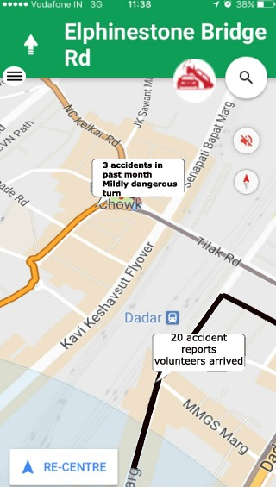

**A general Scenario**

When seated to drive:-

1. Volunteer is expected to open the app
2. The map like GUI will open up which will be kept on during the entire journey.
3. The user can input his destination in the search bar to acquire the safest route
4. The app access the user’s current location and keeps on displaying it on the map.
5. According to the location and route app will gather the statistics of that route from the past year.
6. Then the user is informed about the safety of the current route

*Colour coded pathways*

1. The routes, exits and turns on which most accidents take place will be coloured in red and safest ones in green
2. The location at which an accident took place recently(same day) will be marked in black
3. The colours will change dynamically.

*Voice Prompt*

1. If user’s location coincides with a location marked as accident-prone, a voice prompt which informs the user about the danger ahead is initiated and a certain pace is suggested to the user. The voice prompts then ends

**Volunteer witnesses an incident:**

In case the volunteer witnesses an accident or a case of road rage:-

1. He can help the victim himself

*Or if the volunteer doesn’t have time to help he/she can report the incident using the app*

1. The volunteer clicks on report button (proposed to be at top right corner)
2. The focus changes to Report page activity
3. The volunteer can input some optional details
4. Volunteer clicks the submit button and the report page activity loses focus
5. The **General Scenario** Algorithm takes back the foreground
6. The volunteer can drive away
7. The truthfulness of the report will be calculated after the **app generates request** and **helping volunteer** algorithm takes place.
8. If the incident was reported truthfully, the volunteers credit value will be incremented
9. The user will also be given the details about the incident applauding his little effort.
10. If the incident was falsely reported, the volunteers credit value will be decrease drastically and the volunteer will be warned of legal consequences.

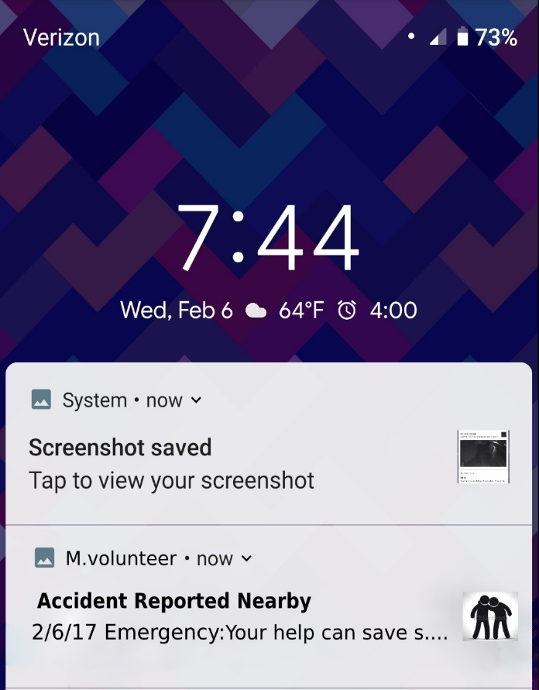

**The App on receiving a report:**

From the perspective of the app when an incident is reported:-

1. The app will pick up the location and input a query into the system.
2. Other volunteers will be notified based on their distance from the incident.
3. If a lot of people report the incident at the same location.
4. A notification will be sent to other volunteers based on their distance from the location of accident
5. The volunteers can accept or decline the request
6. If the app doesn’t get sufficient responses in a set time frame, the radius for volunteer search will be increased and the last 2 steps will be repeated
7. Once sufficient people respond positively the app will select 2-3 people based on their professional degree, availability of first aid and their credit.
8. Then the notification is dismissed
9. The volunteer who responded positively will get a mild increase to their credit
10. The selected helping volunteers will be sent the location of the incident alongside known details
11. If enough people report the accident a request will also be sent to a nearby police station and a hospital
12. In case of a road rage only the police station will be informed

**Helping Volunteer**

From the perspective of the volunteer who responded positively to the request:-

1. After being sent, the location if the user fails to report to the point of accident, his/her credit will be majorly degraded
2. If the volunteer’s location matches the location of the accident, a dialog box appears.
3. Through the dialog box, volunteer will be prompted to report the honesty of the report by clicking on Truthful Report or False Report button.
4. In case the volunteer clicks on the False Report Button, the volunteer will be prompted to leave the location and will be apologised for the inconvenience caused. The algorithm can skip to step 14.
5. Once the truthful report button is clicked the GUI of the volunteer’s app will turn red.
6. 3 new buttons (termed: Resolved, contact medical support and contact the Cops) will be introduced
7. If Incident Resolved button is clicked, volunteer will be asked to inform the concerned authorities (if informed) to save time. The algorithm can skip to step 14.
8. In case the incident hasn’t been resolved, the user can take decisions on his discretion
9. The user can apply first aid (if possible) to the patient
10. If Contact medical support or contact cops button is clicked the app will lose focus and a call will be made to the nearest authorities
11. Once the call is ended, the app starts to run in foreground once again
12. The volunteer can look up for victim’s phone and if the same app is running the volunteer can initiate Victim Volunteer algorithm
13. Once the medical and legal helped reaches the incident the user will click resolved button on the app and will be prompted to leave
14. The red GUI dissolves
15. The **General Scenario** algorithm is initiated again
16. At the end of the day the volunteer will receive a credit boost for his help and will be appreciated accordingly

**Victim Volunteer**

If a volunteer unfortunately experiences an accident:-

1. The volunteer who turns up to help will be prompted to search for the phone
2. If the victims phone is somehow alive and the app is found running in the background
3. The helping volunteer can just click the app notification on the lock screen
4. A 10 second countdown will begin in case the button was clicked by accident and the user wants to cancel the request
5. After the countdown ends the custom message will be sent to all of the victim’s emergency contact and Emergency Contact algorithm is initiated on Emergency contacts’ respective cell phone.
6. The focus returns **lock screen activity**.

**Emergency Contacts**

If the victim’s contacts do not have the app installed they will receive the custom message with the location of the incident

If the victim’s emergency contacts have the app installed:-

1. They will be sent an emergency notification in every few minutes until they respond
2. Once they click the notification, the app starts to run
3. A red GUI is initiated with the introduction of resolved button
4. They receive the location of the incident, the name of the hospital and the live location of the victim
5. They will also receive the status of help
6. Then they can plan their actions accordingly
7. Once resolved button is clicked, the **general scenario** algorithm starts to take place.

s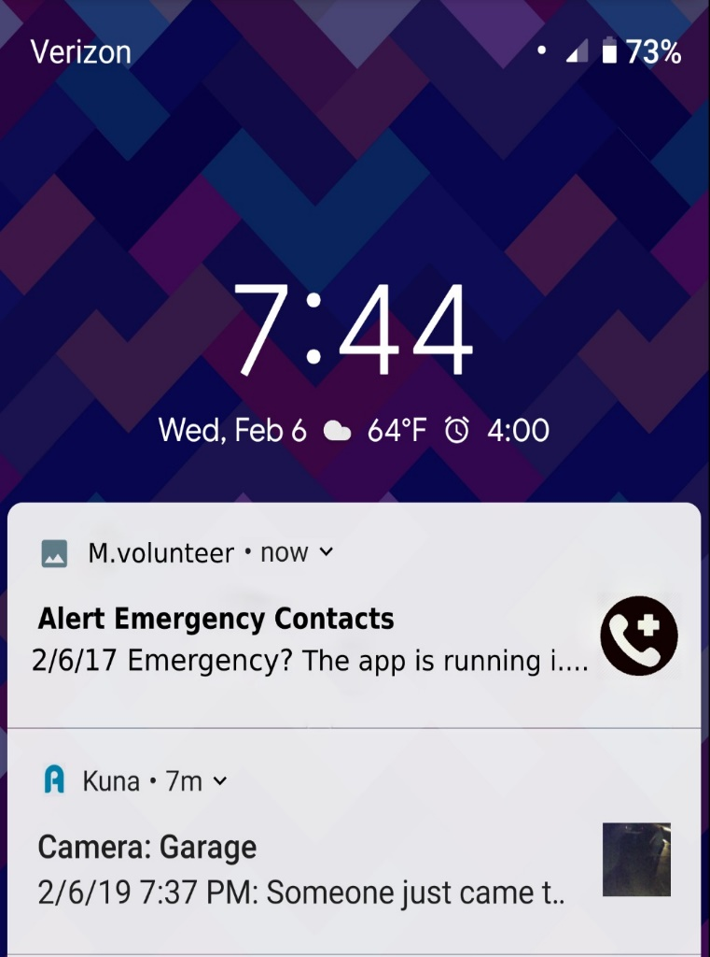

**Call Intercept while Driving**

If any of the volunteer’s contacts call while the volunteer is driving:

1. The call will ring for a (user defined) duration
2. Once the ringing duration exceeds the user defined input the call will stop ringing and the call activity goes background
3. Once the call ends the contact gets the message (via this app or another app defined by the user) that the volunteer is currently driving.
4. **The General Scenario** algorithm will then sustain as usual

**Notification while Driving**

If any other installed app sends a notification on the volunteer’s cell phone while app is running:

1. The notification won’t cause a vibration or a ringtone
2. **The General Scenario** algorithm runs in foreground as usual.

**The picture below represents the entire flow of functionality of the app.**

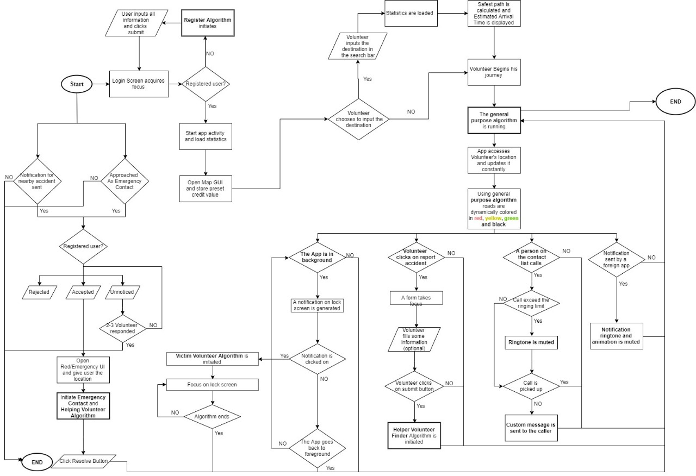

We believe that by making such a collaborative platform we are building upon ideologies like Brotherhood and unanimity which are induced in our culture and widely recognized culture while giving people a chance to partake in social activities in their routine life to feel good about themselves. While we aren’t claiming that we will eradicate road accidents or deaths caused by road accidents entirely, we believe that this solution will prove to show a conspicuous deficit which will have a positive impact on thousands of life. *Helping others is a Nobel job in itself by providing people a platform to encourage such Nobel effect will only make this world a better place to live in.*