Please have lab submitted (whatever you have) by May 5th.

This week’s dataset is again (same as last week):

<http://afodor.github.io/classes/stats2015/prePostPhylum.txt>

For the POST timepoints only:

1. For each phyla, graph the relative abundance of that phyla vs. cage. Does there appear to be a cage effect across different phyla?

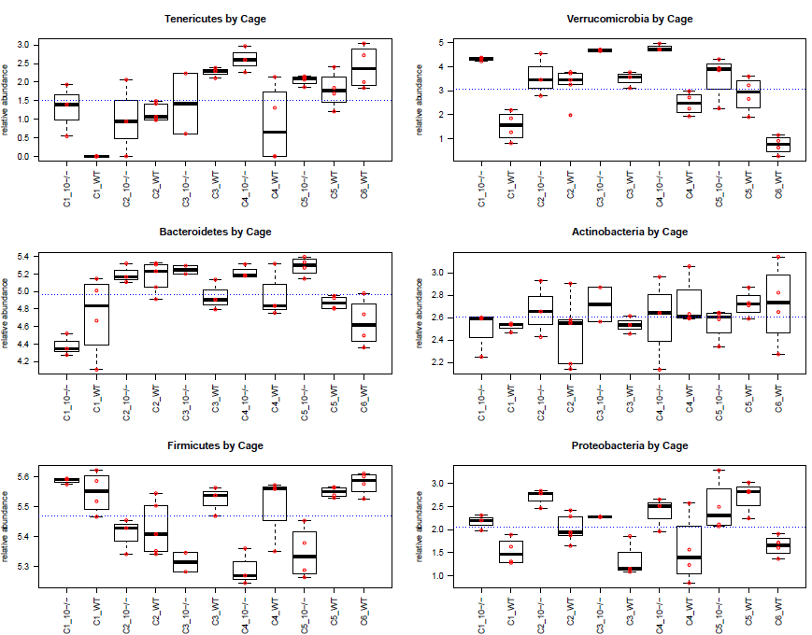

1. For each phyla build a mixed linear model with genotype as the fixed variable and cage as a random variable. Report the intraclass correlation coefficient for each phyla. Are there any phyla that are significantly different for genotype in the mixed model at a 10% false discovery rate?

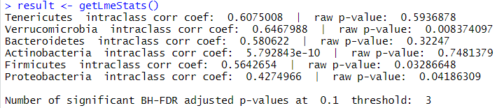

**Hints:**

1. If you use par(mfrow=c(3,2)) you can fit all 6 plots for phyla vs. cage on one graph. You can put the p-values and intraclass correlation coefficient in the “main” text above each graph to make a nice summary figure.
2. It can be useful to make a dataframe with just the data you want before building your model. So if you are looping through columns in a “myT” that you’ve read with read.table and i is your column index..

myT <- myT[myT$time == "POST",]

bug <- myT[,i]

cage <- myT$cage

genotype <- myT$genotype

myFrame <- data.frame(bug, cage, genotype)

(and then build your models with data=myFrame…)

1. Getting a p-value out of the mixed linear model could be done with something like:

unclass(summary(M.mixed))$tTable[2,5]

Getting the rho(intraclass correlation coefficient) out of a GLS model can be done with:

coef(M.gls$modelStruct[1]$corStruct,unconstrained=FALSE)[[1]]

(4) You can have both points and boxplots on a scatter graph with something like:

boxplot(myFrame$bug ~myFrame$cage)

stripchart(bug ~ cage, data = myFrame,vertical = TRUE, pch = 21, add=TRUE