**1. What is the mean and variance for the loaded dice?**

$μ= \sum_{i=1}^{n}{p_{i}}× x_{i}$ = 0.1*1 + 0.1*2 + 0.1*3 + 0.1*4 + 0.1*5 + 0.5*6 = 4.5

Var(X) = $\sum_{i=1}^{n}{\left(p_{i}× x_{i}^{2}\right)-μ^{2}}$

= (0.1*1^2 + 0.1*2^2 + 0.1*3^2 + 0.1*4^2 + 0.1*5^2 + 0.5*6^2) – 4.5^2 = 3.25

**\*\*\*\*\*\*\*\*\*\*\*\*\*\*\*\*R code to calculate mean and variance\*\*\*\*\*\*\*\*\*\*\*\*\*\*\*\***

> remove(list=objects())

> values <- c(1,2,3,4,5,6)

> values_pdf <- c(rep(.1,5), .5)

> # values_pdf <- rep(1/6,6)

> expected_value = sum(values*values_pdf); expected_value

[1] 4.5

> pdf_times_value_squared = sum(values^2*values_pdf); pdf_times_value_squared

[1] 23.5

> variance_die <- pdf_times_value_squared - expected_value^2; variance_die

[1] 3.25

**2. Make a function in R that “rolls” this dice; return a vector containing the rolls.**

**So if I call: myRolls <- rollLoadedDie(10000)**

**I would get a vector of size 10,000 that contains the rolls of my loaded die.**

Function rollLoadedDie.R is located at URL <https://github.com/jyoung67/advstatistics-labs/blob/master/labs/lab01/rollLoadedDie.R>.

**3. Make a histogram of some large number of rolls. Do the rolls of the loaded die approximate a uniform distribution?**

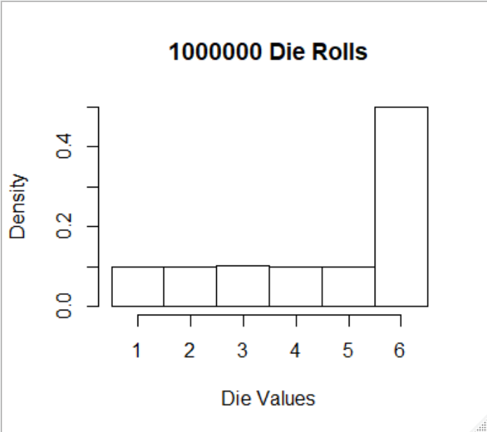

*> rolls <- rollLoadedDie(1000000)*

*> hist(rolls, breaks = seq(.5,7,1), freq=F, main=paste(as.character(length(rolls)),"Die Rolls", collapse = " "), xlab = "Die Values")*

No, the rolls of a loaded die do not approximate a uniform distribution, because the proportion of observations for each value is not approximately equal. That is, the non-uniform density values for 1, 2, 3, 4, 5 & 6 are 0.1, 0.1, 0.1, 0.1, 0.1 and 0.5, respectively.

**4. Modify the code on Slide #58 of lecture #2 so that the mean vs. trial size plots are from the loaded die. Generate these plots a few times. How many rolls appear to be necessary to get convergence on the expected values for the mean and variance?**

Per the following two means/variances vs. trial sizes plots, it took approximately 10^4.8 rolls to converge on the expected values for the mean and variance, 4.5 and 3.25, respectively. The modified R code to produce both plots is located at URL <https://github.com/jyoung67/advstatistics-labs/blob/master/labs/lab01/rollLoadedDieTrials.R>. The following R code was used to invoke rollLoadedDieTrials.R.

> trialSizes <- c(5,10, 15,20,25,30,40,50,100,200,300,400,500,1000,2000,3000,seq(10000, 120000, 1000))

> values <- 1:6

> valuesPdf <- c(rep(.1,5), 0.5)

> rollLoadedDieTrials(trialSizes, values, valuesPdf)

dMean dVariance

1 4.5 3.25

