1. **In a population, there is 1/3 chance that a given person has a mutation in some gene.**

* **You sample 30 people; what are the odds that exactly 12 of the people have the mutation?**
  + > p <- 1/3; k <- 12; n <- 30  
    > p_12 <- dbinom(k, n, p); p_12  
    [1] 0.1101246
* **In R plot a probability density function (with dbinom) that shows the distribution for observing exactly (0,1,2,…30) people with the mutation.**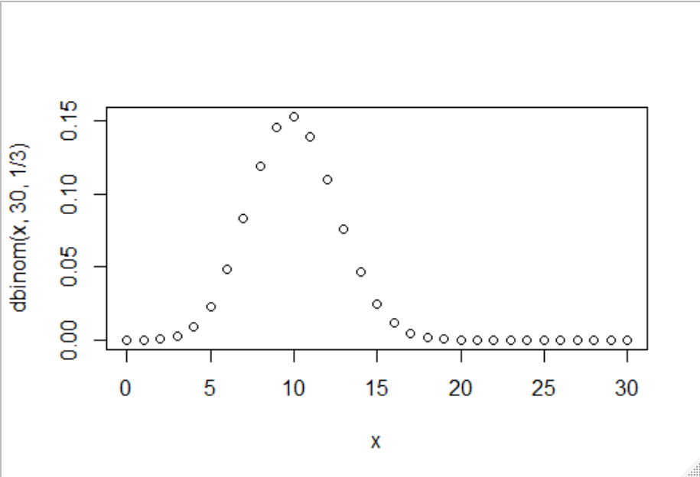  
  > x <- 0:30  
  > plot(x, dbinom(x, 30, 1/3))
* **What is the mean and variance for the expected number of people with the mutation?**
* > n <- 30; p <- 1/3  
  > b_mean <- n*p; b_mean  
  [1] 10  
  > b_variance <- n*p*(1-p); b_variance  
  [1] 6.666667

2. **The background expected survival rate for a disease is 0.4. You are running a clinical trial.**

**You have 100 patients on a new drug. 47 patients die (and 53 survive)**

**From the bionomial test:**

**(2A) Plot out the probability density function with the x-axis the number of patients that survive under the null hypothesis.**

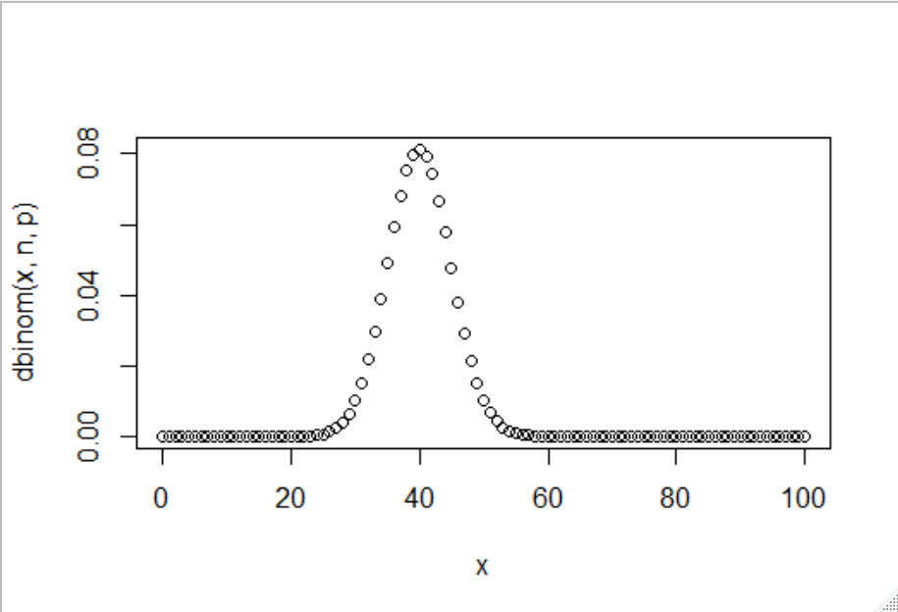

> p <- 0.4; n <- 100; x <- 0:n

> plot(x, dbinom(x, n,p))

**(2B) What is the p-value for a null hypothesis that the drug has no effect?**

**(Show the one line of R code that produces this p-value)**

> binom.test(53, 100, 0.4, alternative="two.sided")

p-value = 0.01036

*alternative hypothesis: true probability of success is not equal to 0.4*

**(2C) What is the p-value for a null hypothesis that the drug does not improve survival.**

**(show you can get the same answer with binom.test(….) and sum(dbinom(….))**

> binom.test(53,100,0.4, alternative="greater")

p-value = 0.005761

*alternative hypothesis: true probability of success is greater than 0.4*

**(3A)** **Use the rbiom function to simulate 1,000 experiments in which 10,000 patients are sampled with a 1/2 chance of seeing a mutation.**

**(You should get 1,000 numbers back with each # the # of patients from the 10,000 that had the mutation…)**

**(What is the one line of r-code that would produce myVals?)**

myVals <- rbinom(1000, 10000, .5)

**(3B) What is the expected mean and variance of the vector in (3A). Show that the actual mean and variance are close to the expected mean and variance.**

|  |  |
| --- | --- |
| Expected Mean | 5000 |
| Actual Mean | 4999.051 |
| Expected Variance | 2500 |
| Actual Variance | 2555.884 |

> n <- 10000; p <- 0.5 ; expected_mean <- n*p; expected_variance<- n*p*(1-p)

> expected_mean

[1] 5000

> expected_variance

[1] 2500

> myVals <- rbinom(1000, 10000, .5)

> actual_mean <- mean(myVals); actual_mean

[1] 4999.051

> actual_variance <- var(myVals); actual_variance

[1] 2555.884

**(3C) Take the vector that results from (3A). For each element in that vector, calculate a p-value with binom.test(….)$p.value for the null hypothesis that the frequency of the allele in the population for that experiment is 1/2.**

**Graph the histogram of all of those p-values.**

* See figure 1.

**What distribution would you expect? Is that what you see?**

* I expected to observe an approximate uniform distribution. Since the function rbinom(1000, 10000, .5), with the underlying pdf illustrated in figure 2 below, will generate nearly all values closely clustered about the mean (5000), the multitude of corresponding p-values are greater than or equal to 0.05. Therefore, the null hypothesis will mostly not be able to be rejected. Consequently, the distribution of null p-values will trend towards a uniform distribution (Fodor et al., “Towards the uniform distribution of null P values on Affymetrix microarrays”).
* Yes, I observed an approximate normal distribution (figure 1).

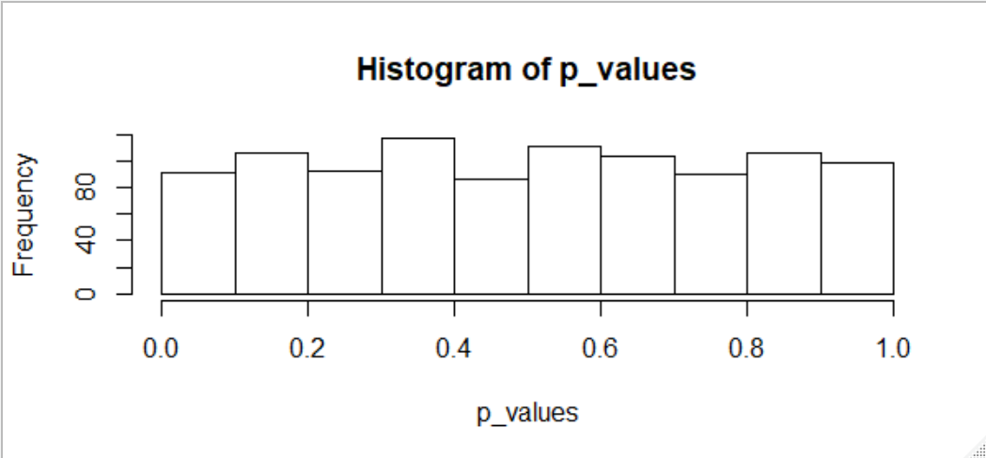

**Figure 1: Histogram of p-values with prob = 0.5**

remove(list=objects())

prob <- 0.5

myVals <- rbinom(1000, 10000, prob)

p_values <- vector(length = length(myVals))

cnt <- 1

for(value in myVals)

{

p_values[cnt] <- binom.test(value, 10000, p=prob, alternative="two.sided")$p.value

cnt <- cnt + 1

}

hist(p_values)

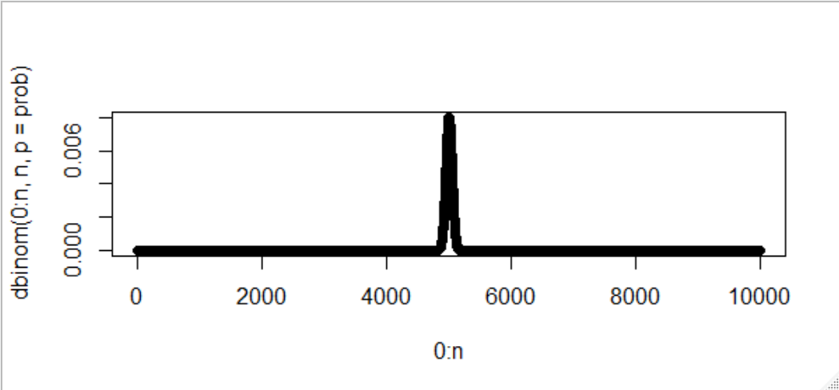

**Figure 2: Plot of dbinom(0:10000, 10000, p=0.5)**

remove(list=objects())

n <- 10000

prob <- 0.5

plot(0:n, dbinom(0:n, n, p=prob))

**(3D) Change the expected value of 1/2 in (3C) to some other value.**

**What happens to the p-values in the histogram?**

I changed the expected value to two extremes: 0.1 and 0.9. See figures 3 & 5, respectively. The p-values in the histogram for both cases are approximately normal. The different expected values just caused the generation of tightly clustered values about the mean of 1000 (figure 4) and 9000 (figure 6), resulting in the approximate uniform distribution of null P values.

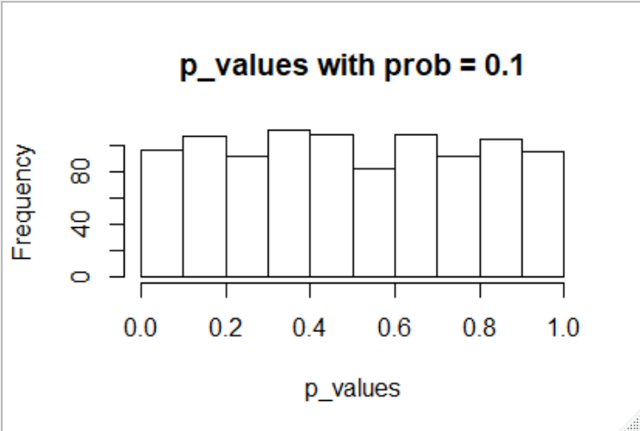

**Figure 3: Histogram of p-values with prob = 0.1**

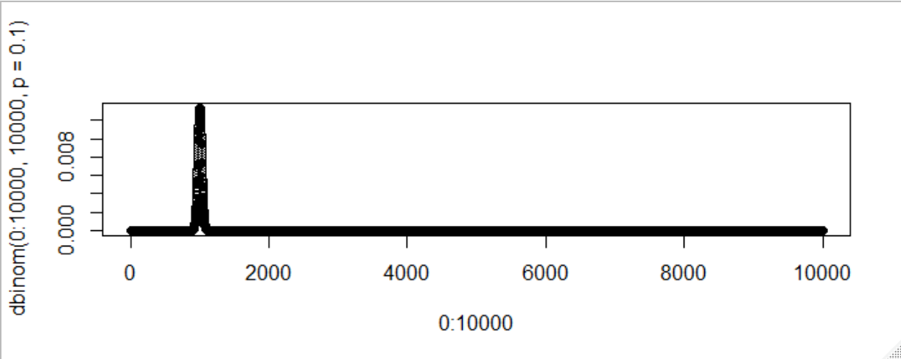

**Figure 4: Plot of dbinom(0:10000, 10000, p=0.1)**

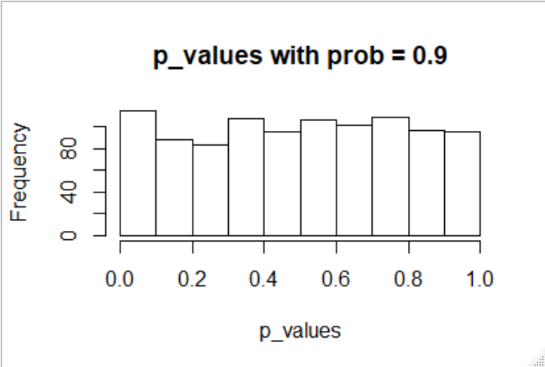

**Figure 5: Histogram of p-values with prob = 0.9**

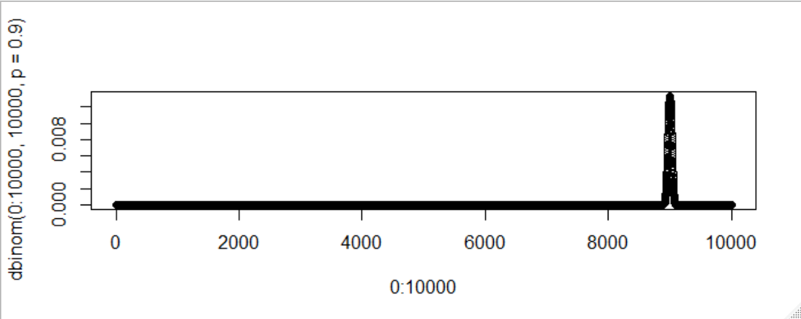

**Figure 6: Plot of dbinom(0:10000, 10000, p=0.9)**

**Would you expect the same shape of the p-value histogram with expected values of .49 as with .51? Why or why not?**

Yes, I would expect the same shape of the p-value histogram with expected values of 0.49 as 0.51. The pdf’s for expected values of 0.49 and 0.51 (figures 7 & 8, respectively) behave in the same manner as previously described for pdf’s for the expected values of 0.1 and 0.9 (figures 4 & 6, respectively).

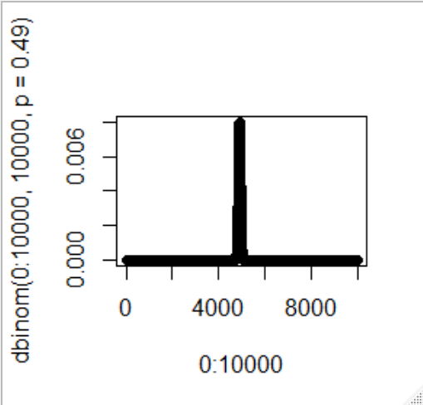

**Figure 7: Plot of dbinom(0:10000, 10000, p=0.49)**

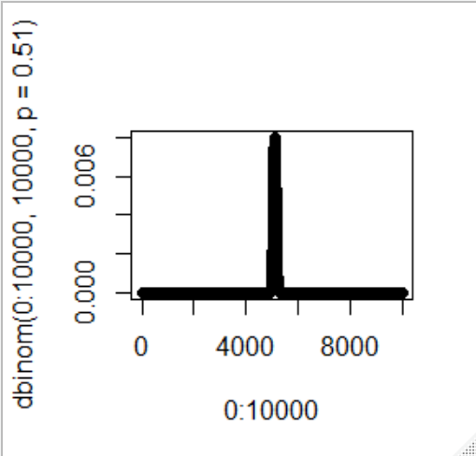

**Figure 8: Plot of dbinom(0:10000, 10000, p=0.51)**