**Part 1**

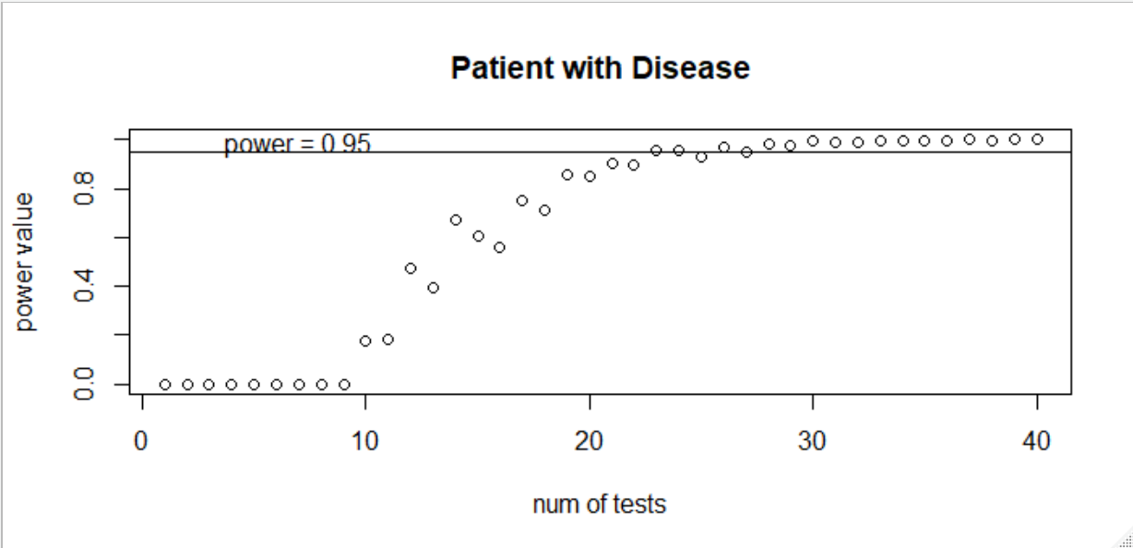

**Figure 1 (Power Values per # of Tests for Patient with Disease):** P(Test+ | Disease+) = 0.91;   
π = (Disease+ = 0.001, Disease-- = 0.999 )

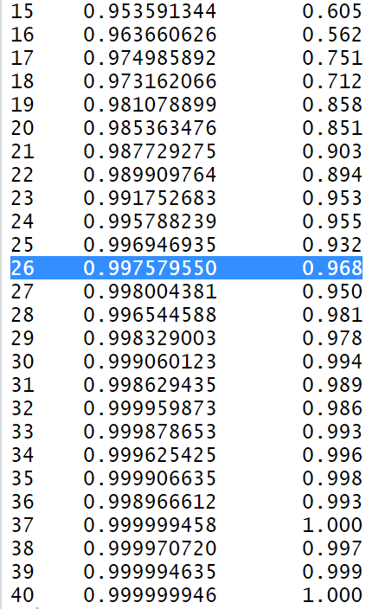  
**Figure 2 (Power Values per # of Tests for Patient with Disease):** P(Test+ | Disease+) = 0.91;   
π = (Disease+ = 0.001, Disease-- = 0.999 )

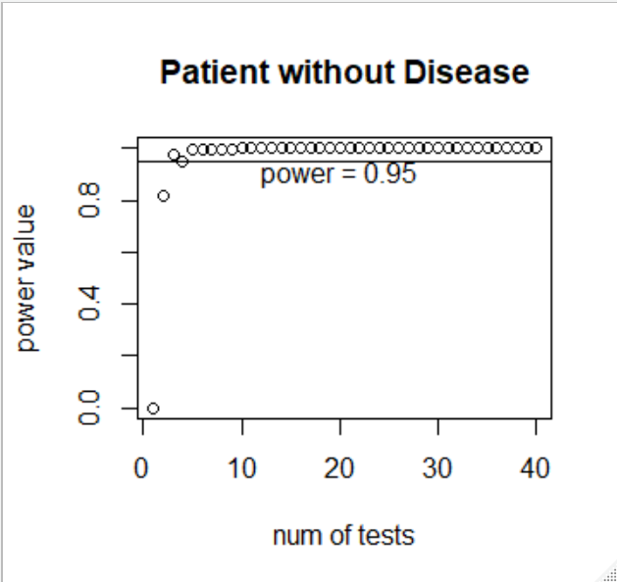

**Figure 3 (Power Values per # of Tests for Patient without Disease):** P(Test+ | Disease--) = 0.16;   
π = (Disease+ = 0.001, Disease-- = 0.999 )

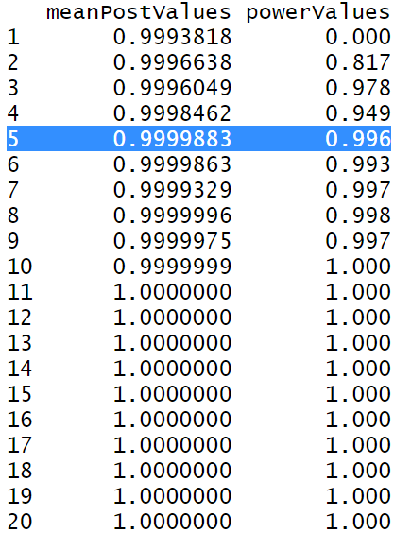

**Figure 4 (Power Values per # of Tests for Patient without Disease):** P(Test+ | Disease--) = 0.16;   
π = (Disease+ = 0.001, Disease-- = 0.999 )