**(1A)** Plot the prior graph for a situation for a coin where the prior belief for p(head) is represented by the following R code :

dexp(x, rate =5) / 0.9932621

for values of 0 <= x <= 1 and 0 otherwise. (We choose the denominator to make the

Integral between 0 and 1 sum to 1).

See figure 1.

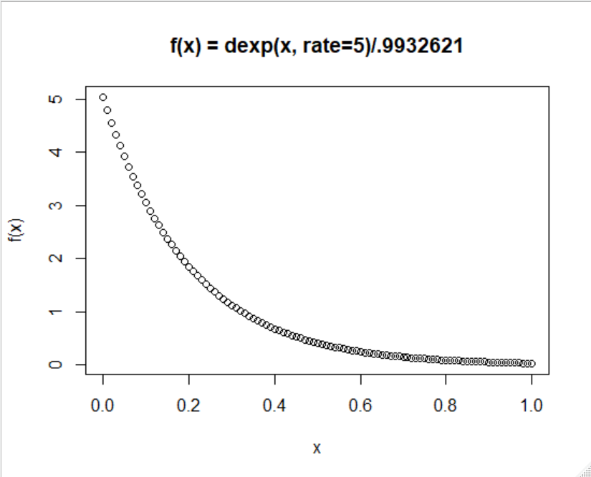

**Figure 1: Plot of function 🡪 dexp(x, rate =5) / 0.9932621**

**R code:**

x <- seq(0, 1, .01)

target <- function(x){dexp(x, rate=5)/.9932621}

plot(x,target(x), main = "f(x) = dexp(x, rate=5)/.9932621", xlab = "x", ylab = "f(x)")

**> integrate(target,0,1)**

**1 with absolute error < 1.1e-14**

**(1B)** Calculate the posterior graph with both the Metropolis algorithm and grid approximation for a case with 14 heads and 10 tails (where x = prob(head)) .

Show the two methods roughly agree. Compare these to a plot with a posterior for

new data of 14 heads and 10 tails with a prior with beta(40,40).

(So for the observation of 14 heads and 10 tails you will end up with a graph with three plots superimposed: (i) the Metropolis algorithm with an exp prior, (ii) grid approximation with an exp prior and (iii) exact analytical solution from a beta(40,40) prior

make the plots different colors so you can visualize them…)

I executed the following command, using 1M iterations, to create the plot illustrated at figure 2. The source file is located at this link: [runMetropolisTest](https://github.com/jyoung67/advstatistics-labs/blob/master/labs/lab05/runMetropolis.R).

* *runMetropolisTest(iterations = 1000000, initialValue=0.5, numHeads=14, numTails=10)*

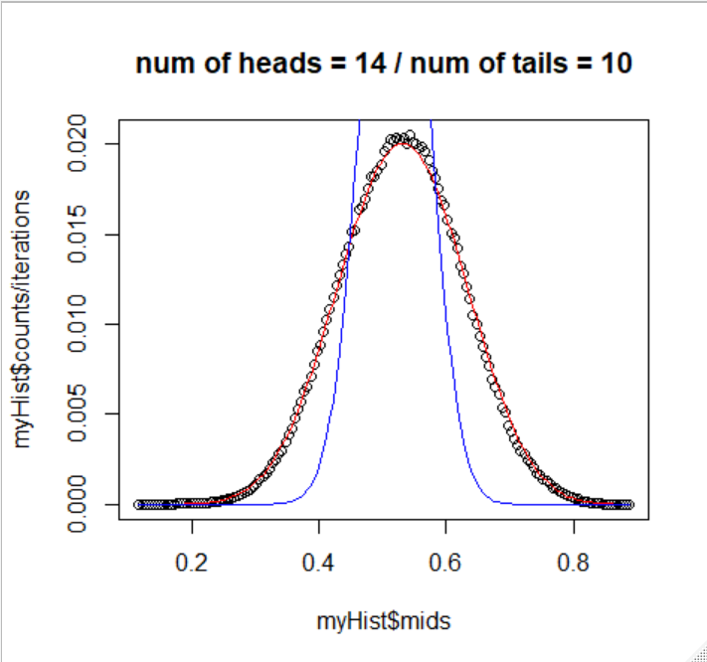

**Figure 2 (num of heads = 14 & num of tails = 10):** Combined plot of (i) Metropolis algorithm with an exp prior, (ii) grid approximation with an exp prior and (iii) exact analytical solution from a beta(40,40) prior using 1M iterations

**(1C)** Repeat the above calculation but for a case of 583 heads and 417 tails.

(You may need to adjust your model step parameters to try and get the grid and Metropolis graphs to match up). How do the three posterior curves relate to each other now? Why does this plot look different than the plot in (1B)?

I executed the following command, using 1M iterations, to create the plot illustrated at figure 3. The source file is located at this link: [runMetropolisTest](https://github.com/jyoung67/advstatistics-labs/blob/master/labs/lab05/runMetropolis.R).

* *runMetropolisTest(iterations = 1000000, initialValue=0.5, numHeads=583, numTails=417)*

All three posterior curves are very similar now. Moreover, the posterior plot for the beta distribution has changed significantly. The plot in figure 3 looks different from the plot in 1B (figure 2), because there were a significant number of additional coin flips observed (1000 flips versus only 24 coin flips). Therefore, the belief has significantly increased with many more observations.

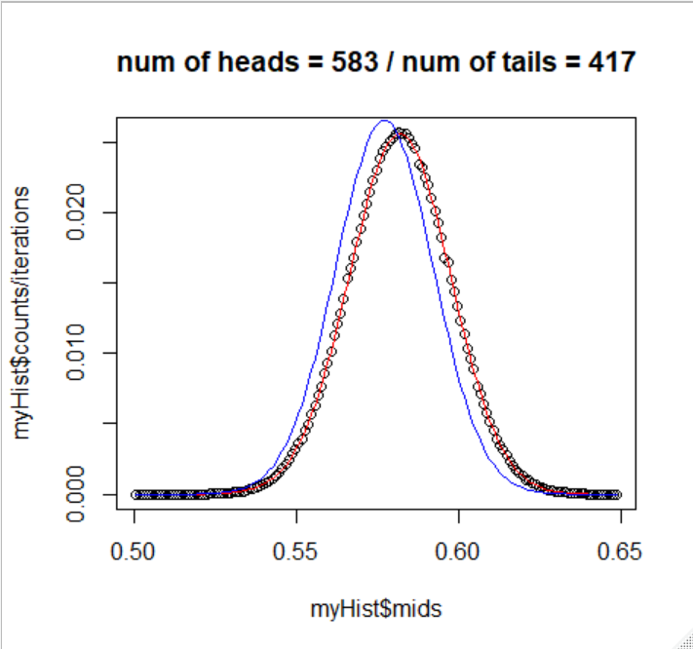

**Figure 3 (num of heads = 583 & num of tails = 417):** Combined plot of (i) Metropolis algorithm with an exp prior, (ii) grid approximation with an exp prior and (iii) exact analytical solution from a beta(40,40) prior using 1M iterations