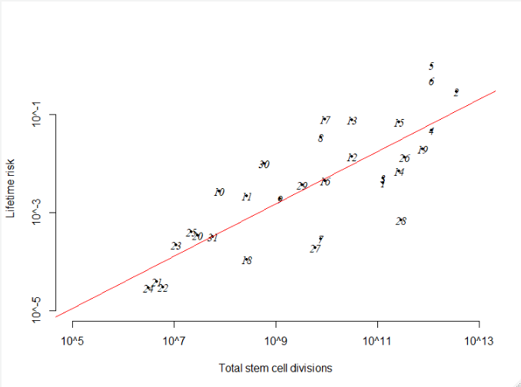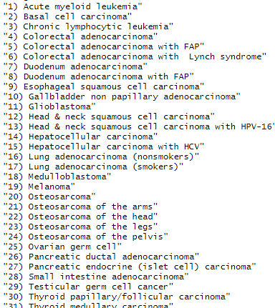

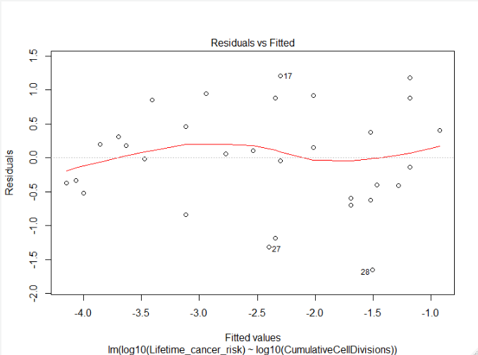

plot(lmodel)

* The residuals “bounce randomly” around the 0 line, suggesting that the assumption of linear relationship between cumulative cell divisions and lifetime cancer risk is reasonable.
* The residuals roughly forma a “horizontal band” around the 0 line. This suggests that the variances of the error terms are equal.

