Corn Demand Monitor: Guardrails for User-Supplied Inputs
Supply, Usage, and the Boundaries of Plausible Price Prediction

1. Background
The corn demand monitor predicts the marketing-year average (MYA) price using a single-equation regression built on a constant-elasticity-of-demand framework. The predicted price takes the form:

Ŷ = 1.19155 + 0.0324 × K × P × G

where P is the observed spot (MYA) price, K ≈ 37.97 is a base-year normalizing constant, and G = (Supply / Usage)^(1/ε) with ε = −0.17 the own-price elasticity of demand. Because G enters multiplicatively with the spot price, the model is nonlinear: the sensitivity of the predicted price to a change in the supply/usage ratio depends on where the spot price currently sits. At P = $4/bu the model is relatively forgiving; at P = $9/bu it amplifies the same ratio move into a much larger dollar swing.
The interactive version of the monitor lets users substitute their own supply and usage figures — either as scenario forecasts or as insider-informed guesses — and observe the predicted price change. This flexibility is valuable but introduces a practical problem: users can enter values that produce predicted prices that are economically impossible or historically unprecedented, with no warning that they have left the guardrails.

2. The Tight Correlation Between Supply and Usage
A first glance at the raw numbers might suggest that supply and usage move independently across a wide range — total supply has grown from roughly 10,600 Mbu in 2002 to over 18,300 Mbu in 2025, and total usage has followed a similar upward arc. But the key quantity for this model is not the level of either variable; it is their ratio. And that ratio is strikingly stable.

Over 25 marketing years (2000–2025), the S/U ratio ranged from only 1.074 to 1.198 — a band of just 12.5 percentage points around a mean of 1.125. The coefficient of variation is 3.0%, and the Pearson correlation between the raw supply and usage series is 0.982. Supply and usage move nearly in lockstep because demand absorbs most supply growth over time.

Figure 2 below illustrates this co-movement: the S/U ratio bar chart shows that the ratio almost never strays far from the mean, and the predicted price line tracks it inversely — a slightly tighter ratio (lower S relative to U) pushes the price up, and a slightly looser ratio (higher S relative to U) pushes it down. The 2011–2012 drought years, when S/U fell to 1.074–1.079, produced predicted prices approaching $9–10/bu; the 2004 and 2005 bumper crops, when S/U reached 1.174–1.199, kept predicted prices below $3.50/bu.
This stability is economically logical: corn demand is inelastic (ε = −0.17), so supply growth is typically met with only modest price declines, and demand grows with income and bio-fuel policy. What it means for guardrail design is that any user-supplied combination that implies an S/U ratio outside the 1.07–1.20 corridor is moving into uncharted territory — not just unusual, but outside the entire historical record.

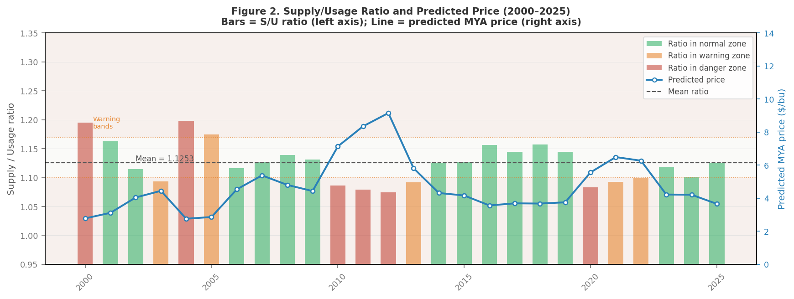
Figure 2. Supply/Usage ratio (bars, left axis) and predicted MYA price (line, right axis), 2000–2025. Warning thresholds
at S/U = 1.10 and 1.17 are shown as dotted lines.

3. Why Spot Price Changes the Shape of the Danger Zone
Because the spot price P enters the prediction formula multiplicatively with G, the same S/U ratio produces a very different predicted price depending on the price environment. Figure 1 shows the supply–usage scatter plot under two conditions: a low spot-price environment (P = $4/bu, representative of 2025) and a high spot-price environment (P = $9/bu, representative of the 2011–2012 drought era).
The diagonal lines in each panel are iso-price contours — combinations of supply and usage that yield the same predicted price. In (Supply, Usage) space these are rays from the origin (lines of constant S/U ratio), color-coded by the guardrail status they imply. The green shaded wedge is the plausible zone; orange lines mark warning thresholds; red lines mark danger thresholds.
Two features stand out when comparing the two panels:
- At P = $4, the entire historical scatter comfortably sits within the green plausible zone, and the danger iso-price lines ($2 and $10) are far from the data cloud. Small deviations from history are relatively harmless.
- At P = $9, the iso-price lines crowd together and the danger thresholds move much closer to the historical data. The same supply/usage miss that produces a $0.50 prediction error at P = $4 produces a $1.10 error at P = $9. Users exploring the model in a high-price environment need tighter guardrails — or at minimum, more prominent warnings.

The purple confidence ellipse drawn around the historical scatter captures the joint distribution of supply and usage values. Its highly elongated, diagonal shape — major axis ≈ 5,700 Mbu, minor axis ≈ 540 Mbu, rotated roughly 42° from horizontal — reflects that 0.982 correlation: almost all of the variation in (S, U) is along the shared growth trend, with very little orthogonal scatter. Any user point that falls outside this ellipse, or between a warning iso-price line and a danger iso-price line, should trigger a message.

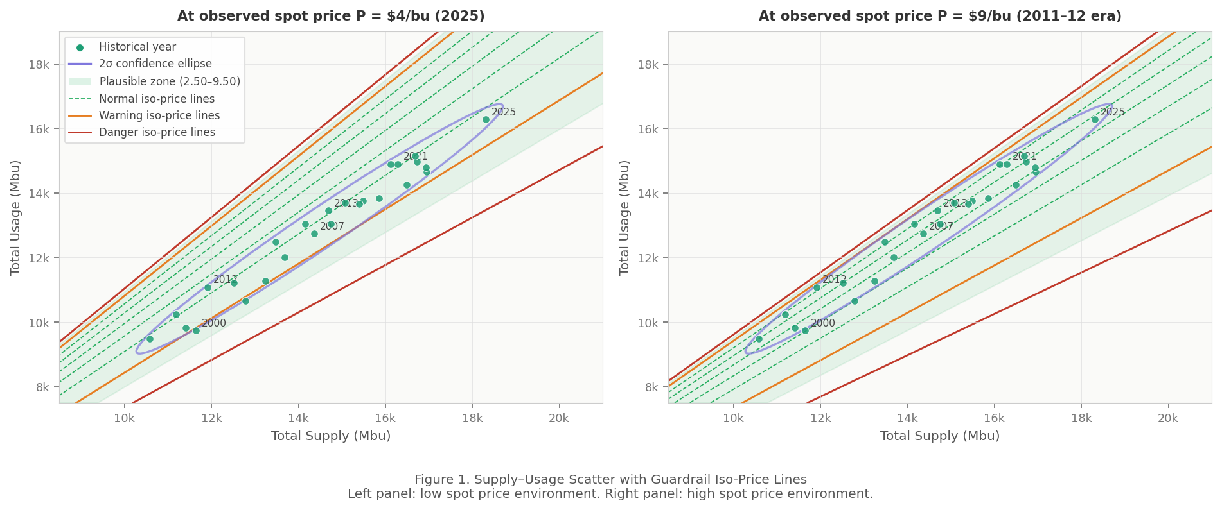
Figure 1. Supply–Usage scatter with iso-price guardrail lines, for P = $4/bu (left) and P = $9/bu (right). Colored lines are contours of constant predicted price; purple ellipse is the 2σ confidence region. Green dots are historical (S, U) pairs; orange dot (user input) updates in real time in the interactive version.

4. Guardrail Design

4.1 Output-Based Rather Than Input-Based
The guardrails are anchored to the model's predicted price output, not to the raw supply or usage inputs. There are two reasons for this choice. First, the "dangerous" quantity in this model is not supply or usage in isolation but their ratio — and bounding individual inputs does not bound the ratio in any useful way. Second, and more importantly, the spot price P is part of the formula: a moderately unusual S/U ratio is benign at P = $4 but alarming at P = $9. Any guardrail that ignores the current P will be systematically wrong in high-price environments precisely when it is most needed.
The procedure is therefore: (1) accept any supply and usage values the user enters; (2) compute the predicted price immediately; (3) evaluate it against the thresholds below.

4.2 Guardrail Thresholds
The thresholds below were developed by combining two criteria: (a) the historical S/U range observed in 2000–2025, and (b) the plausible economic floor and ceiling for corn prices under normal market conditions.

Predicted Price | Status | Fill | Explanation
< $1.50 | Impossible |  | S/U ratio far above history (> ~1.36); model breakdown
$1.50 – $2.50 | Danger |  | S/U > ~1.26; no historical precedent
$2.50 – $3.50 | Warning |  | S/U > ~1.19; above all observed values
$3.50 – $9.50 | Plausible |  | S/U within 1.07–1.19 historical band
$9.50 – $11.00 | Warning |  | S/U < ~1.08; only 2012 drought approached this
> $11.00 | Danger / Impossible |  | S/U < ~1.02; no historical precedent

Note that the thresholds are symmetric in their color-coding but not in their economic interpretation. A sub-$2.50 prediction typically reflects a wildly oversupplied scenario (S/U > 1.26) that has simply never occurred in modern corn markets. A above-$9.50 prediction reflects a supply shock tighter than the 2012 drought — possible, but requiring a specific combination of crop failure and continued strong demand that warrants explicit acknowledgment.

4.3 How the Spot Price Shifts the Thresholds
To make the point concrete: the S/U ratio that produces a $9.50 predicted price at P = $4/bu is approximately 1.052 — well below the historical minimum of 1.074. The same warning threshold at P = $9/bu corresponds to an S/U ratio of approximately 1.075, which is right at the historical minimum. In other words, the $9.50 warning fires much more easily when prices are high, even for supply/usage combinations that would look normal in a low-price year. The guardrail logic must re-evaluate the thresholds at the prevailing spot price every time the user changes P.

5. Communicating Guardrails to Farmers and Subscribers
Farmers and grain merchandisers who use the monitor are not econometricians. They understand supply and usage in physical units — bushels, acres, yield rates — and they understand price in dollars per bushel. The guardrail communication should meet them there, not in the language of S/U ratios and elasticities. Recommended language for each tier:

Plausible (green)
"Your supply and usage inputs are within the range of conditions this model has seen over the past 25 years. The predicted price reflects a plausible market outcome."

Warning (yellow/orange)
"The supply/demand balance you've entered would be tighter (or looser) than anything observed in modern corn markets. The predicted price is technically valid, but treat it as an extrapolation. Consider whether your supply and usage figures are consistent with each other — corn usage tends to grow with supply over time."

Danger (red)
"The supply and usage values you've entered imply a market structure with no historical precedent. The predicted price may not be reliable. Please check your inputs: total supply is typically 7–20% larger than total usage, and both series have grown from roughly 10,600 Mbu to 18,300 Mbu over 25 years. If you are modeling a genuine extreme event (e.g., a major crop failure), please contact us before acting on the prediction."

Two additional design principles are worth emphasizing for the front-end implementation. First, always display the S/U ratio alongside the predicted price — a line such as "Your inputs imply supply is 14% larger than usage (historical range: 7%–20%)" gives farmers an immediate physical check they can verify against their own knowledge. Second, the chart of historical supply/usage scatter (Figure 1) is a powerful self-service communication tool: users can see at a glance where their point falls relative to 25 years of data, without needing to understand the regression mechanics.

Corn Demand Monitor — Guardrail Documentation

