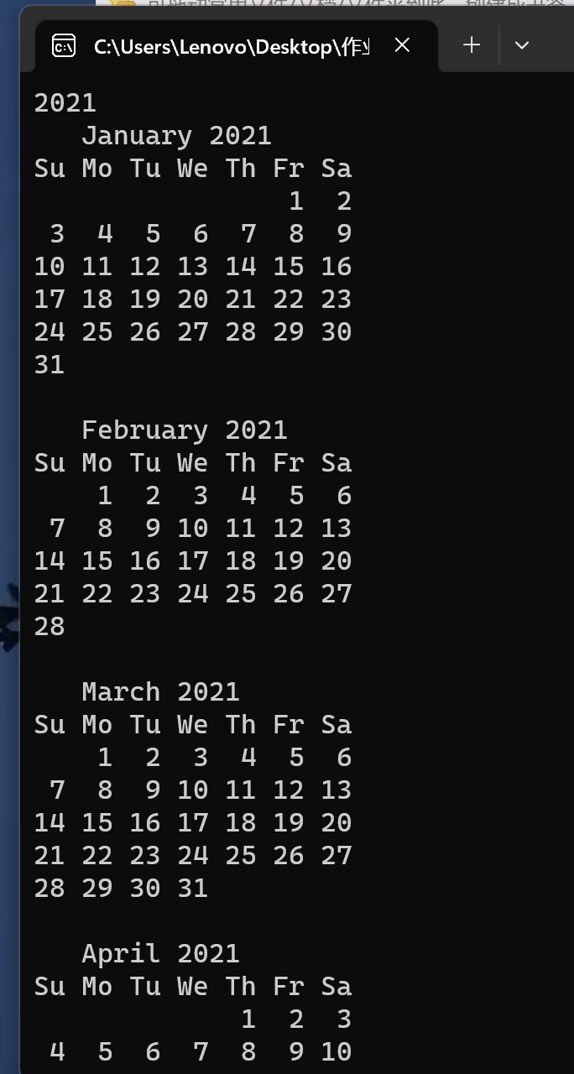

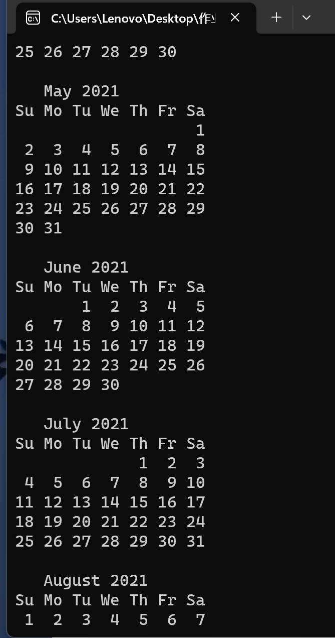

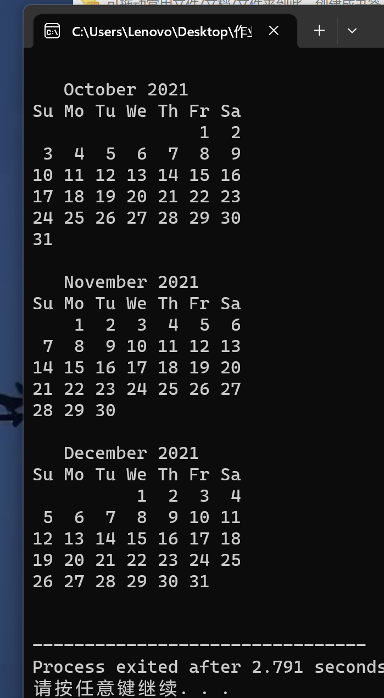

#include <stdio.h>

int leap_year(int n);

int first_day(int n);

void print_first(int month,int n);

void print_second();

int print_calendar(int month,int first,int flag);

void print_day(int first,int n);

/* main */

int main(void)

{

int n,flag,first;

scanf("%d",&n);

flag = leap_year(n);

first = first_day(n);

for(int month=1;month<=12;month++)

{

print_first(month,n);

print_second();

first = print_calendar(month,first,flag);

}

return 0;

}

/* 判断闰年 */

int leap_year(int n)

{

if(!(n%4)&&(n%100)||!(n%400)) return 1;

return 0;

}

/* 判断第一天是星期几 */

int first_day(int n)

{

int day_sum = 0;

for(int i=1900;i<n;i++)

{

if(leap_year(i)){day_sum += 366;}

else{day_sum += 365;}

}

day_sum %= 7;

day_sum++; /*星期天用 7 表示*/

return day_sum;

}

/* 输出每月第一行 */

void print_first(int month,int n)

{

switch(month){

case 1:printf(" January %d\n",n);break;

case 2:printf(" February %d\n",n);break;

case 3:printf(" March %d\n",n);break;

case 4:printf(" April %d\n",n);break;

case 5:printf(" May %d\n",n);break;

case 6:printf(" June %d\n",n);break;

case 7:printf(" July %d\n",n);break;

case 8:printf(" August %d\n",n);break;

case 9:printf(" September %d\n",n);break;

case 10:printf(" October %d\n",n);break;

case 11:printf(" November %d\n",n);break;

case 12:printf(" December %d\n",n);break;

}

}

/* 输出每月第二行 */

void print_second()

{

printf("Su Mo Tu We Th Fr Sa\n");

}

/* 输出日历部分 */

int print_calendar(int month,int first,int flag)

{

if(first != 7)

for(int i = 0;i < 3 * first - 1;i++)

{printf(" ");}

if(month == 2){

if(flag) {print_day(first,29);first += 29;}

else {print_day(first,28);first += 28;}

}else{

switch(month){

case 1:case 3:case 5: case 7:case 8:case 10:case 12:

print_day(first,31);first += 31;break;

case 4:case 6:case 9:case 11:

print_day(first,30);first += 30;break;

}

}

first %= 7;

return first;

}

void print_day(int first,int n)

{

for(int i = 1;i <= n;i++){

if(first == 0){

printf("%2d",i);

first = 1;

}else if(first == 7){

printf("\n%2d",i);

first = 1;

}else{

printf(" %2d",i);

first++;

}

}

printf("\n\n");

}