# Approach

Train and Go is a wheelchair accessory that sends orientation and movement data in the form of controller input over Bluetooth to a VR headset. Train and Go ensures user safety by using an object detection system to provide feedback that alerts users of possible collisions in the real world while they are using a VR headset. Train and Go is designed as a supplement to the “Advancement of Driving Technology for Vocational Enablement” National Science Foundation (NSF) Grant No. 2235863[1] [12]. Figure 2.1 depicts the overall design of Train and Go.

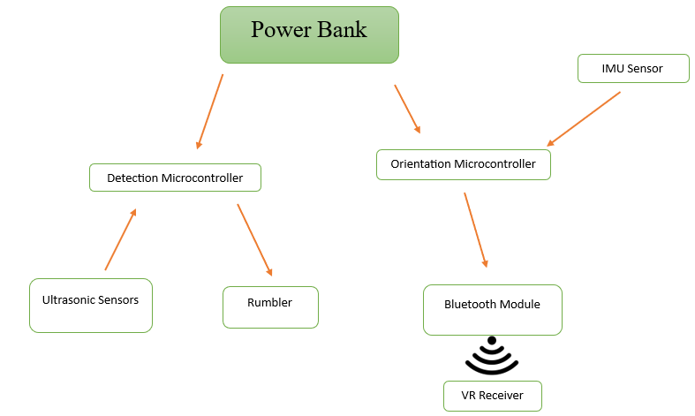

Figure 2.1 – Train and Go System Diagram

Train and Go is divided into four design subsystems. The object detection subsystem notifies the user when they are approaching an obstacle. The motion tracking subsystem is responsible for capturing the wheelchair’s movement and translating it into VR control signals. The wireless communication subsystem is responsible for facilitating communication between Train and Go and the VR headset. The power distribution subsystem handles the distribution of power from the battery to each component of Train and Go. The following sections detail the hardware and software components of Train and Go.

## Hardware

Train and Go utilizes two microprocessors to input sensor data and interpret it appropriately. One of these microprocessors facilitates orientation tracking and wireless communications while the other microprocessor handles object detection and provides feedback. This isolation allows each system to process data continuously at maximum efficiency. Figure 2.2 presents an overview of the hardware placement.

Figure 2.2 – Train and Go Hardware Diagram

Components are selected to satisfy processing and power requirements that allow Train and Go to operate efficiently.

### Inertial Measurement Unit (IMU)

The motion tracking subsystem measures orientation and speed to be translated into controller signals for the VR training system. Orientation measurement is achieved using an IMU. The IMUs compared for Train and Go utilize a gyroscope to measure angular velocity and an accelerometer to measure linear velocity. IMU options that were considered can be found in Table 2.1.

Table 2.1 – IMU Comparison

|  |  |  |  |  |  |  |
| --- | --- | --- | --- | --- | --- | --- |
| **Product** | **Input Voltage (V)** | **Current Usage (mA)** | **Angular Rate Zero-Rate (Degrees Per Second)** | **Linear Acceleration Zero-G Offset Value (mg)** | **Maximum Operating Temperature (Degrees C)** | **Cost (USD)** |
| **Requirements** | **≥ 3.3** | **≤ 5** | **≤ 10** | **≤ 25** | **≥ 40** | **≤ 50.00** |
| ISM330DHCX [13] | 3.3 | 1.2 | 1 | 10 | 105 | 20.00 |
| LSM6DSOX [14] | 3.3 | 0.55 | 1 | 20 | 85 | 12.00 |
| LSM6DSO32 [15] | 3.3 | 0.55 | 0.5 | 20 | 85 | 12.50 |

The ISM330DHCX IMU was selected by the Train and Go design team for its greater linear acceleration accuracy and temperature range despite its current usage being twice as much as the other options. With a higher temperature range, the IMU is less susceptible to a change in accuracy at different temperatures. When wheelchair users are training in a virtual environment, these tiny differences in sensitivity can lead to a significant difference in user experience.

### Orientation Microcontroller

Orientation tracking requires the conversion of raw IMU data into control signals usable by a VR headset. This processing is achieved with a microcontroller that takes IMU data in and sends it to the wireless communication subsystem to be sent to the VR headset. Options for orientation processing microcontrollers are listed in Table 2.2.

Table 2.2 – Orientation Microcontroller Comparison

|  |  |  |  |  |  |
| --- | --- | --- | --- | --- | --- |
| **Product** | **Working Voltage (V)** | **Working Current (mA)** | **Clock Speed (Hz)** | **GPIO Pins** | **Cost (USD)** |
| **Requirements** | **3.3 – 5** | **≤ 1,000** | **≥ 4,000** | **≥ 2** | **≤ 100.00** |
| Raspberry Pi 4B [16] | 5 | 3,000 | 1,500,000,000 | 40 | 152.00 |
| ESP32 [17] | 2.3 **–** 3.6 | 500 | 60,000,000 | 22 | 6.67 |
| Libre Le Potato [18] | 5 | 800 | 1,500,000,000 | 40 | 35.00 |

The microcontroller requires 1,000 clock cycles to process each wireless refresh, which happens four times a second. This refresh rate means the microcontroller requires 4,000 clock cycles per second. Serial communications require a power, ground, data, and clock pin, so the microcontroller requires two GPIO pins to handle data and the clock. The ESP32 has a much lower cost and power consumption than other alternatives that satisfy these requirements.

### Ultrasonic Sensors

Train and Go detects objects within a 2.2-meter radius to meet design specifications. The Train and Go design team has opted to use ultrasonic sensors for object detection. Ultrasonic sensors are more economically viable than LiDAR or stereo camera systems. Their accuracy is within ±3 centimeters. Table 2.3 presents the ultrasonic sensors considered for Train and Go.

Table 2.3 – Ultrasonic Sensor Comparison

|  |  |  |  |  |  |  |
| --- | --- | --- | --- | --- | --- | --- |
| **Product** | **Working Voltage (V)** | **Working Current (mA)** | **Maximum Range (m)** | **Minimum Range (cm)** | **Measuring Angle (Degrees)** | **Cost (USD)** |
| **Requirements** | **3.3 – 5** | **≤ 15** | **≥ 2.2** | **2** | **15** | **4.00** |
| RCWL-1601 [19] | 3.3 **–** 5 | 15 | 4.5 | 2 | 15 | 3.95 |
| US-100 [20] | 3.3 **–** 5 | 15 | 4.5 | 2 | X < 15 | 6.95 |
| HC-SR04 [21] | 3.3 **–** 5 | 15 | 4 | 2 | 15 | 1.30 |
| A02YYUW [22] | 3.3 **–** 5 | 8 | 4.5 | 3 | 60 | 17.88 |
| Grove [23] | 3.3 **–** 5 | 8 | 3.5 | 3 | 15 | 3.95 |

The HC-SR04 was chosen by the Train and Go design team due to it being very economical and using pulse width modulated (PWM) signals. It had the same specifications and quality as the other sensors that used PWM signals to communicate, but it was a third of the price of its closest competitor.

### Rumble Motor

To provide feedback to the user of Train and Go, a rumble motor was chosen. A rumble motor is less obtrusive and faster than audio feedback. The main parameters considered for choosing a rumble motor are the working voltage, working current draw, and rated speed of the motor. The rumble motors considered for Train and Go are listed in Table 2.4.

Table 2.4 – Rumble Motor Comparison

|  |  |  |  |  |
| --- | --- | --- | --- | --- |
| **Product** | **Working Voltage (V)** | **Working Current (mA)** | **Rated Speed (rad/s)** | **Cost (USD)** |
| Requirements | **≥ 3** | **≤ 25** | **≥ 1675** | **4.00** |
| Tatoko [24] | 3 | 20 | 1675 | 2.14 |
| BestTong [25] | 1.5 | 20 | 837 | 1.19 |
| BOJACK [26] | 3 | 20 | 1675 | 3.50 |

The Tatoko rumble motor was chosen because it had a higher motor speed rating at a lower price point. It also operates at 3 volts, which is preferred over 1.5 volts. A higher voltage is preferred because bucking the battery voltage to a much lower voltage can cause excessive heat due to a large amount of power dissipation in the converter.

### Detection Microcontroller

The parameters considered in the decision to choose the microcontroller responsible for object detection were the input voltage, the current rating of the input/output (I/O) pins, the clock speed, and the number of analog general-purpose input/output (GPIO) pins. A total number of sixteen analog GPIO pins is required to ensure that at least eight ultrasonic sensors can be controlled simultaneously. A clock speed of 16 megahertz is sufficient for object detection. The microcontrollers considered for object detection are listed in Table 2.5.

Table 2.5 – Detection Microcontroller Comparison

|  |  |  |  |  |  |
| --- | --- | --- | --- | --- | --- |
| **Product** | **Input Voltage (V)** | **Maximum Current Per I/O Pin (mA)** | **Clock Speed (MHz)** | **Analog GPIO Pins** | **Cost (USD)** |
| Requirements | **7 – 12** | **≥ 20** | **≥ 16** | **≥ 16** | **25.00** |
| Elegoo Mega [27] | 7 **–** 12 | 40 | 16 | 16 | 21.00 |
| Shield Buddy [28] | 7 **–** 12 | 40 | 300 | 16 | 129.94 |
| Arduino Mega [29] | 7 **–** 12 | 40 | 16 | 16 | 48.20 |

The Elegoo Mega was chosen because it meets all necessary requirements and is significantly more economical than the other options. The Elegoo Mega is essentially a clone of the Arduino Mega that provides the same quality without the increase in price associated with the Arduino brand.

### Wireless Communication

Train and Go uses Bluetooth to transmit the orientation data interpreted from the IMU to the VR headset. Table 2.6 presents the Bluetooth transmitters considered for Train and Go.

Table 2.6 – Bluetooth Transmitter Comparison

|  |  |  |  |  |  |
| --- | --- | --- | --- | --- | --- |
| **Product** | **Working Voltage (V)** | **Working Current (mA)** | **Connectivity** | **Type** | **Cost (USD)** |
| **Requirements** | **≤ 5** | **≤ 500** | **Bluetooth** | **Microcontroller** | **≤ 30.00** |
| DSD Tech HM-10 BT Module [30] | 3.6 **–** 6 | 50 | Bluetooth 4.0 BLE | Module | 10.99 |
| ESP32 [17] | 2.3 **–** 3.6 | 500 | Bluetooth 4.2 | Microcontroller | 6.67 |
| Adafruit Feather nRF52840 Express [31] | 3.7 | 500 | Bluetooth LE | Microcontroller | 24.95 |
| Raspberry Pi 4 Model B [16] | 5 | 1300 | Bluetooth 5.0 | Microcontroller | 152.00 |

The chosen microcontroller has a built-in Bluetooth transmitter. The ESP32 was selected because of its low power draw, high flexibility, and low price. The ESP32 has dual cores that can run independently. This two-core system means one core can be used to handle Bluetooth communication, while the other can convert IMU sensor readings.

### VR Headset

Train and Go was developed in collaboration with a team in the computer science department at Mississippi State University (MSU). The Train and Go design team with the computer science team are developing a prototype in aid of the NSF Grant No. 2235863 [12]. Table 2.7 lists the VR headsets considered for both the computer science team and the Train and Go development team to use.

Table 2.7 – VR Headset Comparison

|  |  |  |  |  |
| --- | --- | --- | --- | --- |
| **Product** | **Weight (lbs.)** | **Connection** | **Tracking** | **Cost (USD)** |
| **Requirements** | **≤ 2** | **Wireless** | **Any** | **≤ 1,500** |
| Valve Index [32] | 1.78 | Wired | Steam VR Base Stations | 750.00 |
| Meta Quest 2 [33] | 1.11 | Wireless | On-board | 400.00 |
| HTC Vive XR Elite [34] | 1.38 | Wireless | On-board | 1,100.00 |
| Meta Quest Pro [35] | 1.59 | Wireless | On-board | 1,000.00 |

The Meta Quest Pro is used by Train and Go for its ease of use, on-board tracking, low weight, and wireless connection. Additionally, the computer science team has a familiarity with the software that runs on Meta headsets, so the Meta Quest series was preferred. The Meta Quest Pro has a better processor and is more comfortable to wear than the Meta Quest 2, so the Meta Quest Pro was purchased by the department.

### Power Source

It can be challenging to find space for a power source on a wheelchair. Train and Go is required to operate for five hours. Train and Go’s power source requires 2906 mAh to function for five hours per equation (1). A capacity of 3000 mAh has been selected to ensure this requirement is met.

$Battery Capacity=current⋅time=581.2 mA⋅5 hr=2906 mAh$ (1)

The power source is required to be rechargeable to extend the overall lifetime of Train and Go. The power supply also cannot exceed 150 x 150 x 150 mm to minimize space requirements. Table 2.8 lists the options considered to satisfy these conditions.

Table 2.8 – Power Source Comparison

|  |  |  |  |  |  |
| --- | --- | --- | --- | --- | --- |
| **Product** | **Working Voltage (V)** | **Working Current (mA)** | **Capacity (mAh)** | **Size (mm)** | **Cost (USD)** |
| **Requirements** | **≤ 7.4** | **≤ 3000** | **≥ 3000** | **≤ 150 x 150 x 150** | **≤ 100.00** |
| SoloGood RadioMaster TX16S [36] | 7.4 | 5000 | 5000 | 72 x 42 x 22 | 25.00 |
| Zeee 2s Lipo [37] | 7.4 | 5000 | 5400 | 138 x 47 x 25 | 38.00 |
| Razepony 2s Lipo [38] | 7.4 | 5000 | 4800 | 73 x 20 x 41 | 22.00 |
| HXJNLDC 1s Lipo [39] | 3.7 | 800 | 800 | 6 x 30 x 40 | 15.00 |

The Zeee 2s Lipo was selected as it contains an adequate capacity at an acceptable size under the target price. It can also be recharged.

### Power Conversion

Train and Go requires multiple voltages for its circuits due to its use of two microcontrollers. To provide these differing voltages, a DC-DC converter has been selected to adjust the voltage level for the object detection microcontroller and the ultrasonic sensors. The converter transforms the voltage from 7.4 volts to the 3.3 volts that the orientation processor and ultrasonic sensors require. The object detection microcontroller is powered by the power supply’s default voltage. Table 2.9 contains the power converter options considered to satisfy these requirements.

Table 2.9 – Power Conversion Comparison

|  |  |  |  |
| --- | --- | --- | --- |
| **Product** | **Working Voltage (V)** | **Working Current (mA)** | **Cost (USD)** |
| **Requirements** | **7.4 to 3.3** | **≥ 3000** | **≤ 20.00** |
| YIPIN HEXHA [40] | 24 **–** 5 to 2 **–** 18 | 3000 | 12.00 |
| Drok [41] | 8 **–** 22 to 3 **–** 15 | 3000 | 15.00 |
| Red Wolf [42] | 12 to 3.3, 5, 6, and 9 | 3000 | 14.00 |

The YIPIN HEXHA has been chosen because it offers a range of voltage that is closest to the requirement. It operates within the desired current level and is the most cost-effective option. The potentiometer allows the voltage level to be shifted easily and gives the user specific tuning capabilities.

### Power Rail

Train and Go’s ultrasonic detection system requires many connections to a 3.3-volt power source. To isolate these connections and supply each sensor with power, Train and Go uses a power rail. The power rail requires at least 10 outputs to supply each sensor separately. Table 2.10 presents the options considered to satisfy Train and Go’s power rail needs.

Table 2.10 – Power Rail Comparison

|  |  |  |  |  |
| --- | --- | --- | --- | --- |
| **Product** | **Working Voltage (V)** | **Working Current (mA)** | **Number of Outputs** | **Cost (USD)** |
| **Requirements** | **≥ 3.3** | **≥ 3000** | **≥ 10** | **≤ 20.00** |
| Evemodel PCB007 [43] | 24 | 10000 | 12 | 7.00 |
| OONO D1410 [44] | 48 | 16000 | 12 | 11.00 |
| HCDC D1338 [45] | 300 | 30000 | 12 | 18.00 |

The Evemodel PCB007 was chosen due to it offering the closest values for the voltage and current requirements. It also meets the number of required outputs while remaining the most cost effective.

## Software

Train and Go utilizes two microprocessors running independent software to provide object detection, haptic feedback, and input to a VR environment. Figure 2.3 outlines the software that runs on these microprocessors.

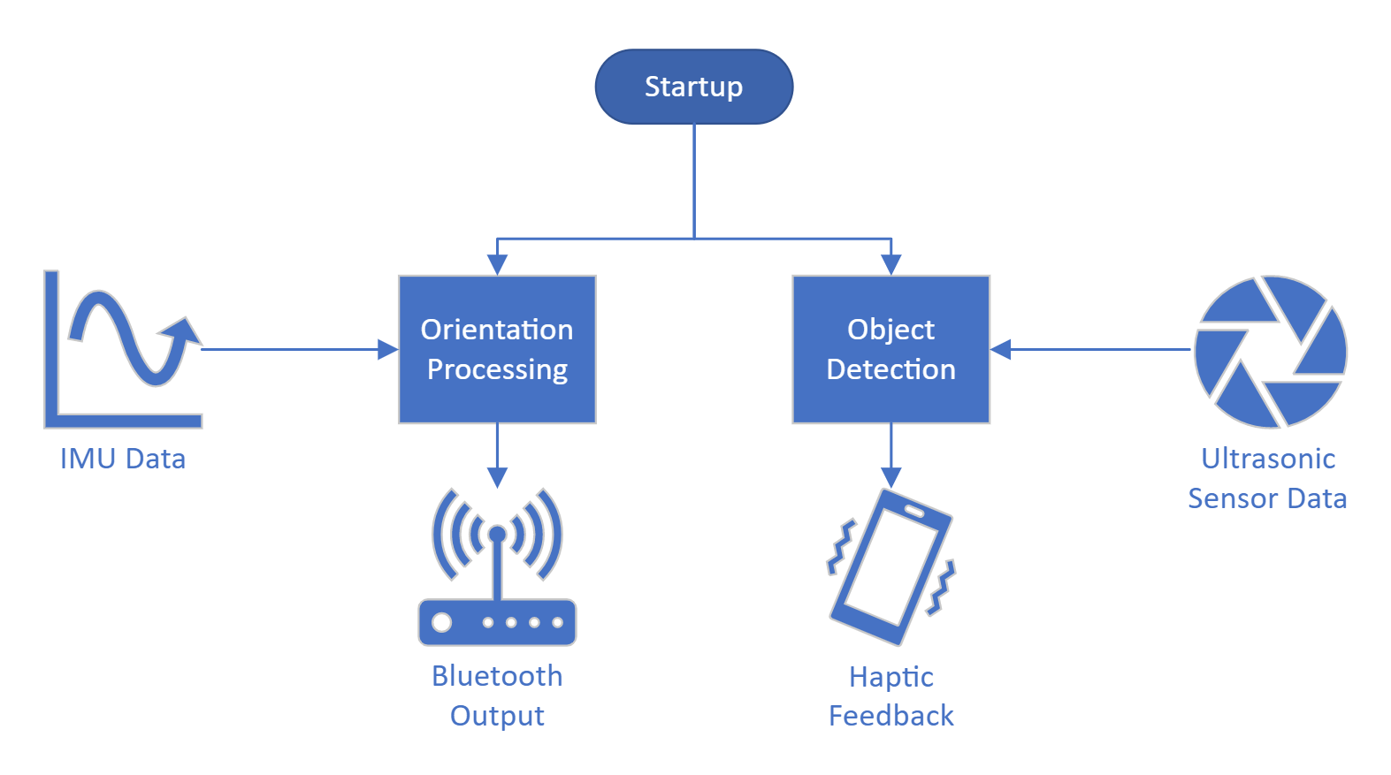

Figure 2.3 – Software Diagram

The orientation process handles the wheelchair’s orientation and transmits a signal over Bluetooth. The object detection protocol handles object detection and provides haptic feedback to the user of Train and Go.

### Orientation Processing

The process handling orientation translates velocity data into two-dimensional axis values that are transmitted over Bluetooth, emulating a video game controller for the VR headset. This is accomplished using the ESP32 microcontroller, which runs Arduino code programmed using the Arduino integrated development environment (IDE). The code written in the Arduino language includes libraries to help gather data from the IMU and output the Bluetooth game controller signal. Figure 2.4 depicts how this processing loop operates in a block diagram format.

Figure 2.4 – Orientation Processing Diagram

Upon process startup, the software calibrates the accelerometer and gyroscope. The microcontroller then enters a processing loop to gather data, translate the data, and output the data. Data is retrieved from the IMU using the inter-integrated circuit (I2C) communication protocol. This process is simplified in the Arduino language with libraries that translate I2C data from the chosen ISM330DHCX IMU into easily accessible programming variables [46]. This data is translated with respect to the calibration vectors into a single two-dimensional vector parallel to the ground. This vector is then communicated over Bluetooth as a video game controller axis, and the data processing cycle repeats. Arduino libraries written specifically for the ESP32 Bluetooth module are used to simplify the process of transmitting the video game controller outputs to the VR headset [47].

### Communication Protocol

With a required update time of 250 milliseconds, a minimum of four full updates occur each second. The I2C protocol, with a maximum bit rate of 400 kilobits per second [48], allows IMU data to be transmitted at a much higher speed than four times each second. Train and Go’s orientation processing system utilizes the I2C protocol to retrieve IMU data to ensure this speed is possible.

### Object Detection Protocol

Train and Go’s object detection protocol takes in sensor data to detect obstacles and output haptic feedback to the user. The process is implemented using the Arduino programming language, and the Arduino IDE is used to program the microcontroller. Figure 2.5 outlines this protocol in block diagram form.

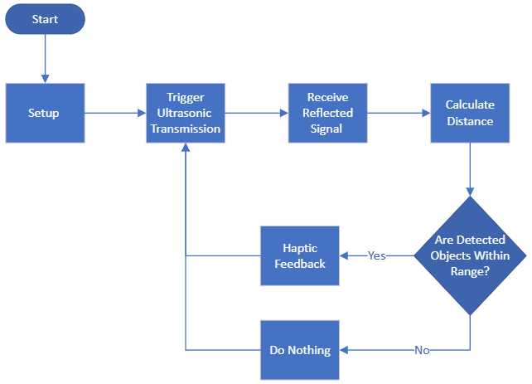

Figure 2.5 – Object Detection Protocol

Train and Go’s object detection protocol begins with the setup state, where variables and functions are defined. The ultrasonic sensors then receive a signal that causes them to begin transmission. The time it takes the reflected waves to return is then measured. The distance the object is from the sensor can be calculated using this time. The distance of the detected object is then compared to the haptic range of the system to determine if haptic feedback occurs. If the distance of the detected object is outside the haptic range, then no feedback occurs. If the object is within the haptic range, haptic feedback occurs.

# REFERENCES

1. “NSF award search: Award # 2235863 - NSF Convergence Accelerator Track H: Advancement of Driving Technology for Vocational Enablement,” nsf.gov. <https://www.nsf.gov/awardsearch/showAward?AWD_ID=2235863> (Accessed: Mar. 29, 2023).
2. “Adafruit ISM330DHCX – 6 DoF IMU.” adafruit.com. <https://www.adafruit.com/product/4502> (Accessed: Mar. 03, 2023).
3. “Adafruit LSM6DSOX 6 DoF Accelerometer and Gyroscope.” adafruit.com. <https://www.adafruit.com/product/4438> (Accessed: Mar. 03, 2023).
4. “Adafruit LSM6DSO32 6-DoF Accelerometer and Gyroscope.” adafruit.com. <https://www.adafruit.com/product/4692> (Accessed: Mar. 03, 2023).
5. “Buy a Raspberry Pi Model B.” raspberrypi.com. <https://www.raspberrypi.com/products/raspberry-pi-4-model-b/> (Accessed: Mar. 03, 2023).
6. “ESP32 datasheet.” adafruit.com. <https://cdn-shop.adafruit.com/product-files/3269/esp32_datasheet_en_0.pdf> (Accessed: Mar. 03, 2023).
7. “AML-S905X-CC (Le Potato).” libre.computer. <https://libre.computer/products/aml-s905x-cc/> (Accessed: Mar. 03, 2023).
8. “RCWL-1601 Ultrasonic Distance Sensor.” digikey.com. <https://www.digikey.com/en/products/detail/adafruit-industries-llc/4742/16584032> (Accessed: Mar. 03, 2023).
9. “US-100 Ultrasonic Distance Sensor.” adafruit.com. <https://www.adafruit.com/product/4019> (Accessed: Mar. 03, 2023).
10. “HC-SR04 Ultrasonic Distance Sensor.” amazon.com. <https://www.amazon.com/ACEIRMC-HC-SR04-Ultrasonic-Distance-ElecRightt/dp/B09J4BN46F/r> (Accessed: Mar. 03, 2023).
11. “A02YYUW Ultrasonic Distance Sensor.” digikey.com. [https://www.digikey.com/en/products/detail/dfrobot/SEN0311/11202577](https://www.digikey.com/en/products/detail/dfrobot/SEN0311/11202577?s=N4IgTCBcDaIIIAYwE1kFUDqIC6BfIA) (Accessed: Mar. 03, 2023).
12. “Grove Ultrasonic Distance Sensor.” seeedstudio.com. [https://www.seeedstudio.com/Grove-Ultrasonic-Distance‑Sensor.html](https://www.seeedstudio.com/Grove-Ultrasonic-Distance-Sensor.html?queryID=39eb6a11e8a817cc697b03c1e5350ba0&objectID=2281&indexName=bazaar_retailer_products) (Accessed: Mar. 03, 2023).
13. “Tatoko Rumble Motor.” amazon.com. <https://www.amazon.com/tatoko-vibration-Waterproof-8000-16000RPM-toothbrush/dp/B07KYLZC1S/> (Accessed: Mar. 03, 2023).
14. “BestTong Rumble Motor.” amazon.com. <https://www.amazon.com/dp/B073JKQ9LN/> (Accessed: Mar. 03, 2023).
15. “BOJACK Rumble Motor.” amazon.com. [https://www.amazon.com/dp/B09KBCY3FQ/](https://www.amazon.com/dp/B09KBCY3FQ/ref=twister_B09KGS7MPC?_encoding=UTF8&th=1) (Accessed: Mar. 03, 2023).
16. “Elegoo Mega Microcontroller.” amazon.com. <https://www.amazon.com/ELEGOO-ATmega2560-ATMEGA16U2-Arduino-Compliant/dp/B01H4ZDYCE/> (Accessed: Mar. 03, 2023).
17. “Shield Buddy Microcontroller.” digikey.com [https://www.digikey.com/en/products/detail/infineon‑technologies/KITA2GTC375ARDSBTOBO1/13563717](https://www.digikey.com/en/products/detail/infineontechnologies/KITA2GTC375ARDSBTOBO1/13563717) (Accessed: Mar. 03, 2023).
18. “Arduino Mega Microcontroller.” amazon.com. <https://www.amazon.com/ARDUINO-MEGA-2560-REV3-A000067/dp/B0046AMGW0/> (Accessed: Mar. 03, 2023).
19. “HM-10 Bluetooth Module.” amazon.com. <https://a.co/d/dheFiz2> (Accessed: Mar. 03, 2023).
20. “Adafruit Feather Microcontroller with Bluetooth.” adafruit.com. [https://www.adafruit.com/product/4062](https://www.adafruit.com/product/4062#technical-details) (Accessed: Mar. 03, 2023).
21. “Valve Index.” amazon.com. <https://www.amazon.com/Valve-Release-Headset-Stations-Controllers/dp/B07VPRVBFF/> (Accessed: Mar. 03, 2023).
22. “Meta Quest 2.” amazon.com. <https://www.amazon.com/Oculus-Quest-Advanced-All-One-Virtual/dp/B099VMT8VZ/> (Accessed: Mar. 03, 2023).
23. “HTC Vive XR Elite.” amazon.com. <https://www.amazon.com/Vive-Elite-Virtual-Reality-Headset-Controllers/dp/B0BQXDFLJ6/> (Accessed: Mar. 03, 2023).
24. “Meta Quest Pro.” amazon.com. <https://www.amazon.com/Meta-Quest-Pro-Oculus/dp/B09Z7KGTVW/> (Accessed: Mar. 03, 2023).
25. “Radio Master Battery.” amazon.com. <https://www.amazon.com/RadioMaster-5000mah-Control-Transmitter-Endurance/dp/B08DNRSKRP> (Accessed: Mar. 03, 2023).
26. “Zeee 2S Lipo Battery.” amazon.com. <https://www.amazon.com/dp/B092CZGW2P> (Accessed: Mar. 03, 2023).
27. “Razepony 2S Battery.” amazon.com. <https://www.amazon.com/dp/B0BHYTFNVN> (Accessed: Mar. 03, 2023).
28. “HXJNLDC Battery.” amazon.com. <https://www.amazon.com/603040-Rechargeable-Lithium-Replacement-Electronic/dp/B09YQ2C1KR> (Accessed: Mar. 03, 2023).
29. “YIPIN HEXHA Voltage Converter.” amazon.com. <https://www.amazon.com/dp/B0BS5ZCP1N> (Accessed: Mar. 03, 2023).
30. “Drok Voltage Converter.” amazon.com. <https://www.amazon.com/DROK-Waterproof-Converter-Adjustable-Transformer/dp/B00C0KL1OM> (Accessed: Mar. 03, 2023).
31. “Red Wolf Voltage Converter.” amazon.com. <https://www.amazon.com/dp/B0945X9JHK> (Accessed: Mar. 03, 2023).
32. “Evemodel Power Rail.” amazon.com. <https://www.amazon.com/PCB007-Position-Distribution-Outputs-Voltage/dp/B07DW2C4ZB> (Accessed: Mar. 03, 2023).
33. “OONO Power Rail.” amazon.com. <https://www.amazon.com/OONO-Position-Terminal-Distribution-Module/dp/B08TBXQ7H6> (Accessed: Mar. 03, 2023).
34. “HCDC Power Rail.” amazon.com. <https://www.amazon.com/dp/B0876W456F> (Accessed: Mar. 03, 2023).
35. “Stm32duino/ISM330DHCX.” github.com. <https://github.com/stm32duino/ISM330DHCX> (Accessed: Mar. 31, 2023).
36. “LemmingDev/ESP32-BLE-gamepad.” github.com. <https://github.com/lemmingDev/ESP32-BLE-Gamepad> (Accessed: Mar. 31, 2023).
37. “Speed – I2C bus.” i2c-bus.org. <https://www.i2c-bus.org/speed/> (Accessed: Mar. 03, 2023).

1. This material is based upon work supported by the National Science Foundation under Grant No. 2235863. Any opinions, findings, and conclusions or recommendations expressed in this material are those of the authors and do not necessarily reflect the views of the National Science Foundation.