# Evaluation

Train and Go is a training simulator that includes obstacle detecting safety features. Train and Go helps its users learn how to operate a powered wheelchair by providing a safe training environment. Table 3.1 lists the technical constraints that Train and Go follows.

Table 3.1. – Technical Design Constraints

|  |  |
| --- | --- |
| **Name** | **Description** |
| Wheelchair Speed | The system is attached to a wheelchair moving no faster than five miles per hour [2]. |
| Detection Distance | The system detects objects within a radius of no more than 2.2 meters. |
| Feedback Latency | This system’s latency for sending feedback to the user in response to an object is no more than 250 milliseconds. |
| Sensor Accuracy | The system’s false detection rate is less than 16 percent. |
| Wireless Range | The system can connect wirelessly to a Quest VR headset within 2.31 meters. |
| Wireless Latency | The wireless latency is less than 250 milliseconds. |

The design team behind Train and Go ran tests to prove that it complies with its technical constraints. These tests and their results are documented in the sections below.

## Test Certification – Wheelchair Speed

Train and Go is designed to attach to a wheelchair moving slower than five miles per hour. This speed is uncomfortably fast and should not be purposefully exceeded by someone attempting to learn how to operate a wheelchair. While moving, the Permobil M5 wheelchair displays its speed on a built-in screen shown in Figure 3.2. Train and Go utilized this speedometer to collect speed test data. While the chair was in motion, the design team verified that the system stayed attached and that the system continued to transmit Bluetooth signals while the chair’s speed increased at increments of 0.5 mph up to the five-mph limit. The data from these speed tests is displayed in Table 3.2. Figure 3.1 displays the logistical setup of this speed test in a hallway.

Table 3.2. – Wheelchair Speed Tests

|  |  |  |
| --- | --- | --- |
| **Estimated Speed (mph)** | **The System is Attached?** | **The System is Transmitting?** |
| **1** |  |  |
| **2** |  |  |
| **3** |  |  |
| **4** |  |  |
| **5** |  |  |

Figure 3.1. – Speed Test Setup

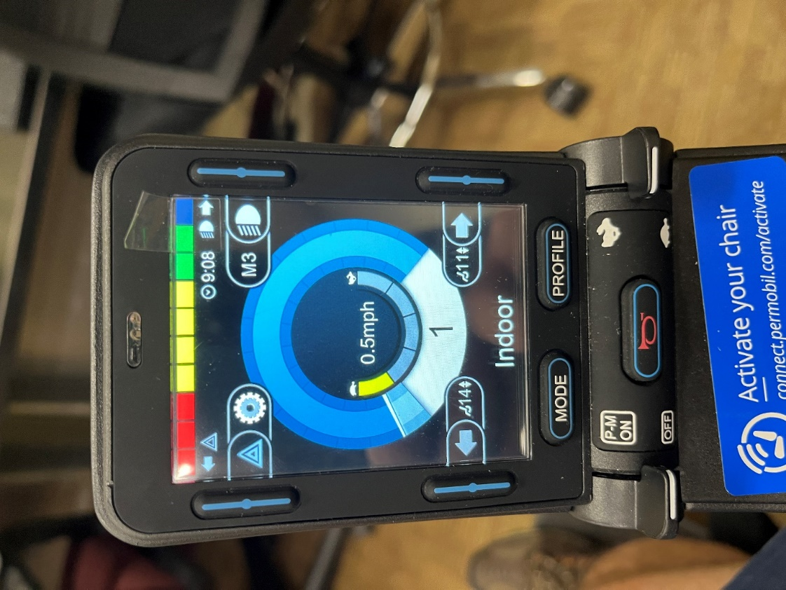

Figure 3.2. – Chair Speedometer

The speed tests recorded in Table 3.2 show that Train and Go can handle the chair moving at its maximum speed of five miles per hour.

## Test Certification – Detection Distance

Train and Go should detect obstacles once they enter a 2.2-meter radius around the chair. This detection radius ensures that the user that is training can stop before they run into an obstacle. Three ultrasonic sensors were tested to ensure that Train and Go is capable of not only detecting obstacles within the 2.2-meter radius but also reading the distance of the object accurately within that range. During the test, an obstacle was placed at a known distance away from the sensors, and the sensor’s distance measurement was captured using Arduino serial communication interface. These detected distances are recorded in Table 3.3. Figure 3.3 shows the setup for these detection distance tests, and Figure 3.4 shows the Arduino serial data results.

Table 3.3. – Detection Distance Data

|  |  |  |  |
| --- | --- | --- | --- |
| **Actual Distance (m)** | **Sensor 1 (m)** | **Sensor 2 (m)** | **Sensor 3 (m)** |
| **0.4** |  |  |  |
| **0.6** |  |  |  |
| **0.8** |  |  |  |
| **1** |  |  |  |
| **1.2** |  |  |  |
| **1.4** |  |  |  |
| **1.6** |  |  |  |
| **1.8** |  |  |  |
| **2** |  |  |  |
| **2.2** |  |  |  |



Figure 3.3. – Detection Distance Test Setup

Figure 3.4. – Detection Distance Test Results

Based on the results in Table 3.3, the design team concluded that the ultrasonic sensors detected objects up to 2.2 meters away. The team determined that the ultrasonic sensors passed the test.

## Test Certification – Detection Feedback Latency

Train and Go’s obstacle detection system responds within 250 milliseconds to keep the system as safe as possible. A low system latency allows users the time necessary to respond to the presence of a detected obstacle. As the rumble motor activates directly from the microcontroller’s digital pins, the detection feedback latency can be entirely attributed to the delays of the microcontroller and ultrasonic sensors. To measure this delay, Arduino code pictured in Figure 3.5 was programmed onto the Elegoo Mega to track the time between requesting a detection from a sensor and providing feedback to the user. The results of a series of these tests are outlined in Table 3.4 and a screenshot of example gathered data is available in Figure 3.6.

Table 3.4. – Detection Feedback Latency

|  |  |
| --- | --- |
| **Test Number** | **Latency (ms)** |
| **1** |  |
| **2** |  |
| **3** |  |
| **4** |  |
| **5** |  |
| **6** |  |
| **7** |  |
| **8** |  |
| **9** |  |
| **10** |  |



Figure 3.5. – Detection Feedback Latency Code



Figure 3.6. – Detection Feedback Latency Results

Based on Table 3.4’s results, Train and Go provides feedback to its user within the latency range set in the technical constraints.

## Test Certification – Ultrasonic Sensor False Detection Rate

Train and Go uses ultrasonic sensors to detect obstacles that users are in danger of colliding with. To guarantee the system can be relied upon, Train and Go’s ultrasonic sensors are required to have a false detection rate of less than 16%. To quantifiably measure detection accuracy, an obstacle was inserted into and taken out of the sensor’s detection radius every 5 seconds for a period of 50 seconds. For the period that the obstacle was in the detection radius, feedback should be received. For the period that the obstacle was not in the detection radius, feedback should not be received. The results of this false detection test are displayed in Table 3.5. The physical setup of this false detection is shown in Figure 3.7, and a screenshot of Arduino serial results are shown in Figure 3.8.

Table 3.5. – Ultrasonic Sensor False Detection Rate Data

|  |  |  |
| --- | --- | --- |
| **Time (s)** | **Obstacle Present?** | **False Detection?** |
| **5** |  |  |
| **10** |  |  |
| **15** |  |  |
| **20** |  |  |
| **25** |  |  |
| **30** |  |  |
| **35** |  |  |
| **40** |  |  |
| **45** |  |  |
| **50** |  |  |



Figure 3.7. – Ultrasonic Sensor False Detection Rate Setup



Figure 3.8. – Ultrasonic Sensor False Detection Rate Results

Based on Table 3.5, the design team determined that there were no false detection readings during the testing. The design team has concluded that the ultrasonic sensors have passed the test.

## Test Certification – Wireless Range

Train and Go has ensured a wireless connection range of 2.2 meters. Tests were performed at a variety of distances to guarantee this requirement is met. The results of the test can be seen in Table 3.6. Figure 3.9 shows the testing being performed.

Table 3.6. – Wireless Range Test Data

|  |  |
| --- | --- |
| **Distance (m)** | **Connected?** |
| **1** |  |
| **2** |  |
| **3** |  |
| **4** |  |
| **5** |  |



Figure 3.9. – Wireless Range Test

Table 3.6’s data shows that Train and Go’s wireless range has exceeded the requirements and allows the design team to confirm Train and Go has passed the test.

## Test Certification – Wireless Latency

Train and Go must have a wireless latency of less than 250 milliseconds to ensure a quality experience for the user. With this wireless latency, the user will not notice a delay that distracts them from the training. Train and Go uses Bluetooth, so an audio test was used to measure its delay. An audio signal was transmitted to a receiving device and recorded. This recorded signal was then compared with the original signal that the ESP32 was transmitting to observe the offset of the received signal from the expected signal in milliseconds. This offset in milliseconds was interpreted as the Bluetooth latency. Three iterations of this test were run and averaged to increase measurement reliability. Figure 3.10 shows how this test was set up. Table 3.7 lists the results of this latency test.

Table 3.7. – Wireless Latency Test Data

|  |  |
| --- | --- |
| **Test** | **Latency (ms)** |
| **1** |  |
| **2** |  |
| **3** |  |
| **Mean** |  |

Figure 3.10. – Wireless Latency Test Setup

Table 3.7 displays data that confirms Train and Go’s wireless latency requirements are met. The design team has determined that Train and Go has passed the test.

# References

1. A. Smith. “How fast do electric wheelchairs go?” Mobility Medical Supply. <https://mobilitymedicalsupply.com/how-fast-do-electric-wheelchairs-go/>. (Accessed Feb. 16, 2023).