# Evaluation

Train and Go is a training simulator that includes obstacle-detecting safety features. Train and Go helps its users learn how to operate a powered wheelchair by providing a safe training environment through VR. To guarantee an accurate virtual environment and safe physical environment, constraints on the functionality of Train and Go’s systems were set. Table 3.1 lists these technical constraints that Train and Go follows.

Table 3.1. – Technical Design Constraints

|  |  |
| --- | --- |
| **Name** | **Description** |
| Wheelchair Speed | The system is attached to a wheelchair moving no faster than five miles per hour [2]. |
| Detection Distance | The system detects objects within a minimum radius of 2.2 meters. |
| Feedback Latency | This system’s latency for sending feedback to the user in response to an object is no more than 250 milliseconds. |
| Sensor Accuracy | The system’s false detection rate is less than 16 percent. |
| Wireless Range | The system can connect wirelessly to a Quest VR headset within 2.31 meters. |
| Wireless Latency | The wireless latency is less than 250 milliseconds. |

The design team behind Train and Go ran tests to prove that it complies with its technical constraints. These tests and their results are documented in the following sections.

## Test Certification – Wheelchair Speed

Train and Go is designed to attach to a wheelchair moving slower than five miles per hour. This speed is uncomfortably fast and should not be purposefully exceeded by someone attempting to learn how to operate a wheelchair. While moving, the Permobil M5 wheelchair displays its speed on a built-in screen. Train and Go utilized this speedometer to collect speed test data. While the chair was in motion, the design team verified that the system stayed attached and that the system continued to transmit Bluetooth signals while the chair’s speed increased at increments of 0.5 mph up to the five-mph limit. The data from these speed tests is displayed in Table 3.2. Figure 3.1 shows the Permobil M5’s speedometer.

Table 3.2. – Wheelchair Speed Tests

|  |  |  |
| --- | --- | --- |
| **Estimated Speed (mph)** | **System Attached Securely** | **System Transmitting** |
| **1** | Yes | Yes |
| **2** | Yes | Yes |
| **3** | Yes | Yes |
| **4** | Yes | Yes |
| **5** | Yes | Yes |

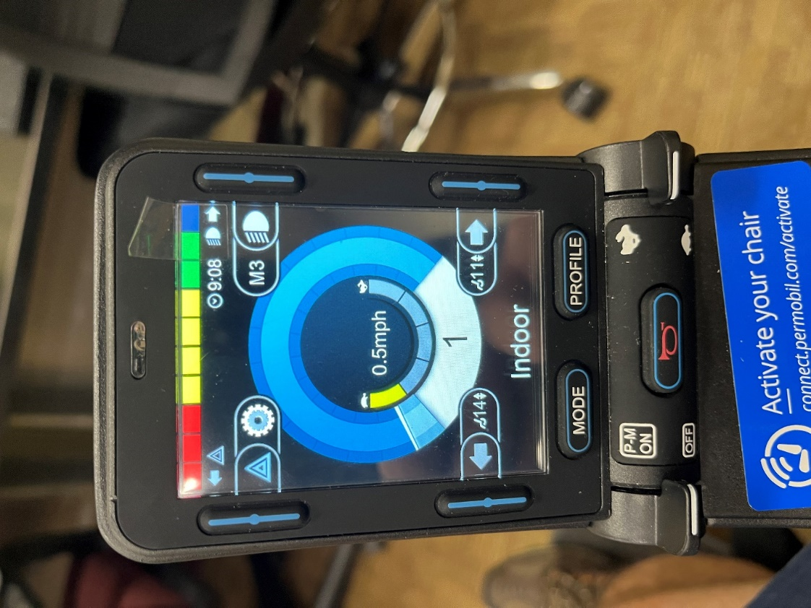

Figure 3.1. – Chair Speedometer

The speed tests recorded in Table 3.2 show that Train and Go passed all tests with the chair moving at its maximum speed of five miles per hour.

## Test Certification – Detection Distance

Train and Go detects obstacles once they enter a 2.2-meter radius around the chair. This detection radius ensures that the user who is training can stop before they run into an obstacle. Three ultrasonic sensors were tested to ensure that Train and Go is capable of not only detecting obstacles within the 2.2-meter radius but also reading the distance of the object accurately within that range. During the test, an obstacle was placed at a known distance away from the sensors, and the sensor’s distance measurement was captured using the Arduino serial communication interface. These detected distances are recorded in Table 3.3. Figure 3.2 shows the setup for these detection distance tests, and Figure 3.3 shows the Arduino serial data results.

Table 3.3. – Detection Distance Data

|  |  |  |  |
| --- | --- | --- | --- |
| **Obstacle Distance from Sensor (m)** | **Sensor 1 (m)** | **Sensor 2 (m)** | **Sensor 3 (m)** |
| **0.40** | 0.44 | 0.45 | 0.44 |
| **0.60** | 0.65 | 0.63 | 0.65 |
| **0.80** | 0.86 | 0.82 | 0.84 |
| **1.00** | 1.04 | 1.03 | 1.03 |
| **1.20** | 1.20 | 1.21 | 1.20 |
| **1.40** | 1.41 | 1.41 | 1.40 |
| **1.60** | 1.61 | 1.61 | 1.60 |
| **1.80** | 1.83 | 1.82 | 1.80 |
| **2.00** | 2.03 | 2.03 | 2.00 |
| **2.20** | 2.25 | 2.23 | 2.21 |

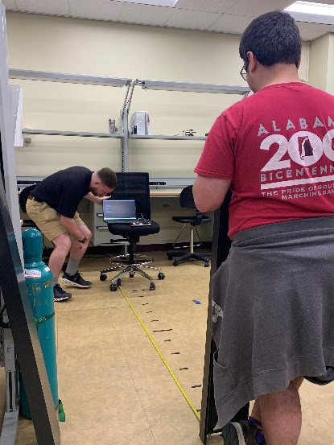

Figure 3.2. – Detection Distance Test Setup

Figure 3.3. – Detection Distance Test Results

Based on the results in Table 3.3, the design team concluded that the ultrasonic sensors detected objects up to 2.2 meters away. The ultrasonic sensors passed 100% of the distance tests.

## Test Certification – Rotational Accuracy

Train and Go utilizes an IMU to track the rotation of the wheelchair to which it is attached. Rotational measurements from the IMU are translated directly into virtual rotations of a wheelchair and must be reasonably accurate. In order to guarantee accuracy, a test was performed as follows. The IMU was programmed with a script to send the measured angle to the Arduino serial monitor. The IMU was then calibrated in relation to the zero-angle of a protractor and rotated around in a circle to compare the angle printed in the Arduino serial monitor with the actual angle on the protractor. The results of this test are listed in Table 3.4. The setup of this test is depicted in Figure 3.4, and a graph of the angle error is shown in Figure 3.5.

Table 3.4. – Rotational Accuracy Test Results

|  |  |  |
| --- | --- | --- |
| **Actual Angle (Degrees)** | **Measured Angle (Degrees)** | **Angle Offset (Degrees)** |
| **0.00** | 0.34 | 0.34 |
| **20.00** | 21.14 | 1.14 |
| **40.00** | 43.20 | 3.20 |
| **60.00** | 63.83 | 3.83 |
| **80.00** | 79.31 | -0.69 |
| **100.00** | 104.55 | 4.55 |
| **120.00** | 123.72 | 3.72 |
| **140.00** | 148.73 | 8.73 |
| **160.00** | 168.91 | 8.91 |
| **180.00** | 188.29 | 8.29 |

Figure 3.4 – Rotational Accuracy Test Setup

Figure 3.5 – Graph of Actual vs. Reported Angle Offset

As visualized in Figure 3.5, the IMU became more inaccurate as it was rotated. The offset began at 0.34 degrees and progressed to 8.29 degrees by the time the IMU was rotated a total of 180 degrees. This offset is a clear example of what is called IMU drift, where the mechanics of the IMU measurement system cause it to drift away from an accurate measurement over time. If this system were implemented in VR, the user would experience noticeable error in the rotation of the chair. The best method of combatting IMU drift is to co-register the IMU with another type of sensor like a global positioning system module or a camera. In this case, the Train and Go design team was able to utilize the technology that comes standard on the controllers that are included with the Meta Quest Pro headset the team is using. Each controller has three cameras co-registered with an IMU that ensure its orientation is accurately tracked.

## Test Certification – Detection Feedback Latency

Train and Go’s obstacle detection system responds within 250 milliseconds to keep the system as safe as possible. A low system latency allows users the time necessary to respond to the presence of a detected obstacle. As the rumble motor activates directly from the microcontroller’s digital pins, the detection feedback latency can be entirely attributed to the delays of the microcontroller and ultrasonic sensors. To measure this delay, Arduino code was programmed onto the Elegoo Mega to track the time between requesting a detection from a sensor and providing feedback to the user. The results of a series of these tests are outlined in Table 3.5, the code can be seen in Figure 3.6, and an image of the experiment’s setup is available in Figure 3.7.

Table 3.5. – Detection Feedback Latency

|  |  |
| --- | --- |
| **Test Number** | **Latency (ms)** |
| **1** | 72 |
| **2** | 73 |
| **3** | 72 |
| **4** | 72 |
| **5** | 72 |
| **6** | 73 |
| **7** | 72 |
| **8** | 73 |
| **9** | 72 |
| **10** | 72 |

Figure 3.6. – Detection Feedback Latency Code

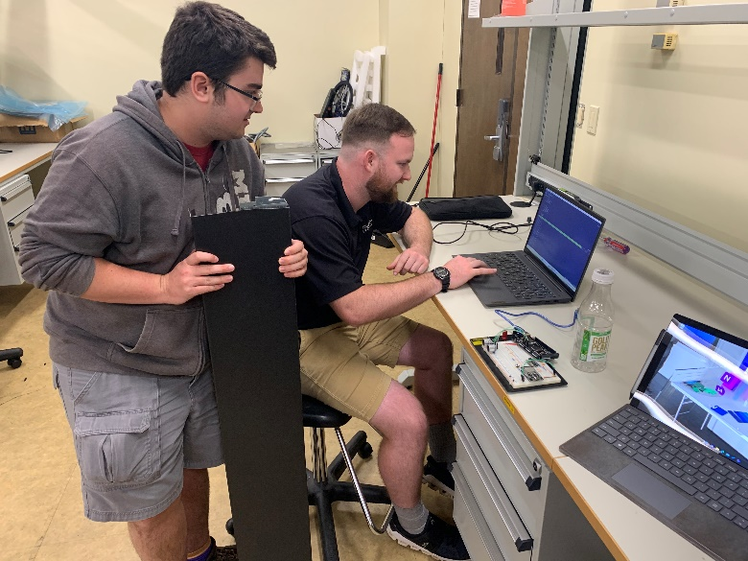

Figure 3.7. – Detection Feedback Latency Results

Based on Table 3.5’s results, Train and Go provides feedback to its user within the latency range set in the technical constraints. Train and Go passed 100% of its detection feedback latency tests.

## Test Certification – Ultrasonic Sensor False Detection Rate

Train and Go uses ultrasonic sensors to detect physical obstacles. To guarantee the system is dependable, Train and Go’s ultrasonic sensors are required to have a false detection rate of less than 16%. To measure the sensor’s detection accuracy, an obstacle was inserted into and taken out of the sensor’s detection radius every 5 seconds for a period of 50 seconds. For the period that the obstacle was in the detection radius, feedback should have been received. For the period that the obstacle was not in the detection radius, feedback should not be received. The results of this false detection test are displayed in Table 3.6. The physical setup of this test is shown in Figure 3.8, and a screenshot of Arduino serial results is shown in Figure 3.9.

Table 3.6. – Ultrasonic Sensor False Detection Rate Test Data

|  |  |  |
| --- | --- | --- |
| **Time (s)** | **Obstacle Present?** | **False Detection?** |
| **5** | No | No |
| **10** | Yes | Yes |
| **15** | No | No |
| **20** | Yes | Yes |
| **25** | No | No |
| **30** | Yes | Yes |
| **35** | No | No |
| **40** | Yes | Yes |
| **45** | No | No |
| **50** | Yes | Yes |

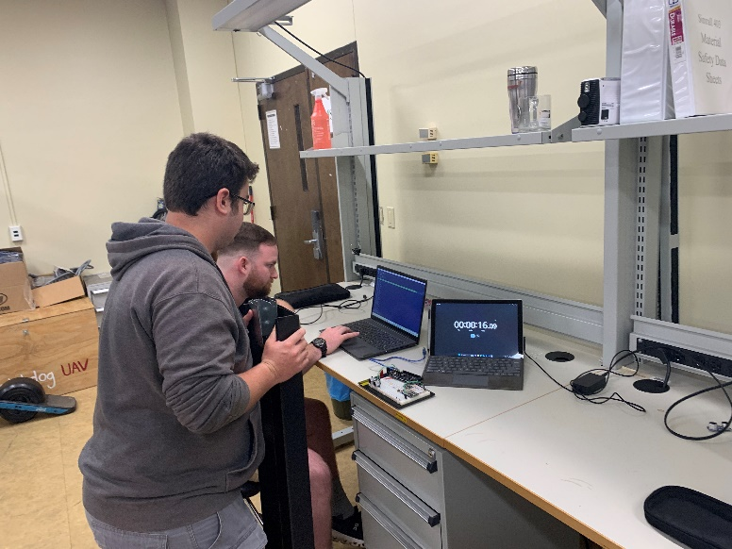

Figure 3.8. – Ultrasonic Sensor False Detection Rate Test Setup

Figure 3.9. – Ultrasonic Sensor False Detection Rate Test Results

Based on Table 3.6, the design team found that there were no false detection readings during the testing. The design team has concluded that the ultrasonic sensors have passed the tests and met the constraint.

## Test Certification – Wireless Range

Train and Go has ensured a wireless connection range of 2.2 meters. To guarantee this requirement is met, a distance test was performed. A Windows laptop was connected to the ESP32’s Bluetooth gamepad output and a visualization tool displayed the communicated axes of the ESP32. As the laptop was moved physically five meters away from the ESP32 in increments of one meter, the visualization tool proved that it remained connected and receiving new data from the ESP32. The results of the test can be seen in Table 3.6. Figure 3.10 shows the testing being performed.

Table 3.6. – Wireless Range Test Data

|  |  |
| --- | --- |
| **Distance (m)** | **Connected?** |
| **1** | Yes |
| **2** | Yes |
| **3** | Yes |
| **4** | Yes |
| **5** | Yes |

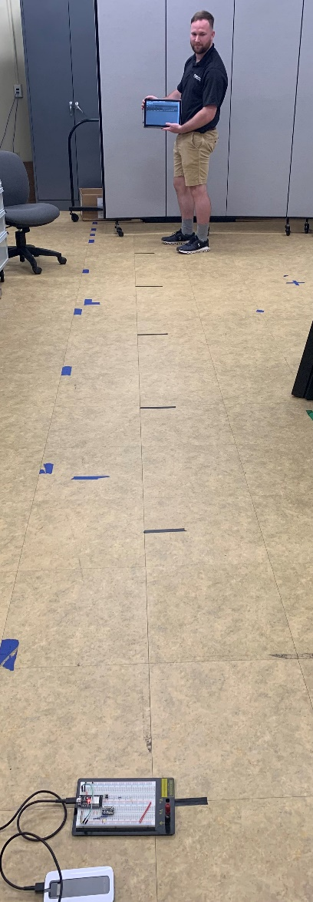

Figure 3.10. – Wireless Range Test

Table 3.6 shows that Train and Go’s wireless range has exceeded the requirements and allows the design team to confirm Train and Go has passed the test.

## Test Certification – Wireless Latency

Train and Go has a wireless latency of less than 250 milliseconds to ensure a quality experience for the user. With this wireless latency, the user does not notice a delay that distracts them from the training. Train and Go uses Bluetooth to connect with a Quest headset, so an automated performance measurement tool built into the Quest headset was utilized to measure the Bluetooth latency. The headset reports the motion-to-photon latency, which measures the time that the headset takes to reflect the movements of a user on the VR screen. For Train and Go, the motion of the user is communicated via our Bluetooth controller. Figure 3.11 shows the Quest headset report of the latency between the Bluetooth controller motion and the screen.

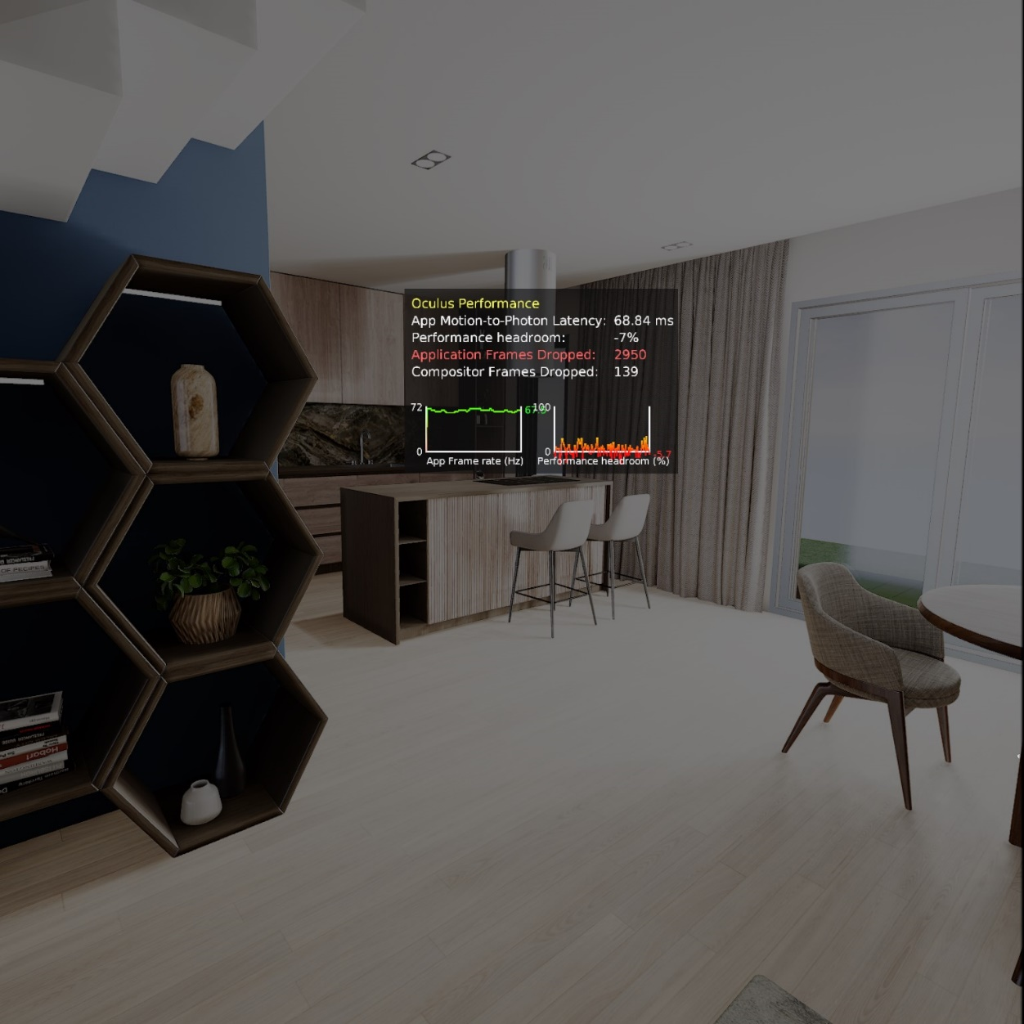

Figure 3.11. – Wireless Latency Test Setup

Figure 3.11 displays data that confirms Train and Go’s wireless latency requirements are met. The motion-to-photon latency is 68.84 milliseconds, well below the necessary 250 millisecond constraint. The design team has determined that Train and Go has met the constraint.

## Test Certification – Water Resistance

Train and Go’s engineering standards require that the product have protection from ingress of water and dust according to the International Electrotechnical Commission’s IP44 standard. In order to meet the IP44 standard, Train and Go must be able to withstand splashed water against the enclosure from all angles with no harmful effects and be protected from solid foreign object of 1 millimeter or greater. In order to verify that the enclosure met the minimum IP44 protection rating, paper towels were placed into the enclosure that houses Train and Go’s electrical components. The enclosure then had water poured over the enclosure from various angles. Figure 3.12 shows the enclosure and Figure 3.13 shows the paper towels, both after this test was completed.

Figure 3.12. – IP44 Rating Test

Figure 3.13. – IP44 Rating Test Results

After drying off the outside of the enclosure, the cover was removed, and the paper towels were inspected for drops of water or any sign of moisture. Figure 3.13 shows that the paper towels placed inside of the enclosure remained dry, and that Train and Go satisfies the IP-44 Engineering Standard.

# References

1. A. Smith. “How fast do electric wheelchairs go?” Mobility Medical Supply. <https://mobilitymedicalsupply.com/how-fast-do-electric-wheelchairs-go/>. (Accessed Feb. 16, 2023).