**Executive Summary**

When an individual experiences a catastrophic event that limits their mobility, they must learn to operate a wheelchair alongside the frustration that comes with losing their physical mobility. The learning process may be difficult and dangerous, involving damage to property, injury to loved ones, and a complete and utter loss of self-confidence. Staff in disability centers are available to make the process of learning to operate a wheelchair simpler and safer. Meetings with these staff can be frustrating to schedule, especially if no training centers are nearby.

Train and Go offers a convenient solution in the form of a virtual training simulator with orientation tracking and obstacle detection. Train and Go communicates with a virtual reality headset that can be used to navigate a virtual environment and learn wheelchair operation. To guarantee the connection to the VR headset is consistent, Train and Go incorporates specific distance constraints tested during prototyping. The VR system is paired with an obstacle detection system that provides haptic feedback to ensure the user’s safety while operating the VR headset. This obstacle-detection system exceeded initial accuracy requirements to maintain the safety that is of utmost importance for Train and Go users. Train and Go is able to train its users and increase their confidence while helping them learn in a protected environment.

Train and Go translates a wheelchair’s motion into VR inputs using an inertial measurement unit. The wheelchair’s motion is captured using an inertial measurement unit. That motion is then formatted and sent to a VR headset using a microcontroller with on-board Bluetooth. Train and Go also keeps its user safe by notifying them of eminent collisions with walls, furniture, or pets via haptic feedback from a rumble motor. Train and Go’s object detection is implemented using ultrasonic sensors, which are controlled alongside the rumble motor using a separate microcontroller. The operation of these systems is visualized in Figure 1.

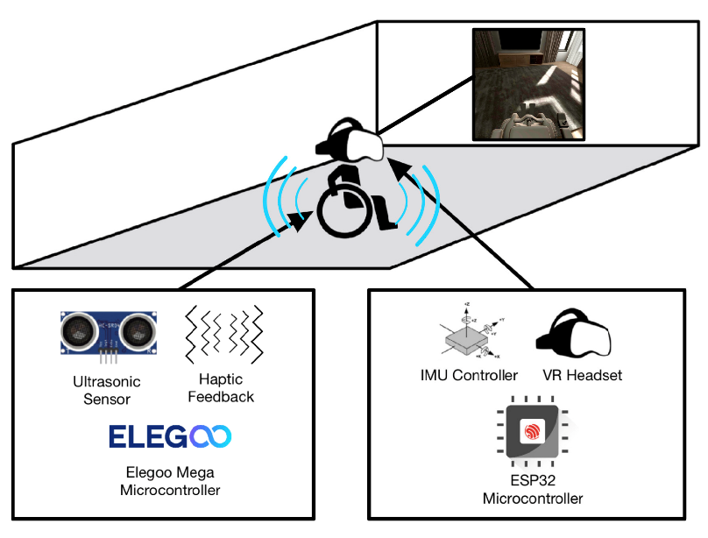

Figure 1. Train and Go Overview

Train and Go’s goal is to help people with disabilities by providing them with a safe environment in which to practice using a power wheelchair through realistic scenarios. Train and Go empowers wheelchair operators with the skills they need in the real world through VR.