Design document for

**Department of Electrical and Computer Engineering**

**Train and Go**

Submitted to:

Dr. Lalitha Dabbiru

ECE 4512: Senior Design I

Department of Electrical and Computer Engineering

413 Hardy Road, Box 9571

Mississippi State University

Mississippi State, Mississippi 39762

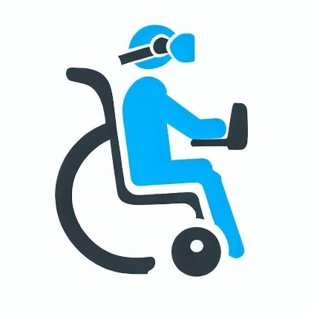

May 10, 2023

Prepared by:

G. Bradshaw, S. Hicks, K. Smith, and B. Waldrup

Faculty Advisor: Dr. Ryan Green

Industrial Advisor: Dr. Adam Jones, Computer Science Department

Department of Electrical and Computer Engineering

Mississippi State University

413 Hardy Road, Box 9571

Mississippi State, Mississippi 39762

email: {gmb271, sch456, kss445, bww134}@msstate.edu



**LIST OF ABBREVIATIONS**

FDA – Food and Drug Administration

GPIO – General Purpose Input/Output

I2C – Inter-Integrated Circuit

IDE – Integrated Development Environment

IEC – International Electrotechnical Commission

IEEE – Institution of Electrical and Electronics Engineers

IMU – Inertial Measurement Unit

I/O – Input/Output

MSU – Mississippi State University

NSF – National Science Foundation

PWM – Pulse Width Modulation

**Executive Summary**

When an individual experiences a catastrophic event that limits their mobility, they must learn to operate a wheelchair alongside the frustration that comes with losing their physical mobility. The learning process may be difficult and dangerous, involving damage to property, injury to loved ones, and a complete and utter loss of self-confidence. Staff in disability centers are available to make the process of learning to operate a wheelchair simpler and safer. Meetings with these staff can be frustrating to schedule, especially if no training centers are nearby.

Train and Go offers a convenient solution in the form of a virtual training simulator with orientation tracking and obstacle detection. Train and Go communicates with a virtual reality headset that can be used to navigate a virtual environment and learn wheelchair operation. To guarantee the connection to the VR headset is consistent, Train and Go incorporates specific distance constraints tested during prototyping. The VR system is paired with an obstacle detection system that provides haptic feedback to ensure the user’s safety while operating the VR headset. This obstacle-detection system exceeded initial accuracy requirements to maintain the safety that is of utmost importance for Train and Go users. Train and Go is able to train its users and increase their confidence while helping them learn in a protected environment.

Train and Go translates a wheelchair’s motion into VR inputs using an inertial measurement unit. The wheelchair’s motion is captured using an inertial measurement unit. That motion is then formatted and sent to a VR headset using a microcontroller with on-board Bluetooth. Train and Go also keeps its user safe by notifying them of eminent collisions with walls, furniture, or pets via haptic feedback from a rumble motor. Train and Go’s object detection is implemented using ultrasonic sensors, which are controlled alongside the rumble motor using a separate microcontroller. The operation of these systems is visualized in Figure 1.

Figure 1. Train and Go Overview

Train and Go’s goal is to help people with disabilities by providing them with a safe environment in which to practice using a power wheelchair through realistic scenarios. Train and Go empowers wheelchair operators with the skills they need in the real world through VR.

**Table of Contents**

1. Design requirements/constraints 5

1.1. Technical Design Constraints 5

1.2. Practical Design Constraints 6

1.3. Appropriate Engineering Standards 8

2. Approach 9

2.1. Hardware 10

2.2. Software 18

3. Evaluation 21

3.1. Test Certification – Wheelchair Speed 22

3.2. Test Certification – Detection Distance 23

3.3. Test Certification – Rotational Accuracy 25

3.4. Test Certification – Detection Feedback Latency 27

3.5. Test Certification – Ultrasonic Sensor False Detection Rate 30

3.6. Test Certification – Wireless Range 32

3.7. Test Certification – Wireless Latency 34

3.8. Test Certification – Water Resistance 35

4. Summary and future work 37

5. Acknowledgements 37

6. References 38

# Design requirements/constraints

Power wheelchair operation, although seemingly innocuous, can be a challenging and dangerous task for individuals who are not accustomed to it. Power wheelchairs can weigh 250 pounds (113.4 kilograms) and can cause harm to both people and property in a collision [1]. Therefore, experts observe people who are learning to use power wheelchairs to ensure they have the dexterity and training necessary to operate their chairs safely. Even during this training, a lack of experience can result in scuffs and scratches on walls and furniture. Train and Go is a system designed to complement virtual reality training environments by providing features to assist wheelchair users in VR.

## Technical Design Constraints

Train and Go meets all technical design constraints outlined in Table 1.1. These constraints ensure a safe and reliable design.

Table 1.1. Technical Design Constraints

|  |  |
| --- | --- |
| **Name** | **Description** |
| Wheelchair Speed | The system is attached to a wheelchair moving no faster than five miles per hour [2]. |
| Detection Distance | The system detects objects within a radius of no more than 2.2 meters. |
| Feedback Latency | This system’s latency for sending feedback to the user in response to an object is no more than 250 milliseconds. |
| Sensor Accuracy | The system’s false detection rate is less than 16 percent. |
| Wireless Range | The system can connect wirelessly to a Quest VR headset within 2.31 meters. |
| Wireless Latency | The wireless latency is less than 250 milliseconds. |

These technical constraints are explained in more detail in the following sections.

### Wheelchair Speed

The average power wheelchair maintains a speed of approximately five miles per hour [2]. Train and Go is designed to affix to a power wheelchair and withstand traveling at those speeds.

### Detection Distance

Train and Go can detect objects within a radius of 2.2 meters so that the user has time to react to Train and Go’s feedback. If an object is detected while the wheelchair is moving at five miles per hour, as in equation (1), then 2.2 meters are traveled in one second. This time is sufficient for a human to react to Train and Go’s feedback before a collision occurs [3].

### Feedback Latency

After detecting an obstacle, Train and Go notifies the user within 250 milliseconds. This latency limit is to give the chair operator a reasonable amount of time to react at varying speeds. The average human reaction time is 250 milliseconds [3]. The average human reaction time combined with the system reaction time of 250 milliseconds allows the user to respond to an obstacle in 500 milliseconds, well before they are likely to collide with the obstacle as established in equation (1) as one second.

### Sensor Accuracy

Train and Go’s false detection rate is less than 16 percent. This rate is the same as other obstacle detection systems that analyze video data to determine whether an obstacle exists [4]. These sensors serve a purpose similar to vehicular systems that minimize collisions and thus react as reliably as those systems.

### Wireless Range

The connection distance between Train and Go and a Quest VR headset is large enough that a person of any height has a wireless connection to Train and Go. Assuming the maximum distance case, Train and Go may be affixed below the wheelchair, and the Quest VR headset may be on the head of an individual in the wheelchair. The average human is less than 180 centimeters tall, and the average wheelchair is 51 centimeters tall [5]-[6]. These heights combine to give 2.31 meters that Train and Go’s wireless signal can span.

### Wireless Latency

Train and Go’s communication with a Quest VR headset occurs quickly so that the user does not notice a delay. The VR headset receives an update within the 250 milliseconds it takes a human to react [3].

## Practical Design Constraints

The practical design constraints listed in Table 1.2 determine, to a large extent, the design and marketing of Train and Go. These constraints include sustainability, accessibility, and economic concerns. These areas of concern are addressed in the design of Train and Go.

Table 1.2. Practical Design Constraints

|  |  |  |
| --- | --- | --- |
| **Type** | **Name** | **Description** |
| Sustainability | Reliability | Train and Go is designed to operate for at least five years without component failure. |
| Sustainability | Sensor Maintenance | Sensor connections are placed strategically to allow simple maintenance or replacement. |
| Usability | Product Versatility | Train and Go offers a flexible packaging system to attach to a variety of wheelchair designs and does not inhibit existing chair functionality. |
| Safety | Collision Detection | Train and Go provides the user with feedback to minimize the risk of collisions with obstacles. |
| Functionality | VR Communication | Train and Go communicates with a Quest VR headset. |

These practical design constraints are explained in more detail in the following sections.

### Reliability

Train and Go is designed to last the lifespan of an individual’s wheelchair. Funding is typically available for a new wheelchair from insurance companies every five years, so Train and Go is able to last until the user needs a new wheelchair, after which time a new Train and Go can be installed [7].

### Sensor Maintenance

All sensors are installed in areas that are easy to reach in case they need to be replaced. The sensors are connected in such a way that they can each be replaced in the case of component failure.

### Product Versatility

Train and Go’s design allows it to be attached to a variety of different wheelchairs without inhibiting their functionality. As a wheelchair training device, Train and Go does not change the handling of the wheelchair during operation.

### Collision Detection

Train and Go provides feedback to the user indicating the possibility of a collision when the user comes too close to an obstacle. This feedback ensures safety while the user is operating the Quest VR headset.

### VR Communication

Train and Go connects wirelessly to a Quest VR headset. This brand of VR headset has been selected by the external source in charge of the National Science Foundation (NSF) project Train and Go is supporting.

## Engineering Standards

Table 1.3 outlines the engineering standards that Train and Go satisfies. These standards from organizations like the International Electrotechnical Commission (IEC), the Institution of Electrical and Electronics Engineers (IEEE), and the Food and Drug Administration (FDA) guarantee industrially acceptable aspects of the design.

Table 1.3. Appropriate Engineering Standards

|  |  |  |
| --- | --- | --- |
| **Specific Standard** | **Standard Document** | **Specification / Application** |
| IP-44 | IEC Standard 60529 | The system is protected from solid particles that are over 1 millimeter in size and from splashes of water [8]. |
| Bluetooth | IEEE 802-15.1 | The system adheres to IEEE Bluetooth standards [9]. |
| Protection Against Electric Shock | IEC 62368 | The electrical components of the system are isolated from the user to prevent electric shock [10]. |
| Wheelchair Accessory | FDA 21 Code of Federal Regulations § 890.3910 | Train and Go satisfies the FDA standards for a wheelchair accessory [11]. |

These engineering standards are explained in more detail in the following sections.

### IP-44

Train and Go complies with Ingress Protection Rating IP44. It states that components should be protected against solid objects greater than one millimeter and should not be harmed by the splashing of water from any direction.

### Bluetooth

Train and Go conforms to the statutes outlined in IEEE 802-15.1, which describes how Bluetooth modules are required to operate. Following this standard ensures wireless compatibility across platforms and consistent operation.

### Protection Against Electric Shock

IEC Standard 62368 gives guidance on protection from electrical shock. The standard classifies direct current and alternating current sources according to their maximum voltage and current magnitudes.

### FDA 21 Code of Federal Regulations § 890.3910

The FDA’s Code of Federal Regulations Section 890.3910 defines what qualifies as a wheelchair accessory. Train and Go meets this definition and can be communicated as such to an insurance agency [11].

# Approach

Train and Go is a wheelchair accessory that sends orientation and movement data in the form of controller input over Bluetooth to a VR headset. Train and Go ensures user safety by using an object detection system to provide feedback that alerts users of possible collisions in the real world while they are using a VR headset. Train and Go is designed as a supplement to the “Advancement of Driving Technology for Vocational Enablement” NSF Grant No. 2235863[1] [12]. Figure 2.1 depicts the overall design of Train and Go.

Figure 2.1 – Train and Go System Diagram

Train and Go is divided into four design subsystems. The object detection subsystem notifies the user when they are approaching an obstacle. The motion tracking subsystem is responsible for capturing the wheelchair’s movement and translating it into VR control signals. The wireless communication subsystem is responsible for facilitating communication between Train and Go and the VR headset. The power distribution subsystem handles the distribution of power from the battery to each component of Train and Go. The following sections detail the hardware and software components of Train and Go.

## Hardware

Train and Go utilizes two microprocessors to input sensor data and interpret it appropriately. One of these microprocessors facilitates orientation tracking and wireless communications while the other microprocessor handles object detection and provides feedback. This isolation allows each system to process data continuously at maximum efficiency. Figure 2.2 presents an overview of the hardware placement.

Figure 2.2 – Train and Go Hardware Diagram

Components are selected to satisfy processing and power requirements that allow Train and Go to operate efficiently.

### Inertial Measurement Unit (IMU)

The motion tracking subsystem measures orientation and speed to be translated into controller signals for the VR training system. Orientation measurement is achieved using an IMU. The IMUs compared for Train and Go utilize a gyroscope to measure angular velocity and an accelerometer to measure linear velocity. IMU options that were considered can be found in Table 2.1.

Table 2.1 – IMU Comparison

|  |  |  |  |  |  |  |
| --- | --- | --- | --- | --- | --- | --- |
| **Product** | **Input Voltage (V)** | **Current Usage (mA)** | **Angular Rate Zero-Rate (Degrees Per Second)** | **Linear Acceleration Zero-G Offset Value (mg)** | **Maximum Operating Temperature (Degrees C)** | **Cost (USD)** |
| **Requirements** | **≥ 3.3** | **≤ 5** | **≤ 10** | **≤ 25** | **≥ 40** | **≤ 50.00** |
| ISM330DHCX [13] | 3.3 | 1.2 | 1 | 10 | 105 | 20.00 |
| LSM6DSOX [14] | 3.3 | 0.55 | 1 | 20 | 85 | 12.00 |
| LSM6DSO32 [15] | 3.3 | 0.55 | 0.5 | 20 | 85 | 12.50 |

The ISM330DHCX IMU was selected by the Train and Go design team for its greater linear acceleration accuracy and temperature range despite its current usage being twice as much as the other options. With a higher temperature range, the IMU is less susceptible to a change in accuracy at different temperatures. When wheelchair users are training in a virtual environment, these tiny differences in sensitivity can lead to a significant difference in user experience.

### Orientation Microcontroller

Orientation tracking requires the conversion of raw IMU data into control signals usable by a VR headset. This processing is achieved with a microcontroller that takes IMU data in and sends it to the wireless communication subsystem to be sent to the VR headset. Options for orientation processing microcontrollers are listed in Table 2.2.

Table 2.2 – Orientation Microcontroller Comparison

|  |  |  |  |  |  |
| --- | --- | --- | --- | --- | --- |
| **Product** | **Working Voltage (V)** | **Working Current (mA)** | **Clock Speed (Hz)** | **GPIO Pins** | **Cost (USD)** |
| **Requirements** | **3.3 – 5** | **≤ 1,000** | **≥ 4,000** | **≥ 2** | **≤ 100.00** |
| Raspberry Pi 4B [16] | 5 | 3,000 | 1,500,000,000 | 40 | 152.00 |
| ESP32 [17] | 2.3 **–** 3.6 | 500 | 60,000,000 | 22 | 6.67 |
| Libre Le Potato [18] | 5 | 800 | 1,500,000,000 | 40 | 35.00 |

The microcontroller requires 1,000 clock cycles to process each wireless refresh, which happens four times a second. This refresh rate means the microcontroller requires 4,000 clock cycles per second. Serial communications require a power, ground, data, and clock pin, so the microcontroller requires two GPIO pins to handle data and the clock. The ESP32 has a much lower cost and power consumption than other alternatives that satisfy these requirements.

### Ultrasonic Sensors

Train and Go detects objects within a 2.2-meter radius to meet design specifications. The Train and Go design team has opted to use ultrasonic sensors for object detection. Ultrasonic sensors are more economically viable than LiDAR or stereo camera systems. Their accuracy is within ±3 centimeters. Table 2.3 presents the ultrasonic sensors considered for Train and Go.

Table 2.3 – Ultrasonic Sensor Comparison

|  |  |  |  |  |  |  |
| --- | --- | --- | --- | --- | --- | --- |
| **Product** | **Working Voltage (V)** | **Working Current (mA)** | **Maximum Range (m)** | **Minimum Range (cm)** | **Measuring Angle (Degrees)** | **Cost (USD)** |
| **Requirements** | **3.3 – 5** | **≤ 15** | **≥ 2.2** | **2** | **15** | **4.00** |
| RCWL-1601 [19] | 3.3 **–** 5 | 15 | 4.5 | 2 | 15 | 3.95 |
| US-100 [20] | 3.3 **–** 5 | 15 | 4.5 | 2 | X < 15 | 6.95 |
| HC-SR04 [21] | 3.3 **–** 5 | 15 | 4 | 2 | 15 | 1.30 |
| A02YYUW [22] | 3.3 **–** 5 | 8 | 4.5 | 3 | 60 | 17.88 |
| Grove [23] | 3.3 **–** 5 | 8 | 3.5 | 3 | 15 | 3.95 |

The HC-SR04 was chosen by the Train and Go design team due to it being very economical and using pulse width modulated (PWM) signals. It had the same specifications and quality as the other sensors that used PWM signals to communicate, but it was a third of the price of its closest competitor.

### Rumble Motor

To provide feedback to the user of Train and Go, a rumble motor was chosen. A rumble motor is less obtrusive and faster than audio feedback. The main parameters considered for choosing a rumble motor are the working voltage, working current draw, and rated speed of the motor. The rumble motors considered for Train and Go are listed in Table 2.4.

Table 2.4 – Rumble Motor Comparison

|  |  |  |  |  |
| --- | --- | --- | --- | --- |
| **Product** | **Working Voltage (V)** | **Working Current (mA)** | **Rated Speed (rad/s)** | **Cost (USD)** |
| Requirements | **≥ 3** | **≤ 25** | **≥ 1675** | **4.00** |
| Tatoko [24] | 3 | 20 | 1675 | 2.14 |
| BestTong [25] | 1.5 | 20 | 837 | 1.19 |
| BOJACK [26] | 3 | 20 | 1675 | 3.50 |

The Tatoko rumble motor was chosen because it had a higher motor speed rating at a lower price point. It also operates at 3 volts, which is preferred over 1.5 volts. A higher voltage is preferred because bucking the battery voltage to a much lower voltage can cause excessive heat due to a large amount of power dissipation in the converter.

### Detection Microcontroller

The parameters considered in the decision to choose the microcontroller responsible for object detection were the input voltage, the current rating of the input/output (I/O) pins, the clock speed, and the number of analog general-purpose input/output (GPIO) pins. A total number of sixteen analog GPIO pins is required to ensure that at least eight ultrasonic sensors can be controlled simultaneously. A clock speed of 16 megahertz is sufficient for object detection. The microcontrollers considered for object detection are listed in Table 2.5.

Table 2.5 – Detection Microcontroller Comparison

|  |  |  |  |  |  |
| --- | --- | --- | --- | --- | --- |
| **Product** | **Input Voltage (V)** | **Maximum Current Per I/O Pin (mA)** | **Clock Speed (MHz)** | **Analog GPIO Pins** | **Cost (USD)** |
| Requirements | **7 – 12** | **≥ 20** | **≥ 16** | **≥ 16** | **25.00** |
| Elegoo Mega [27] | 7 **–** 12 | 40 | 16 | 16 | 21.00 |
| Shield Buddy [28] | 7 **–** 12 | 40 | 300 | 16 | 129.94 |
| Arduino Mega [29] | 7 **–** 12 | 40 | 16 | 16 | 48.20 |

The Elegoo Mega was chosen because it meets all necessary requirements and is significantly more economical than the other options. The Elegoo Mega is essentially a clone of the Arduino Mega that provides the same quality without the increase in price associated with the Arduino brand.

### Wireless Communication

Train and Go uses Bluetooth to transmit the orientation data interpreted from the IMU to the VR headset. Table 2.6 presents the Bluetooth transmitters considered for Train and Go.

Table 2.6 – Bluetooth Transmitter Comparison

|  |  |  |  |  |  |
| --- | --- | --- | --- | --- | --- |
| **Product** | **Working Voltage (V)** | **Working Current (mA)** | **Connectivity** | **Type** | **Cost (USD)** |
| **Requirements** | **≤ 5** | **≤ 500** | **Bluetooth** | **Microcontroller** | **≤ 30.00** |
| DSD Tech HM-10 BT Module [30] | 3.6 **–** 6 | 50 | Bluetooth 4.0 BLE | Module | 10.99 |
| ESP32 [17] | 2.3 **–** 3.6 | 500 | Bluetooth 4.2 | Microcontroller | 6.67 |
| Adafruit Feather nRF52840 Express [31] | 3.7 | 500 | Bluetooth LE | Microcontroller | 24.95 |
| Raspberry Pi 4 Model B [16] | 5 | 1300 | Bluetooth 5.0 | Microcontroller | 152.00 |

The chosen microcontroller has a built-in Bluetooth transmitter. The ESP32 was selected because of its low power draw, high flexibility, and low price. The ESP32 has dual cores that can run independently. This two-core system means one core can be used to handle Bluetooth communication, while the other can convert IMU sensor readings.

### VR Headset

Train and Go was developed in collaboration with a team in the computer science department at Mississippi State University (MSU). The Train and Go design team with the computer science team are developing a prototype in aid of the NSF Grant No. 2235863 [12]. Table 2.7 lists the VR headsets considered for both the computer science team and the Train and Go development team to use.

Table 2.7 – VR Headset Comparison

|  |  |  |  |  |
| --- | --- | --- | --- | --- |
| **Product** | **Weight (lbs.)** | **Connection** | **Tracking** | **Cost (USD)** |
| **Requirements** | **≤ 2** | **Wireless** | **Any** | **≤ 1,500** |
| Valve Index [32] | 1.78 | Wired | Steam VR Base Stations | 750.00 |
| Meta Quest 2 [33] | 1.11 | Wireless | On-board | 400.00 |
| HTC Vive XR Elite [34] | 1.38 | Wireless | On-board | 1,100.00 |
| Meta Quest Pro [35] | 1.59 | Wireless | On-board | 1,000.00 |

The Meta Quest Pro is used by Train and Go for its ease of use, on-board tracking, low weight, and wireless connection. Additionally, the computer science team has a familiarity with the software that runs on Meta headsets, so the Meta Quest series was preferred. The Meta Quest Pro has a better processor and is more comfortable to wear than the Meta Quest 2, so the Meta Quest Pro was purchased by the department.

### Power Source

It can be challenging to find space for a power source on a wheelchair. Train and Go is required to operate for five hours. Train and Go’s power source requires 2906 mAh to function for five hours per equation (1). A capacity of 3000 mAh has been selected to ensure this requirement is met.

(1)

The power source is required to be rechargeable to extend the overall lifetime of Train and Go. The power supply also cannot exceed 150 x 150 x 150 mm to minimize space requirements. Table 2.8 lists the options considered to satisfy these conditions.

Table 2.8 – Power Source Comparison

|  |  |  |  |  |  |
| --- | --- | --- | --- | --- | --- |
| **Product** | **Working Voltage (V)** | **Working Current (mA)** | **Capacity (mAh)** | **Size (mm)** | **Cost (USD)** |
| **Requirements** | **≤ 7.4** | **≤ 3000** | **≥ 3000** | **≤ 150 x 150 x 150** | **≤ 100.00** |
| SoloGood RadioMaster TX16S [36] | 7.4 | 5000 | 5000 | 72 x 42 x 22 | 25.00 |
| Zeee 2s Lipo [37] | 7.4 | 5000 | 5400 | 138 x 47 x 25 | 38.00 |
| Razepony 2s Lipo [38] | 7.4 | 5000 | 4800 | 73 x 20 x 41 | 22.00 |
| HXJNLDC 1s Lipo [39] | 3.7 | 800 | 800 | 6 x 30 x 40 | 15.00 |

The Zeee 2s Lipo was selected as it contains an adequate capacity at an acceptable size under the target price. It can also be recharged.

### Power Conversion

Train and Go requires multiple voltages for its circuits due to its use of two microcontrollers. To provide these differing voltages, a DC-DC converter has been selected to adjust the voltage level for the object detection microcontroller and the ultrasonic sensors. The converter transforms the voltage from 7.4 volts to the 3.3 volts that the orientation processor and ultrasonic sensors require. The object detection microcontroller is powered by the power supply’s default voltage. Table 2.9 contains the power converter options considered to satisfy these requirements.

Table 2.9 – Power Conversion Comparison

|  |  |  |  |
| --- | --- | --- | --- |
| **Product** | **Working Voltage (V)** | **Working Current (mA)** | **Cost (USD)** |
| **Requirements** | **7.4 to 3.3** | **≥ 3000** | **≤ 20.00** |
| YIPIN HEXHA [40] | 24 **–** 5 to 2 **–** 18 | 3000 | 12.00 |
| Drok [41] | 8 **–** 22 to 3 **–** 15 | 3000 | 15.00 |
| Red Wolf [42] | 12 to 3.3, 5, 6, and 9 | 3000 | 14.00 |

The YIPIN HEXHA has been chosen because it offers a range of voltage that is closest to the requirement. It operates within the desired current level and is the most cost-effective option. The potentiometer allows the voltage level to be shifted easily and gives the user specific tuning capabilities.

### Power Rail

Train and Go’s ultrasonic detection system requires many connections to a 3.3-volt power source. To isolate these connections and supply each sensor with power, Train and Go uses a power rail. The power rail requires at least 10 outputs to supply each sensor separately. Table 2.10 presents the options considered to satisfy Train and Go’s power rail needs.

Table 2.10 – Power Rail Comparison

|  |  |  |  |  |
| --- | --- | --- | --- | --- |
| **Product** | **Working Voltage (V)** | **Working Current (mA)** | **Number of Outputs** | **Cost (USD)** |
| **Requirements** | **≥ 3.3** | **≥ 3000** | **≥ 10** | **≤ 20.00** |
| Evemodel PCB007 [43] | 24 | 10000 | 12 | 7.00 |
| OONO D1410 [44] | 48 | 16000 | 12 | 11.00 |
| HCDC D1338 [45] | 300 | 30000 | 12 | 18.00 |

The Evemodel PCB007 was chosen due to it offering the closest values for the voltage and current requirements. It also meets the number of required outputs while remaining the most cost effective.

## Software

Train and Go utilizes two microprocessors running independent software to provide object detection, haptic feedback, and input to a VR environment. Figure 2.3 outlines the software that runs on these microprocessors.

Figure 2.3 – Software Diagram

The orientation process handles the wheelchair’s orientation and transmits a signal over Bluetooth. The object detection protocol handles object detection and provides haptic feedback to the user of Train and Go.

### Orientation Processing

The process handling orientation translates velocity data into two-dimensional axis values that are transmitted over Bluetooth, emulating a video game controller for the VR headset. This is accomplished using the ESP32 microcontroller, which runs Arduino code programmed using the Arduino integrated development environment (IDE). The code written in the Arduino language includes libraries to help gather data from the IMU and output the Bluetooth game controller signal. Figure 2.4 depicts how this processing loop operates in a block diagram format.

Figure 2.4 – Orientation Processing Diagram

Upon process startup, the software calibrates the accelerometer and gyroscope. The microcontroller then enters a processing loop to gather data, translate the data, and output the data. Data is retrieved from the IMU using the inter-integrated circuit (I2C) communication protocol. This process is simplified in the Arduino language with libraries that translate I2C data from the chosen ISM330DHCX IMU into easily accessible programming variables [46]. This data is translated with respect to the calibration vectors into a single two-dimensional vector parallel to the ground. This vector is then communicated over Bluetooth as a video game controller axis, and the data processing cycle repeats. Arduino libraries written specifically for the ESP32 Bluetooth module are used to simplify the process of transmitting the video game controller outputs to the VR headset [47].

### Communication Protocol

With a required update time of 250 milliseconds, a minimum of four full updates occur each second. The I2C protocol, with a maximum bit rate of 400 kilobits per second [48], allows IMU data to be transmitted at a much higher speed than four times each second. Train and Go’s orientation processing system utilizes the I2C protocol to retrieve IMU data to ensure this speed is possible.

### Object Detection Protocol

Train and Go’s object detection protocol takes in sensor data to detect obstacles and output haptic feedback to the user. The process is implemented using the Arduino programming language, and the Arduino IDE is used to program the microcontroller. Figure 2.5 outlines this protocol in block diagram form.

Figure 2.5 – Object Detection Protocol

Train and Go’s object detection protocol begins with the setup state, where variables and functions are defined. The ultrasonic sensors then receive a signal that causes them to begin transmission. The time it takes the reflected waves to return is then measured. The distance the object is from the sensor can be calculated using this time. The distance of the detected object is then compared to the haptic range of the system to determine if haptic feedback occurs. If the distance of the detected object is outside the haptic range, then no feedback occurs. If the object is within the haptic range, haptic feedback occurs.

# Evaluation

Train and Go is a training simulator that includes obstacle-detecting safety features. Train and Go helps its users learn how to operate a powered wheelchair by providing a safe training environment through VR. To guarantee an accurate virtual environment and safe physical environment, constraints on the functionality of Train and Go’s systems were set. Table 3.1 lists these technical constraints that Train and Go follows.

Table 3.1. – Technical Design Constraints

|  |  |
| --- | --- |
| **Name** | **Description** |
| Wheelchair Speed | The system is attached to a wheelchair moving no faster than five miles per hour [2]. |
| Detection Distance | The system detects objects within a minimum radius of 2.2 meters. |
| Feedback Latency | This system’s latency for sending feedback to the user in response to an object is no more than 250 milliseconds. |
| Sensor Accuracy | The system’s false detection rate is less than 16 percent. |
| Wireless Range | The system can connect wirelessly to a Quest VR headset within 2.31 meters. |
| Wireless Latency | The wireless latency is less than 250 milliseconds. |

The design team behind Train and Go ran tests to prove that it complies with its technical constraints. These tests and their results are documented in the following sections.

## Test Certification – Wheelchair Speed

Train and Go is designed to attach to a wheelchair moving slower than five miles per hour. This speed is uncomfortably fast and should not be purposefully exceeded by someone attempting to learn how to operate a wheelchair. While moving, the Permobil M5 wheelchair displays its speed on a built-in screen. Train and Go utilized this speedometer to collect speed test data. While the chair was in motion, the design team verified that the system stayed attached and that the system continued to transmit Bluetooth signals while the chair’s speed increased at increments of 0.5 mph up to the five-mph limit. The data from these speed tests is displayed in Table 3.2. Figure 3.1 shows the Permobil M5’s speedometer.

Table 3.2. – Wheelchair Speed Tests

|  |  |  |
| --- | --- | --- |
| **Estimated Speed (mph)** | **System Attached Securely** | **System Transmitting** |
| **1** | Yes | Yes |
| **2** | Yes | Yes |
| **3** | Yes | Yes |
| **4** | Yes | Yes |
| **5** | Yes | Yes |

Figure 3.1. – Chair Speedometer

The speed tests recorded in Table 3.2 show that Train and Go passed all tests with the chair moving at its maximum speed of five miles per hour.

## Test Certification – Detection Distance

Train and Go detects obstacles once they enter a 2.2-meter radius around the chair. This detection radius ensures that the user who is training can stop before they run into an obstacle. Three ultrasonic sensors were tested to ensure that Train and Go is capable of not only detecting obstacles within the 2.2-meter radius but also reading the distance of the object accurately within that range. During the test, an obstacle was placed at a known distance away from the sensors, and the sensor’s distance measurement was captured using the Arduino serial communication interface. These detected distances are recorded in Table 3.3. Figure 3.2 shows the setup for these detection distance tests, and Figure 3.3 shows the Arduino serial data results.

Table 3.3. – Detection Distance Data

|  |  |  |  |
| --- | --- | --- | --- |
| **Obstacle Distance from Sensor (m)** | **Sensor 1 (m)** | **Sensor 2 (m)** | **Sensor 3 (m)** |
| **0.40** | 0.44 | 0.45 | 0.44 |
| **0.60** | 0.65 | 0.63 | 0.65 |
| **0.80** | 0.86 | 0.82 | 0.84 |
| **1.00** | 1.04 | 1.03 | 1.03 |
| **1.20** | 1.20 | 1.21 | 1.20 |
| **1.40** | 1.41 | 1.41 | 1.40 |
| **1.60** | 1.61 | 1.61 | 1.60 |
| **1.80** | 1.83 | 1.82 | 1.80 |
| **2.00** | 2.03 | 2.03 | 2.00 |
| **2.20** | 2.25 | 2.23 | 2.21 |

Figure 3.2. – Detection Distance Test Setup

Figure 3.3. – Detection Distance Test Results

Based on the results in Table 3.3, the design team concluded that the ultrasonic sensors detected objects up to 2.2 meters away. The ultrasonic sensors passed 100% of the distance tests.

## Test Certification – Rotational Accuracy

Train and Go utilizes an IMU to track the rotation of the wheelchair to which it is attached. Rotational measurements from the IMU are translated directly into virtual rotations of a wheelchair and must be reasonably accurate. In order to guarantee accuracy, a test was performed as follows. The IMU was programmed with a script to send the measured angle to the Arduino serial monitor. The IMU was then calibrated in relation to the zero-angle of a protractor and rotated around in a circle to compare the angle printed in the Arduino serial monitor with the actual angle on the protractor. The results of this test are listed in Table 3.4. The setup of this test is depicted in Figure 3.4, and a graph of the angle error is shown in Figure 3.5.

Table 3.4. – Rotational Accuracy Test Results

|  |  |  |
| --- | --- | --- |
| **Actual Angle (Degrees)** | **Measured Angle (Degrees)** | **Angle Offset (Degrees)** |
| **0.00** | 0.34 | 0.34 |
| **20.00** | 21.14 | 1.14 |
| **40.00** | 43.20 | 3.20 |
| **60.00** | 63.83 | 3.83 |
| **80.00** | 79.31 | -0.69 |
| **100.00** | 104.55 | 4.55 |
| **120.00** | 123.72 | 3.72 |
| **140.00** | 148.73 | 8.73 |
| **160.00** | 168.91 | 8.91 |
| **180.00** | 188.29 | 8.29 |

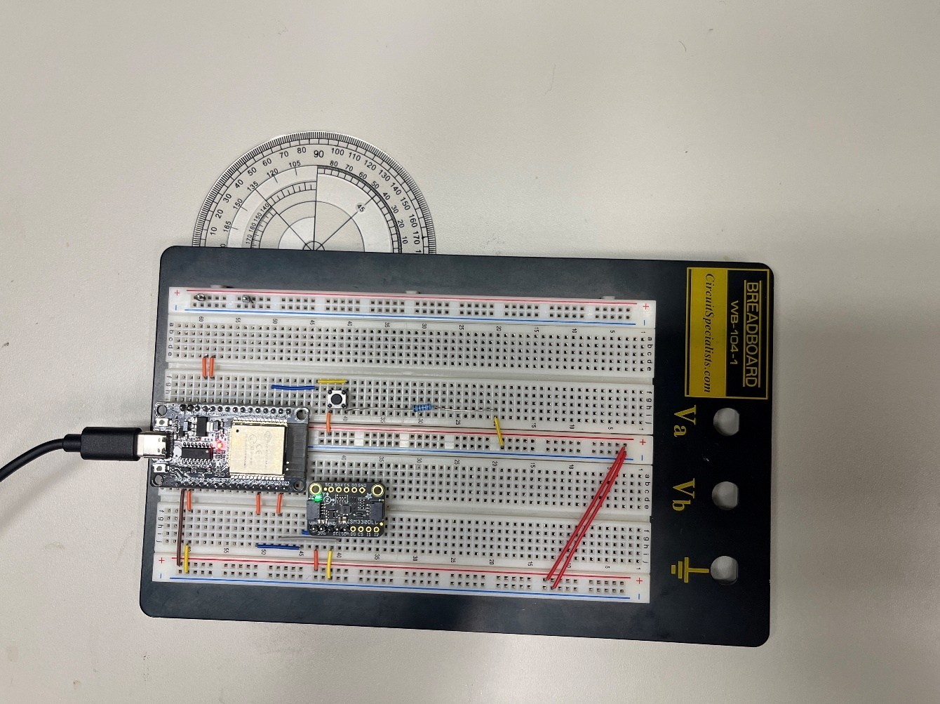

Figure 3.4 – Rotational Accuracy Test Setup

Figure 3.5 – Graph of Actual vs. Reported Angle Offset

As visualized in Figure 3.5, the IMU became more inaccurate as it was rotated. The offset began at 0.34 degrees and progressed to 8.29 degrees by the time the IMU was rotated a total of 180 degrees. This offset is a clear example of what is called IMU drift, where the mechanics of the IMU measurement system cause it to drift away from an accurate measurement over time. If this system were implemented in VR, the user would experience noticeable error in the rotation of the chair. The best method of combatting IMU drift is to co-register the IMU with another type of sensor like a global positioning system module or a camera. In this case, the Train and Go design team was able to utilize the technology that comes standard on the controllers that are included with the Meta Quest Pro headset the team is using. Each controller has three cameras co-registered with an IMU that ensure its orientation is accurately tracked.

## Test Certification – Detection Feedback Latency

Train and Go’s obstacle detection system responds within 250 milliseconds to keep the system as safe as possible. A low system latency allows users the time necessary to respond to the presence of a detected obstacle. As the rumble motor activates directly from the microcontroller’s digital pins, the detection feedback latency can be entirely attributed to the delays of the microcontroller and ultrasonic sensors. To measure this delay, Arduino code was programmed onto the Elegoo Mega to track the time between requesting a detection from a sensor and providing feedback to the user. The results of a series of these tests are outlined in Table 3.5, the code can be seen in Figure 3.6, and an image of the experiment’s setup is available in Figure 3.7.

Table 3.5. – Detection Feedback Latency

|  |  |
| --- | --- |
| **Test Number** | **Latency (ms)** |
| **1** | 72 |
| **2** | 73 |
| **3** | 72 |
| **4** | 72 |
| **5** | 72 |
| **6** | 73 |
| **7** | 72 |
| **8** | 73 |
| **9** | 72 |
| **10** | 72 |

Figure 3.6. – Detection Feedback Latency Code

Figure 3.7. – Detection Feedback Latency Results

Based on Table 3.5’s results, Train and Go provides feedback to its user within the latency range set in the technical constraints. Train and Go passed 100% of its detection feedback latency tests.

## Test Certification – Ultrasonic Sensor False Detection Rate

Train and Go uses ultrasonic sensors to detect physical obstacles. To guarantee the system is dependable, Train and Go’s ultrasonic sensors are required to have a false detection rate of less than 16%. To measure the sensor’s detection accuracy, an obstacle was inserted into and taken out of the sensor’s detection radius every 5 seconds for a period of 50 seconds. For the period that the obstacle was in the detection radius, feedback should have been received. For the period that the obstacle was not in the detection radius, feedback should not be received. The results of this false detection test are displayed in Table 3.6. The physical setup of this test is shown in Figure 3.8, and a screenshot of Arduino serial results is shown in Figure 3.9.

Table 3.6. – Ultrasonic Sensor False Detection Rate Test Data

|  |  |  |
| --- | --- | --- |
| **Time (s)** | **Obstacle Present?** | **False Detection?** |
| **5** | No | No |
| **10** | Yes | Yes |
| **15** | No | No |
| **20** | Yes | Yes |
| **25** | No | No |
| **30** | Yes | Yes |
| **35** | No | No |
| **40** | Yes | Yes |
| **45** | No | No |
| **50** | Yes | Yes |

Figure 3.8. – Ultrasonic Sensor False Detection Rate Test Setup

Figure 3.9. – Ultrasonic Sensor False Detection Rate Test Results

Based on Table 3.6, the design team found that there were no false detection readings during the testing. The design team has concluded that the ultrasonic sensors have passed the tests and met the constraint.

## Test Certification – Wireless Range

Train and Go has ensured a wireless connection range of 2.2 meters. To guarantee this requirement is met, a distance test was performed. A Windows laptop was connected to the ESP32’s Bluetooth gamepad output and a visualization tool displayed the communicated axes of the ESP32. As the laptop was moved physically five meters away from the ESP32 in increments of one meter, the visualization tool proved that it remained connected and receiving new data from the ESP32. The results of the test can be seen in Table 3.6. Figure 3.10 shows the testing being performed.

Table 3.6. – Wireless Range Test Data

|  |  |
| --- | --- |
| **Distance (m)** | **Connected?** |
| **1** | Yes |
| **2** | Yes |
| **3** | Yes |
| **4** | Yes |
| **5** | Yes |

Figure 3.10. – Wireless Range Test

Table 3.6 shows that Train and Go’s wireless range has exceeded the requirements and allows the design team to confirm Train and Go has passed the test.

## Test Certification – Wireless Latency

Train and Go has a wireless latency of less than 250 milliseconds to ensure a quality experience for the user. With this wireless latency, the user does not notice a delay that distracts them from the training. Train and Go uses Bluetooth to connect with a Quest headset, so an automated performance measurement tool built into the Quest headset was utilized to measure the Bluetooth latency. The headset reports the motion-to-photon latency, which measures the time that the headset takes to reflect the movements of a user on the VR screen. For Train and Go, the motion of the user is communicated via our Bluetooth controller. Figure 3.11 shows the Quest headset report of the latency between the Bluetooth controller motion and the screen.

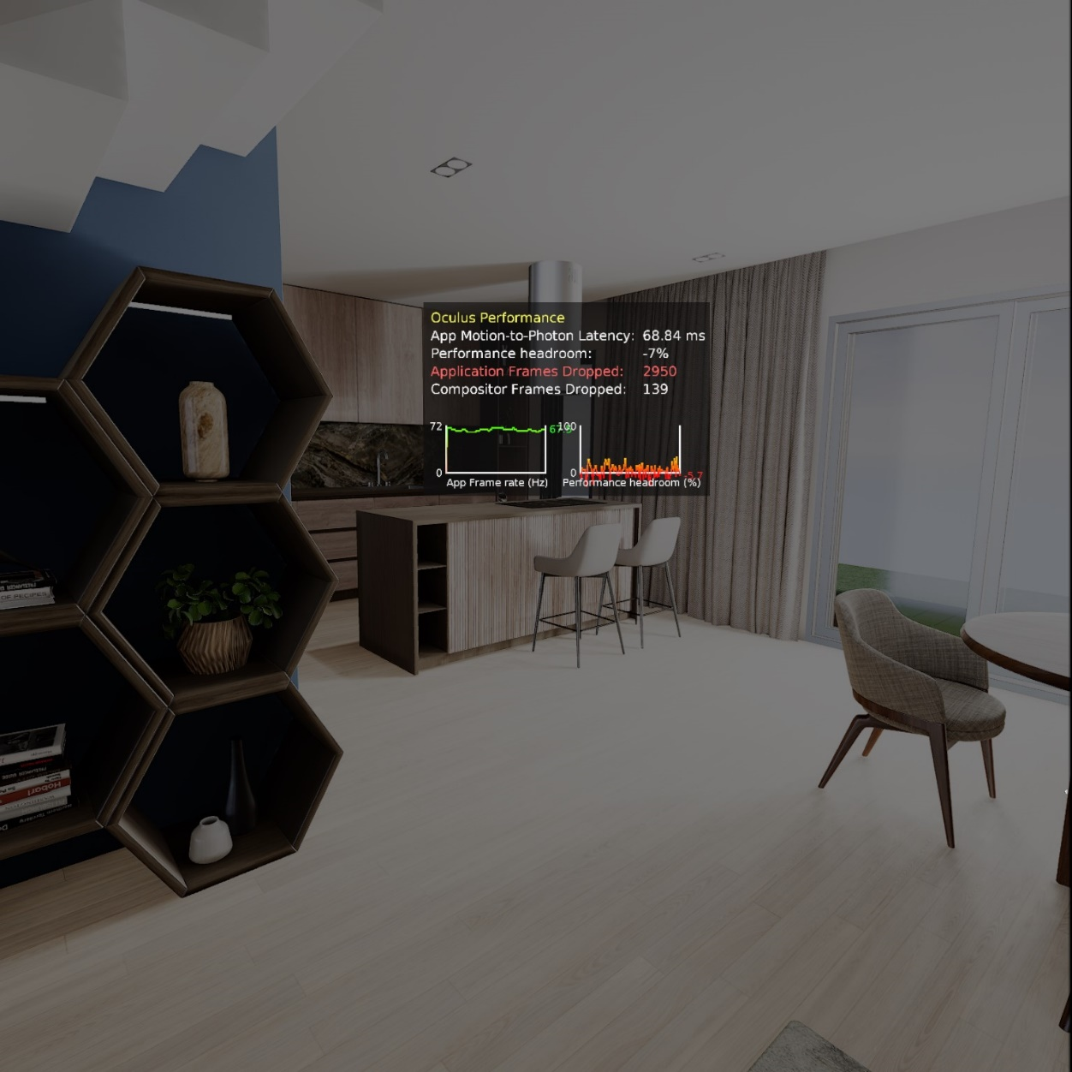

Figure 3.11. – Wireless Latency Test Setup

Figure 3.11 displays data that confirms Train and Go’s wireless latency requirements are met. The motion-to-photon latency is 68.84 milliseconds, well below the necessary 250 millisecond constraint. The design team has determined that Train and Go has met the constraint.

## Test Certification – Water Resistance

Train and Go’s engineering standards require that the product have protection from ingress of water and dust according to the International Electrotechnical Commission’s IP44 standard. In order to meet the IP44 standard, Train and Go must be able to withstand splashed water against the enclosure from all angles with no harmful effects and be protected from solid foreign object of 1 millimeter or greater. In order to verify that the enclosure met the minimum IP44 protection rating, paper towels were placed into the enclosure that houses Train and Go’s electrical components. The enclosure then had water poured over the enclosure from various angles. Figure 3.12 shows the enclosure and Figure 3.13 shows the paper towels, both after this test was completed.

Figure 3.12. – IP44 Rating Test

Figure 3.13. – IP44 Rating Test Results

After drying off the outside of the enclosure, the cover was removed, and the paper towels were inspected for drops of water or any sign of moisture. Figure 3.13 shows that the paper towels placed inside of the enclosure remained dry, and that Train and Go satisfies the IP-44 Engineering Standard.

# Summary and future work

Learning to do something that is challenging can lead to stress and anxiety. Oftentimes the perception of progress increases the confidence of the learner and their stress decreases proportionally. In the case of something as important as vehicle operation, mistakes can lead to injury or result in damage to property. These kinds of setbacks can be debilitating to the self-confidence of someone who is just starting out. For people with disabilities, the pressure of making a mistake can be amplified by the fact that they may not be able to fix the mistake by themselves. In order to help this group of people, Train and Go was designed. Train and Go is a tool designed to help people with disabilities by ensuring their safety while they are in the process of learning how to operate power wheelchairs. This task is accomplished using a virtual reality training simulator that includes a wheelchair modeled after the wheelchair they are using in the real world. In the virtual environment, the user of Train and Go can experience and practice anxiety inducing tasks that could otherwise put them, their loved ones, or their possessions at risk. This allows the user of Train and Go to learn without fear of the consequences of their mistakes. The training simulation reflects the conditions the user may encounter in the real world closely enough that the skills they develop in the simulation can be directly applied in the real world. In the future, Train and Go could be used to assist rehabilitation specialists by making use of the Meta Quest Pro’s eye tracking features. This feature could enable trainers to gauge where the attention of their trainee is in order to tailor the instruction provided to each individual client.

# Acknowledgements

We wish to acknowledge Dr. Kasee Stratton-Gadke and Mr. Eric Knox of MSU’s TK Martin Center and Dr. Zaccheus Ahonle of MSU’s Department of Counseling, Educational Psychology, and Foundations for their continued support and feedback regarding this project. We also acknowledge the National Science Foundation for its funding of this project, which enables many useful on-line documents to be developed. Dr. Adam Jones and Dr. Ryan Green’s interactions have helped us enhance the capabilities of the system.

# References

1. “How much does a wheelchair weigh?” 1800 Wheelchair. <https://www.1800wheelchair.com/faq/how-much-does-a-wheelchair-weigh/>. (Accessed Feb. 16, 2023).
2. A. Smith. “How fast do electric wheelchairs go?” Mobility Medical Supply. <https://mobilitymedicalsupply.com/how-fast-do-electric-wheelchairs-go/>. (Accessed Feb. 16, 2023).
3. E. Ackerman. “Enabling superhuman reflexes without feeling like a robot.” IEEE Spectrum. <https://spectrum.ieee.org/enabling-superhuman-reflexes-without-feeling-like-a-robot>. (Accessed Feb. 16, 2023).
4. Z. Yankun, C. Hong and N. Weyrich. "A single camera based rear obstacle detection system." *2011 IEEE Intelligent Vehicles Symposium (IV)*, Baden-Baden, Germany, 2011, pp. 485-490, doi: 10.1109/IVS.2011.5940499.
5. M. Roser. “Human height.” Our World in Data. <https://ourworldindata.org/human-height>. (Accessed Feb. 16, 2023).
6. "Are there standard wheelchair dimensions?” Orange Badge. <https://orangebadge.co.uk/are-there-standard-wheelchair-dimensions/>. (Accessed Feb. 16, 2023).
7. “Replacing DME.” Medicare Interactive. <https://www.medicareinteractive.org/get-answers/medicare-covered-services/durable-medical-equipment-dme/replacing-dme>. (Accessed Feb. 16, 2023).
8. *Degrees of protection provided by enclosures (IP Code),* International Electrotechnical Commission 60529, International Electrotechnical Commission, 2019. <https://www.iec.ch/ip-ratings>. (Accessed Feb. 22, 2023).
9. *Medium access control and physical layers,* Institute of Electrical and Electronics Engineers802.15.1, Institute of Electrical and Electronics Engineers, 2005. <https://standards.ieee.org/ieee/802.15.1/3513/>. (Accessed Feb. 22, 2023).
10. *Audio/video, information, and communication technology equipment - Part 1: Safety requirements,* International Electrotechnical Commission 62368, International Electrotechnical Commission, 2018. <https://webstore.iec.ch/publication/63964>. (Accessed Feb. 22, 2023).
11. *Wheelchair accessory,* Code of Federal Regulations Title 21 Section 890.3910, FDA, 2001. <https://www.accessdata.fda.gov/scripts/cdrh/cfdocs/cfcfr/cfrsearch.cfm?fr=890.3910>. (Accessed Feb. 22, 2023).
12. “NSF award search: Award # 2235863 - NSF Convergence Accelerator Track H: Advancement of Driving Technology for Vocational Enablement,” nsf.gov. <https://www.nsf.gov/awardsearch/showAward?AWD_ID=2235863> (Accessed: Mar. 29, 2023).
13. “Adafruit ISM330DHCX – 6 DoF IMU.” adafruit.com. <https://www.adafruit.com/product/4502> (Accessed: Mar. 03, 2023).
14. “Adafruit LSM6DSOX 6 DoF Accelerometer and Gyroscope.” adafruit.com. <https://www.adafruit.com/product/4438> (Accessed: Mar. 03, 2023).
15. “Adafruit LSM6DSO32 6-DoF Accelerometer and Gyroscope.” adafruit.com. <https://www.adafruit.com/product/4692> (Accessed: Mar. 03, 2023).
16. “Buy a Raspberry Pi Model B.” raspberrypi.com. <https://www.raspberrypi.com/products/raspberry-pi-4-model-b/> (Accessed: Mar. 03, 2023).
17. “ESP32 datasheet.” adafruit.com. <https://cdn-shop.adafruit.com/product-files/3269/esp32_datasheet_en_0.pdf> (Accessed: Mar. 03, 2023).
18. “AML-S905X-CC (Le Potato).” libre.computer. <https://libre.computer/products/aml-s905x-cc/> (Accessed: Mar. 03, 2023).
19. “RCWL-1601 Ultrasonic Distance Sensor.” digikey.com. <https://www.digikey.com/en/products/detail/adafruit-industries-llc/4742/16584032> (Accessed: Mar. 03, 2023).
20. “US-100 Ultrasonic Distance Sensor.” adafruit.com. <https://www.adafruit.com/product/4019> (Accessed: Mar. 03, 2023).
21. “HC-SR04 Ultrasonic Distance Sensor.” amazon.com. <https://www.amazon.com/ACEIRMC-HC-SR04-Ultrasonic-Distance-ElecRightt/dp/B09J4BN46F/r> (Accessed: Mar. 03, 2023).
22. “A02YYUW Ultrasonic Distance Sensor.” digikey.com. [https://www.digikey.com/en/products/detail/dfrobot/SEN0311/11202577](https://www.digikey.com/en/products/detail/dfrobot/SEN0311/11202577?s=N4IgTCBcDaIIIAYwE1kFUDqIC6BfIA) (Accessed: Mar. 03, 2023).
23. “Grove Ultrasonic Distance Sensor.” seeedstudio.com. [https://www.seeedstudio.com/Grove-Ultrasonic-Distance‑Sensor.html](https://www.seeedstudio.com/Grove-Ultrasonic-Distance-Sensor.html?queryID=39eb6a11e8a817cc697b03c1e5350ba0&objectID=2281&indexName=bazaar_retailer_products) (Accessed: Mar. 03, 2023).
24. “Tatoko Rumble Motor.” amazon.com. <https://www.amazon.com/tatoko-vibration-Waterproof-8000-16000RPM-toothbrush/dp/B07KYLZC1S/> (Accessed: Mar. 03, 2023).
25. “BestTong Rumble Motor.” amazon.com. <https://www.amazon.com/dp/B073JKQ9LN/> (Accessed: Mar. 03, 2023).
26. “BOJACK Rumble Motor.” amazon.com. [https://www.amazon.com/dp/B09KBCY3FQ/](https://www.amazon.com/dp/B09KBCY3FQ/ref=twister_B09KGS7MPC?_encoding=UTF8&th=1) (Accessed: Mar. 03, 2023).
27. “Elegoo Mega Microcontroller.” amazon.com. <https://www.amazon.com/ELEGOO-ATmega2560-ATMEGA16U2-Arduino-Compliant/dp/B01H4ZDYCE/> (Accessed: Mar. 03, 2023).
28. “Shield Buddy Microcontroller.” digikey.com. [https://www.digikey.com/en/products/detail/infineon‑technologies/KITA2GTC375ARDSBTOBO1/13563717](https://www.digikey.com/en/products/detail/infineontechnologies/KITA2GTC375ARDSBTOBO1/13563717) (Accessed: Mar. 03, 2023).
29. “Arduino Mega Microcontroller.” amazon.com. <https://www.amazon.com/ARDUINO-MEGA-2560-REV3-A000067/dp/B0046AMGW0/> (Accessed: Mar. 03, 2023).
30. “HM-10 Bluetooth Module.” amazon.com. <https://a.co/d/dheFiz2> (Accessed: Mar. 03, 2023).
31. “Adafruit Feather Microcontroller with Bluetooth.” adafruit.com. [https://www.adafruit.com/product/4062](https://www.adafruit.com/product/4062#technical-details) (Accessed: Mar. 03, 2023).
32. “Valve Index.” amazon.com. <https://www.amazon.com/Valve-Release-Headset-Stations-Controllers/dp/B07VPRVBFF/> (Accessed: Mar. 03, 2023).
33. “Meta Quest 2.” amazon.com. <https://www.amazon.com/Oculus-Quest-Advanced-All-One-Virtual/dp/B099VMT8VZ/> (Accessed: Mar. 03, 2023).
34. “HTC Vive XR Elite.” amazon.com. <https://www.amazon.com/Vive-Elite-Virtual-Reality-Headset-Controllers/dp/B0BQXDFLJ6/> (Accessed: Mar. 03, 2023).
35. “Meta Quest Pro.” amazon.com. <https://www.amazon.com/Meta-Quest-Pro-Oculus/dp/B09Z7KGTVW/> (Accessed: Mar. 03, 2023).
36. “Radio Master Battery.” amazon.com. <https://www.amazon.com/RadioMaster-5000mah-Control-Transmitter-Endurance/dp/B08DNRSKRP> (Accessed: Mar. 03, 2023).
37. “Zeee 2S Lipo Battery.” amazon.com. <https://www.amazon.com/dp/B092CZGW2P> (Accessed: Mar. 03, 2023).
38. “Razepony 2S Battery.” amazon.com. <https://www.amazon.com/dp/B0BHYTFNVN> (Accessed: Mar. 03, 2023).
39. “HXJNLDC Battery.” amazon.com. <https://www.amazon.com/603040-Rechargeable-Lithium-Replacement-Electronic/dp/B09YQ2C1KR> (Accessed: Mar. 03, 2023).
40. “YIPIN HEXHA Voltage Converter.” amazon.com. <https://www.amazon.com/dp/B0BS5ZCP1N> (Accessed: Mar. 03, 2023).
41. “Drok Voltage Converter.” amazon.com. <https://www.amazon.com/DROK-Waterproof-Converter-Adjustable-Transformer/dp/B00C0KL1OM> (Accessed: Mar. 03, 2023).
42. “Red Wolf Voltage Converter.” amazon.com. <https://www.amazon.com/dp/B0945X9JHK> (Accessed: Mar. 03, 2023).
43. “Evemodel Power Rail.” amazon.com. <https://www.amazon.com/PCB007-Position-Distribution-Outputs-Voltage/dp/B07DW2C4ZB> (Accessed: Mar. 03, 2023).
44. “OONO Power Rail.” amazon.com. <https://www.amazon.com/OONO-Position-Terminal-Distribution-Module/dp/B08TBXQ7H6> (Accessed: Mar. 03, 2023).
45. “HCDC Power Rail.” amazon.com. <https://www.amazon.com/dp/B0876W456F> (Accessed: Mar. 03, 2023).
46. “Stm32duino/ISM330DHCX.” github.com. <https://github.com/stm32duino/ISM330DHCX> (Accessed: Mar. 31, 2023).
47. “LemmingDev/ESP32-BLE-gamepad.” github.com. <https://github.com/lemmingDev/ESP32-BLE-Gamepad> (Accessed: Mar. 31, 2023).
48. “Speed – I2C bus.” i2c-bus.org. <https://www.i2c-bus.org/speed/> (Accessed: Mar. 03, 2023).

1. This material is based upon work supported by the National Science Foundation under Grant No. 2235863. Any opinions, findings, and conclusions or recommendations expressed in this material are those of the authors and do not necessarily reflect the views of the National Science Foundation.