## Market Summary

## Market Analysis

The target market for Train and Go is people with disabilities learning to use electric wheelchairs. With Train and Go, Owl is attempting to enter the assistive technology industry. Due to Train and Go’s purpose as assistive technology, Train and Go can be classified as a medical necessity for its users. This makes it possible for customers to purchase Train and Go using insurance by writing a letter of medical necessity to their insurance provider.

## Marketing Strategy

Owl’s primary marketing strategy for Train and Go will center around cultivating organic growth through the power of word-of-mouth referrals and expert endorsements. We recognize that building a reputation as a reliable and reputable service within our industry is paramount. By having industry professionals recommend and promote Train and Go, customers will have assurance in Train and Go’s quality and performance.

## Sales Projection

The United States Department of Transportation conducted the National Household Travel Survey in 2017 which estimates 2.9 million wheelchair users in the United States [1]. Each of these individuals may need to purchase a new wheelchair or better learn how to use their existing wheelchair and would thus benefit from using Train and Go. Projecting that Owl can converse with clinicians resulting in 0.05% of the population of wheelchair users purchasing Owl’s product within the first year, Train and Go would have a first-year sales figure of 1,450 units. Assuming 10 new users per previous user each year given clinician influence, Figure 4.1 illustrates a three-year sales projection for Train and Go, resulting in 145,000 sales in the third year.

Figure 4.1 – Three-Year Sales Projection

Considering the three-year projected sales, the $70 materials cost, and a $30 labor cost per product, Train and Go’s target market price is $200 dollars. A price of $200 leaves Owl with a 100% profit margin that can be reinvested into the company. Owl will earn $145,000 of profit in the first year at an overall loss, but with $14.5 million annually after 3 years Owl will be able to pay back debts in full.

## Manufacturing and Distribution Strategy

Train and Go will be made and packaged at the Owl corporate office. The assembly process will consist of soldering, wiring, final assembly, testing, and packaging stations. The soldering and wiring stations will provide a steady supply of sub-parts to the final assembly station. After leaving the final assembly station, the products will go to the testing station where their function will be verified. Any products that fail testing will be sent to the appropriate station for rework or to the scrap bin if rework is not possible. The products that pass testing will then go to the packaging station, where they will be made ready to ship. The products will then be shipped from the Starkville post office. For the first year, all executives will work on the floor. Since there are 5 stations, an additional worker will need to be hired. This production assistant will be paid $14 an hour. If they do well, it is possible for them to be promoted to the role of production manager in year 3. By the second year, all five stations will be manned by 2 hourly workers for a total of 11 employees on the floor. The first worker will be team leader and will be responsible for meeting production goals. By year 3, the original worker will be promoted to production manager, and each station will consist of a team of 5 for a total of 26 employees on the floor.

## Organization Overview

## Company Structure

Owl’s board of directors consists of the CEO, CFO, COO, CSCO, and anyone appointed by the board including investors. The board of directors has full joint ownership of Owl. The board is tasked with overseeing corporate activities and judging performance. Members of the board must sign a noncompete and a nondisclosure agreement upon appointment. Figure 5.1 depicts the responsibilities of each member of the board of directors.

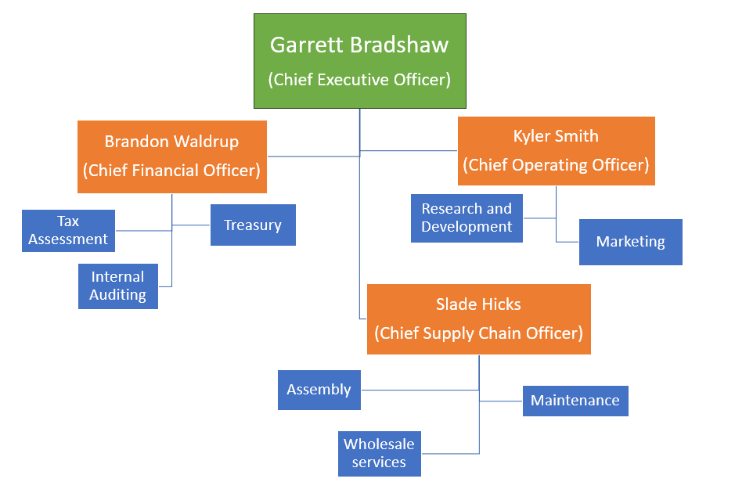

Figure 5.1 – Responsibilities of the Board of Directors

The Chief Executive Officer (CEO) is responsible for making major corporate decisions, managing overall operations, and setting the company’s strategic direction. The Chief Financial Officer (CFO) is the financial controller who handles everything relating to cash flow, financial planning, and taxes. The Chief Operating Officer (COO) is tasked with overseeing the day-to-day administrative and operational functions of the business. The Chief Supply Chain Officer (CSCO) is responsible for overseeing and delivering value throughout the end-to-end supply chain operation of the organization. As part of the supply chain operation, the CSCO will oversee the production manager.

## Personnel Plan

Owl’s employee body consists of 4 directors and a group of production floor workers. These 4 directors each earn the same amount of money annually with pay increases as the company is projected to gain profit as a result of their efforts. The CSCO oversees the floor with assistance from the others on the board of directors as needed. Profit earned from sales will be invested back into the company as assets to fund further production, innovation, and growth. The breakdown of payroll amounts is listed in Table 5.1.

Table 5.1 – Personnel Plan Breakdown

|  |  |  |  |  |  |  |
| --- | --- | --- | --- | --- | --- | --- |
|  | **Oct** | **Nov** | **Dec** | **2023** | **2024** | **2025** |
| CEO | $3,750.00 | $3,750.00 | $3,750.00 | $11,250.00 | $96,000.00 | $98,880.00 |
| CFO | $3,750.00 | $3,750.00 | $3,750.00 | $11,250.00 | $96,000.00 | $98,880.00 |
| COO | $3,750.00 | $3,750.00 | $3,750.00 | $11,250.00 | $96,000.00 | $98,880.00 |
| CSCO | $3,750.00 | $3,750.00 | $3,750.00 | $11,250.00 | $96,000.00 | $98,880.00 |
| Floor | $1,733.33 | $1,733.33 | $1,733.33 | $5,200.00 | $349,440.00 | $436,000.00 |
| **Subtotal** | $16,733.33 | $16,733.33 | $16,733.33 | $50,200.00 | $733,440.00 | $831,520.00 |

## References

[1] “National Household Travel survey,” National Household Travel Survey, https://nhts.ornl.gov/ (accessed Oct. 10, 2023).