COMP5048 Week 4 Tutorial

1. yEd

yEd is a graph visualisation software.

- Install Java from https://java.com/en/download if you don't have it yet.
- Go to the yEd website at https://www.yworks.com/yed and go to the download page.
- Select the appropriate package for your system and download.
- Run the installer or uncompress the package. For compressed packages, yEd commands can now be executed from the directory where the archive has been uncompressed.
This tutorial will run a few examples to show how to load data, create layout and customize visualization.

Runthrough Examples
1.1 Load a graph from file
- Run the yEd executable, or alternatively the JAR from the command line: java -jar yed.jar
- Choose Open and then select a file, e.g., select can_144.graphml from additional materials
- After the graph is loaded, click “Layout” → “Organic” and click OK. This is a force-based layout. Drag around the visualisation using right-click drag.
- You can also try other layouts, such as Circular or Orthogonal.
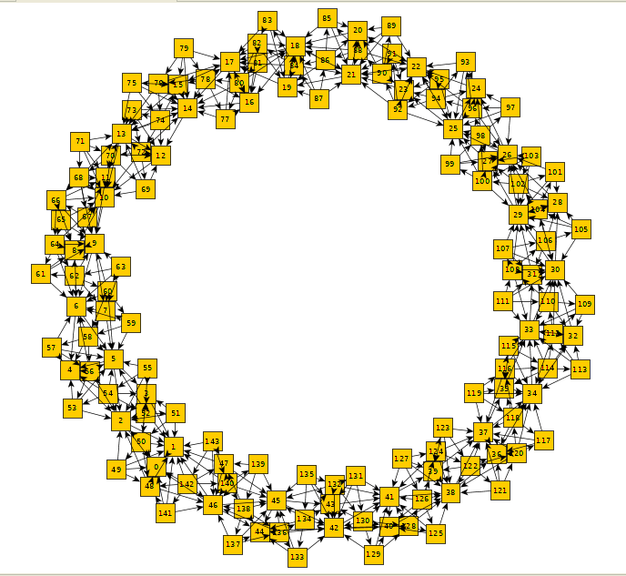
Figure 1: Organic layout
1.2 Visualize a tree using yEd
- Load tree.tgf
- Choose “Layout” → “Radial” and click OK. Then try to use other tree layouts such as Tree (Directed) and Tree (Balloon)
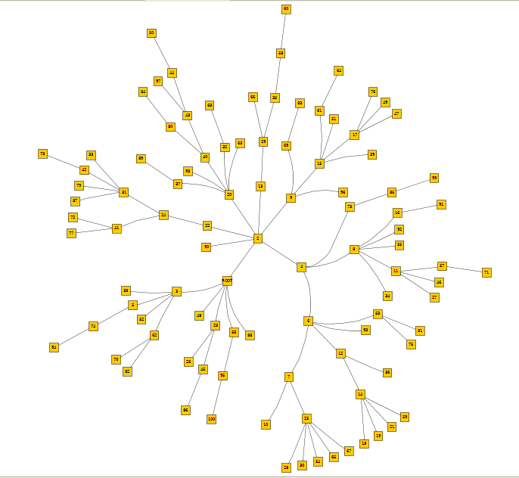

Figure 2: Radial layout
3. Select Hierarchical layout for the same graph.
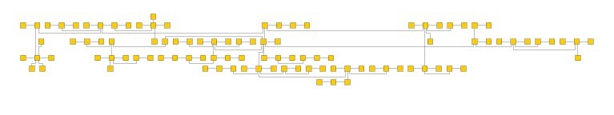
Figure 3: Hierarchical layout
1.3. Customize visualization
'
- Load planar1.graphml
- Left-click drag to select all nodes. You may need to zoom with ctrl + scroll to be able to select all nodes.
- On the right sidebar, double click the circle node
- Right click on the circle node and click “Apply”. The nodes are now circular.
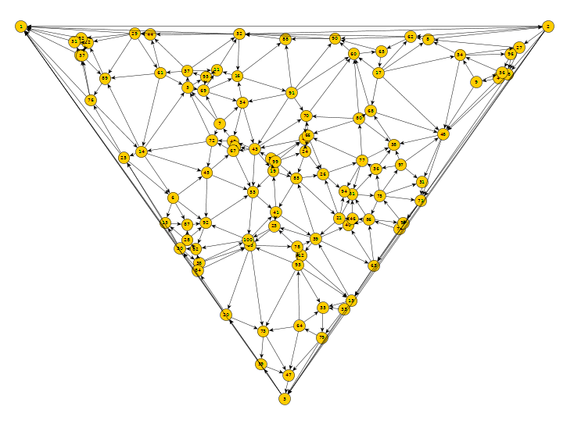
Figure 4: Circular nodes
- NetworkX

NetworkX is a Python software for analysis of complex networks. Installation instructions are given at https://networkx.github.io/documentation/networkx-1.10/install.html.
- Install Python if you haven't yet
- Make sure to have setuptools, numpy, and matplotlib installed first using pip (e.g. pip install setuptools, or pip install -U numpy to update an existing installation)
- Then issue the command: pip install networkx

This tutorial will give several examples to show how to use the software. For more usage examples, see at https://networkx.github.io/documentation/networkx-1.10/tutorial/index.html.

Runthrough examples:

- Open a Python console
- Make sure to import the networkx package before using it. The following lines will create an empty graph:
    - import networkx as nx

    - G=nx.Graph()

- To add a node to the graph, use

    - G.add_node(1)

- To add an edge, use

    - G.add_edge(1,2)

- To get the number of nodes and edges, use G.number_of_nodes() and G.number_of_edges().

- Analyze a graph: some graph-theoretic functions can be directly invoked. For example, to get the number of connected components of a graph G, use nx.connected_components(G). To get the clustering of a graph G, use nx.clustering(G). Furthermore, nx.degree(G) returns a degree mapping of G.

- Drawing graphs: NetworkX has basic drawing with Matplotlib and it has an interface to use the Graphviz software package.
First, import Matplotlib’s plot interface: import matplotlib.pyplot as plt.
Then import a sample graph: G=nx.karate_club_graph()

To test if the import of networkx.drawing was successful draw G using one of:

  - nx.draw(G)

  - nx.draw_random(G)

  - nx.draw_circular(G)

  - nx.draw_spring(G) (this is a force-based layout)

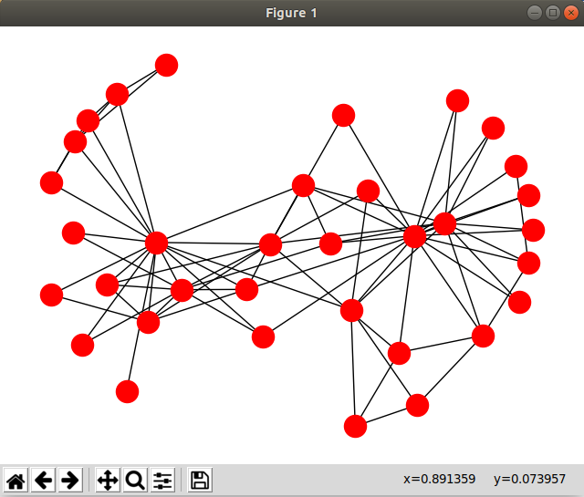
when drawing to an interactive display. Note that you need to issue plt.show() after each of the above commands to view the change in layout. To save drawings to a file, use, for example, plt.savefig("path.png"), or click the save icon in the pop-up window.
Figure 5: Spring layout in pop-out window

For more tutorials and examples, see https://networkx.github.io/documentation/networkx-
1.10/examples/index.html. NetworkX comes with many analyses. The reference is available at http://networkx.readthedocs.io/en/stable/reference/index.html.

