Average people have access to wheel lock and flintlock pistols and rifles.
The Powder Guild has access to primitive, magical revolvers that self-destruct if un-attuned or a command word is spoken.

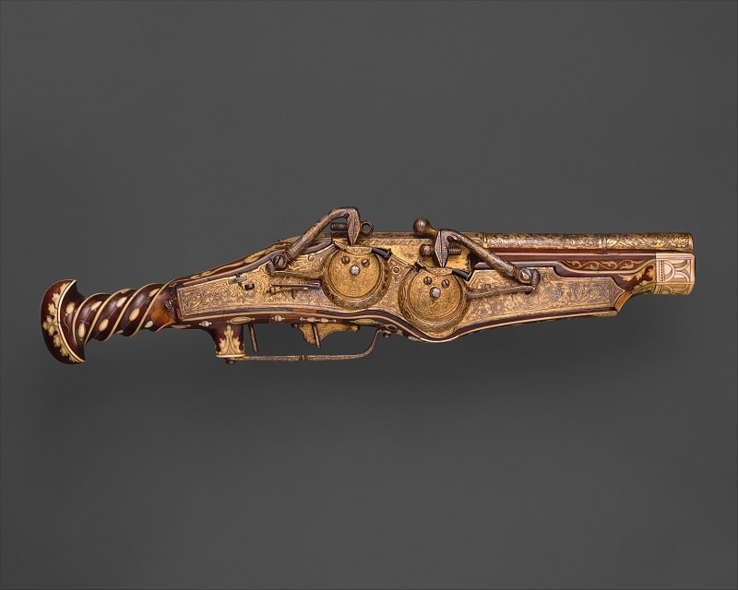
Emperor Charles V Double-barrel Wheel Lock Pistol (1540-1545)

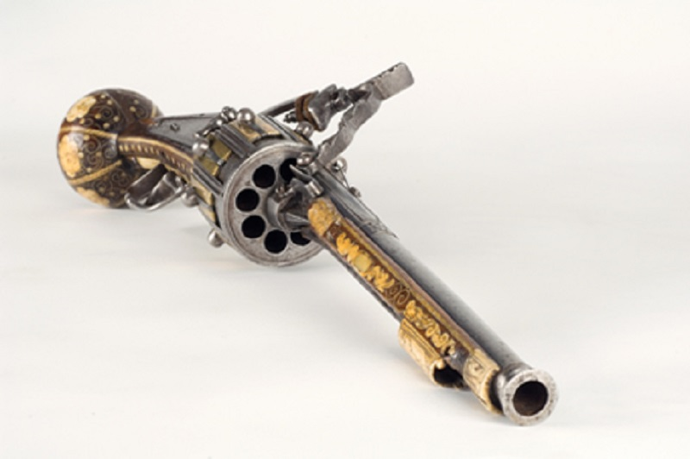
George von Reichweins Manual Revolver (1597)

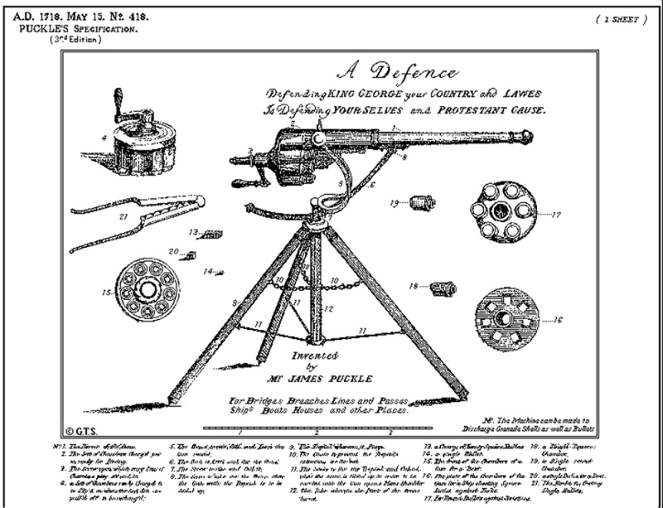
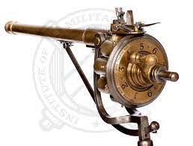

Puckle Gun (1718) “early gatling gun”

