**Lab1 Report -BIOINSTRUMENTATION**

**Group members:**

Nazmur Rafin, Yuhua Huang, Ziwen Mao

**Experiment Overview:**

*Iridium Oxide (IrOx) pH Electrodes for pH Measurement:*

This experiment is designed to assess the effectiveness of IrOx electrodes in detecting slight pH variations, comparing their performance with standard reference electrodes.

*Neurotransmitter Sensors:*

This experiment investigates the selectivity and sensitivity of neurotransmitter sensors, specifically targeting the detection of dopamine. The focus is on examining how well the sensor can distinguish dopamine from other substances and determine its lower detection limits.

**Experiment Setup:**

*IrOx pH Electrodes for pH Measurement:*

The experiment submerged IrOx electrodes, functioning as pseudo-reference electrodes, in solutions with pH values of 4, 7, and 10 sequentially. Measurements of the open circuit potential are taken for each pH value. Calibration is conducted at these points, and sensitivity is calculated based on the linear regression of potential changes obtained in response to the pH variations.

*Neurotransmitter Sensors:*

The neurotransmitter sensor measures the initial baseline with a clean solution, followed by the incremental addition of 50 mol dopamine solutions at 3 intervals. The response of the sensor is monitored to evaluate both the selectivity against other substances like ascorbic acid and the precision in measuring dopamine concentrations. This can be used to calculate the sensor's sensitivity based on linear regression of the current obtained and establish its limit of detection (LOD) with the equation.

**Experiment Result:**

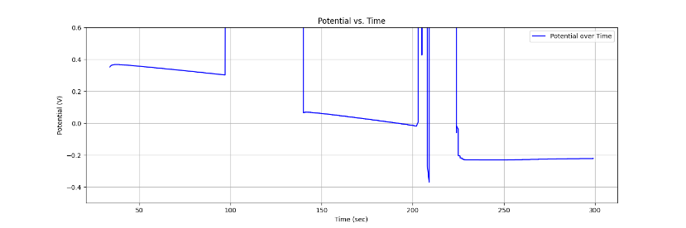

Sensitivity =

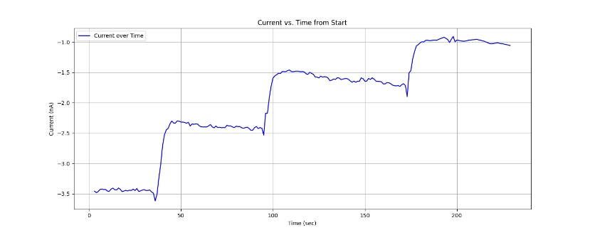

Limit of Detection (LOD) = $\frac{\left(3× standard deviation of the baseline\right)}{least squares slope}=\frac{3×0.0197}{0.0116} =5.08 μM$

Sensitivity = $13.46x{10}^{-3} nA/s$