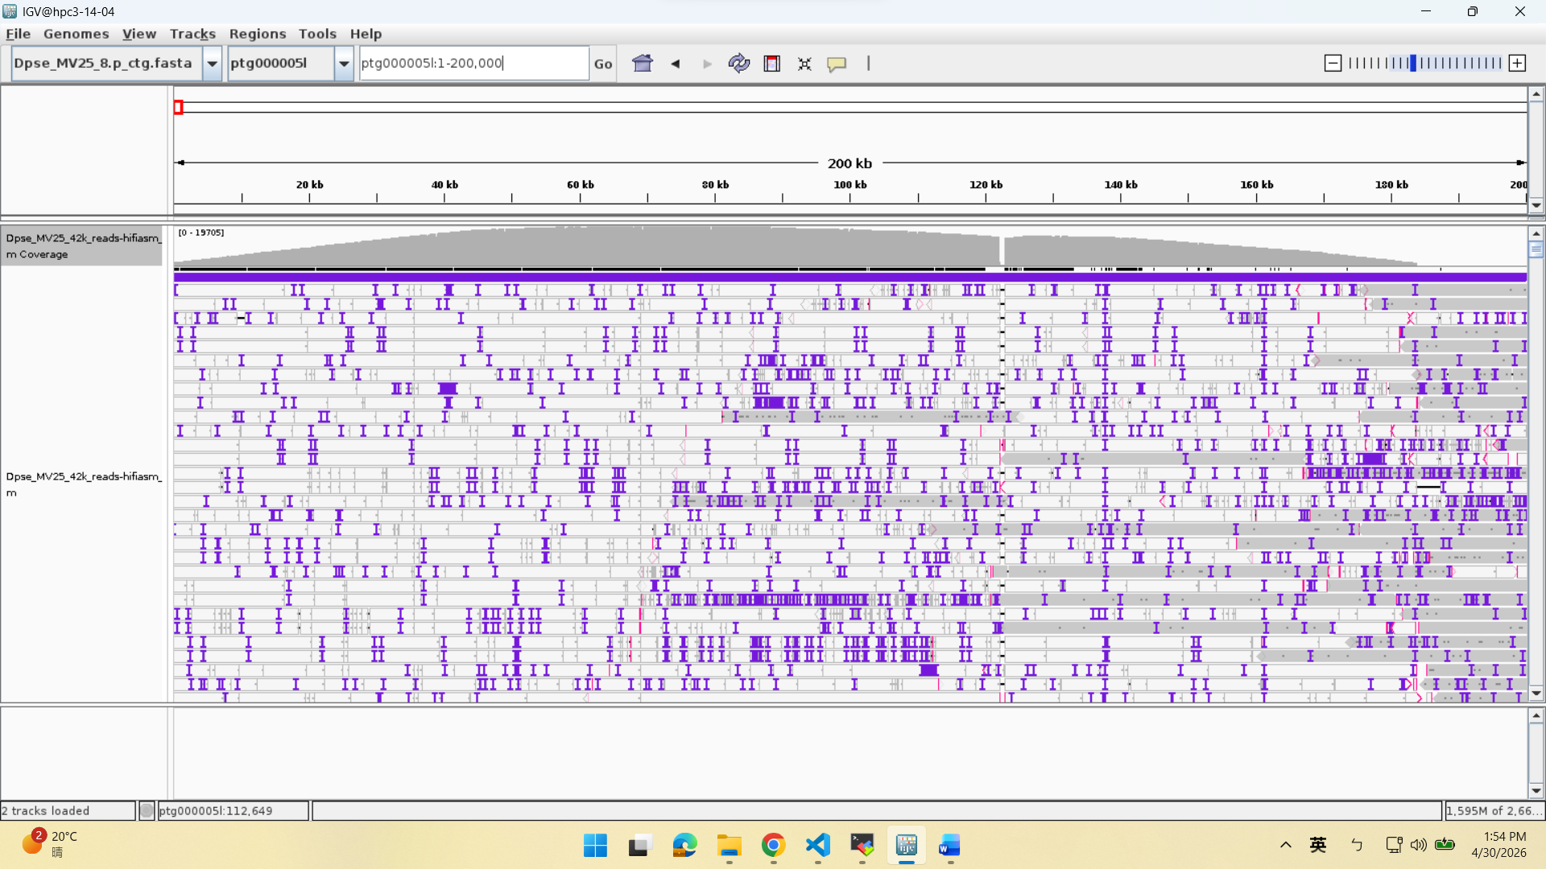
The head of ptg000005, telomere

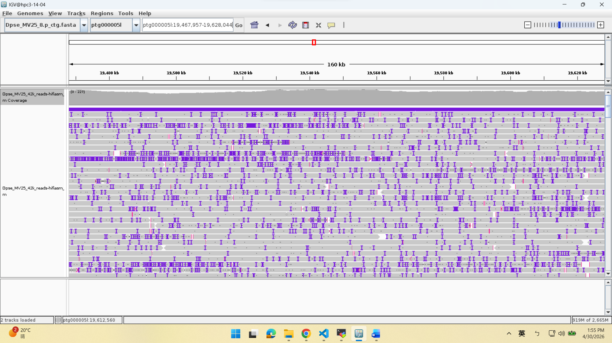
The center is 19.548 Mb of ptg000005, which corresponds to the old telomere end

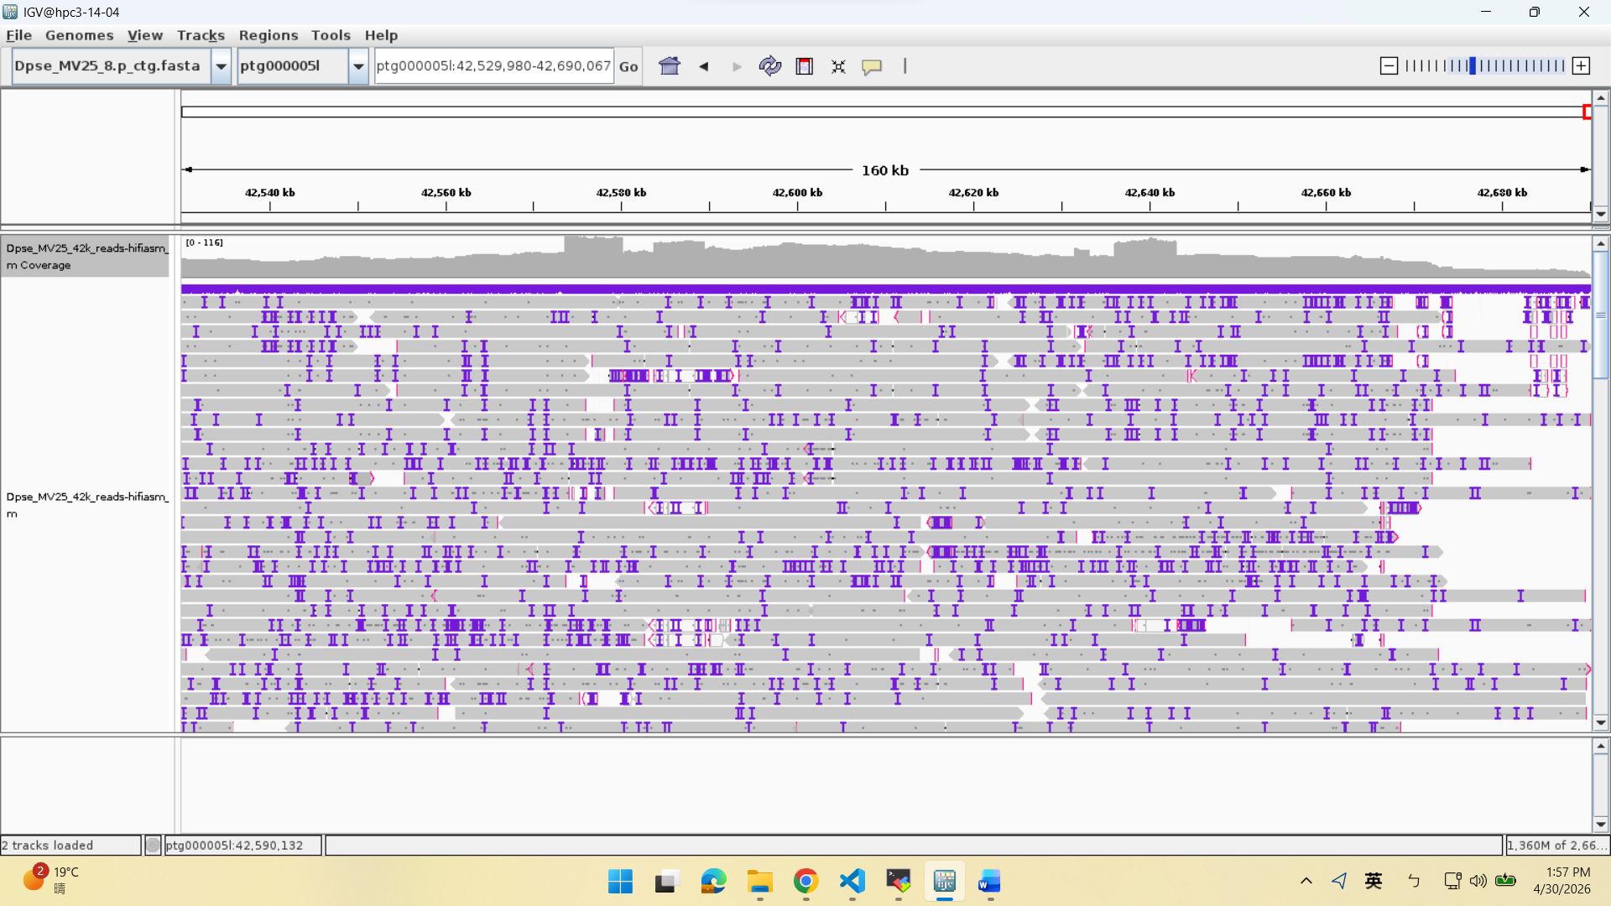
The end of ptg000005 is supposed to be the centromere of X chromosome. Fewer mapped reads are seen.

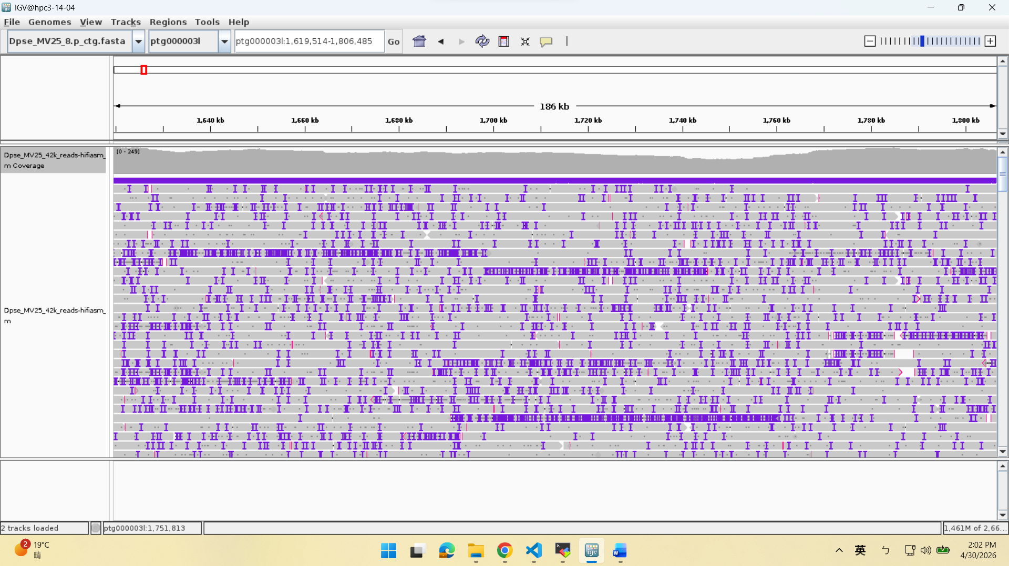
The center is at the 1.713Mb of ptg000003, which matches the last part of centromere on chrX

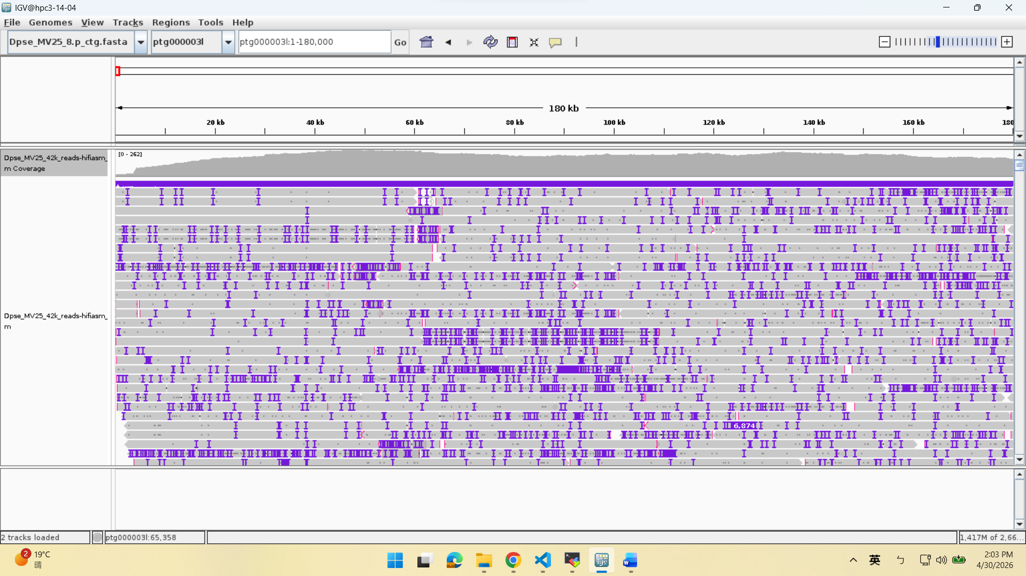
The head of ptg000003. It should also be the centromere.

