A video watermarking with on motion vectors mode selection method in MATLAB

In this code you can see simplified realization of H.264 encoding +based on this watermarking method.

For H.264 encoding was created next files:

Inter/encode_p_frame.m – inter mode encode function

Intra/encode_i_frame.m – for intra mode

For H.264 decoding was created next files:

Inter/decode_p_frame.m – inter mode decode function

Intra/decode_i_frame.m – for intra mode

Watermark label you can see in line 11 of main file (A00_Main.m):

L = [0 1 0 1 1 1 0 0 0 1 0 1 1 1 0 0]; % Binary 0101110001011100

Each bit of this message will encoding in a single frame: bit 1 in frame 2, bit 2 in frame 3 etc.

For encoding user can select any block from 1 to last (variable NumOfBlocks, see line 12 and 104)

For encoding is used next algorithm:

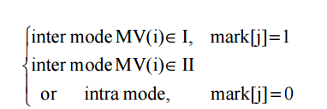

This algorithm you can see in lines 61-71 of file A00_Main.m

if k<=length(L)

change=double(L(k))+1;% 1 or 2

else

change=0;

end

[Seq_r(:,:,2),bits] = encode_p_frame(X,QP,ext,block_size, change);

and in lines 400-412 of file encode_p_frame.m:

[mvx,mvy,rec,bits,ssd] = motion_comp_block(bs,bs,mr,i,j,'m');

water_value = change;

if block_id==BlockForEncode&&water_value>0

pred_dir=1;%predictive direction

if mvx<0 pred_dir = 2;%left

else pred_dir = 1;%right

end

if pred_dir==water_value% same with water mark label

else

[mvx,mvy,rec,bits,ssd] = motion_comp_block_part(bs,bs,mr,i,j,water_value); %restricted range search

end

end

For decoding is used next algorithm:

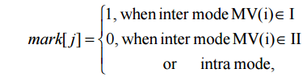

This algorithm you can see in lines 105-117 of file A00_Main.m

global GetWaterMark

GetWaterMark = [0 0 0 0 0 0 0 0 0 0 0 0 0 0 0 0];

for k = 2:N

if (bitstream(idx:idx+3)=='0000')

disp(['Decoding P Frame: ', num2str(k)])

idx = idx + 4;

frame_id = k-1;

[Ceq_r(:,:,k),idx]= decode_p_frame(idx,bitstream,Ceq_r(:,:,k-1));

Frames_Dec(:,:,k)=Ceq_r(:,:,k);

label = GetWaterMark(frame_id)

end

end

and in lines 47-54 of file decode_p_frame.m:

if block_id==BlockForEncode

if frame_id<=length(GetWaterMark)

if mvx < 0 watervalue = 1;

else watervalue = 0;

end

GetWaterMark(frame_id) = watervalue;

end

end

Result watermarked video is HaveDecoded.avi and H.264 compressed file is 02BitStream.mat.

Watermark label variable got from video is GetWaterMark.