A video watermarking with on motion vectors mode selection method in MATLAB

In this code you can see simplified realization of H.264 encoding +based on this watermarking method.

For H.264 encoding was created next files:

Encode.m – main encode function

inter_cons.m – for inter mode

intra_cons.m – for intra mode

For H.264 decoding was created next files:

Encode.m – main decode function

inter_recons.m – for inter mode

intra_recons.m – for intra mode

Watermark label you can see in line 16 of main file (Watermark_MotionVector_2.m):

L = [0 1 0 1 1 1 0 0 0 1 0 1 1 1 0 0]>0; % Binary 0101110001011100

Each bit of this message will encoding in a single frame: bit 1 in frame 2, bit 2 in frame 3 etc.

For encoding user can select any block from 1 to last (variable NumOfBlocks, see line 37)

For encoding is used next algorithm:

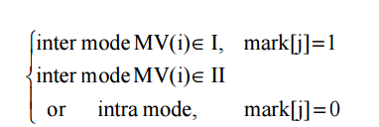

This algorithm you can see in lines 82-90 of file Watermark_MotionVector_2.m

if st<=nL

if NumBit==BlockForEncode

change=double(L(st-1))+1;% 1 or 2

else

change=0;

end

else

change=0;

end

and in lines 19-20 and 24-28 of file Encode.m:

if err_tp<=err_lt||change==2

%do Inter prediction itself

….

if change==2

motion(1)=-1*(abs(motion(1))+3);%Watermark=1

elseif change==1

motion(1)=+1*(abs(motion(1))+3);%Watermark=0

end

For decoding is used next algorithm:

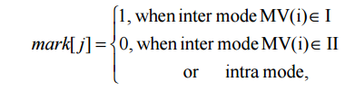

This algorithm you can see in lines 126-134 of file Watermark_MotionVector_2.m

if strcmp(Side_Info{st}(i,j).prediction,'Intra')||strcmp(Side_Info{st}(i,j).prediction,'IPCM')

MessageRecovered(st-1)=false;

else

if Side_Info{st}(i,j).motion(1)<0

MessageRecovered(st-1)=true;

else

MessageRecovered(st-1)=false;

end

end

Results frames you can see in folder named Video.