Newton Report

1. Problem

Evaulate the error of polynomial interpolation, Numerical Integration using Simpson, Trapezoidal rules and its application.

2. Description of Work

1) Using different interpolation point count, evaluate error of functions.

Here , , n = 10, 20

2) Application of Interpolation

Using polynomial interpolation, predict the average yearly temperature for a variety of years.

3) Trapezoid Rule and Simpson Rule

Apply Trapezoid Rule and Simpson Rule to calculate the numerical integral for several functions.

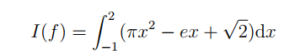

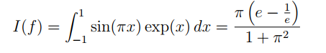

4) Application of Numerial Integration

Apply Numerical Integration to simulate process nameed “carburizing”

3. Discussion of test results

3.1 Interpolation

## 3.1.2 Interpolation Result

- The number of nodes: n=10+1, evaluating points: N=400+1.

Interploation Result

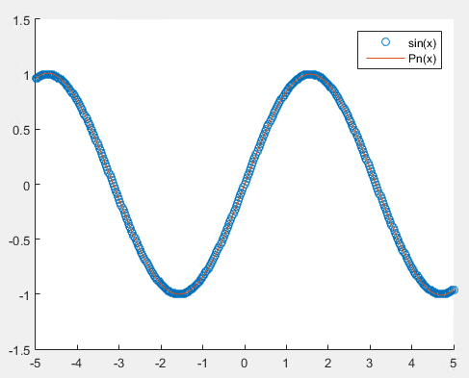

Inerpolation Error

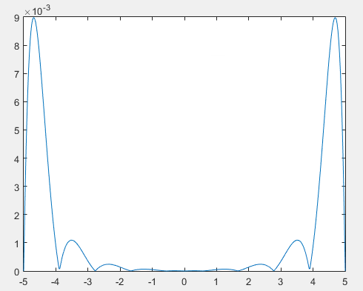

- The number of nodes: n=20+1, evaluating points: N=400+1.

Interploation Result

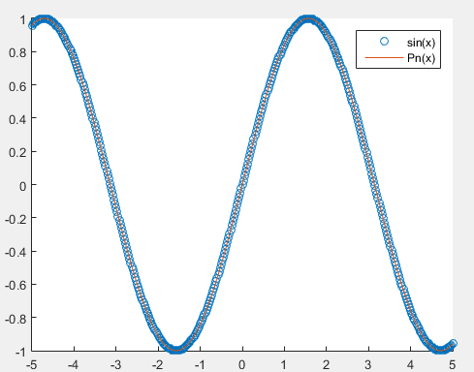

Inerpolation Error

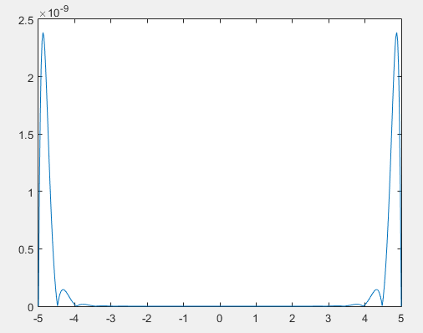

## 3.1.2 Interpolation Result

- The number of nodes: n=10+1, evaluating points: N=400+1.

Interploation Result

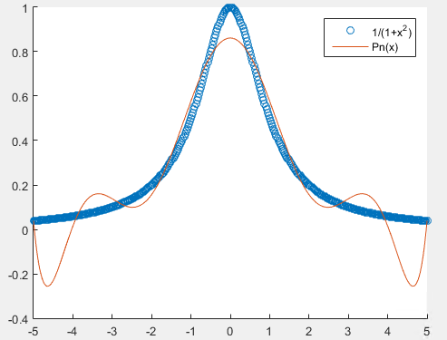

Inerpolation Error

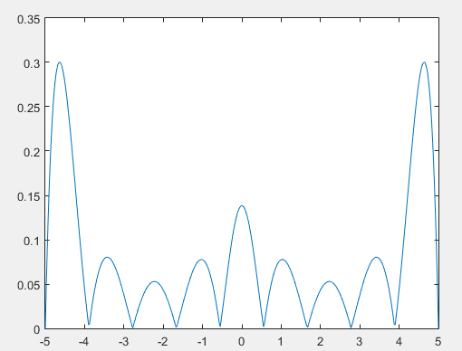

- The number of nodes: n=20+1, evaluating points: N=400+1.

Interploation Result

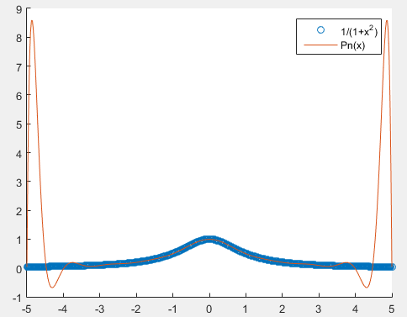

Inerpolation Error

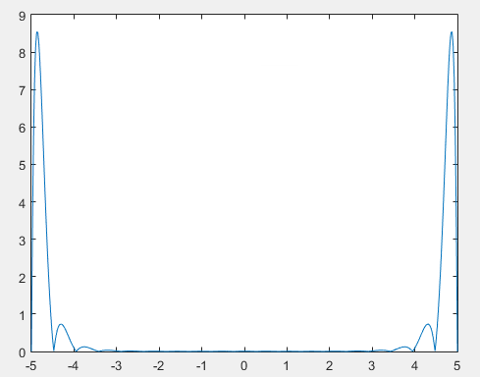

## 3.1.3 How the value of (n + 1) affects the interpolation error[1][2]

In $f\left(x\right)=sin⁡(x)$, the more interpolcation count is, the more accuracy is, but in $f\left(x\right)=\frac{1}{1+x^{2}}$, when interperation count is increased, accuracy is decreased. It means that larangue polynomial interpolation not always convergence to f(x) when interpolation count is increased.

Because $f\left(x\right)=\frac{1}{1+x^{2}}$’s nth derivative value is large when n is increased.

## 3.1.4 Derive the error upper bound

By the interpolation error theorem for equally-spaced nodes, we have

$$\left|f\left(x\right)-p_{n}(x)\right|≤\frac{M}{4\left(n+1\right)}h^{n+1}$$

Where ,

So

,

,

4. Explanation of results, answers to questions.

Newton algorithm give different result according to initial guess.

Initial Guess = -3 => root = -1

Initial Guess = -1 => root = 0

Initial Guess = 2 => root = -1

Initial Guess = 4 => root = 3

- How does the performance of Newton’s method change as you vary the initial guess?

When change initial guess, iteration count vary.

For example, when start from 1, newton method find room at 21, 34 iterations.

But if start from 2, algorithm terminates at 2 iterations.

-How does Newton’s method change as you vary the tolerance?

The smaller tolerance is, the bigger iteration count is.

For example, Initial guest = 1, tol = 1e-6 requires 21 iterations.

But when tol = 1e-10, it requires 34 iterations.