Bisection Report

1. Problem

Implement bisection algorithm for finding root of nonlinear equation.

2. Description of Work

1) Make nonlinear function file f1.m

Here

2) Make Test routing test_bisect.m

Here error tolerance of $ε={10}^{-4}$, using starting interval of [-5, 5]

3) Implement bisection.m function

Step1: Approximate the root r by the middle point $c=\frac{a+b}{2}$

Step2: If $b-c<ε$ (error tolerance), stop the method, Otherwise continue to the next step.

Step3: If f(a) and f(c) have different signs, the root r is in [a,c], and we assign c to a new b; Otherwise (i.e. f(c) and f(b) have different signs), the root r is in [c, b], and we assign c to a new a.

In either case, we now have a root r in the [a, b]

Step4: Go back to Step1 to repeat the process.

3. Discussion of test results

When run test_bisect.m script with tolerance of $ε={10}^{-4}$, using starting interval of [-5, 5], test result is as follow.

Interval is smaller half as prev steps and precious will be improved 2 times

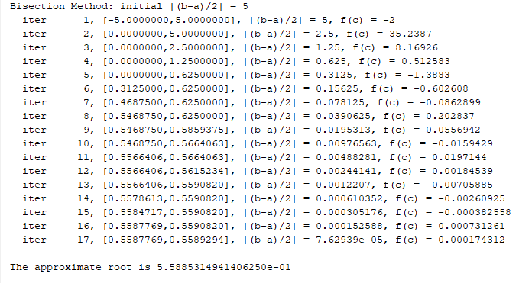

4. Explanation of results, answers to questions.

Bisect algorithm integrates 17 and find the root of $f_{1}\left(x\right)=10+x^{3}-12cos⁡(x)$ is 0.5588531494.

- Why is the starting interval [-5, 5] a valid interval for the method.

f is continueous on [-5, 5], f(-5) = -118.4039 < 0, f(5) = 131.5961 > 0

therefore due to Intermediate Value Theorem(IVT), there must exist at least a number r in [-5, 5] such that f(r) = 0 $∈[-118.4039, 131.5961]$

-Theoretically predict the number of bisection iterations.

$$\frac{b-a}{2^{n}}<ϵ$$

Therefore $n>\log_{2}\left(\frac{b-a}{ε}\right)=\log_{2}{\frac{10}{{10}^{-4}}=\log_{2}100000≈}16.609$

* Is the result from the code consistence with your prediction.

Yes.