1. Please change user exists message:

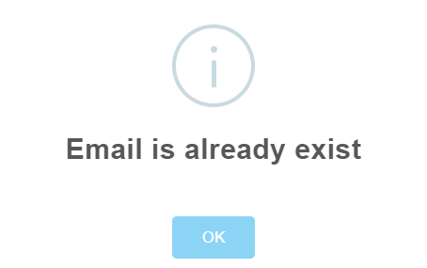

Change message to: **User or Email already exists in system**

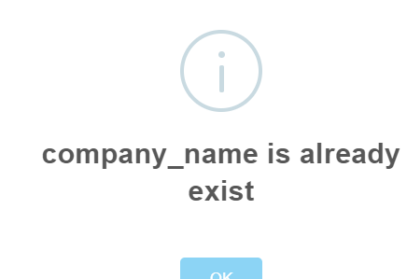

Change message to: **Company or Email already exists in system**

1. Please remove this color and use white as requested.

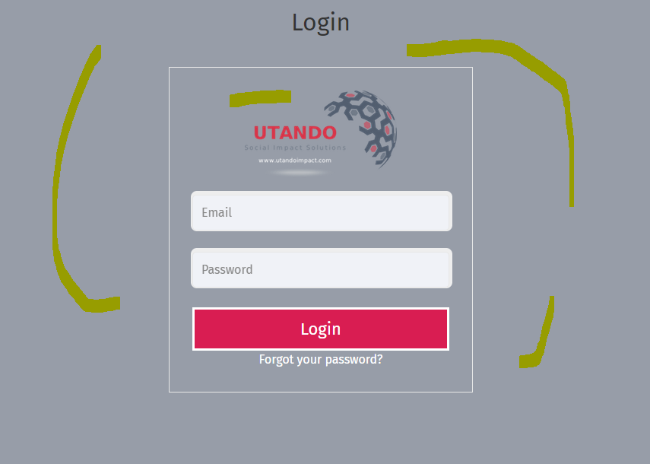

1. Please create a cancel button for login page – the button must take user back to landing page.
2. Please change email account that send forgot password emails to users. Change [team.labhaa@gmail.com](mailto:team.labhaa@gmail.com) to [support@utandoimpact.com](mailto:support@utandoimpact.com)
3. I cannot test further as I can’t create new account due to password field missing on account creation page, or do I use default password? If so, what is the default password?. See:

