1. Please make input fields to be in one line going down – user should scroll down for other fields. Do no put inputs side-by-side as it appears too busy on the page. Apply same logic to every page that requires input from user. See example:

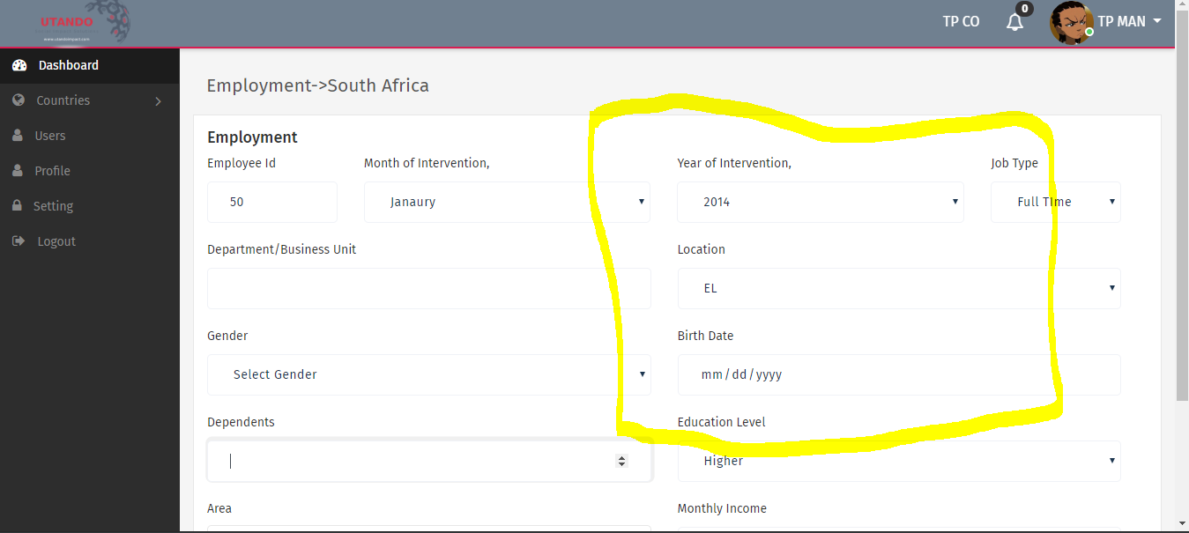

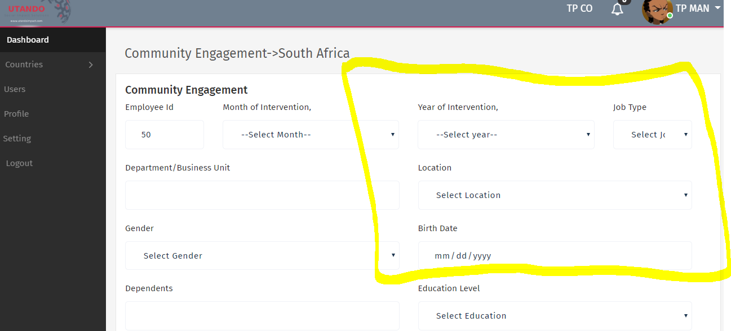

1. Can you put basic info from Company profile in a box, and below put another box for interventions per country according to user selections. Example :

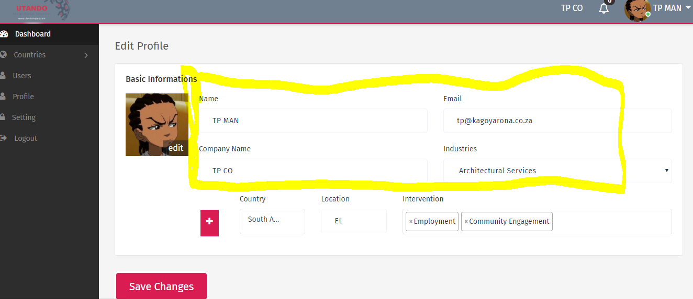

1. Please fix the highlighted as follows:

* Please select the Country, Locations, and Social Impact Interventions of your interest.
* Additional countries and Interventions can be added by clicking the Add button.

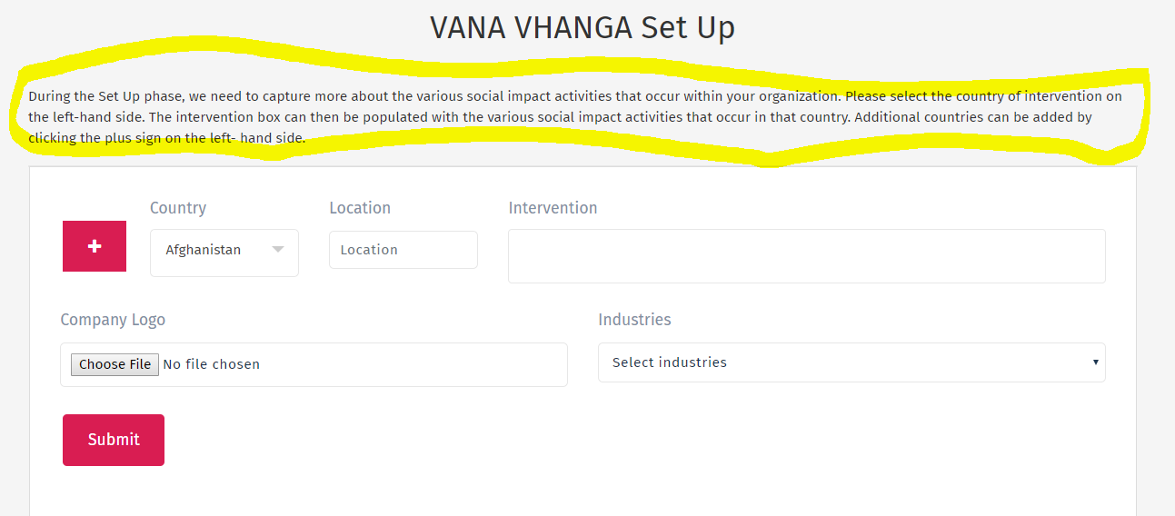

Update this as follows:

Old: Company/User Name (example here: VANA VHANGA) **Set Up**

New: Company/User Name (example here: VANA VHANGA) **customize your access.**

