**Pickadova Changes Doc**

1.Reply to comment (In reply to comment it should be open below comment)

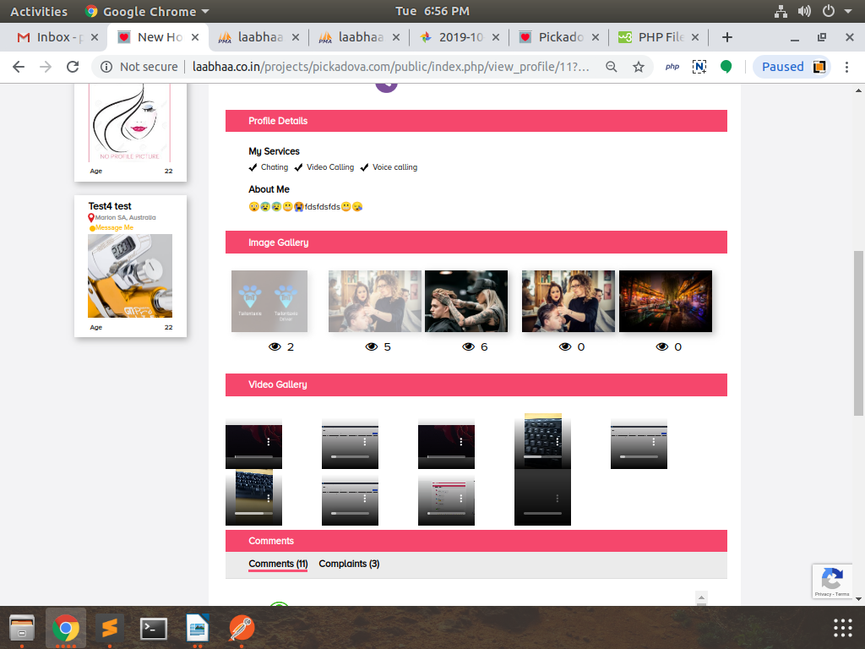

2.Photo Bluring for locked images (It is working)

3.can we also move the "Replied" comment for the right... so it looks like sub category to main comment

4.another words user "Buy" a position on "Top Profiles" and Have their "Main Profile" Highlighted.

5.The Button or "Check" box Must Remain inactive until user has finished first Highlight

6.Email verification is enough for go live