**Pickadova Update**

1.We need to make this is a drop down selection box 1km-2km-4km-5km-10km

(It is work on search by name, age ,services and if you put any location then it will take default 5 km if you also select within then it will be work according within km)

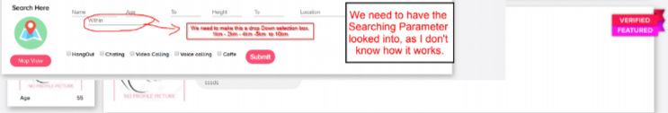

2.Bottom highlight is not showing and we have a large blank space under profile can we keep it to desgin

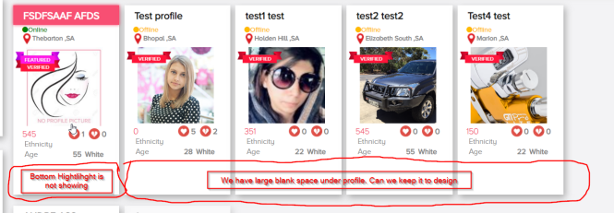

3.*Can we Move this more to right so it look. Like it i. under the original comment

*can we have a text that say Your Replying to "THIS NAME" Comment

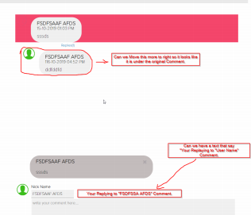

4.Can we Remove "State From Editeblee, as state is extract from suburb Qtherwise If Change state without Subrub it wont work good for searching

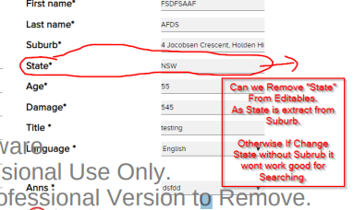

5.When user is previewing their Own Profile It must show (View Count)

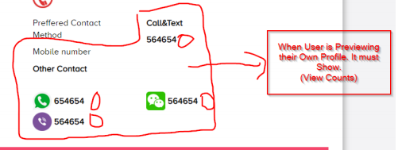

6.*Video Player is Very Bad. Upload is Pretty Bad and Painfully Slow.

* Play back does not work properly. We need either Increase the Size by defualt. or show the video in Popup.. Video Function is very important and don't want to compromise.

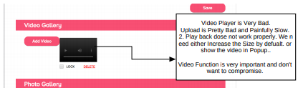

7.Question: Can you tell what is the Size to which the Photo are down sized tol?

Ans:- 600 * 40 px