**Pickadova Design Point**

1.Front end Chat design should be like client design

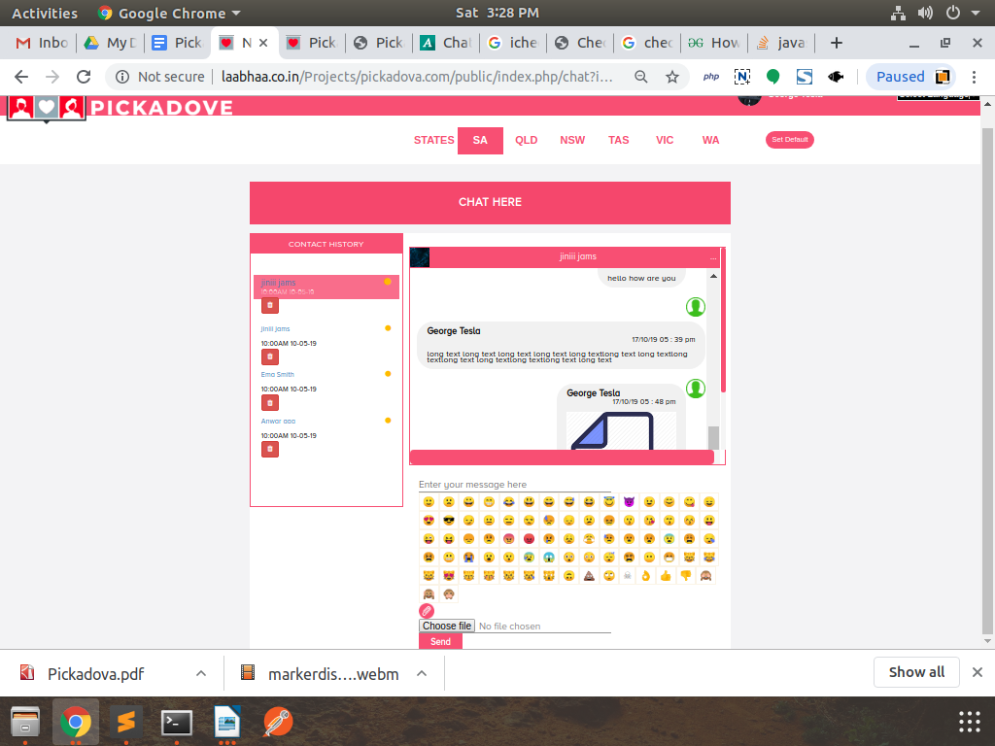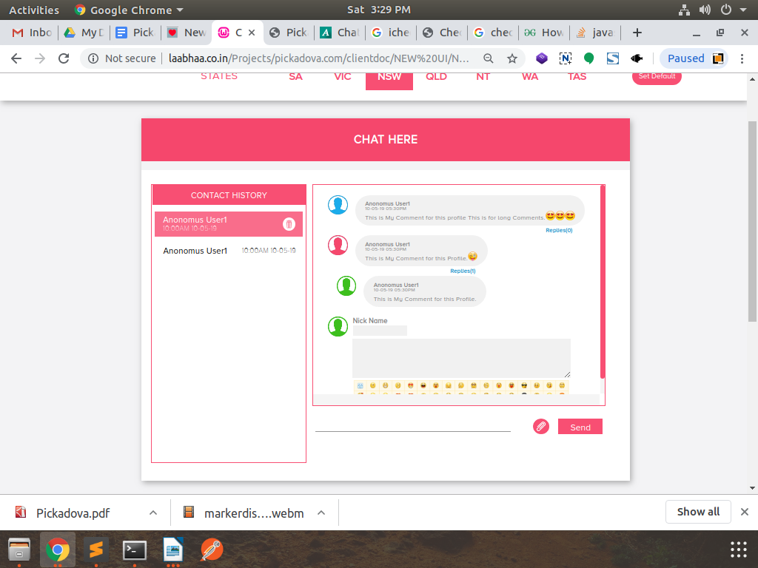

------->

2.Front end chat button submit hover

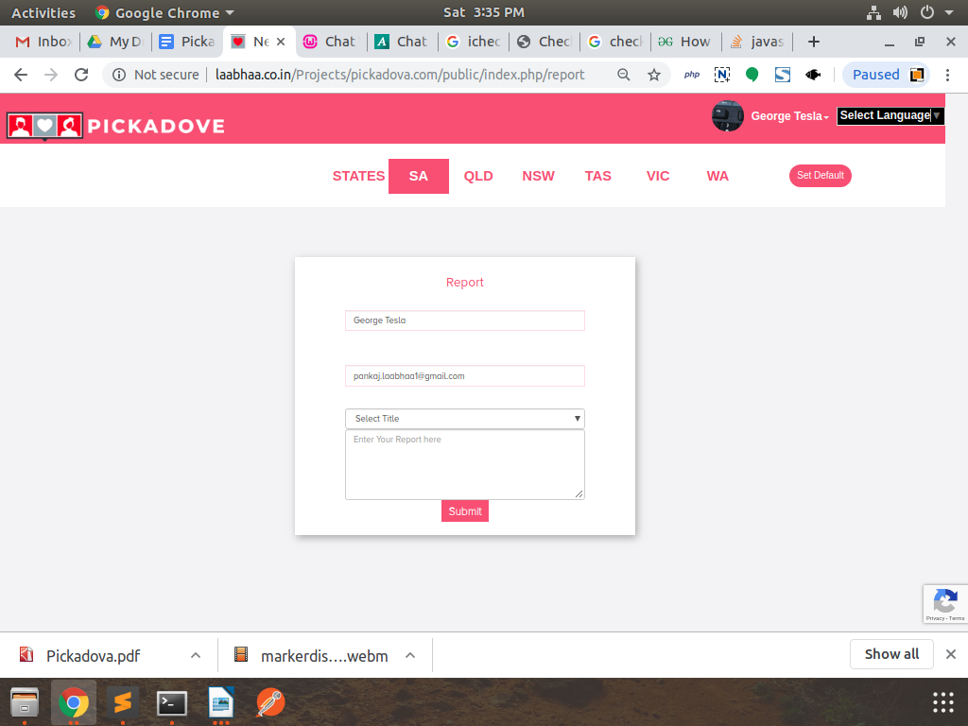

3.Report page design

3.Browser preview profile and edit profile should be like client desgin

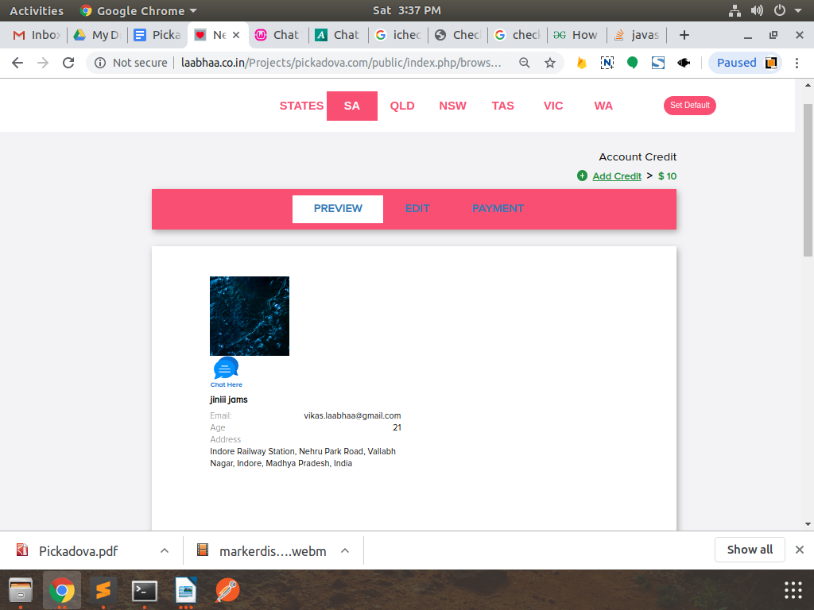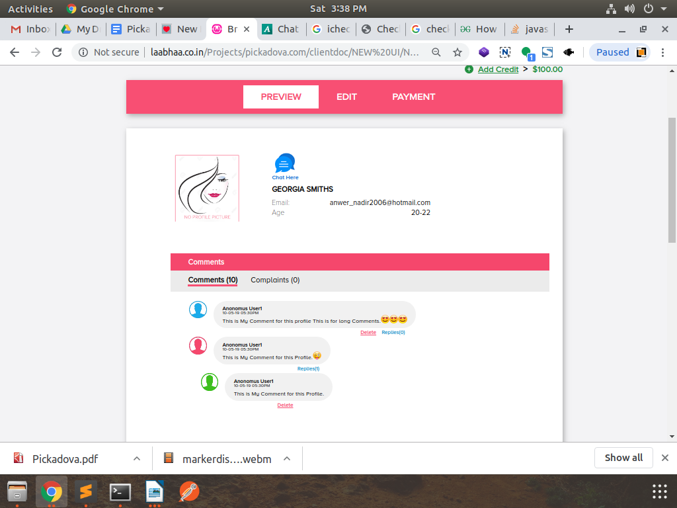

--->

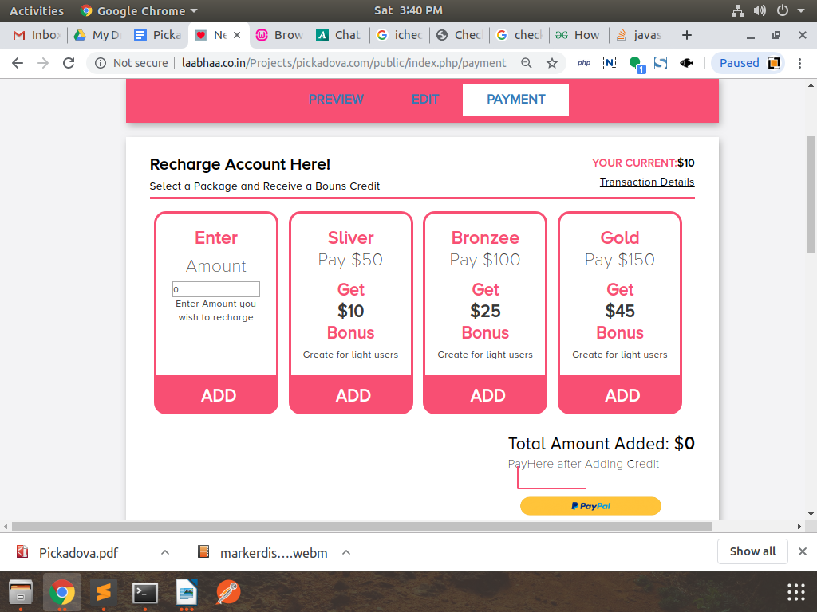

4.on payment page above paypal button design

5.preview edit and payment button on top should be same everywhere

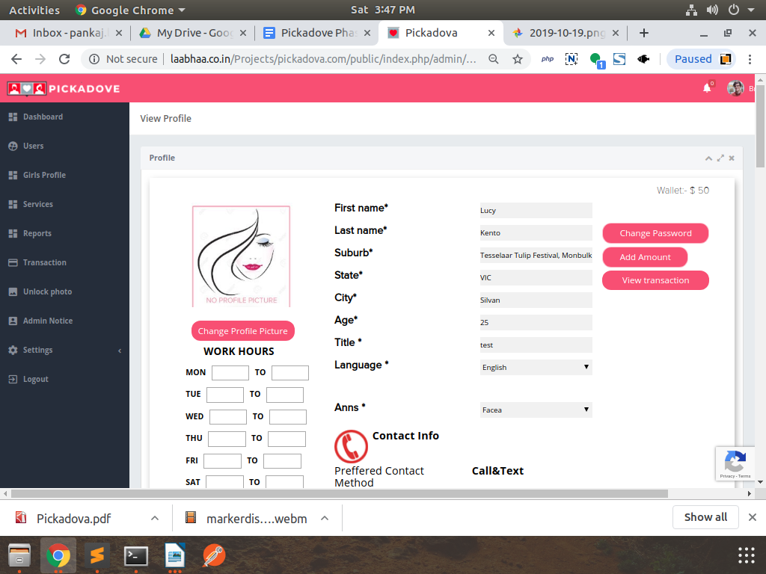

6.In Admin Panel girls profile design should be like frontend

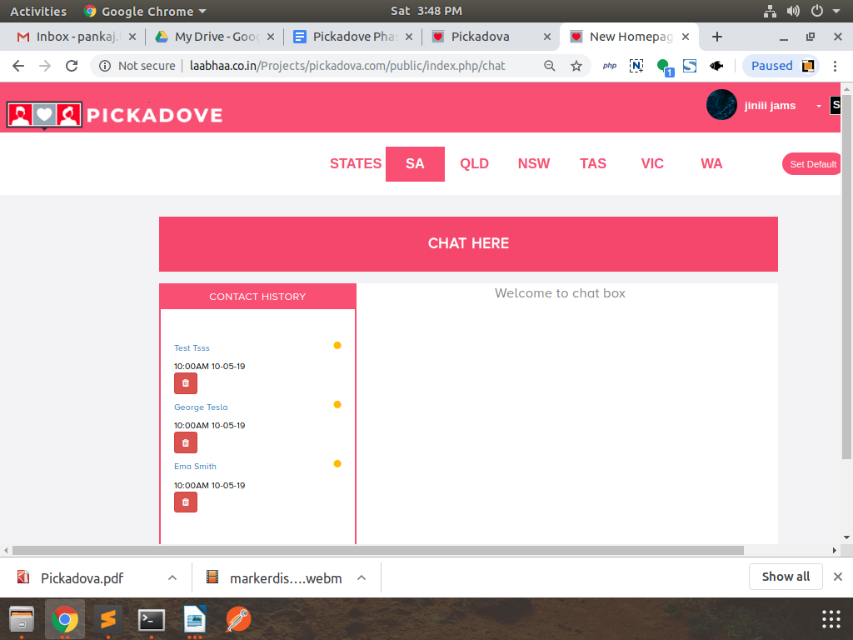

7.If no chat user selected then design should be good

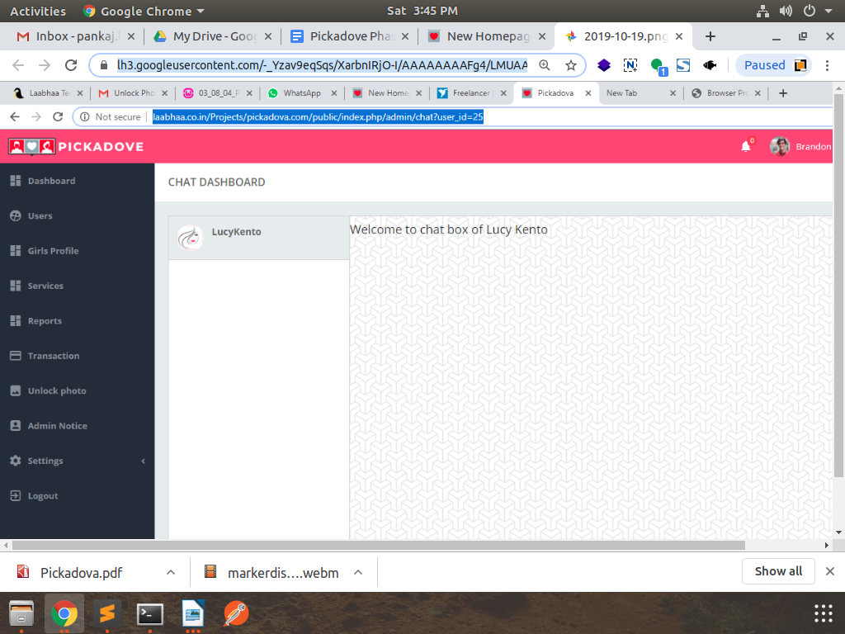

8.In admin profile chat profile design