**Dating Website**

**Module Requirements**

* Admin
* Front
* Paypal Gateway
* Credit Card
* Email
* Chat System
* Virtual Wallet
* Google Location

**Front End Requirements**

We want Full multi language support english and chinese for the front end.

Users.

* 1. Girls
  2. Browers

1. Girls
   1. First name
   2. Last name
   3. Address (This not Full address, but Only Suburb And State Only. this will show as radius. )
   4. State
   5. Age
   6. Admin Added Fields
   7. Admin Added Dropdown Selection
   8. Hours Available
   9. Profile Pictures and Gallery
   10. Video upload and Youtube Link
   11. About Me
   12. Comments
   13. Complaints.
2. Girls Hobby
   1. This is “CheckBox” Selection and All Girls Hobby is added by admin.
3. Contact info
   1. Mobile Number
   2. Wechat (Auto redirect to wechat app)
   3. Whatsapp (Auto Redirected to the App)
   4. Vider
   5. Other
   6. All Number are Hidden by Default (only Showing some part) and user must click on “Reveal Number” to show all.
   7. System must Keep a Record of Number of times the number has been revealed.
4. Terms and Conditions on signup.
   1. Admin to Write the Terms of use. And all users must agree before signup.
   2. System will check mobile number and Email to ensure we don’t have Duplicate account.
5. States/Location.
   1. Google api
   2. All Girls are divided in their Relevant (State/Territory) Refer to website homepage Design.
   3. All new Visitor To select their Relevant State/Territory to so they see relevant results.
   4. Auto Detect Visitors IP and Ask Visitor if It is Correct.
   5. User can Select a State and chose it as Default, their IP will be saved and automatically be directed to their preferred State/Territory if visit again.
   6. For Visitors it will Always Ask for “Relevant State” if it is not saved in database.
   7. Registered users will Automatically be Guided to right State based on their Profile location info
6. Home Page Layout.
   1. User Filtering System
   2. We need to have (Top Profile) Section where is showcases random Users who has highlighted their profiles.
   3. Recent Profiles from all (States/Location) showing on the left.
   4. We need to have 5 Profiles showing in row.
7. Girls Profile Functions
   1. User Sign up via Email using Verification code.
   2. User Complete all the Required Profile Information (Set by admin)
   3. Required Fields are highlighted to make it easy for user...
   4. User Requires to Pay X amount To “Go live” refer to (9.0)
   5. “Bump up Profile” user Pays X amount to Move to the top of the listing
8. Function “Go Live”
   1. “Go Live” will make Girls Profile Visible in Homepage Relevant to their “Location” User May need to pay X amount (Admin Controlled) to post their profile to homepage
      1. Admin Controls the Post Expiry Period(hours and Days).
      2. Each Repost profile will cost user $X (Amount Controlled ) =$0.00 Athen it is Free.
      3. Admin message for “Go live” 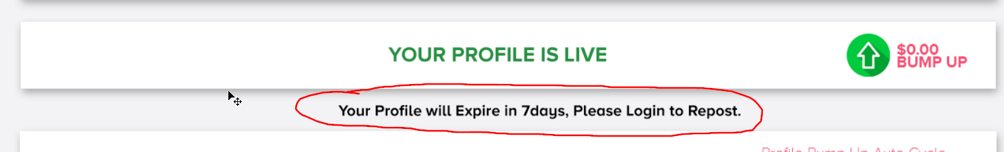 to be Editable from admin page.
      4. “Paused” Profile to Show as inactive in homepage and fully disappear (x Days) Admin Controlled
      5. “Paused” Profile Are for the user who has “Pressed” Paused their Ad or User’s Ad Expired.
      6. 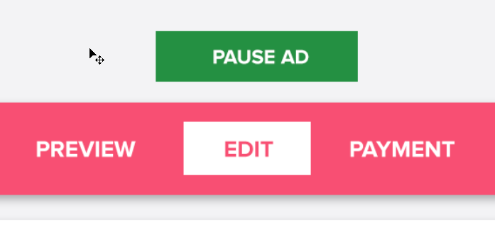
   2. Conditions to go live = user Must Fill in all required Fields (Admin Set)
   3. Pay X amount (if Set By Admin) Before going live If any any.
9. “Bump Up” Profile is for User to pump up their to the top of the listing.
   1. This function is for the User to Show their Profile in 1st position.Condition = User must be at least 4 positions away from 1st profile.
   2. User must Pay X amount (Set by Admin)
   3. User can set Auto Cycle, where System will “Bump up” their Profile Automatically every set hours or min. (User to Set the time.)
10. “Featured or Hightlight” profile
    1. Featured Profile are Profile that will Show in “Top Profile” section in homepage.
    2. Featured profile will have “Pink Tag” “Featured” Refer to design.
    3. User pay X amount for 24/hours to have their profile Show in Top Profile Section in home page.
    4. “Featured” Profile will Highlight their Profile in homepage listing.
    5. Top Profile Will Randomly Showcase all users (Relevant to their Location) who are “Featured”
11. Photos Upload in gallery.
    1. All Photo uploaded to Website must be Resized or downsized to 940*X before upload
    2. All Profile to have Set Aspect ratio for thumbnails.
    3. Photo View Count = if any photo is open (by Anyone) for more than 3 sec = 1view
    4. Photo Likes. Only registered users can Like the photo. Or direct unlock via paypal.
12. “Lock Photos”
    1. User Can Choose to upload and or Lock their Existing Photo from the profile
    2. User “Photo Owner” will Chose the Amount they need for the photo to be unlocked. (Limit is Controlled by Admin)
    3. These photos can not be shown to any other User in the visitors including Registered users.
    4. For anyone who wishes to view the Locked photo They must pay (Amount Set by User) to view the photo.
    5. The payment will be Shared between admin and (User). Admin will Decide the Share Ratio e.g Admin can do 50-50 or 40-60. Girls Share will be saved in the admin panel, and Admin can push it to their wallet, or pay them Directly.
    6. Public Visitors can unlock these photo Direct from their Profile via paypal.* When Unlocking photo Direct Via PayPay user will be shown the photo and a Backup Link to the photo will be sent to their Email Address.
    7. All Photos unlocked has timer to Lock Again. This includes the (view Links) Send to user’s who unlock direct via paypal. (Lock timer is Set by admin.)
    8. Whenever a photo is closed after view there will be question: “Do like this photo?” if yes = 1 new like.
    9. Locked Photo Admin Approval “Icon” And icon will be added to the bottom of the photo, if the photo has been Approved by admin. Refer to admin requirements for this.
13. “Wallet” Virtual Wallet
    1. User Can Recharge their Wallet Via Paypal. This amount will be used to Fund all the “Payment Required” functions including “Unlocking photo” “Going Live” “Highlight Profile” or any other function which may require payment.
    2. Admin Will Setup a plan where user can get x amount Bonus if the re-charge their via choosing one of our “Packages” Refer to design from the old website.
    3. Packages are full Created By Admin
    4. “Add to wallet” Admin to Be able to add “Virtual Money” to Any “Registered user’s” account.
    5. Admin Have the Ability to Freeze their funds.
14. “Verified Users”
    1. We will provide a button in “Girls Profile” to Request Admin to Verify their Account.
    2. This Request will show in Admin Notification and Admin will Manually do what it takes to Satisfy the requirement and Verify their Account
15. “Comments and Complaint”
    1. Each user has their own comment Section where all user and Visitors can add a comment.
    2. Full emoji Support
    3. All Comments before submitting must go through google “Verification” before submitted to ensure we are not spammed.
16. “Payment History”
    1. All the credit added to profile must be recorded
    2. All the charges made to users for their purchases must show in their transaction history.
17. “Boys Testimonials”
    1. Girls will add a Mobile Number and Attach a Comment to it.
    2. This Details will be saved with Time and date stamp.
    3. When Any other “Girl” user Searches Using Boy mobile number, if Match is found, it will display in the search result.
    4. This function is only Available between “Girls” profiles not Shared with browser Users.
18. “Video uploads” and youtube links
    1. Full video uploading and downsizing from all mobiles and desktop.
    2. All mobile = support all major video format like iOS and Android.
    3. Youtube links and outsource links.
19. “About me” section.
    1. Users to be able to fully control their text size boldness and color.
    2. Full emoji support with in text.
20. “Chat Function” Chat between all Registered users:
    1. Browser to Girls
    2. Ability for the girls to block user and unblock
    3. Send attachments and emoji
    4. Show online or Offline Status on their profile
    5. Delete chat history. If girls deletes it will delete both side. Message = “Userx Deleted this conversation.”
21. “Report” for visitors and Users
    1. User to Report issues or concerns to admin
    2. Each report has a title which is “Selected by dropdown” e.g “Technical Issue” , “Fake Profile”, “Feedback”
    3. These reports will show in admin profile and there will Marked as “Complete” function.
    4. When user send out these “Reports” they must go through google Verification” to ensure we don’t get spammed.
22. “Admin Notice”
    1. Admin can Send Message to Individual user or All the users at once.
    2. The message will show on top their profile Covering to section “Refer to Design”
    3. Each notice needs to be confirmed by the user for it to disappear.
    4. If Admin Sends out e.g 5 notification It will stack up on one on top of the others until all is confirmed by the user.
23. “Home page Google Map View”
    1. All User to be shown on the map based on their Location from their profile.
    2. Location are not exact and they will be showing as radius.
    3. Use will have Special Icon showing their profile pictures.
    4. Refer to design I will be sending.
24. “Home Page User Filtering”
    1. Home Page user filtering are done by
       1. First Name Last Name
       2. All other Profile Added my Admin.
    2. Girls Hobby
       1. Girls Hobby Selection as Checkboxes. Refer to Design.
       2. There can be multiple selections of these “Girls Hobby”
25. “Browser Users”
    1. Nick Name
    2. Age
    3. Mobile number
    4. Terms and condition.
    5. Email address
26. Home Page Mobile Responsive. We do not want Mobile Responsive.
    1. We want all Pages to Be in Desktop view… Some Page like Chat Page can be optimised.
    2. We want max limit of 200 Profiles in First page before it moves to the next page...
27. Browser User has Access to Chat System and Wallet system to add money to their wallet and use it to Unlock photos or any other form of payment that might be required.
    1. They will have transaction history
    2. Chat history.
28. Password recovery via email for all users.

**Admin Requirements**

1. Admin Users
   1. Super Admin
   2. Sub Admin
      1. SubAdmin Access and restriction to this Account is Controlled by SuperAdmin
2. Admin profile
   1. Admin Profile is to update email address for password recovery
   2. Password change
   3. Setting All the Admin Control Variable\
      1. Go live Ad Post Charges
      2. Ad Expiry date
      3. Inactive profile expiry
      4. Bump up Price
      5. Lock photo Commision Settings
      6. Lock Photo Timer to Lock back again.
      7. Highlight Profile Prices
      8. Highlight Profile Duration
   4. Default Logos for Different Profile.
   5. Website logo
3. Adding New Information Field to User’s Profile
   1. Adding Manual Entry Field
   2. Adding New Multi Selection Drop Down Box to users
   3. Selecting The required Fields Before user can “go live”
   4. Adding New Contact Info With Icons.
4. User Profile Editing Girls and Browsers account
   1. Update all the Account details.
   2. Send Password Reset
   3. View Profile image
   4. Image Gallery and video
   5. View and Delete Comments and Complaint
   6. Account Verification Slider to “Verify” User.
5. Chat Review by admin
6. Transaction History
   1. Transaction by User
   2. Transaction Show all Payment Via PayPal
   3. Transaction showing amount only for photo unlock
   4. Transaction Showing All Credits Added to user by Admin
   5. Transaction Showing commission from photo unlocks.
7. Reports and Feedback
   1. We need a page to list out all the feedback and reports by User from front end.
   2. Each listing will have Check Box of “Completed” or “Urgent”
   3. Listing can sorted by “Completed” or “Urgent”
   4. Report Message or title can be Edited by Admin.
8. Admin Notice
   1. Admin to Create a notice and push it a Selected User or Multiple Users at a time.
   2. Notice to Visitors when visiting once per IP
   3. View of old messages Send
9. Invites.
   1. Visitor from the Front end can
10. Locked Photo Approval
    1. All Locked photo will be listed on in single page sorted by most recent one.
    2. Admin Will check and you Slide bar to approve the photo.