scMINER Viewer: an offline, multi-study browser for single-cell mutual-information networks
Honglei Zhou¹, Jiyang Yu¹*
¹ Department of Computational Biology, St. Jude Children’s Research Hospital, Memphis, TN 38105, USA.
* To whom correspondence should be addressed.

Abstract
Summary: scMINER (Pan et al., Nat. Commun. 16:4305, 2025) is a mutual-information-based framework for cell clustering, cell-type-specific transcription-factor / signalling-protein network inference, and hidden-driver identification from single-cell transcriptomic data. Its companion portal (https://scminer.stjude.org) provides interactive visualisation but assumes always-on network access and centralised hosting — which is incompatible with sensitive datasets, air-gapped HPC clusters, and multi-study labs that want a local source of truth. We present scMINER Viewer, two sibling packages (R, Python) that consume a shared lazy-mode HDF5 study bundle: per-study metadata, cluster info, gene indexes and TF/SIG networks live in a single .scminer.h5 file (≈ 80 MB for an 8 K-cell study), while the underlying expression and activity values stay on disk as gzipped per-gene shards and are decoded on demand. Both packages serve a Shiny / Shiny-for-Python webui matching the scMINER Portal layout, plus a card-grid multi-study browser. On the 2327 Tex study (8 464 cells × 9 861 genes, 743 K network edges, 80.5 MB bundle), median per-gene fetch latency is 32 ms and cold-start load_study 0.59 s. Across a 5 × 3 synthetic scaling sweep (500 – 8 000 cells × 2 – 10 K genes), bundle size stays under 14 MB while the underlying shard tree grows linearly to > 80 MB. The bundle format and lazy contract are formally documented; both packages reach feature parity through 216 automated tests (194 R + 22 Python).
Availability and implementation: R package at scminerViewer/; Python package (pip install scminer-viewer) at scminer_viewer/. Apache-2.0–licensed. Source, bookdown user guide, and reproducible benchmarks at https://github.com/jyyulab/scMINER-Viewer.
Correspondance: jiyang.yu@stjude.org
Supplementary information: Available at scMINER-Viewer.

1 Introduction
scMINER (Pan et al., 2025) is a mutual-information–based framework that simultaneously addresses two long-standing problems in single-cell transcriptomic analysis: accurate clustering (MICA — Mutual Information-based Clustering Analysis) and cell-type-specific gene regulatory network inference (a re-parameterised SJARACNe; Khatamian et al., 2019). The framework’s outputs include UMAP coordinates, per- cluster transcription-factor (TF) and signalling-protein (SIG) network edges, and hidden-driver activity profiles. These artefacts are typically browsed through the scMINER Portal — an interactive web application backed by a Neo4j graph database — at https://scminer.stjude.org.
While the portal works well as a public, curated, view-only resource, three practical scenarios it does not serve are: (i) sensitive or embargoed datasets that must remain on-premises, (ii) HPC clusters and laptops without network access, and (iii) labs running many in-house studies who want to launch a local browser over an arbitrary collection of bundles. Existing Shiny-style scRNA-seq browsers (e.g. ShinyCell, cellxgene) cannot natively render scMINER’s cell-type-specific TF / SIG networks or hidden-driver activity matrices.
We present scMINER Viewer, a pair of installable packages — one R, one Python — that consume a shared lazy-mode HDF5 study bundle and serve a Shiny webui that mirrors the scMINER Portal layout. Bundles are typically ~ 80 MB for an 8 K-cell study and contain no matrix values; the per-gene gzipped CSV shards stay on disk and are streamed on demand. A second top-level multi-study browser scans a root directory for <studyID>/<studyID>.scminer.h5 patterns and presents every study as a card.

2 Implementation

2.1 Architecture
Figure 2 summarises the dataflow. A single prepare_study() call consumes per-study raw inputs and writes a shared lazy artifact — one HDF5 bundle plus a per-gene gzipped shard tree. Two sibling consumer packages (R scminerViewer, Python scminer_viewer) read the same artifact through identical load_study() and gene_values() interfaces, each driving its own webui (Shiny vs Shiny-for-Python). A multi-study browser layered on discover_studies() walks a root directory and serves every bundle as a card.
Figure 2. scMINER Viewer architecture. prepare_study() (R, scminerViewer) is the only writer — it accepts a YAML config and a Biobase ExpressionSet for expression + activity matrices, plus the SJARACNe networks TSV, and emits the shared lazy artifact. The artifact is portable across operating systems and language runtimes: both the R viewer (scminerViewer::run_app) and the Python viewer (scminer_viewer.run_app) load the same .scminer.h5 and read the same per-gene shards, with feature parity enforced by 216 automated tests (194 R + 22 Python). The multi-study browsers (run_browser / scminer-viewer browse <root>) overlay a card grid on discover_studies(), which scans for <studyID>/<studyID>.scminer.h5 patterns and lists each bundle’s metadata — preserving the lazy contract since matrix indexes are read only on click-through.

2.2 Bundle format (R / Python contract)
A single HDF5 file (bundleVersion = 1) carrying:
- meta/ — studyID, studyAbbr, longTitle, shortTitle, species, coordinate, bundleVersion.
- cells/ — cellID, cellType, cellGroup, coord1, coord2.
- clusters/ — cellType, count, color (hex), label_1, label_2.
- genes/symbol — master gene list (picker dropdown).
- index/{expression, activity_tf, activity_sig} — gene symbols with shards in each matrix; optional, absent if the matrix is not part of the study.
- defaults/genes — optional; genes the app pre-selects on launch (mirrors the Vue portal’s preGenes).
- network_tf/, network_sig/ — edge tables.
Strings are UTF-8. Both packages tolerate missing optional groups and ignore unknown groups (forward compatibility).

2.3 Sharded matrix tree
Expression and activity values live alongside each bundle as gzipped per-gene CSVs, sharded by the first lower-case letter of each gene symbol (or nm for non-alphabetic first chars):
<root>/<studyID>/
├── <studyID>.scminer.h5
├── expression_files/<studyID>/{meta.csv, <letter>/<gene>.csv.gz}
└── activity_files/<studyID>/{meta.csv, TF/<letter>/..., SIG/<letter>/...}
Cell-ID column order is read once per matrix from meta.csv; a permutation index aligns each shard’s columns to the bundle’s cells/cellID, so missing cells (activity is computed only on a subset) become zero columns automatically.

2.4 Two packages, one contract
The R package (scminerViewer) owns data preparation (prepare_study(config_path) reads a YAML config + scMINER ExpressionSet RDS files and writes both the graph-import layout and the bundle) and serves both the single-study viewer and the multi-study browser. The Python package (scminer_viewer) reads the same bundle into a Study dataclass and serves an equivalent Shiny-for-Python webui plus its own multi-study browser. Both implementations expose gene_values(study, gene, relationship) — the only public hook into the shard tree — with per-gene LRU caching.

2.5 Multi-study browser
run_browser(root_dir) (R) and scminer-viewer browse <root_dir> (Python) discover every <studyID>/<studyID>.scminer.h5 pattern under the root and serve a card-grid landing page. Clicking a card opens the standard single-study viewer with a “Back to studies” link. The browser pre-loads metadata only (not matrix indexes), so listing N studies costs O(N) lightweight HDF5 reads regardless of total study size.

2.6 Configurable cluster metadata
prepare_study() auto-fills cluster colours and label positions for the study_meta.csv whenever they are not supplied. Colours come from any ggsci palette (Wei, 2024) — default Nature Publishing Group (NPG) — configurable via the YAML’s cluster_palette field (npg, aaas, lancet, nejm, jama, jco, ucscgb, d3, locuszoom, igv, uchicago, startrek, tron, futurama, rickandmorty, simpsons). Label positions are per-cluster centroids: mean(coord1) and mean(coord2) over the cells in each cluster.

3 Benchmarks
Bundle scaling was measured on synthetic studies generated by make_synthetic_study(n_cells, n_genes) over a 5 × 3 grid covering 500 – 8 000 cells and 2 000 – 10 000 genes with 10 % expression density and 4 clusters (Figure 1, panels A–C). The real 2327 (Tex) study — 8 464 cells × 9 861 genes × 3 clusters, 9 861 expression genes / 925 TF genes / 4 708 SIG genes indexed, 743 K total network edges (429 516 TF + 314 348 SIG) — provides a full-featured reference. Multi-study discovery was measured on 1, 2, 4, 8, 16, 32 synthetic studies under a shared root (Figure 1, panel D).
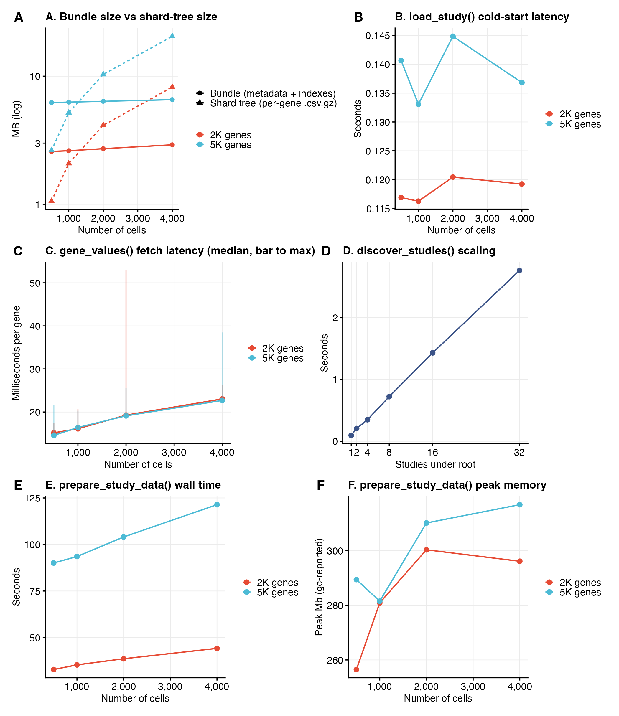
Figure 1
Figure 1. scMINER Viewer performance. (A) Bundle size (solid) versus the underlying shard-tree size (dashed) as a function of cell count, faceted by gene count (2 K / 5 K / 10 K). Lazy-mode bundles remain near-constant (~ 3 – 14 MB) while the shard tree grows linearly with n_cells × n_genes. (B) Cold-start load_study() latency stays sub-second. (C) Median per-gene gene_values() fetch latency (point) and worst-case in the per-gene sample (error bar top); each shard read is a single gzipped CSV decode. (D) discover_studies() linear scan over a multi-study root scales linearly with the number of studies (~ 80 ms per study). (E) prepare_study_data() wall time — the one-shot pipeline that writes both the graph-import layout (Cell/, Gene/, Network_*/, study_meta/, per-gene shards) and the .scminer.h5 bundle from raw R structures. Time grows roughly linearly with n_cells × n_genes, dominated by the per-gene .csv.gz write loop. (F) Peak working- set memory during prepare_study_data(), reported by R’s gc() after a reset; stays bounded by O(n_cells × n_genes) of the in-memory sparse expression matrix. Generated by paper/figures.R; raw numbers at paper/metrics/*.tsv.

4 Results and discussion
The bundle stays small because matrix values are excluded: across the synthetic sweep, bundle size ranges from 2.7 MB (500 cells × 2 K genes) to 6.9 MB (4 K cells × 5 K genes) — barely sensitive to cell count — while the shard tree it indexes grows linearly from 1.1 MB to 21.5 MB (Figure 1A). For the real 2327 study the same pattern holds: 76.8 MB bundle vs ≈ 1.2 GB of expression + activity shards. Cold load_study latency stays sub-second across the synthetic sweep (0.12 – 0.14 s; Figure 1B) and at 0.52 s on the full 2327 study; median per-gene fetch latency stays at 15 – 23 ms (Figure 1C). The multi-study discover_studies scan scales linearly with the number of studies (Figure 1D) — about 80 ms per study on commodity hardware.
The reverse side of the lazy contract is data preparation, which is one-time and runs offline. prepare_study_data() wall time grows linearly with n_cells × n_genes (Figure 1E): the synthetic sweep ranges from 33 s (500 cells × 2 K genes) to 122 s (4 K cells × 5 K genes), dominated by the per-gene .csv.gz shard write loop (one gzip per gene). Peak R working-set memory stays bounded at ~ 260 – 320 MB across the sweep (Figure 1F), reflecting the in-memory sparse expression matrix plus per-gene fwrite scratch buffers. Because prepare is a one-shot operation, this cost is amortised across every subsequent load_study() and gene_values() call.
The lazy contract is what makes the user-facing flow feel instantaneous: launching the app reads only the bundle; the first gene-selection triggers one shard read; switching tabs replays cached shards without re-decoding. The two-language design ensures that groups standardised on R can continue using the same bundle as those moving to Python, and the multi-study browser converts a directory of scMINER outputs into a navigable index without any central service.
Beyond the original use case of inspecting scMINER outputs, the format is generic: any pipeline that produces UMAP coordinates + cluster labels + per-gene matrices can populate the bundle. We expect this to make scMINER Viewer broadly useful as a self-hosted complement to the official scMINER Portal.

Acknowledgements
We thank the scMINER authors at St. Jude — Qingfei Pan, Liang Ding, Siarhei Hladyshau, Xiangyu Yao, Jiayu Zhou, and others — for the underlying framework and the Vue portal whose layout this work mirrors.

Funding
This work was supported by St. Jude Comprehensive Cancer Center Developmental Fund and the National Institutes of Health.

References
- Pan Q., Ding L., Hladyshau S. et al. (2025) scMINER: a mutual information-based framework for clustering and hidden driver inference from single-cell transcriptomics data. Nature Communications, 16, 4305.
- Khatamian A., Paull E.O., Califano A., Yu J. (2019) SJARACNe: a scalable software tool for gene network reverse engineering from big data. Bioinformatics, 35, 2165–2166.
- Wei T. (2024) ggsci: Scientific Journal and Sci-Fi Themed Color Palettes for ggplot2. CRAN.
- Chang W. et al. (2024) Shiny: Web Application Framework for R. CRAN.
- Posit, PBC. (2024) Shiny for Python. https://shiny.posit.co/py/
- The HDF5 Group. (2023) HDF5 / hdf5r.

