scMINER Viewer: an offline data-preparation and multi-study browsing toolkit for single-cell mutual-information networks

Abstract
Motivation: scMINER is a mutual-information-based framework for cell clustering, cell-type-specific transcription-factor/signaling-protein network inference, and hidden-driver identification from single-cell transcriptomic data. Its companion portal provides interactive visualization on network access and centralized hosting, which is incompatible with sensitive datasets, air-gapped HPC clusters, and multi-study labs that want a local source of truth.
Results: We present scMINER Viewer, an end-to-end offline toolkit comprising (1) a YAML-driven data-preparation module that converts the raw scMINER outputs: Biobase ExpressionSets for expression and activity matrices plus the SJARACNe networks into a shared lazy artifact, and (2) two sibling viewer packages (R, Python) that consume that artifact. Both viewers serve a Shiny/Shiny-for-Python webui matching the scMINER Portal layout, plus a card-grid multi-study browser.
Availability and implementation: Apache-2.0–licensed R package and Python package, bookdown user guide, and reproducible benchmarks at https://github.com/jyyulab/scMINER-Viewer.

1. Introduction
scMINER is a mutual-information–based framework that simultaneously addresses two long-standing problems in single-cell transcriptomic analysis: accurate clustering (MICA: Mutual Information-based Clustering Analysis) and cell-type-specific gene regulatory network inference (a re-parameterised SJARACNe). The framework’s outputs include UMAP coordinates, per- cluster transcription-factor (TF) and signaling-protein (SIG) network edges, and hidden-driver activity profiles. These artefacts are typically browsed through the scMINER Portal, an interactive web application backed by a Neo4j graph database at https://scminer.stjude.org.
While the portal works well as a public, curated, view-only resource, three practical scenarios it does not serve are: (i) sensitive or embargoed datasets that must remain on-premises, (ii) HPC clusters and laptops without network access, and (iii) labs running many in-house studies who want to launch a local browser over an arbitrary collection of bundles. Existing Shiny-style scRNA-seq browsers (e.g. ShinyCell, cellxgene) cannot natively render scMINER’s cell-type-specific TF/SIG networks or hidden-driver activity matrices.
We present scMINER Viewer, a pair of installable packages including one R and one Python, that consume a shared lazy-mode HDF5 study bundle and serve a Shiny webui that mirrors the scMINER Portal layout. Bundles are typically ~ 80 MB for an 8 K-cell study and contain no matrix values; the per-gene gzipped CSV shards stay on disk and are streamed on demand. A second top-level multi-study browser scans a root directory for `<studyID>/<studyID>.scminer.h5` patterns and presents every study as a card.
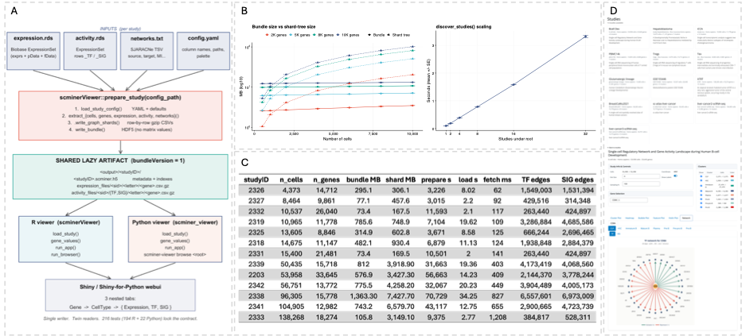
Figure 1. scMINER Viewer workflow and performance. (A) prepare_study() (R, scminerViewer) is the writer in the pipeline. It accepts a YAML config and a Biobase ExpressionSet containing the expression and activity matrices, together with the SJARACNe networks TSV, and emits a shared lazy artifact. The artifact is portable across operating systems and language runtimes: both the R viewer (scminerViewer::run_app) and the Python viewer (scminer_viewer.run_app) load the same `. scminer.h5` and read from the same per-gene shards. The multi-study browsers overlay a card grid and list each bundle's metadata. The lazy contract is preserved, where matrix indexes are read only on click-through. (B) Bundle size (Bundle series) versus underlying shard-tree size (Shard tree series) as a function of cell count, colored by gene count (2K / 5K / 8K / 10K). Lazy bundles stay near-constant (~2.6–13.2 MB), while the shard tree grows roughly linearly with n_cells × n_genes. Cold-start latency remains below 200 ms. (C) Per-study metrics for the 13 production scMINER Portal studies, sorted in ascending order of n_cells. Bundle (MB) is the size of the lazy `. scminer.h5`; Shard (MB) is the size of the per-gene gzipped CSV tree. Load (s) is the median cold-start latency, and Fetch (ms) is the median retrieve gene value time over 25 randomly sampled genes per study. (D) Example browse view across the 13 studies in the Python package, together with the layout of an individual study page, which mirrors the scMINER Portal.
2. scMINER Viewer implementation
Figure 1A summarizes the dataflow. A single prepare_study() call consumes per-study raw inputs and writes a shared lazy artifact: one HDF5 bundle plus a per-gene gzipped shard tree, that two sibling consumer packages (R scminerViewer, Python scminer_viewer) read through identical load_study() and gene_values() interfaces, each driving its own web UI (Shiny vs. Shiny-for-Python), with a multi-study browser layered on discover_studies() that walks a root directory and serves every bundle as a card.
The bundle is a single HDF5 file holding study metadata, the cell table with embedding coordinates, cluster definitions, a master gene list, optional per-matrix indexes for expression and TF/SIG activity, optional pre-selected default genes, and optional network edge tables; strings are UTF-8, and both implementations tolerate missing optional groups and ignore unknown ones for forward compatibility. Expression and activity values sit alongside the bundle as gzipped per-gene CSVs, sharded by the first letter of the gene symbol; cell-ID order is read once per matrix from a sidecar meta.csv and aligned to the bundle's cell list via a permutation index, so cells missing from a matrix (activity is typically computed on a subset) appear as zero columns automatically. The R package owns preparation, where prepare_study(config_path) reads a YAML config plus scMINER ExpressionSet inputs and emits the bundle. gene_values(study, gene, relationship) is the only public hook into the shard tree, with per-gene LRU caching in both runtimes. The multi-study entry points (run_browser in R, scminer-viewer browse <root> in Python) discover every `<studyID>/<studyID>.scminer.h5` under a root directory and pre-load metadata only, so listing N studies costs O(N) lightweight reads regardless of total study size. Where inputs don't supply them, prepare_study() auto-fills cluster colors from a configurable ggsci palette (default NPG) and computes label positions as per-cluster centroids over the embedding coordinates.
3. Results
3.1 Benchmarks: Bundle scaling and multi-study discovery scaling
Bundle scaling measures the marginal cost of the lazy artefact as the input shape grows. We sweep a 7 × 4 grid of shapes, n_cells ∈ {500, 1,000, 2,000, 4,000, 6,000, 8,000, 10,000} × n_genes ∈ {2,000, 5,000, 8,000, 10,000}, yielding 28 configurations. Each configuration is rerun N = 5 times with independent random seeds; Figure 1B reports means ± standard error across the five replicates, and the raw per-rep metrics persisted at Supplemental Table 1. Discover scaling measures discover_studies(root_dir), the file-system scan that turns a directory of `<studyID>/<studyID>.scminer.h5` trees into a card-grid index for the multi-study browser (run_browser() in R, scminer-viewer browse in Python). The benchmark builds 1, 2, 4, 8, 16, and 32 lightweight synthetic studies (200 cells × 500 genes each) under a single root, then times discover_studies() end-to-end. Like the bundle sweep, each cell of the grid runs five times with independent seeds (Supplemental Table 2). Because the browser only reads per-study metadata (no matrix indexes), the test isolates the linear file-system scan from any data decoding.
3.2 scMINER Viewer on the 13 TF/SIG-eligible real portal studies
Across 13 portal studies (range from 4,373 to 138,268 cells, 0.7M to 13.5M total TF + SIG edges), three architectural patterns hold. (1) Bundle size is governed by network edges, not cells. Bundle-MB per edge ≈ 100 B across the set: 2333 has the largest population (138K cells) but only a 106 MB bundle (913K edges), while 2326 has just 4,373 cells yet a 295 MB bundle (3.1M edges). (2) Fetch latency is linear in n_cells, ≈ 8.7 µs/cell, that is 62 ms at 4,373 cells, 1,208 ms at 138,268, comfortably interactive up to ~100K, tractable at 138K. (3) Prepare time is dominated by network sharding, not cells. 2333 (138K cells, 0.9M edges) finishes in 9,375 s, which is less than 2331 (15K cells, 0.7M edges) at 10,501 s, while 2338 (96K cells, 13.5M edges) takes 70,729 s. Cold load scales with bundle size alone (from 2.0 s to 34.3 s) and is independent of underlying matrix size. Bundles average 5.0 % of input size (median 8.3 %). Lazy-by-design holds: any study opens in seconds and serves per-gene plots in under 1.2 s.
4. Discussion
Single-cell transcriptomic analysis in clinical and translational research depends on lab-local infrastructure: sensitive patient datasets cannot leave their institutional perimeter, HPC clusters are routinely air-gapped, and multi-study groups need a navigable index over their own outputs. The scMINER Portal solves visualization for the public studies it hosts, but its hosted-service architecture fails in these settings. scMINER Viewer closes that gap with a minimal deployment surface: a single R writer (prepare_study) emits an HDF5 bundle of indexes and metadata alongside a per-gene gzipped shard tree of values, and two viewer packages: R (scminerViewer) and Python (scminer_viewer) consume the same artifact through identical load_study() and gene_values() interfaces. A multi-study browser layered on discover_studies() makes a directory of outputs immediately navigable with no central service. The lazy contract holds in production. Across the 13 scMINER Portal studies (4,373–138,268 cells; 0.7M–13.5M TF + SIG edges), bundles compress the input footprint up to 7×, cold-start load lands at 2.0 to 34.3 s, and median per-gene fetch stays at 62 to 1,208 ms, interactive across the full production cell-count range. Discovery scales linearly at ~80 ms per study (30 studies in <3 s). Beyond scMINER, the bundle format is generic: any pipeline producing UMAP coordinates, cluster labels, and per-gene matrices can populate it, making the Viewer a template for self-hosted single-cell visualization.

