Career Evaluation in Software Publishing
Data science and adjacent AI and ML roles in 2024
Group 10
October 8, 2026
Our product connects a narrowly scoped job-market analysis with practical decisions for a student entering data science. Ten audited 2024 software-publishing postings separate into analytics-and-data and AI-and-ML architecture segments. Our current profile aligns more closely with the first segment, while Machine Learning and MLOps remain development priorities. The sample’s experience requirements, missing pay, and small size limit any claim about accessibility or market-wide opportunity.

1. Product framing
Our product helps college students and recent graduates plan a path into data science within U.S. Software Publishers, NAICS 2022 code 513210. We focus on skill readiness and distinguish explicit Data Scientist roles from adjacent analytics, AI, machine-learning, and architecture roles. Software publishing is the industry boundary; the adjacent titles are part of the same defined career pathway, not an expansion into other industries (U.S. Census Bureau, 2022).
Our decision: prioritize early-career versions of analytics and data roles while developing the production and cloud skills needed for longer-term AI and ML work. This is a learning and search strategy. The ten historical postings do not establish that entry-level vacancies are plentiful or that our current profile satisfies a specific employer’s requirements.

1.1 The question our product answers
Within the audited 2024 software-publishing sample, which role segments best align with our current skills, what barriers affect accessibility, and which learning priorities should guide our next career decision?
The product combines a market baseline, a documented student profile, and an explainable segmentation analysis. A reader can inspect the evidence, identify relevant role families, compare their own demonstrated skills with the reported patterns, and choose a portfolio project. Salary, location, and experience provide context rather than a promise of an offer.

1.2 Why this scope matters
Job titles hide meaningful differences in skill combinations. De Mauro et al. organize big-data work into job families and skill sets, supporting our decision to compare related roles without treating them as interchangeable (De Mauro et al., 2018).

2. Scope and data
Our final analysis uses ten distinct Lightcast job postings from May through September 2024 in U.S. Software Publishers. Earlier exploratory material used a different 2026 source. We exclude those observations from the final market findings, skill comparison, segmentation, and recommendations (AD688 Group 10, 2026; Lightcast, 2024).
Scope decision | Final definition
Industry | Software Publishers, exact NAICS 513210
Career pathway | Data Scientist plus explicitly labeled adjacent analytics and AI or ML roles
Geography | United States
Posting window | May 1 through September 30, 2024
Unit of analysis | One distinct posting ID
Retained sample | 10 postings, including 1 core and 9 adjacent roles

2.1 Sample construction and restoration
The earlier Step 3 scope audit documented 72,498 source rows and 1,037 exact-industry records before the pathway and date restrictions. The approved cohort contains explicit Data Scientist, data-science-adjacent, applied or decision scientist, AI technical, machine-learning technical, and analytics engineer titles. Occupation codes provide supporting metadata; a generic software title does not qualify solely because its description mentions AI.
Our full-source restoration run scanned 72,498 rows and found all ten approved posting IDs. Using the original preparation code reproduced the archived baseline tables, skill-demand counts, model scores, and cluster membership. We then removed one false R-programming match caused by the phrase “R D team.” This reduced the recurring model features from 38 to 37 while preserving the ten-posting cohort and its six/four grouping.
The restoration holds the approved IDs and core or adjacent labels fixed using the saved description corpus. It verifies their source records and downstream results; it does not independently rerun the original inclusion and exclusion decisions for every other industry title. The 1,037-record industry count remains an earlier scope-audit figure.

2.2 Cleaning and missing values
The restored panel has one row per posting ID. We standardize dates, salaries, experience, locations, and skill labels. The skill bridge combines normalized source labels with controlled description-keyword matches and records their origin. Alias normalization prevents equivalent terms from counting twice in the model. A separate NLP workflow decodes HTML entities, removes markup and URLs, normalizes whitespace and case, and preserves technical symbols in ten nonempty descriptions.
Salary analysis uses seven usable annual salary-range midpoints. We preserve the other three as missing and do not infer pay from title or employer. An annual midpoint summarizes an advertised range rather than realized earnings or total compensation. Unknown remote and education values remain unknown. Posting IDs connect the panel, skill bridge, descriptions, and model results.

3. Market baseline
The retained sample describes a narrow set of advertised roles, with substantially more adjacent technical roles than exact Data Scientist titles.
Indicator | Result
Distinct postings | 10
Core and adjacent roles | 1 core and 9 adjacent
Usable advertised salary | 7 of 10 postings
Median annual salary midpoint | $173,200 among those 7 postings
Salary midpoint range | $120,000 to $195,000
Remote status | 2 explicitly remote and 8 unknown
Education | 6 bachelor’s-degree requirements and 4 unknown
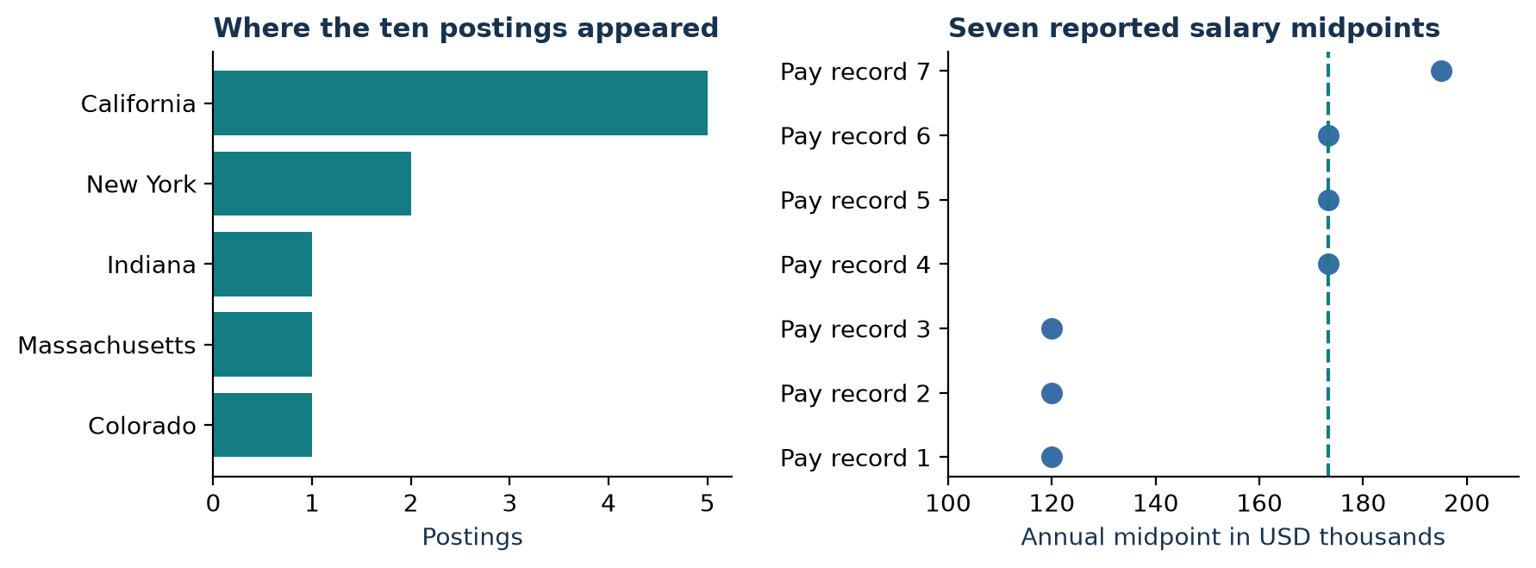
Geography for ten postings and the seven reported salary midpoints. The dashed line marks the overall salary median.

3.1 Demand and geography
Monthly counts are one in May, one in June, four in July, two in August, and two in September. These small counts do not establish market growth or seasonality. The role mix consists of four AI technical postings, two data-science-adjacent postings, and one each in core data science, machine learning, applied or decision science, and analytics engineering.
California accounts for five postings and New York for two. Colorado, Indiana, and Massachusetts contribute one each. C3 Iot, Klaviyo, and Workday have two postings apiece; Guidewire Software, Microsoft, Sigma Computing, and Theoris Group have one each. These are search leads, not employer-quality or cost-of-living-adjusted location rankings.

3.2 Pay and accessibility
All seven salary observations belong to adjacent roles. The sole core Data Scientist posting has no usable pay, so the sample cannot estimate its typical salary. Both restored skill segments have a median minimum experience requirement of five years. That result and the senior-oriented titles indicate an accessibility barrier for a recent graduate; a stronger skill match does not remove it.
The two remote postings establish only an explicitly remote share of 20% in this sample. The other eight are not confirmed onsite. We therefore avoid a remote-versus-onsite market-share claim or a remote-status classifier.

4. Skill gap analysis
One completed self-assessment was available at the analysis cutoff. We use that documented student profile for our comparison and do not infer another member’s ratings. The scale is 1 beginner, 2 basic, 3 intermediate, 4 advanced, and 5 expert. Ratings are self-reported.
For each skill, we count distinct postings in our combined skill evidence, which includes source labels and description-keyword matches. A posting share of at least 50% maps to priority 5; 40–49% to 4; 30–39% to 3; 20–29% to 2; and below 20% to 1. The priority gap equals market priority minus our rating.
Skill | Postings | Priority | Our rating | Gap
MLOps | 5/10 | 5 | 1 | 4
Machine Learning | 6/10 | 5 | 2 | 3
AWS | 4/10 | 4 | 2 | 2
Generative AI | 4/10 | 4 | 2 | 2
Python | 5/10 | 5 | 3 | 2
Data Modeling | 3/10 | 3 | 3 | 0
Data Visualization | 3/10 | 3 | 3 | 0
SQL | 3/10 | 3 | 3 | 0
This is a project-defined learning scale. Demand frequency is not an employer’s required proficiency level, so the subtraction is an ordinal planning heuristic. A zero gap does not establish qualification, and a four-point gap does not measure four units of missing ability.
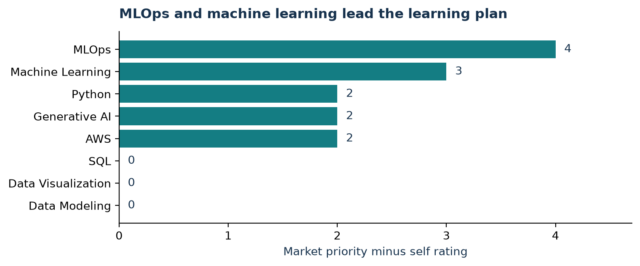
Learning priorities from combined skill evidence and our available self-assessment.

4.1 Why skill evidence sources differ
MLOps appears in five postings in the prepared skill bridge. Three postings carry an explicit source skill label, and three match the narrower NLP dictionary. The broader preparation rules also recognize MLOps within joined wording in two C3 Iot descriptions, explaining the additional combined-evidence matches. Calling all five “structured records” would be inaccurate.
Using only the three narrow text matches would lower the MLOps priority from 5 to 3 and its gap from 4 to 2. Machine Learning would then become the largest gap. Our final scorecard uses combined evidence consistently; the other seven profile skills have the same counts under the combined and narrow-text rules. The R-language correction changes none of these eight profile counts.
Our practical conclusion is to strengthen Machine Learning and MLOps, develop Python and cloud skills, and maintain SQL, Data Modeling, and Data Visualization. Requirements in a target vacancy and evidence from completed projects should guide the ordering of similar learning priorities.

5. Final analytics

5.1 Decision supported and analytical track
We use Option C, segmentation, to distinguish role families by their skill combinations and connect those differences to our student profile. The decision is which role family should guide our search and learning plan, considering skill fit, experience barriers, and reported pay. The model does not estimate hiring probability or a salary premium for individual skills.

5.2 Variables and method
Our input is the restored ten-posting panel and its prepared skill bridge. The bridge combines normalized source skill labels with controlled description-keyword matches. After removing one false R-language match, 37 skills occurring in at least three postings enter the binary feature matrix. These include technical, business, and communication skills. Each row is a posting; each feature records whether the skill appears at least once.
We use average-linkage hierarchical clustering with Jaccard distance, which compares shared skill presences without rewarding two postings for both omitting a skill. Each retained skill has equal weight. Salary, location, experience, employer identity, and our self-ratings are excluded from clustering and used for interpretation. We do not combine pay, accessibility, and fit into a weighted opportunity score.

5.3 Model selection and evaluation
We compare two, three, and four clusters. Our selection rule chooses the highest silhouette score among solutions containing at least two postings in every cluster. This rule avoids treating a single advertisement as an actionable role segment.
Clusters | Silhouette | Smallest group | Singleton groups | Selected
2 | 0.291 | 4 | 0 | Yes
3 | 0.327 | 1 | 1 | No
4 | 0.311 | 1 | 2 | No
The two-cluster solution is selected, with a silhouette of 0.291. Three clusters have the highest score, 0.327, but create a singleton. Four clusters create two singletons. Only two clusters pass the minimum-size rule.
Silhouette measures internal separation on a scale from negative one to one, with larger values indicating clearer separation and values near zero indicating overlap (scikit-learn developers, n.d.). Our result supports an exploratory comparison with overlapping skill profiles. It is not a prediction-accuracy measure or a test on unseen postings.

5.4 Result and career meaning
We name the groups after reviewing their skill patterns. The naming rule identifies the architecture group through its average prevalence of Artificial Intelligence, Machine Learning, MLOps, Solution Architecture, and Cloud Computing Architecture. These names summarize the sample; they are not externally validated occupation classes.
Segment | Postings | Salary coverage | Median pay | Median min years
Analytics and Data | 4 | 1/4 | $120,000 | 5
AI/ML Architecture | 6 | 6/6 | $173,225 | 5
Median pay is the annual advertised salary midpoint among reporting postings. Median minimum years is the median stated minimum experience requirement.
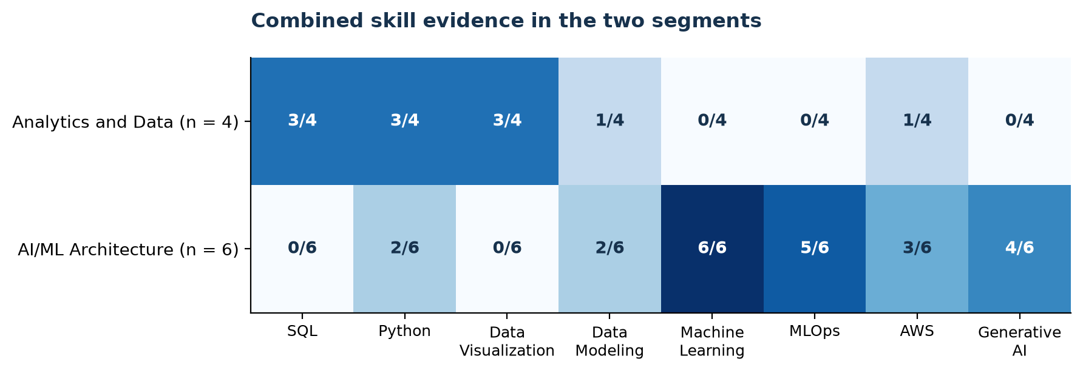
Combined skill prevalence in each segment. Cells show a posting count divided by the segment size.
SQL, Python, and Data Visualization each appear in three of four Analytics and Data postings. These skills align with our intermediate ratings. Machine Learning appears in all six AI/ML Architecture postings, MLOps in five, and Generative AI in four. That combination overlaps with our larger development needs.
We therefore recommend Analytics and Data as our nearer-term role-family search direction, with AI/ML Architecture as a longer-term learning target. Both groups require a median minimum of five years of experience. This is a relative skill-fit judgment; we still need to find early-career vacancies and check their requirements individually.
The median pay difference cannot establish a reliable segment premium. Salary coverage is six of six in AI/ML Architecture and only one of four in Analytics and Data. We cannot infer that cluster membership or a particular skill causes higher compensation.

5.5 Verification and practical limits
The unmodified preparation code reproduces the archived scores of 0.283, 0.319, and 0.305. Removing the single false R match produces the final scores of 0.291, 0.327, and 0.311. Cluster membership and all eight profile skill counts remain unchanged. Our final build also checks exact agreement with the restored feature matrix and posting assignments.
This verifies computational continuity and the effect of one extraction correction. It does not establish stability under new postings, employer changes, or other feature rules. With only ten observations, the groups remain hypotheses for organizing a career search. A new vacancy requires direct review of its responsibilities, experience, location, and pay.

6. Recommendations

6.1 Our recommended search direction
We recommend a staged career plan. First, search for early-career analytics and data roles in software publishers and match each application to demonstrated SQL, Python, modeling, and visualization work. Examples of search titles include Data Analyst, Business Intelligence Analyst, Junior Analytics Engineer, and Junior Data Scientist. These are proposed search terms, not a claim that the ten-posting sample contains those entry-level vacancies.
Treat ML engineering, MLOps, applied-science, and AI architecture work as longer-term options. The six-posting AI and ML segment signals a different skill combination, while the reported experience requirements limit immediate accessibility. Broader searches can be a next step without changing the historical scope of this project.

6.2 A practical screening process
For each vacancy, check explicit minimum experience, responsibilities, required versus preferred skills, location or remote arrangements, and disclosed compensation. Record missing information as unknown. Evaluate skills through specific artifacts and examples rather than a single readiness percentage. Compare pay only when experience level, location, and disclosure coverage are sufficiently similar.
California and New York, and the employers represented in the sample, provide starting points for exploration. Counts alone do not justify relocation, rank workplace quality, or establish current hiring activity. Verify fresh postings before investing time in an application.

6.3 Our 90 day development plan
Days 1–30: demonstrate the foundation. Refactor the market-analysis workflow into reusable Python components. Document the data model, validate joins and missing values, and present an analysis with SQL and clear visualizations. Produce a reproducible portfolio case study with an environment file and a concise account of decisions.
Days 31–60: strengthen Machine Learning and MLOps. Build a second workflow on a dataset large enough for appropriate evaluation. Track experiments, preserve model versions, and explain validation choices and limitations. Produce evaluation results, a model card, and reproducible training or analysis instructions. The current ten-posting corpus remains a descriptive case study.
Days 61–90: show deployment and applied NLP. Package one small project, demonstrate cloud storage and deployment, and improve the description skill extractor. Manually review a labeled set of job descriptions and measure extraction errors before adding synonyms. Produce a working demonstration, deployment notes, and an error analysis.

6.4 Measures of progress
Our proposed targets are two documented portfolio case studies, one cloud demonstration, and at least three revised self-ratings supported by artifacts. Course completion alone will not increase a rating. Once the first portfolio project is ready, review each cycle of 20 targeted applications to assess whether title choices, evidence, and application materials need adjustment. These are planned actions, not completed achievements or predicted outcomes.

7. Limitations
Our product supports a learning and search plan, but several limits constrain the conclusions.
Coverage and representativeness. Ten postings from one industry and five months are not a probability sample of U.S. hiring. One posting represents ten percentage points of this sample. Repeated employer and title combinations may represent related vacancies or templates. We retain the source’s industry assignments. Restoration verifies the approved cohort’s records and results but does not independently reevaluate every original title exclusion.
Accessibility and compensation. The sample is senior-oriented. A closer skill match does not establish entry-level eligibility. Seven postings disclose usable salary, all in adjacent roles, and coverage differs sharply by segment. We cannot estimate a reliable salary premium, rank employers by opportunity quality, or infer the chance of receiving an offer.
Skills and model design. Source labels and keyword rules can miss synonyms, match terms out of context, and blur required and preferred skills. The R-language correction illustrates this risk. Binary presence captures mentions rather than expected proficiency. Our gap scale is a planning heuristic based on one self-assessment. A reproduced six/four grouping and silhouette of 0.291 do not establish a general market taxonomy or out-of-sample stability.
Time and next steps. These are historical 2024 findings. Before operational use, collect a larger, recent sample within the same industry, seek more entry-level observations, review the original scope decisions, and validate skill extraction against human annotations. Update self-ratings using portfolio evidence. Preserve the versioned panel, skill bridge, code, and audit before considering predictive modeling or a weighted career scorecard.

Team contributions
Our contribution record reflects completed project work and a proposed presentation role as of October 8, 2026.
Member | Contribution | Status
Jiecheng | Project framing and literature review; data preparation and market baseline; skill-gap and NLP analysis; final analytics and verification; website and written report preparation. | Completed
Julia | Proposed role in writing and revising the final presentation slides. | Completed
The proposed presentation role will be recorded as a completed contribution after the slide work is delivered and reviewed.

Reproducibility
The website and this report share section files. Run python3 scripts/build_final_analytics.py to rebuild the final tables, skill-source comparison, figures, and validation summary from the restored panel and skill bridge. It executes the same numeric model code as our restored ML Methods page and checks exact agreement with the 37-feature matrix, posting assignments, and final candidate scores. It also reproduces the saved narrow NLP posting–skill pairs.
Run quarto render final_report.qmd --to docx to generate the Word report, then quarto render to build the website. The original preparation script, corrected script, approved cohort, and source-restoration verification record provide the upstream audit. The full-source run has already passed; rebuilding the final presentation tables does not repeat that scan or replace its verification record.

References
AD688 Group 10. (2026). Restored career market panel skill bridge and verification records.
De Mauro, A., Greco, M., Grimaldi, M., & Ritala, P. (2018). Human resources for big data professions: A systematic classification of job roles and required skill sets. Information Processing & Management, 54(5), 807–817. https://doi.org/10.1016/j.ipm.2017.05.004
Lightcast. (2024). Job postings extract used in the AD688 group 10 project.
scikit-learn developers. (n.d.). Silhouette score. Retrieved October 8, 2026, from https://scikit-learn.org/stable/modules/generated/sklearn.metrics.silhouette_score.html
U.S. Census Bureau. (2022). 2022 NAICS definition: 513210 software publishers. https://www.census.gov/naics/?details=513210&input=software&year=2022

