Module 3 Assignment: Big Data Visualization on Scale
Jiecheng Zhu
September 27, 2026
Table of contents

1. Submission Validation and Setup
This assignment uses a private API key to create one Excel workbook for your responses. The first run creates a dated workbook in research_submissions/. Later runs reuse that same workbook, so you can safely rerun this document without overwriting your work.
- Update the .env.example file in this folder with your Employability API key and rename it to .env.
- Update the EMPLOYABILITY_API_KEY value with your Employability API key from the previous step.
- Run the following code chunk to verify that your API key is working.
- Do not run the code chunk below this one until you have updated your API key.
If Quarto reports StdinNotImplementedError in prepare_workbook(), the API key was not loaded from .env. Quarto cannot answer the helper’s interactive fallback prompt, so save the real key in ~/assignment-03/.env and rerun the render command; do not place the key directly in this document.
EMPLOYABILITY_API_KEY=replace_with_your_student_api_key
EMPLOYABILITY_API_BASE_URL=https://met-employability-services.azurewebsites.net
EMPLOYABILITY_API_PATH_PREFIX=/met-career-match
RESEARCH_ASSIGNMENT_CODE=M03_A
Do not commit .env, API keys, screenshots of keys, or generated response files unless your instructor explicitly asks for them.

1.1 System Check
Operating System: Linux 7.0.0-1013-aws
Python Version: 3.12.14
Machine: x86_64
Processor:
Total Memory (MB): 908.67
Available Memory (MB): 371.3
{'captured_at': '2026-09-27T14:22:06.875229+00:00',
'hostname': 'ip-172-31-28-80',
'operating_system': 'Linux 7.0.0-1013-aws',
'python_version': '3.12.14',
'machine': 'x86_64',
'processor': '',
'aws': {'is_aws_ec2': True,
'instance_id': 'i-08e14ac9f15cea0c8',
'instance_type': 't3.micro',
'availability_zone': 'us-east-1c',
'public_hostname': 'ec2-34-229-205-164.compute-1.amazonaws.com',
'local_ipv4': '172.31.28.80'},
'memory_total_mb': 908.67,
'memory_available_mb': 371.3}

1.2 Create or Reuse Your Excel Workbook
The course announcement confirms that Individual Assignment 3 uses the research assignment code M03_A. The cell below creates a new workbook or reuses the existing workbook in research_submissions/.
Using existing workbook: research_submissions/M03_A_response_workbook_20260927_015146.xlsx
Open the generated workbook inside research_submissions/ folder, complete the Survey, Assignment, and AI Chat sheets, then save the file.

1.3 Validate Your Filled Workbook
The completed workbook is validated during rendering. Finish and save the Survey, Assignment, and AI Chat sheets before running this cell.
Workbook validation passed. No data was submitted to the course API or Django database.
Local validation report: research_submissions/M03_A_response_workbook_20260927_015146_validation.json
PosixPath('research_submissions/M03_A_response_workbook_20260927_015146_validation.json')
This validation step checks the Excel workbook locally and creates a local validation report.

2. Assignment Responses
GitHub repository: https://github.com/jz116/assignment-03
All large-scale filtering, cleaning, and aggregation is performed with Spark. Only the columns needed for a visualization, or already-aggregated results, are converted to pandas for Plotly.
If the dataset is not already present on the EC2 instance, download the current course folder with the updated link below. The download folder can contain supporting items in addition to Parquet files; the loader in Section 1.1 discovers the Parquet data recursively.
#| label: download-current-dataset
#| eval: false
mkdir -p ../data/MET_CareerCompass_2026
gdown --folder "https://drive.google.com/drive/folders/1wf3kZeUWO_0fnZJqcXZN-53l8MILX0a_?usp=sharing" \
-O ../data/MET_CareerCompass_2026

2.1 Shared Analysis Setup
from pathlib import Path
import gc
import os
import re
import numpy as np
import pandas as pd
import plotly.express as px
import plotly.graph_objects as go
import plotly.io as pio
from IPython.display import Image, Markdown, display
from pyspark.sql import SparkSession
from pyspark.sql import functions as F
from pyspark.sql.window import Window
np.random.seed(42)
OUTPUT_DIR = Path("output")
OUTPUT_DIR.mkdir(parents=True, exist_ok=True)
STATIC_EXPORT = os.getenv("AD688_STATIC_EXPORT", "0").strip() == "1"
pio.templates["ad688"] = go.layout.Template(
layout=go.Layout(
font={
"family": "Arial, Helvetica, sans-serif",
"size": 14,
"color": "#243447",
},
title={
"font": {
"family": "Arial, Helvetica, sans-serif",
"size": 24,
"color": "#0B3B6E",
},
"x": 0.5,
"xanchor": "center",
},
colorway=[
"#0B5FA5",
"#2A9D8F",
"#E67E22",
"#6C5CE7",
"#D1495B",
"#7A8B99",
],
paper_bgcolor="#FFFFFF",
plot_bgcolor="#F7F9FC",
hovermode="closest",
legend={
"bgcolor": "rgba(255,255,255,0.88)",
"bordercolor": "#D9E2EC",
"borderwidth": 1,
},
xaxis={
"showgrid": False,
"linecolor": "#AAB7C4",
"title_font": {"size": 15},
},
yaxis={
"showgrid": True,
"gridcolor": "#D9E2EC",
"zeroline": False,
"title_font": {"size": 15},
},
margin={"l": 80, "r": 40, "t": 90, "b": 80},
)
)
pio.templates.default = "ad688"
pio.renderers.default = "notebook"
def export_and_display_figure(fig, name, width=1200, height=700, scale=1):
"""Save interactive HTML and display an interactive or static figure."""
html_path = OUTPUT_DIR / f"{name}.html"
png_path = OUTPUT_DIR / f"{name}.png"
fig.write_html(
str(html_path),
full_html=True,
include_plotlyjs="cdn",
)
if not STATIC_EXPORT:
display(fig)
return
try:
fig.write_image(
str(png_path),
width=width,
height=height,
scale=scale,
)
display(Image(filename=str(png_path)))
except Exception as exc:
print(f"Static export failed for {name}: {exc}")
print("Displaying the interactive Plotly figure instead.")
display(fig)
def stratified_plot_sample(
spark_df,
group_column,
selected_columns,
maximum_rows_per_group,
seed=42,
):
"""Collect a bounded stratified sample while leaving full data in Spark."""
group_count_rows = spark_df.groupBy(group_column).count().collect()
sampling_fractions = {}
target_rows = 0
for row in group_count_rows:
group_value = row[group_column]
group_count = int(row["count"])
if group_value is None or group_count <= 0:
continue
target_count = min(maximum_rows_per_group, group_count)
sampling_fractions[group_value] = target_count / group_count
target_rows += target_count
if not sampling_fractions:
return pd.DataFrame(columns=selected_columns)
sample_pdf = (
spark_df
.sampleBy(group_column, fractions=sampling_fractions, seed=seed)
.select(*selected_columns)
.toPandas()
)
print(
f"Plot sample collected: {len(sample_pdf):,} rows "
f"(target approximately {target_rows:,})."
)
return sample_pdf
def display_two_sentence_insight(sentence_one, sentence_two):
display(Markdown(f"**Key insights.** {sentence_one} {sentence_two}"))
def safe_file_name(value):
cleaned = re.sub(r"[^a-z0-9]+", "_", value.lower())
return cleaned.strip("_")

3. 1. Load and Clean the Dataset

3.1 1.1 Load the Raw Dataset
The updated course download contains 33 top-level items: 21 current job-data Parquet files named jobs_2026_part_00001.parquet through jobs_2026_part_00021.parquet, plus 12 coverage, change-log, manifest, verification, README, and provenance files. The code below locates every Parquet file, including files placed in nested directories, and reports the complete folder inventory before loading only the job-data partitions into a distributed Spark DataFrame.
spark = (
SparkSession.builder
.appName("AD688-Assignment03")
.config("spark.sql.shuffle.partitions", "16")
.getOrCreate()
)
data_candidates = [
Path("../data/MET_CareerCompass_2026"),
Path("data/MET_CareerCompass_2026"),
Path("MET_CareerCompass_2026"),
]
dataset_dir = None
parquet_files = []
for candidate in data_candidates:
if not candidate.exists():
continue
candidate_parquet_files = sorted(
path for path in candidate.rglob("*.parquet") if path.is_file()
)
if candidate_parquet_files:
dataset_dir = candidate.resolve()
parquet_files = candidate_parquet_files
break
if dataset_dir is None:
raise FileNotFoundError(
"No Parquet files were found in MET_CareerCompass_2026. Expected the "
"folder in ../data, data/, or the repository root."
)
top_level_items = list(dataset_dir.iterdir())
all_files = [path for path in dataset_dir.rglob("*") if path.is_file()]
support_file_count = len(all_files) - len(parquet_files)
parquet_paths = [str(path.resolve()) for path in parquet_files]
df = spark.read.parquet(*parquet_paths)
df.createOrReplaceTempView("job_postings")
print(f"Dataset directory: {dataset_dir}")
print(f"Top-level items found: {len(top_level_items)}")
print(f"Files found recursively: {len(all_files)}")
print(f"Parquet files loaded: {len(parquet_files)}")
print(f"Non-Parquet support files ignored: {support_file_count}")
print(f"Columns available: {len(df.columns)}")
if len(parquet_files) == 21:
print("Current package check passed: all 21 Parquet files were found.")
else:
print(
"Package notice: the current course download normally contains 21 "
f"Parquet files, but {len(parquet_files)} were found."
)
Dataset directory: /home/ubuntu/data/MET_CareerCompass_2026
Top-level items found: 33
Files found recursively: 33
Parquet files loaded: 21
Non-Parquet support files ignored: 12
Columns available: 134
Current package check passed: all 21 Parquet files were found.
The loader selects the 21 Parquet partitions and ignores the 12 supporting files, so manifests and provenance records cannot be mistaken for job postings. It reports a notice rather than terminating if a later course release changes the partition count, while Spark keeps the full raw dataset out of EC2 driver memory.

3.2 1.2 Cast Salary and Experience Columns
numeric_columns = [
"SALARY_FROM",
"SALARY_TO",
"SALARY",
"MIN_YEARS_EXPERIENCE",
"MAX_YEARS_EXPERIENCE",
]
clean_df = df
for column_name in numeric_columns:
numeric_expression = (
f"try_cast(regexp_replace(trim(`{column_name}`), '[,$]', '') as double)"
)
clean_df = clean_df.withColumn(
column_name,
F.expr(numeric_expression),
)
The salary and experience fields are converted from strings to numeric values so they can be summarized and visualized correctly. try_cast safely converts malformed or structured salary strings to missing values instead of stopping the Spark job.

3.3 1.3 Compute Medians and Impute Missing Salaries
median_row = clean_df.agg(
F.percentile_approx("SALARY_FROM", 0.5).alias("median_from"),
F.percentile_approx("SALARY_TO", 0.5).alias("median_to"),
F.percentile_approx("SALARY", 0.5).alias("median_salary"),
).first()
median_from = median_row["median_from"]
median_to = median_row["median_to"]
median_salary = median_row["median_salary"]
print("Medians:", median_from, median_to, median_salary)
if median_from is None or median_to is None:
raise ValueError("Salary-bound medians could not be calculated.")
clean_df = (
clean_df
.withColumn(
"SALARY_FROM",
F.when(
F.col("SALARY_FROM").isNull() | (F.col("SALARY_FROM") <= 0),
F.lit(float(median_from)),
).otherwise(F.col("SALARY_FROM")),
)
.withColumn(
"SALARY_TO",
F.when(
F.col("SALARY_TO").isNull() | (F.col("SALARY_TO") <= 0),
F.lit(float(median_to)),
).otherwise(F.col("SALARY_TO")),
)
.withColumn(
"Average_Salary",
(F.col("SALARY_FROM") + F.col("SALARY_TO")) / 2.0,
)
.withColumn(
"SALARY",
F.coalesce(F.col("SALARY"), F.col("Average_Salary")),
)
)
salary_preview = (
clean_df
.select(
"Average_Salary",
"SALARY",
"EDUCATION_LEVELS_NAME",
"REMOTE_TYPE_NAME",
"MAX_YEARS_EXPERIENCE",
"ONET_NAME",
)
.limit(5)
.toPandas()
)
salary_preview_display = salary_preview.copy()
salary_preview_display["Average_Salary"] = [
f"${value:,.2f}" for value in salary_preview_display["Average_Salary"]
]
salary_preview_display["SALARY"] = [
f"${value:,.2f}" for value in salary_preview_display["SALARY"]
]
display(Markdown(salary_preview_display.to_markdown(index=False)))
Medians: 62354.0 79040.0 75500.0
Average_Salary | SALARY | EDUCATION_LEVELS_NAME | REMOTE_TYPE_NAME | MAX_YEARS_EXPERIENCE | ONET_NAME
$100,000.00 | $100,000.00 | [“Bachelor’s degree”, “Master’s degree”] | Hybrid | nan | Models
$70,697.00 | $70,697.00 | [“High school diploma or equivalent”] | nan | 1 | Registered Nurses
$70,697.00 | $70,697.00 | [“High school diploma or equivalent”] | nan | 1 | Actors
$162,700.00 | $162,700.00 | [“High school diploma or equivalent”] | nan | 1 | Software Developers
$70,697.00 | $70,697.00 | [“High school diploma or equivalent”] | nan | 1 | Models
The median advertised salary bounds are used to replace missing or zero lower and upper salary values before calculating a row-level average salary. This approach retains incomplete postings for analysis, although imputed observations should be interpreted cautiously because they reduce some of the natural salary variation.

3.4 1.4 Clean the Education Column
clean_df = clean_df.withColumn(
"EDUCATION_LEVELS_NAME",
F.trim(
F.regexp_replace(
F.regexp_replace(
F.col("EDUCATION_LEVELS_NAME"),
r"[\r\n]+",
" ",
),
r"\\[nr]",
" ",
)
),
)
education_preview = (
clean_df
.select(
"Average_Salary",
"SALARY",
"EDUCATION_LEVELS_NAME",
"REMOTE_TYPE_NAME",
"MAX_YEARS_EXPERIENCE",
"ONET_NAME",
)
.limit(5)
.toPandas()
)
education_preview_display = education_preview.copy()
education_preview_display["Average_Salary"] = [
f"${value:,.2f}" for value in education_preview_display["Average_Salary"]
]
education_preview_display["SALARY"] = [
f"${value:,.2f}" for value in education_preview_display["SALARY"]
]
display(Markdown(education_preview_display.to_markdown(index=False)))
Average_Salary | SALARY | EDUCATION_LEVELS_NAME | REMOTE_TYPE_NAME | MAX_YEARS_EXPERIENCE | ONET_NAME
$100,000.00 | $100,000.00 | [“Bachelor’s degree”, “Master’s degree”] | Hybrid | nan | Models
$70,697.00 | $70,697.00 | [“High school diploma or equivalent”] | nan | 1 | Registered Nurses
$70,697.00 | $70,697.00 | [“High school diploma or equivalent”] | nan | 1 | Actors
$162,700.00 | $162,700.00 | [“High school diploma or equivalent”] | nan | 1 | Software Developers
$70,697.00 | $70,697.00 | [“High school diploma or equivalent”] | nan | 1 | Models
Removing newline and carriage-return characters standardizes education labels and prevents visually identical categories from being separated during grouping. The list-like structure is retained because a posting can identify more than one acceptable education level.

3.5 1.5 Export the Cleaned Data
cleaned_output_path = Path("../data/MET_CareerCompass_2026_cleaned")
rows_retained = clean_df.count()
(
clean_df.write
.mode("overwrite")
.parquet(str(cleaned_output_path.resolve()))
)
print(f"Data cleaning complete. Rows retained: {rows_retained}")
print(f"Cleaned data exported to: {cleaned_output_path.resolve()}")
Data cleaning complete. Rows retained: 504208
Cleaned data exported to: /home/ubuntu/data/MET_CareerCompass_2026_cleaned
The cleaning workflow retains the available job postings while standardizing the salary, experience, and education fields required in later sections. Saving the result as Parquet provides an efficient reusable dataset without adding the large files to Git.

4. 2. Salary Distribution by Industry and Employment Type
salary_industry_df = (
clean_df
.filter(
F.col("SALARY_FROM").isNotNull()
& (F.col("SALARY_FROM") > 0)
& F.col("NAICS2_NAME").isNotNull()
& (F.trim(F.col("NAICS2_NAME")) != "")
)
.withColumn(
"EMPLOYMENT_TYPE_NAME",
F.when(
F.col("EMPLOYMENT_TYPE_NAME").isNull()
| (F.trim(F.col("EMPLOYMENT_TYPE_NAME")) == ""),
F.lit("Unknown"),
).otherwise(F.trim(F.col("EMPLOYMENT_TYPE_NAME"))),
)
.withColumn(
"_Plot_Group",
F.concat_ws(
" | ",
F.col("NAICS2_NAME"),
F.col("EMPLOYMENT_TYPE_NAME"),
),
)
)
salary_distribution_summary = (
salary_industry_df
.groupBy("NAICS2_NAME", "EMPLOYMENT_TYPE_NAME")
.agg(
F.count("*").alias("Job_Postings"),
F.percentile_approx("SALARY_FROM", 0.25).alias("Q1_Salary"),
F.percentile_approx("SALARY_FROM", 0.50).alias("Median_Salary"),
F.percentile_approx("SALARY_FROM", 0.75).alias("Q3_Salary"),
)
)
industry_order_rows = (
salary_industry_df
.groupBy("NAICS2_NAME")
.agg(
F.percentile_approx("SALARY_FROM", 0.50).alias("Industry_Median")
)
.orderBy(F.desc("Industry_Median"))
.collect()
)
industry_order = [row["NAICS2_NAME"] for row in industry_order_rows]
salary_industry_pdf = stratified_plot_sample(
salary_industry_df,
group_column="_Plot_Group",
selected_columns=[
"NAICS2_NAME",
"SALARY_FROM",
"EMPLOYMENT_TYPE_NAME",
],
maximum_rows_per_group=600,
)
salary_minimum = salary_industry_pdf["SALARY_FROM"].min()
salary_maximum = salary_industry_pdf["SALARY_FROM"].max()
use_industry_log_scale = (
salary_minimum > 0
and salary_maximum / salary_minimum > 100
)
industry_box = px.box(
salary_industry_pdf,
x="NAICS2_NAME",
y="SALARY_FROM",
color="EMPLOYMENT_TYPE_NAME",
category_orders={"NAICS2_NAME": industry_order},
points="outliers",
log_y=use_industry_log_scale,
title="Starting Salary Distribution by Industry and Employment Type",
labels={
"NAICS2_NAME": "NAICS Industry",
"SALARY_FROM": "Starting Salary",
"EMPLOYMENT_TYPE_NAME": "Employment Type",
},
)
industry_box.update_layout(
template="ad688",
height=850,
boxmode="group",
legend={
"orientation": "h",
"y": 1.12,
"x": 0.5,
"xanchor": "center",
"title": {"text": "Employment Type"},
},
margin={"l": 90, "r": 40, "t": 140, "b": 280},
)
industry_box.update_xaxes(tickangle=-40, showgrid=False)
industry_box.update_yaxes(
title_text=(
"Starting Salary (USD, logarithmic scale)"
if use_industry_log_scale
else "Starting Salary (USD)"
),
tickprefix="$",
tickformat=",.0f",
)
industry_box.update_traces(
marker={"size": 5, "opacity": 0.60},
line={"width": 1.3},
)
industry_box.add_annotation(
text=(
"Each industry/employment group is capped at approximately 600 "
"displayed observations; reported medians use the full Spark data."
),
xref="paper",
yref="paper",
x=1,
y=-0.38,
showarrow=False,
font={"size": 11, "color": "#5B6770"},
)
export_and_display_figure(
industry_box,
"salary_distribution_by_industry_employment_type",
width=1500,
height=950,
)
top_industry_row = industry_order_rows[0]
top_employment_row = (
salary_industry_df
.groupBy("EMPLOYMENT_TYPE_NAME")
.agg(F.percentile_approx("SALARY_FROM", 0.50).alias("Median_Salary"))
.orderBy(F.desc("Median_Salary"))
.first()
)
display_two_sentence_insight(
(
f"{top_industry_row['NAICS2_NAME']} has the highest median starting "
f"salary at approximately ${top_industry_row['Industry_Median']:,.0f}."
),
(
f"Among employment types, {top_employment_row['EMPLOYMENT_TYPE_NAME']} "
f"has the highest median starting salary at approximately "
f"${top_employment_row['Median_Salary']:,.0f}; the "
f"{'logarithmic' if use_industry_log_scale else 'linear'} scale keeps "
"the cross-industry comparison readable."
),
)
del salary_industry_pdf
del industry_box
gc.collect()
Plot sample collected: 90,330 rows (target approximately 90,023).
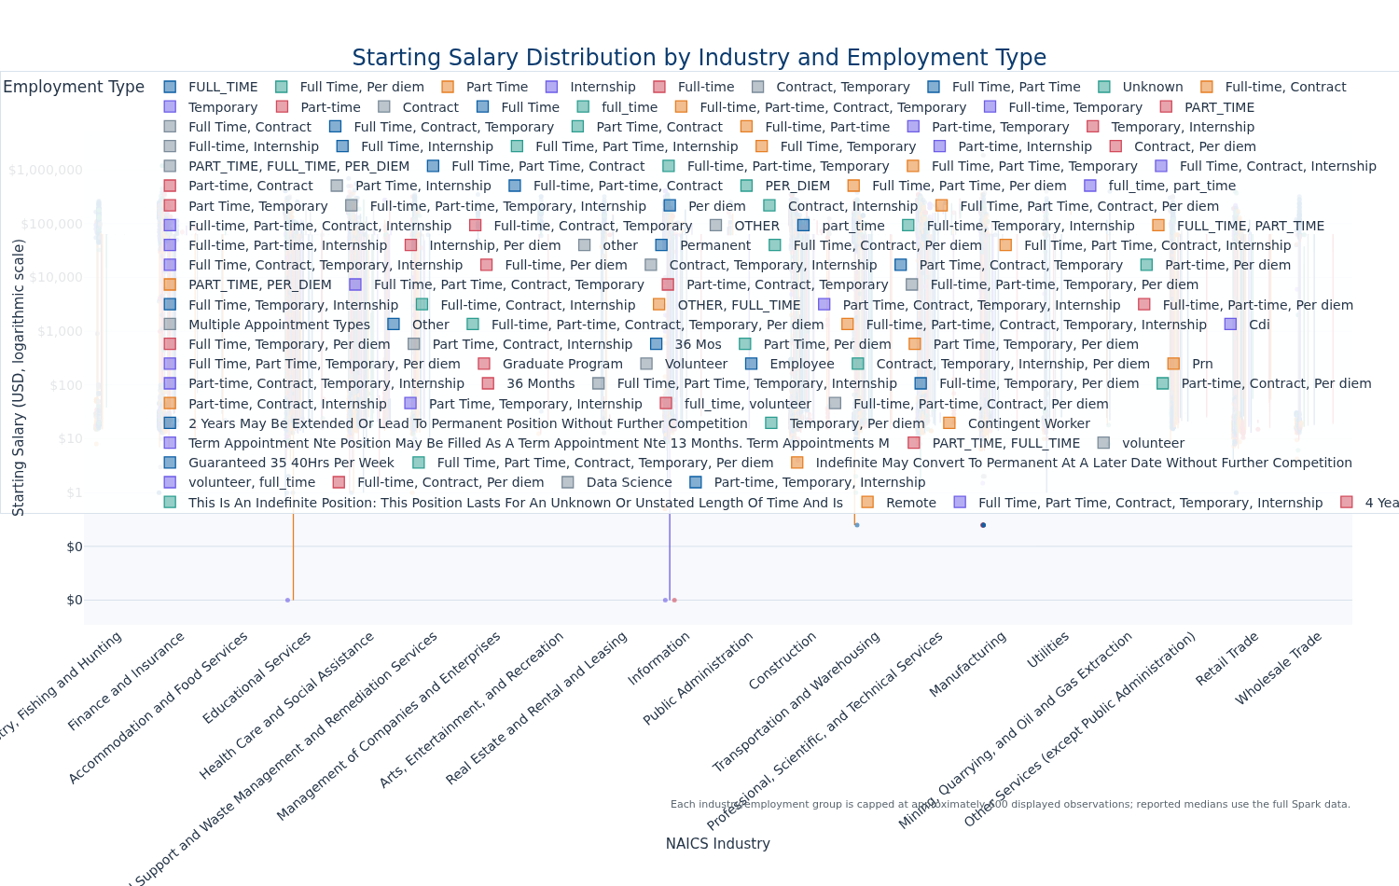
Key insights. Agriculture, Forestry, Fishing and Hunting has the highest median starting salary at approximately $62,354. Among employment types, Investment Banking has the highest median starting salary at approximately $400,000; the logarithmic scale keeps the cross-industry comparison readable.
5772

5. 3. Salary Analysis by ONET Occupation Type
onet_salary_df = (
clean_df
.filter(
F.col("ONET_NAME").isNotNull()
& (F.trim(F.col("ONET_NAME")) != "")
& F.col("SALARY").isNotNull()
& (F.col("SALARY") > 0)
)
.groupBy("ONET_NAME")
.agg(
F.percentile_approx("SALARY", 0.50).alias("Median_Salary"),
F.count("*").alias("Job_Postings"),
)
.withColumnRenamed("ONET_NAME", "Occupation_Name")
.orderBy(F.desc("Job_Postings"), F.asc("Occupation_Name"))
.limit(10)
)
onet_salary_pdf = onet_salary_df.toPandas()
if onet_salary_pdf.empty:
raise ValueError("No usable ONET salary records were available.")
onet_bubble = px.scatter(
onet_salary_pdf,
x="Occupation_Name",
y="Median_Salary",
size="Job_Postings",
color="Job_Postings",
size_max=72,
color_continuous_scale=[
[0.00, "#DCEAF7"],
[0.35, "#65A7C9"],
[0.70, "#2A7F9E"],
[1.00, "#0B3B6E"],
],
title="Salary by ONET Occupation Type: Top 10 by Job Postings",
labels={
"Occupation_Name": "ONET Occupation",
"Median_Salary": "Median Salary",
"Job_Postings": "Job Postings",
},
hover_name="Occupation_Name",
)
bubble_minimum = onet_salary_pdf["Median_Salary"].min()
bubble_maximum = onet_salary_pdf["Median_Salary"].max()
bubble_padding = max(
(bubble_maximum - bubble_minimum) * 0.10,
bubble_minimum * 0.02,
1000,
)
onet_bubble.update_layout(
template="ad688",
height=720,
margin={"l": 90, "r": 80, "t": 100, "b": 220},
coloraxis_colorbar={"title": "Job Postings"},
)
onet_bubble.update_xaxes(tickangle=-40)
onet_bubble.update_yaxes(
range=[bubble_minimum - bubble_padding, bubble_maximum + bubble_padding],
tickprefix="$",
tickformat=",.0f",
)
onet_bubble.update_traces(
marker={"line": {"color": "#FFFFFF", "width": 1.2}, "opacity": 0.82}
)
export_and_display_figure(
onet_bubble,
"salary_by_onet_bubble_chart",
width=1300,
height=800,
)
largest_onet = onet_salary_pdf.iloc[0]
highest_salary_onet = onet_salary_pdf.loc[
onet_salary_pdf["Median_Salary"].idxmax()
]
display_two_sentence_insight(
(
f"{largest_onet['Occupation_Name']} is the most frequently represented "
f"ONET occupation with {int(largest_onet['Job_Postings']):,} postings."
),
(
f"Within the ten largest occupation groups, "
f"{highest_salary_onet['Occupation_Name']} has the highest median salary "
f"at approximately ${highest_salary_onet['Median_Salary']:,.0f}, while "
"bubble size shows how salary comparisons vary in market coverage."
),
)
del onet_salary_pdf
del onet_bubble
gc.collect()
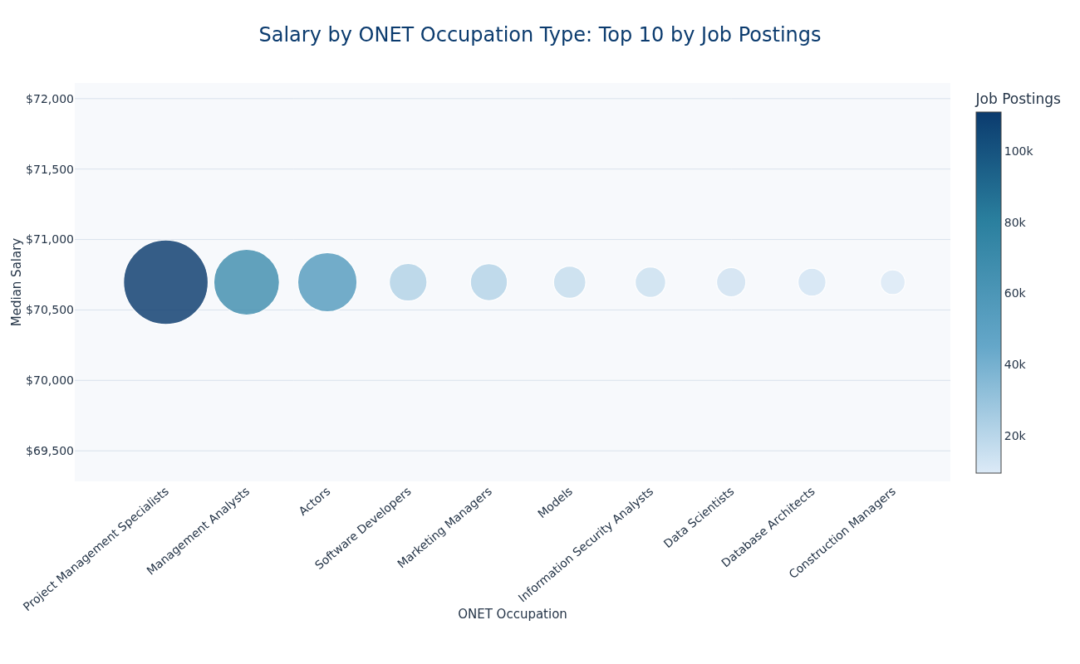
Key insights. Project Management Specialists is the most frequently represented ONET occupation with 110,911 postings. Within the ten largest occupation groups, Project Management Specialists has the highest median salary at approximately $70,697, while bubble size shows how salary comparisons vary in market coverage.
883

6. 4. Salary by Education Level
The assignment prompt says “two groups” but lists four education categories; therefore, the analysis creates all four requested groups. When a posting lists multiple degrees, it is assigned to the highest detected education level so that it appears in only one group.
education_text = F.lower(
F.coalesce(F.col("EDUCATION_LEVELS_NAME"), F.lit(""))
)
education_analysis_df = (
clean_df
.withColumn(
"Education_Group",
F.when(
education_text.rlike(r"ph\.?d|doctor|professional degree"),
F.lit("PhD"),
)
.when(
education_text.rlike(r"master"),
F.lit("Master's"),
)
.when(
education_text.rlike(r"bachelor"),
F.lit("Bachelor's"),
)
.when(
education_text.rlike(
r"associate|ged|high school|secondary school|no education"
),
F.lit("Associate's or lower"),
),
)
.withColumn(
"ONET_NAME",
F.when(
F.col("ONET_NAME").isNull()
| (F.trim(F.col("ONET_NAME")) == ""),
F.lit("Unknown ONET occupation"),
).otherwise(F.trim(F.col("ONET_NAME"))),
)
.filter(
F.col("Education_Group").isNotNull()
& F.col("MAX_YEARS_EXPERIENCE").isNotNull()
& (F.col("MAX_YEARS_EXPERIENCE") >= 0)
& F.col("Average_Salary").isNotNull()
& (F.col("Average_Salary") > 0)
)
.withColumn(
"Experience_Jittered",
F.col("MAX_YEARS_EXPERIENCE") + ((F.rand(42) - 0.5) * 0.30),
)
)
education_summary_rows = (
education_analysis_df
.groupBy("Education_Group")
.agg(
F.count("*").alias("Job_Postings"),
F.percentile_approx("Average_Salary", 0.50).alias("Median_Salary"),
F.percentile_approx("MAX_YEARS_EXPERIENCE", 0.50).alias(
"Median_Experience"
),
)
.collect()
)
education_summary = {}
for row in education_summary_rows:
education_summary[row["Education_Group"]] = row.asDict()
education_occupation_window = Window.partitionBy("Education_Group").orderBy(
F.desc("Job_Postings"),
F.asc("ONET_NAME"),
)
education_top_occupation_rows = (
education_analysis_df
.groupBy("Education_Group", "ONET_NAME")
.agg(F.count("*").alias("Job_Postings"))
.withColumn(
"Occupation_Rank",
F.row_number().over(education_occupation_window),
)
.filter(F.col("Occupation_Rank") == 1)
.collect()
)
education_top_occupations = {}
for row in education_top_occupation_rows:
education_top_occupations[row["Education_Group"]] = row["ONET_NAME"]
education_plot_pdf = stratified_plot_sample(
education_analysis_df,
group_column="Education_Group",
selected_columns=[
"Education_Group",
"MAX_YEARS_EXPERIENCE",
"Experience_Jittered",
"Average_Salary",
"ONET_NAME",
],
maximum_rows_per_group=4000,
)
if education_plot_pdf.empty:
raise ValueError("No usable education-level records were available.")
education_colors = {
"Associate's or lower": "#2A9D8F",
"Bachelor's": "#0B5FA5",
"Master's": "#E67E22",
"PhD": "#6C5CE7",
}
education_groups = [
"Associate's or lower",
"Bachelor's",
"Master's",
"PhD",
]
education_salary_min = education_plot_pdf["Average_Salary"].min()
education_salary_max = education_plot_pdf["Average_Salary"].max()
education_log_scale = (
education_salary_min > 0
and education_salary_max / education_salary_min > 100
)
education_experience_range = [
education_plot_pdf["Experience_Jittered"].min() - 0.5,
education_plot_pdf["Experience_Jittered"].max() + 0.5,
]
if education_log_scale:
education_salary_range = [
np.log10(education_salary_min) - 0.05,
np.log10(education_salary_max) + 0.05,
]
else:
education_salary_padding = max(
(education_salary_max - education_salary_min) * 0.05,
1000,
)
education_salary_range = [
max(0, education_salary_min - education_salary_padding),
education_salary_max + education_salary_padding,
]
def plot_education_group(group_name):
group_pdf = education_plot_pdf.loc[
education_plot_pdf["Education_Group"] == group_name
].copy()
if group_pdf.empty:
display(Markdown(f"**Key insights.** No usable records were available for {group_name}."))
return
education_scatter = px.scatter(
group_pdf,
x="Experience_Jittered",
y="Average_Salary",
hover_name="ONET_NAME",
custom_data=["MAX_YEARS_EXPERIENCE"],
render_mode="webgl",
log_y=education_log_scale,
title=f"Experience versus Salary: {group_name}",
labels={
"Experience_Jittered": "Maximum Years of Experience (jittered)",
"Average_Salary": "Average Salary",
},
)
education_scatter.update_traces(
marker={
"color": education_colors[group_name],
"size": 8,
"opacity": 0.55,
"line": {"color": "#FFFFFF", "width": 0.5},
},
hovertemplate=(
"<b>%{hovertext}</b><br>"
"Maximum experience: %{customdata[0]:.1f} years<br>"
"Average salary: $%{y:,.0f}<extra></extra>"
),
)
education_scatter.update_layout(
template="ad688",
height=650,
showlegend=False,
margin={"l": 90, "r": 40, "t": 90, "b": 90},
)
education_scatter.update_xaxes(range=education_experience_range)
education_scatter.update_yaxes(
range=education_salary_range,
title_text=(
"Average Salary (USD, logarithmic scale)"
if education_log_scale
else "Average Salary (USD)"
),
tickprefix="$",
tickformat=",.0f",
)
education_scatter.add_annotation(
text=(
"Horizontal jitter separates overlapping experience values; "
"up to 4,000 observations are displayed per education group."
),
xref="paper",
yref="paper",
x=1,
y=-0.18,
showarrow=False,
font={"size": 11, "color": "#5B6770"},
)
export_and_display_figure(
education_scatter,
f"education_{safe_file_name(group_name)}_scatter",
width=1200,
height=720,
)
group_summary = education_summary[group_name]
posting_count = int(group_summary["Job_Postings"])
median_salary_value = group_summary["Median_Salary"]
median_experience_value = group_summary["Median_Experience"]
top_occupation = education_top_occupations[group_name]
display_two_sentence_insight(
(
f"The {group_name} group contains {posting_count:,} postings, "
f"with a median average salary of ${median_salary_value:,.0f} and "
f"a median maximum experience requirement of "
f"{median_experience_value:.1f} years."
),
(
f"{top_occupation} is the most frequently represented ONET "
"occupation in this education group, while the jitter makes "
"overlapping experience requirements visible."
),
)
for education_group in education_groups:
plot_education_group(education_group)
del education_plot_pdf
gc.collect()
Plot sample collected: 16,180 rows (target approximately 16,000).
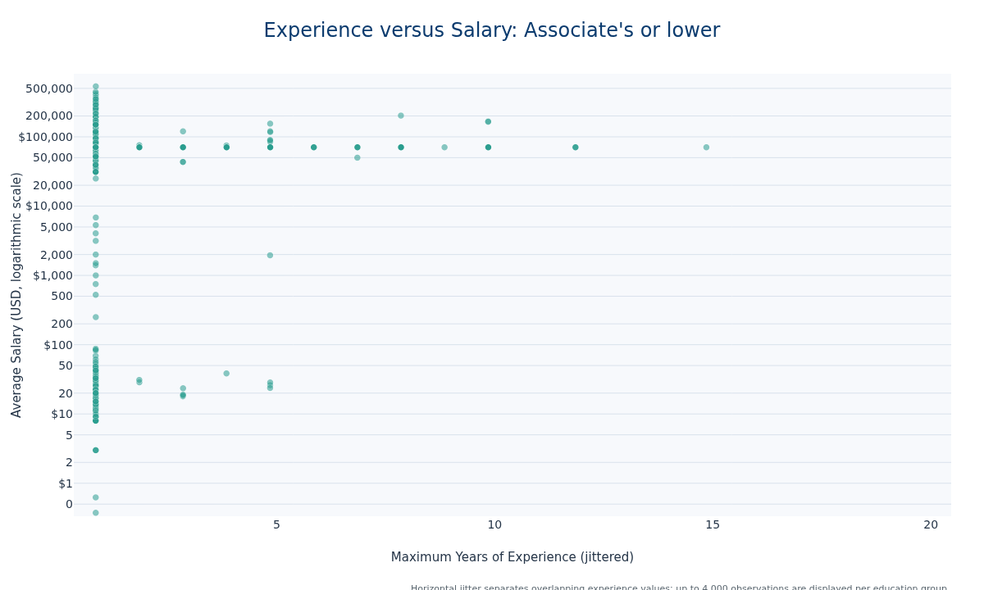
Key insights. The Associate’s or lower group contains 239,389 postings, with a median average salary of $70,697 and a median maximum experience requirement of 1.0 years. Project Management Specialists is the most frequently represented ONET occupation in this education group, while the jitter makes overlapping experience requirements visible.
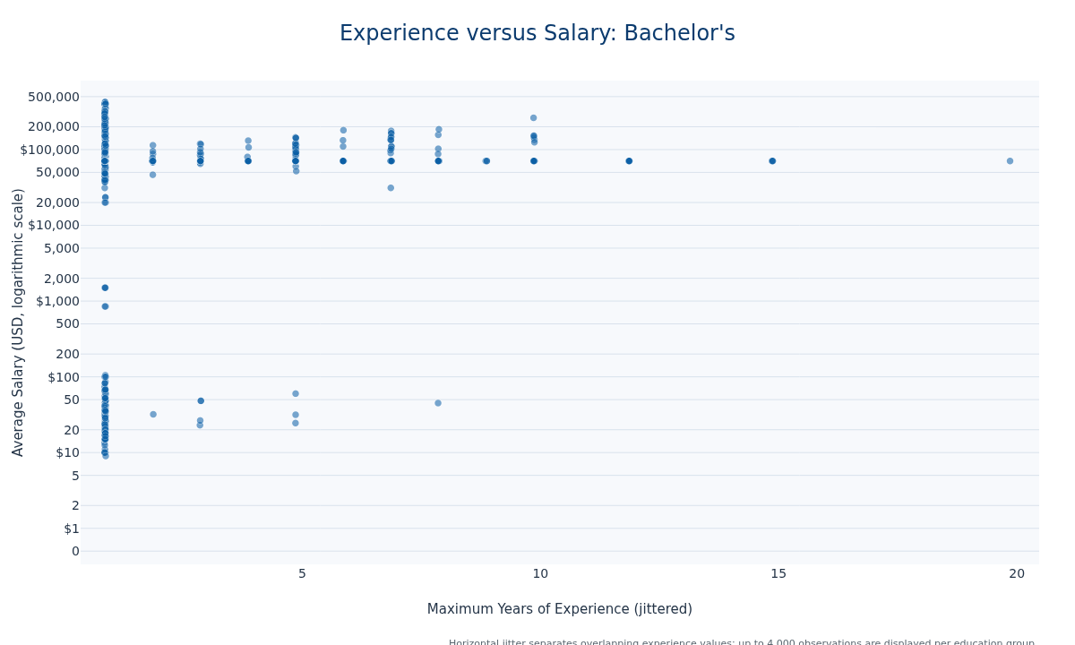
Key insights. The Bachelor’s group contains 45,533 postings, with a median average salary of $70,697 and a median maximum experience requirement of 1.0 years. Management Analysts is the most frequently represented ONET occupation in this education group, while the jitter makes overlapping experience requirements visible.
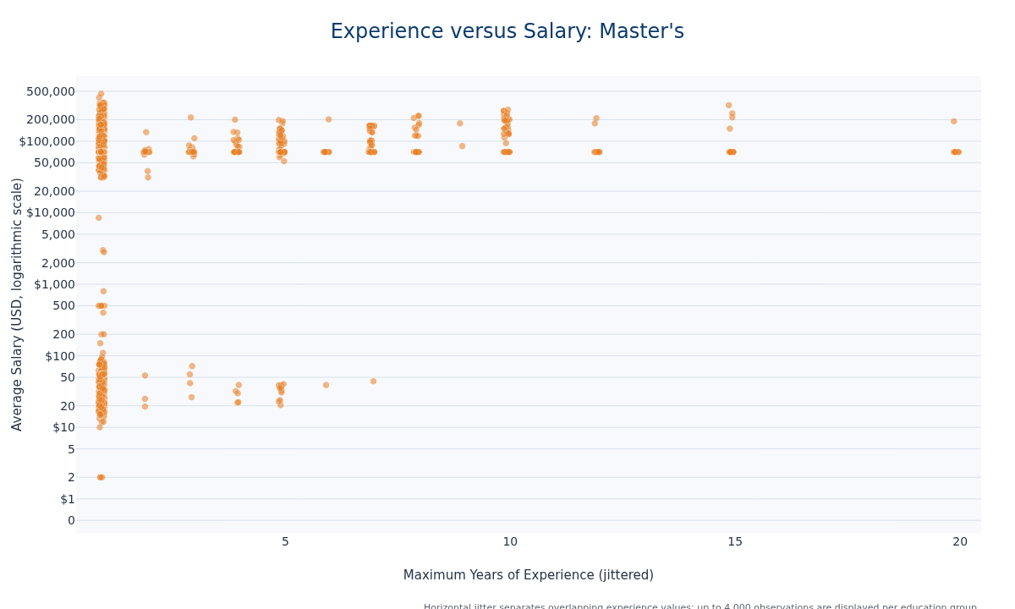
Key insights. The Master’s group contains 9,052 postings, with a median average salary of $70,697 and a median maximum experience requirement of 1.0 years. Project Management Specialists is the most frequently represented ONET occupation in this education group, while the jitter makes overlapping experience requirements visible.
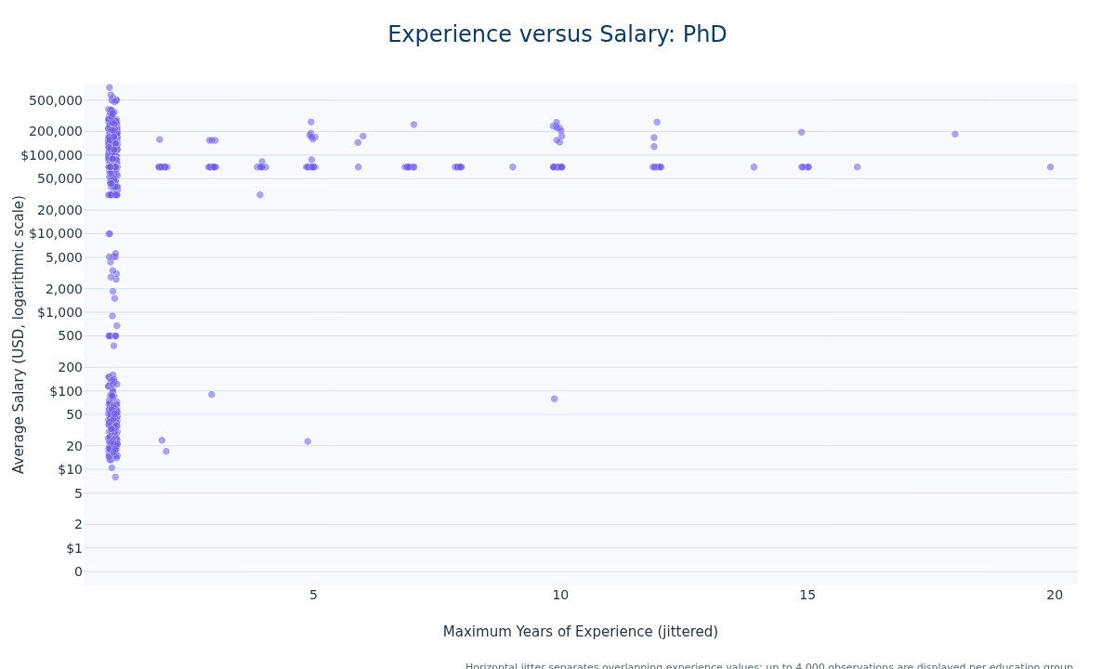
Key insights. The PhD group contains 6,469 postings, with a median average salary of $70,697 and a median maximum experience requirement of 1.0 years. Registered Nurses is the most frequently represented ONET occupation in this education group, while the jitter makes overlapping experience requirements visible.
1933

7. 5. Salary by Remote Work Type
Missing, blank, [None], Unknown, and explicitly on-site values are classified as Onsite, following the assignment instructions. Hybrid is evaluated before Remote so that labels containing both words are classified correctly.
remote_text = F.lower(
F.trim(F.coalesce(F.col("REMOTE_TYPE_NAME"), F.lit("")))
)
remote_analysis_df = (
clean_df
.withColumn(
"Remote_Group",
F.when(remote_text.contains("hybrid"), F.lit("Hybrid"))
.when(remote_text.contains("remote"), F.lit("Remote"))
.otherwise(F.lit("Onsite")),
)
.withColumn(
"ONET_NAME",
F.when(
F.col("ONET_NAME").isNull()
| (F.trim(F.col("ONET_NAME")) == ""),
F.lit("Unknown ONET occupation"),
).otherwise(F.trim(F.col("ONET_NAME"))),
)
.filter(
F.col("Average_Salary").isNotNull()
& (F.col("Average_Salary") > 0)
& F.col("MAX_YEARS_EXPERIENCE").isNotNull()
& (F.col("MAX_YEARS_EXPERIENCE") >= 0)
)
.withColumn(
"Experience_Jittered",
F.col("MAX_YEARS_EXPERIENCE") + ((F.rand(42) - 0.5) * 0.30),
)
)
remote_summary_rows = (
remote_analysis_df
.groupBy("Remote_Group")
.agg(
F.count("*").alias("Job_Postings"),
F.percentile_approx("Average_Salary", 0.25).alias("Q1_Salary"),
F.percentile_approx("Average_Salary", 0.50).alias("Median_Salary"),
F.percentile_approx("Average_Salary", 0.75).alias("Q3_Salary"),
F.percentile_approx("MAX_YEARS_EXPERIENCE", 0.50).alias(
"Median_Experience"
),
)
.orderBy(F.desc("Median_Salary"))
.collect()
)
remote_summary = {}
remote_median_ranking = []
for row in remote_summary_rows:
group_name = row["Remote_Group"]
remote_summary[group_name] = row.asDict()
remote_median_ranking.append(group_name)
remote_occupation_window = Window.partitionBy("Remote_Group").orderBy(
F.desc("Job_Postings"),
F.asc("ONET_NAME"),
)
remote_top_occupation_rows = (
remote_analysis_df
.groupBy("Remote_Group", "ONET_NAME")
.agg(F.count("*").alias("Job_Postings"))
.withColumn(
"Occupation_Rank",
F.row_number().over(remote_occupation_window),
)
.filter(F.col("Occupation_Rank") == 1)
.collect()
)
remote_top_occupations = {}
for row in remote_top_occupation_rows:
remote_top_occupations[row["Remote_Group"]] = row["ONET_NAME"]
remote_plot_pdf = stratified_plot_sample(
remote_analysis_df,
group_column="Remote_Group",
selected_columns=[
"Remote_Group",
"MAX_YEARS_EXPERIENCE",
"Experience_Jittered",
"Average_Salary",
"ONET_NAME",
],
maximum_rows_per_group=5000,
)
if remote_plot_pdf.empty:
raise ValueError("No usable remote-work records were available.")
remote_colors = {
"Remote": "#0B5FA5",
"Hybrid": "#E67E22",
"Onsite": "#2A9D8F",
}
remote_groups = ["Remote", "Hybrid", "Onsite"]
remote_salary_min = remote_plot_pdf["Average_Salary"].min()
remote_salary_max = remote_plot_pdf["Average_Salary"].max()
remote_log_scale = (
remote_salary_min > 0
and remote_salary_max / remote_salary_min > 100
)
remote_experience_range = [
remote_plot_pdf["Experience_Jittered"].min() - 0.5,
remote_plot_pdf["Experience_Jittered"].max() + 0.5,
]
if remote_log_scale:
remote_salary_range = [
np.log10(remote_salary_min) - 0.05,
np.log10(remote_salary_max) + 0.05,
]
else:
remote_salary_padding = max(
(remote_salary_max - remote_salary_min) * 0.05,
1000,
)
remote_salary_range = [
max(0, remote_salary_min - remote_salary_padding),
remote_salary_max + remote_salary_padding,
]
remote_histogram_bin_count = 30
if np.isclose(remote_salary_min, remote_salary_max):
remote_histogram_padding = max(remote_salary_min * 0.05, 1.0)
remote_histogram_bin_edges = np.array(
[
max(remote_salary_min - remote_histogram_padding, 0.01),
remote_salary_max + remote_histogram_padding,
]
)
elif remote_log_scale:
remote_histogram_bin_edges = np.geomspace(
remote_salary_min,
remote_salary_max,
remote_histogram_bin_count + 1,
)
else:
remote_histogram_bin_edges = np.linspace(
remote_salary_min,
remote_salary_max,
remote_histogram_bin_count + 1,
)
Plot sample collected: 15,067 rows (target approximately 15,000).

7.1 5.1 Experience and Salary Scatter Plots
def plot_remote_scatter(group_name):
group_pdf = remote_plot_pdf.loc[
remote_plot_pdf["Remote_Group"] == group_name
].copy()
if group_pdf.empty:
display(Markdown(f"**Key insights.** No usable records were available for {group_name}."))
return
remote_scatter = px.scatter(
group_pdf,
x="Experience_Jittered",
y="Average_Salary",
hover_name="ONET_NAME",
custom_data=["MAX_YEARS_EXPERIENCE"],
render_mode="webgl",
log_y=remote_log_scale,
title=f"Experience versus Salary: {group_name} Work",
labels={
"Experience_Jittered": "Maximum Years of Experience (jittered)",
"Average_Salary": "Average Salary",
},
)
remote_scatter.update_traces(
marker={
"color": remote_colors[group_name],
"size": 8,
"opacity": 0.55,
"line": {"color": "#FFFFFF", "width": 0.5},
},
hovertemplate=(
"<b>%{hovertext}</b><br>"
"Maximum experience: %{customdata[0]:.1f} years<br>"
"Average salary: $%{y:,.0f}<extra></extra>"
),
)
remote_scatter.update_layout(
template="ad688",
height=650,
showlegend=False,
margin={"l": 90, "r": 40, "t": 90, "b": 90},
)
remote_scatter.update_xaxes(range=remote_experience_range)
remote_scatter.update_yaxes(
range=remote_salary_range,
title_text=(
"Average Salary (USD, logarithmic scale)"
if remote_log_scale
else "Average Salary (USD)"
),
tickprefix="$",
tickformat=",.0f",
)
remote_scatter.add_annotation(
text=(
"Horizontal jitter separates overlapping experience values; "
"up to 5,000 observations are displayed per work arrangement."
),
xref="paper",
yref="paper",
x=1,
y=-0.18,
showarrow=False,
font={"size": 11, "color": "#5B6770"},
)
export_and_display_figure(
remote_scatter,
f"remote_{safe_file_name(group_name)}_scatter",
width=1200,
height=720,
)
group_summary = remote_summary[group_name]
posting_count = int(group_summary["Job_Postings"])
median_salary_value = group_summary["Median_Salary"]
median_experience_value = group_summary["Median_Experience"]
top_occupation = remote_top_occupations[group_name]
display_two_sentence_insight(
(
f"The {group_name} group contains {posting_count:,} postings, "
f"with a median average salary of ${median_salary_value:,.0f} and "
f"a median maximum experience requirement of "
f"{median_experience_value:.1f} years."
),
(
f"{top_occupation} is the most common ONET occupation in this "
"work arrangement, and the jitter reveals postings with identical "
"experience requirements."
),
)
for remote_group in remote_groups:
plot_remote_scatter(remote_group)
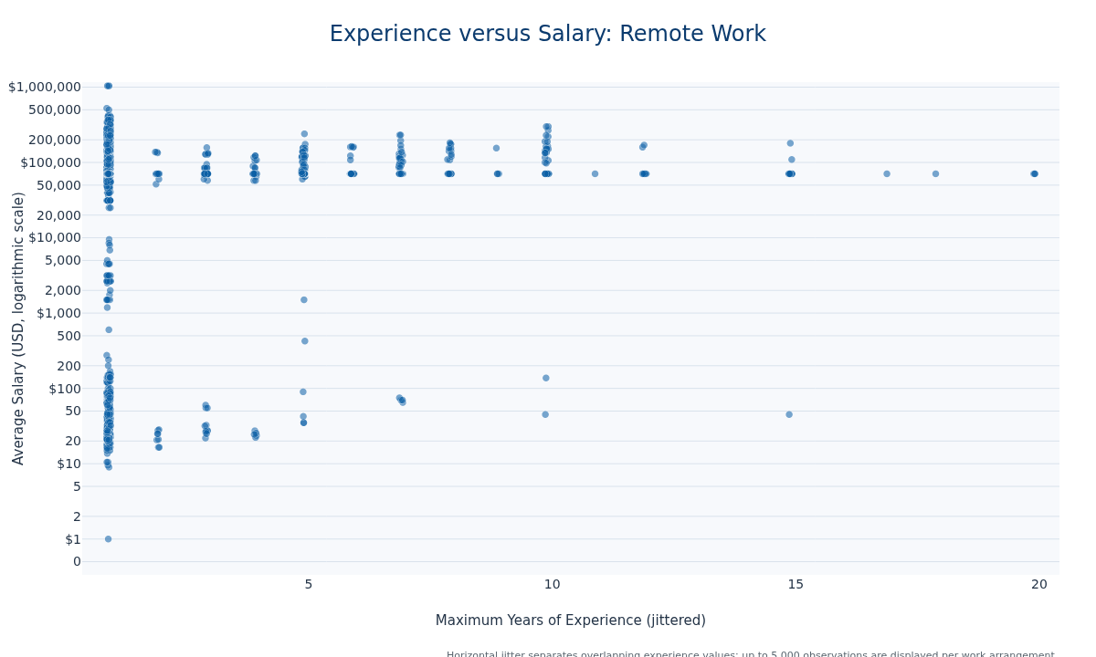
Key insights. The Remote group contains 17,800 postings, with a median average salary of $70,697 and a median maximum experience requirement of 1.0 years. Project Management Specialists is the most common ONET occupation in this work arrangement, and the jitter reveals postings with identical experience requirements.
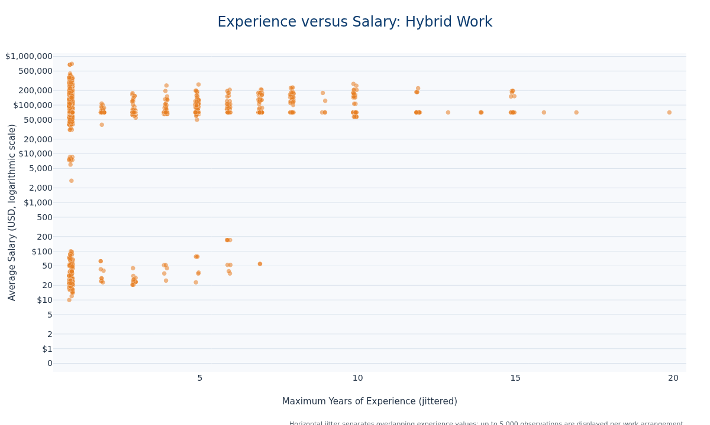
Key insights. The Hybrid group contains 12,712 postings, with a median average salary of $70,697 and a median maximum experience requirement of 1.0 years. Unknown ONET occupation is the most common ONET occupation in this work arrangement, and the jitter reveals postings with identical experience requirements.
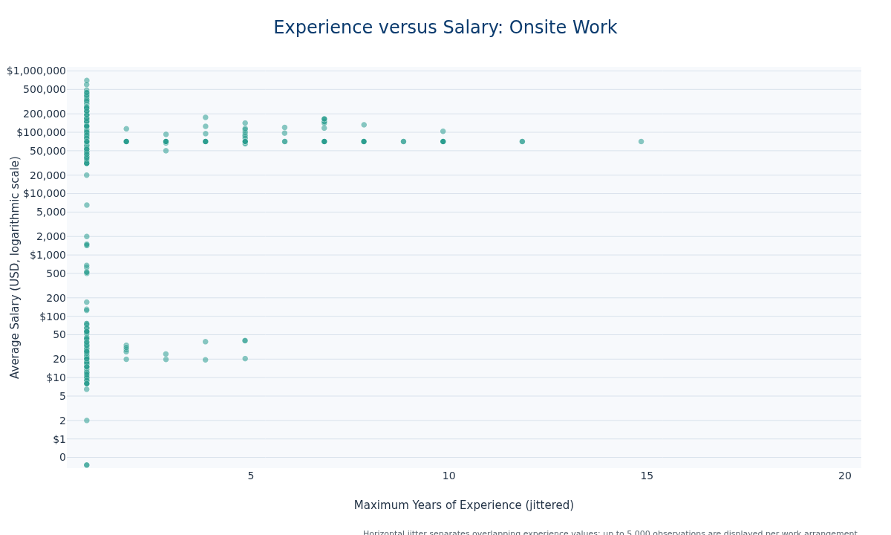
Key insights. The Onsite group contains 281,918 postings, with a median average salary of $70,697 and a median maximum experience requirement of 1.0 years. Project Management Specialists is the most common ONET occupation in this work arrangement, and the jitter reveals postings with identical experience requirements.

7.2 5.2 Salary Histograms
def plot_remote_histogram(group_name):
group_pdf = remote_plot_pdf.loc[
remote_plot_pdf["Remote_Group"] == group_name
].copy()
if group_pdf.empty:
display(Markdown(f"**Key insights.** No salary records were available for {group_name}."))
return
salary_values = pd.to_numeric(
group_pdf["Average_Salary"],
errors="coerce",
).to_numpy(dtype=float)
salary_values = salary_values[
np.isfinite(salary_values) & (salary_values > 0)
]
if salary_values.size == 0:
display(Markdown(f"**Key insights.** No valid salary values were available for {group_name}."))
return
histogram_counts, histogram_edges = np.histogram(
salary_values,
bins=remote_histogram_bin_edges,
)
nonempty_bins = histogram_counts > 0
histogram_left_edges = histogram_edges[:-1][nonempty_bins]
histogram_right_edges = histogram_edges[1:][nonempty_bins]
histogram_widths = (
histogram_right_edges - histogram_left_edges
)
if remote_log_scale:
histogram_centers = np.sqrt(
histogram_left_edges * histogram_right_edges
)
else:
histogram_centers = (
histogram_left_edges + histogram_right_edges
) / 2.0
histogram_hover_data = np.column_stack(
[histogram_left_edges, histogram_right_edges]
)
remote_histogram = go.Figure(
go.Bar(
x=histogram_centers,
y=histogram_counts[nonempty_bins],
width=histogram_widths,
customdata=histogram_hover_data,
marker={
"color": remote_colors[group_name],
"line": {"color": "#FFFFFF", "width": 0.7},
},
opacity=0.85,
hovertemplate=(
"Salary range: $%{customdata[0]:,.0f} to "
"$%{customdata[1]:,.0f}<br>"
"Job postings: %{y:,}<extra></extra>"
),
)
)
remote_histogram.update_layout(
template="ad688",
title=f"Salary Distribution: {group_name} Work",
height=560,
showlegend=False,
bargap=0.04,
xaxis_title=(
"Average Salary (USD, logarithmic scale)"
if remote_log_scale
else "Average Salary (USD)"
),
yaxis_title="Number of Job Postings",
margin={"l": 80, "r": 40, "t": 90, "b": 80},
)
remote_histogram.update_xaxes(
type="log" if remote_log_scale else "linear",
range=remote_salary_range,
tickprefix="$",
tickformat=",.0f",
)
remote_histogram.update_yaxes(rangemode="tozero")
remote_histogram.add_annotation(
text=(
"Histogram displays up to 5,000 observations for this work "
"arrangement; quartiles and medians use the full Spark data."
),
xref="paper",
yref="paper",
x=1,
y=-0.20,
showarrow=False,
font={"size": 11, "color": "#5B6770"},
)
export_and_display_figure(
remote_histogram,
f"remote_{safe_file_name(group_name)}_salary_histogram",
width=1200,
height=650,
)
group_summary = remote_summary[group_name]
median_salary_value = group_summary["Median_Salary"]
first_quartile = group_summary["Q1_Salary"]
third_quartile = group_summary["Q3_Salary"]
median_rank = remote_median_ranking.index(group_name) + 1
display_two_sentence_insight(
(
f"The {group_name} salary distribution has a median of "
f"${median_salary_value:,.0f}, with the middle 50% ranging from "
f"${first_quartile:,.0f} to ${third_quartile:,.0f}."
),
(
f"Its median ranks {median_rank} of {len(remote_median_ranking)} "
"work-arrangement groups, which provides a direct comparison with "
"the other salary distributions."
),
)
for remote_group in remote_groups:
plot_remote_histogram(remote_group)
del remote_plot_pdf
gc.collect()
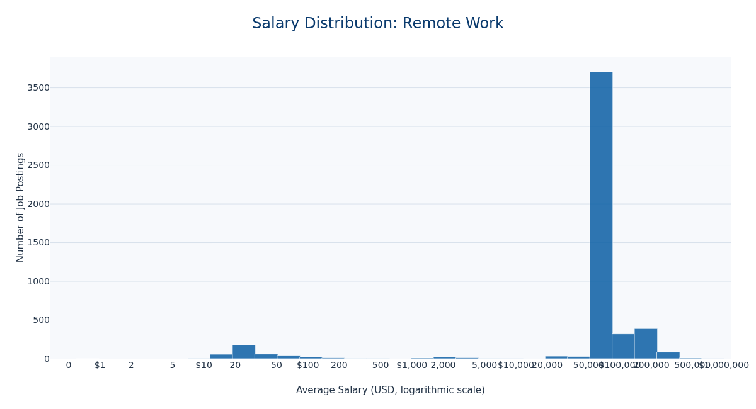
Key insights. The Remote salary distribution has a median of $70,697, with the middle 50% ranging from $70,697 to $70,697. Its median ranks 3 of 3 work-arrangement groups, which provides a direct comparison with the other salary distributions.
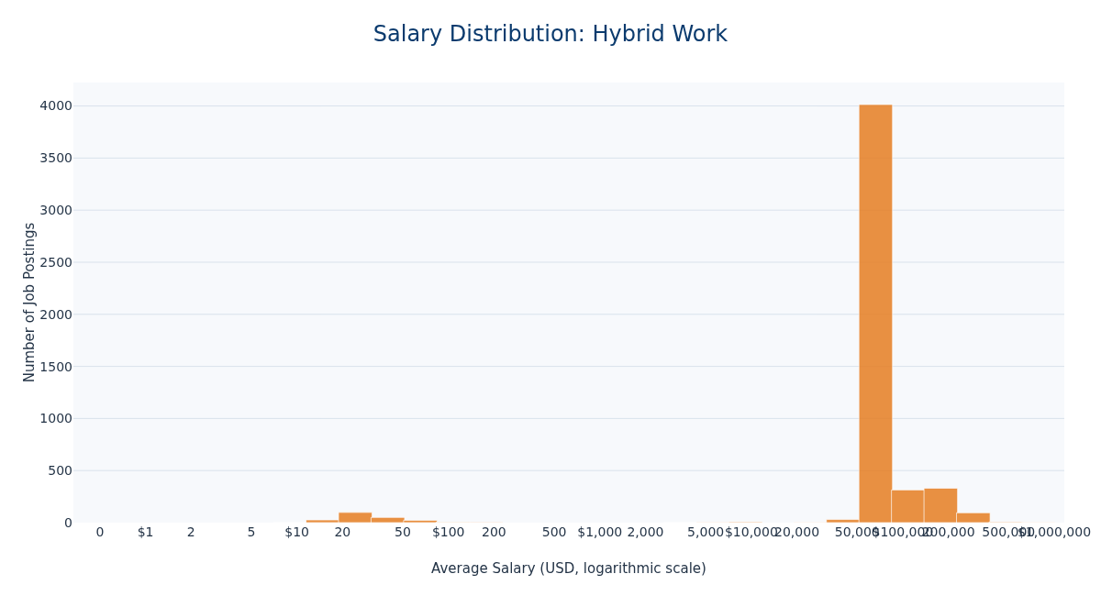
Key insights. The Hybrid salary distribution has a median of $70,697, with the middle 50% ranging from $70,697 to $70,697. Its median ranks 2 of 3 work-arrangement groups, which provides a direct comparison with the other salary distributions.
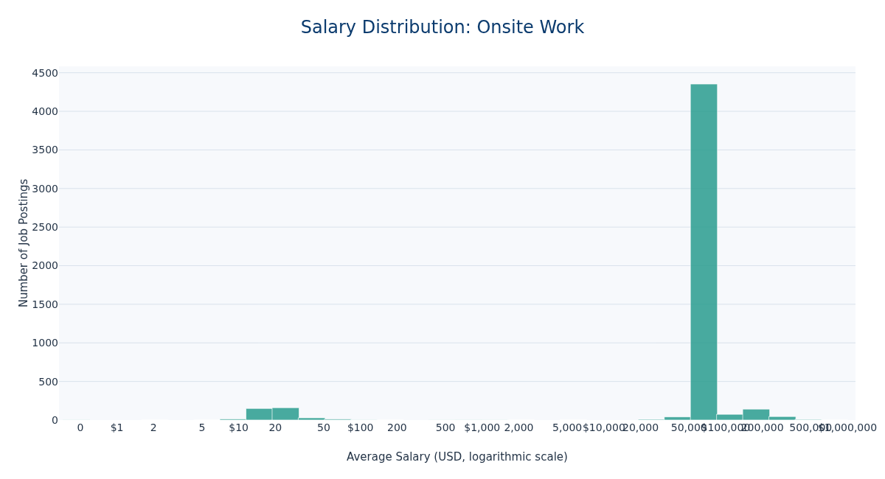
Key insights. The Onsite salary distribution has a median of $70,697, with the middle 50% ranging from $70,697 to $70,697. Its median ranks 1 of 3 work-arrangement groups, which provides a direct comparison with the other salary distributions.
3867

8. Conclusion
The Spark workflow preserves distributed processing for the full MET dataset while using pandas only for focused Plotly inputs. Together, the industry, occupation, education, experience, and remote-work analyses show how both job characteristics and market composition shape the salary patterns visible to job seekers.

