Structured Data and SQL Workflows
  - AD688 - Big Data and Cloud Analytics for Business
Jiecheng Zhu
September 20, 2026
Table of contents

1. Submission Information
GitHub repository: https://github.com/jz116/assignment-02
This report uses Apache Spark to transform the MET Employability Career Match job-postings dataset into four related tables. It then uses Spark SQL to examine technology-sector salaries, remote hiring in California, monthly posting trends, and salary differences across selected metropolitan areas. Query results are shown in tables before their required visualizations.

2. Submission Validation and Setup
This assignment uses a private API key to create one Excel workbook for the required research survey. The first run creates a dated workbook in research_submissions/. Later runs reuse that workbook.
- Put the Employability API key in .env; never paste it into this document.
- Do not commit .env, API keys, screenshots of keys, or generated survey response files unless the instructor explicitly requests them.
- Use the following structure in .env:
EMPLOYABILITY_API_KEY=replace_with_your_student_api_key
EMPLOYABILITY_API_BASE_URL=https://met-employability-services.azurewebsites.net
EMPLOYABILITY_API_PATH_PREFIX=/met-career-match
RESEARCH_ASSIGNMENT_CODE=M02_A

2.1 System Check
Operating System: Linux 7.0.0-1012-aws
Python Version: 3.14.4
Machine: x86_64
Processor:
Total Memory (MB): 908.67
Available Memory (MB): 343.32
{'captured_at': '2026-09-20T03:12:03.387501+00:00',
'hostname': 'ip-172-31-28-80',
'operating_system': 'Linux 7.0.0-1012-aws',
'python_version': '3.14.4',
'machine': 'x86_64',
'processor': '',
'aws': {'is_aws_ec2': True,
'instance_id': 'i-08e14ac9f15cea0c8',
'instance_type': 't3.micro',
'availability_zone': 'us-east-1c',
'public_hostname': 'ec2-18-215-173-242.compute-1.amazonaws.com',
'local_ipv4': '172.31.28.80'},
'memory_total_mb': 908.67,
'memory_available_mb': 343.32}

2.2 Create or Reuse the Research Workbook
Using existing workbook: research_submissions/M02_A_response_workbook_20260920_015850.xlsx
Open the generated workbook in research_submissions/, complete the Survey, Assignment, and AI Chat sheets, and save it. After the workbook is complete, change eval: false to eval: true in the validation chunk below.

3. Spark Environment and Dataset
The final submission must use all 17 Parquet partitions. USE_SAMPLE can temporarily be changed to True during development, but it is set to False here for the final analysis.
import os
import sys
from pathlib import Path
import matplotlib.pyplot as plt
import pandas as pd
import plotly.express as px
import seaborn as sns
from IPython.display import Image, Markdown, display
from matplotlib.ticker import StrMethodFormatter
from pyspark import StorageLevel
from pyspark.sql import SparkSession
from pyspark.sql import functions as F
os.environ["PYSPARK_PYTHON"] = sys.executable
os.environ["PYSPARK_DRIVER_PYTHON"] = sys.executable
# Keep Spark shuffle files on the EC2 project volume instead of the small /tmp
# partition. Add spark_work/ to .gitignore because these are temporary files.
spark_work_dir = Path("spark_work").resolve()
spark_work_dir.mkdir(parents=True, exist_ok=True)
spark = (
SparkSession.builder
.appName("JobPostingsAnalysis")
.master("local[2]")
.config("spark.driver.host", "localhost")
.config("spark.local.dir", str(spark_work_dir))
.config("spark.sql.shuffle.partitions", "8")
.config("spark.sql.adaptive.enabled", "true")
.getOrCreate()
)
spark.conf.set("spark.sql.execution.arrow.pyspark.enabled", "false")
sns.set_theme(style="whitegrid")
# Set to True only while testing. The final submission must use False.
USE_SAMPLE = False
candidate_data_dirs = [
Path("../data/MET_CareerCompass_2026"),
Path("data/MET_CareerCompass_2026"),
]
data_dir = next((path for path in candidate_data_dirs if path.exists()), None)
if data_dir is None:
searched = "\n".join(str(path) for path in candidate_data_dirs)
raise FileNotFoundError(
"MET_CareerCompass_2026 was not found. Expected one of:\n" + searched
)
parquet_files = sorted(data_dir.glob("*.parquet"))
if not parquet_files:
raise FileNotFoundError(f"No Parquet files were found in {data_dir}")
if USE_SAMPLE:
parquet_files = parquet_files[:1]
elif len(parquet_files) != 17:
print(
f"Warning: the assignment specifies 17 Parquet files, "
f"but {len(parquet_files)} were found."
)
df = spark.read.parquet(*[str(path.resolve()) for path in parquet_files])
df = df.toDF(*[column.lower() for column in df.columns])
# Keep only records with a usable posting ID and enforce one row per primary key.
df = (
df.filter(F.col("id").isNotNull() & (F.trim(F.col("id")) != ""))
.dropDuplicates(["id"])
)
print(f"Data directory: {data_dir}")
print(f"Parquet files loaded: {len(parquet_files)}")
print(f"Sample mode: {USE_SAMPLE}")
# Development-only previews; leave commented out for the rendered submission.
# df.printSchema()
# df.show(5, truncate=False)
Data directory: data/MET_CareerCompass_2026
Parquet files loaded: 17
Sample mode: False
The source columns are normalized to lowercase once after loading. The raw dataset remains outside version control.

4. Relational Table Design
The model contains three dimension tables and one job-postings fact table. Spark temporary views do not enforce primary-key or foreign-key constraints. Therefore, the workflow creates explicit surrogate keys and then checks key uniqueness and referential integrity.
Table | Primary key | Foreign keys | Purpose
companies | company_id | None | One row per distinct company record
industries | industry_id | None | One row per distinct NAICS/SOC occupation combination
locations | location_id | None | One row per distinct location and MSA combination
job_postings | id | company_id, industry_id, location_id | One row per job posting

4.1 Create Dimension Tables
The helper below creates a null-safe natural key from each dimension’s source columns. This prevents missing source values from breaking the joins used to add foreign keys to job_postings. The assignment-provided monotonically_increasing_id() function supplies each surrogate primary key.
def add_natural_key(frame, source_columns, key_name):
"""Add a repeatable, null-safe hash key based on source columns."""
key_parts = [
F.coalesce(F.trim(F.col(name).cast("string")), F.lit("<NULL>"))
for name in source_columns
]
return frame.withColumn(
key_name,
F.sha2(F.concat_ws("||", *key_parts), 256),
)
COMPANY_COLUMNS = [
"company",
"company_name",
"company_raw",
"company_is_staffing",
]
INDUSTRY_COLUMNS = [
"naics_2022_6",
"naics_2022_6_name",
"soc_5",
"soc_5_name",
"onet_name",
"soc_2_name",
]
LOCATION_COLUMNS = [
"location",
"city_name",
"state_name",
"county_name",
"msa",
"msa_name",
]
companies_lookup_df = (
add_natural_key(
df.select(*COMPANY_COLUMNS).distinct(),
COMPANY_COLUMNS,
"_company_key",
)
.withColumn("company_id", F.monotonically_increasing_id())
.persist(StorageLevel.MEMORY_AND_DISK)
)
# Materializing the lookup keeps generated IDs stable across later SQL actions.
companies_lookup_df.count()
companies_df = companies_lookup_df.select(
"company_id",
*COMPANY_COLUMNS,
)
industries_lookup_df = (
add_natural_key(
df.select(*INDUSTRY_COLUMNS).distinct(),
INDUSTRY_COLUMNS,
"_industry_key",
)
.withColumn("industry_id", F.monotonically_increasing_id())
.persist(StorageLevel.MEMORY_AND_DISK)
)
industries_lookup_df.count()
industries_df = industries_lookup_df.select(
"industry_id",
"naics_2022_6",
"naics_2022_6_name",
F.col("soc_5").alias("soc_code"),
F.col("soc_5_name").alias("soc_name"),
F.col("onet_name").alias("specialized_occupation"),
F.col("soc_2_name").alias("occupation_group"),
)
locations_lookup_df = (
add_natural_key(
df.select(*LOCATION_COLUMNS).distinct(),
LOCATION_COLUMNS,
"_location_key",
)
.withColumn("location_id", F.monotonically_increasing_id())
.persist(StorageLevel.MEMORY_AND_DISK)
)
locations_lookup_df.count()
locations_df = locations_lookup_df.select(
"location_id",
*LOCATION_COLUMNS,
)

4.2 Create the Job Postings Table
The salary-related fields arrive as strings. The helper removes dollar signs and commas and casts only valid numeric strings. Invalid or structured strings become null rather than causing the Spark job to fail.
def numeric_or_null(column_name):
cleaned = F.regexp_replace(
F.trim(F.col(column_name).cast("string")),
r"[$,]",
"",
)
numeric_pattern = r"^[+-]?(?:[0-9]+(?:\.[0-9]*)?|\.[0-9]+)$"
return F.when(cleaned.rlike(numeric_pattern), cleaned.cast("double"))
job_source_df = add_natural_key(df, COMPANY_COLUMNS, "_company_key")
job_source_df = add_natural_key(job_source_df, INDUSTRY_COLUMNS, "_industry_key")
job_source_df = add_natural_key(job_source_df, LOCATION_COLUMNS, "_location_key")
job_source_df = (
job_source_df
.join(
companies_lookup_df.select("_company_key", "company_id"),
on="_company_key",
how="left",
)
.join(
industries_lookup_df.select("_industry_key", "industry_id"),
on="_industry_key",
how="left",
)
.join(
locations_lookup_df.select("_location_key", "location_id"),
on="_location_key",
how="left",
)
)
job_postings_df = job_source_df.select(
"id",
"title_clean",
"company_id",
"industry_id",
"employment_type_name",
"remote_type_name",
"body",
numeric_or_null("min_years_experience").alias("min_years_experience"),
numeric_or_null("max_years_experience").alias("max_years_experience"),
numeric_or_null("salary").alias("salary"),
numeric_or_null("salary_from").alias("salary_from"),
numeric_or_null("salary_to").alias("salary_to"),
"location_id",
"posted",
"expired",
"duration",
)

4.3 Register Tables in Spark SQL
companies_df.createOrReplaceTempView("companies")
industries_df.createOrReplaceTempView("industries")
locations_df.createOrReplaceTempView("locations")
job_postings_df.createOrReplaceTempView("job_postings")
# The four analyses need only these columns. Persisting this column-pruned
# projection prevents Spark from rebuilding all three foreign-key joins for
# every query and avoids caching the large job-description body column.
job_postings_analysis_df = (
job_postings_df.select(
"id",
"title_clean",
"company_id",
"industry_id",
"location_id",
"remote_type_name",
"salary",
"posted",
)
.persist(StorageLevel.MEMORY_AND_DISK)
)
# Materialize the cache once. All validation and analysis queries reuse it.
job_postings_count = job_postings_analysis_df.count()
job_postings_analysis_df.createOrReplaceTempView("job_postings_analysis")
table_summary = pd.DataFrame(
{
"table": ["job_postings", "companies", "industries", "locations"],
"rows": [
job_postings_count,
companies_df.count(),
industries_df.count(),
locations_df.count(),
],
"primary_key": ["id", "company_id", "industry_id", "location_id"],
}
)
display(table_summary)
 | table | rows | primary_key
0 | job_postings | 165386 | id
1 | companies | 19104 | company_id
2 | industries | 3822 | industry_id
3 | locations | 18811 | location_id
Five-row previews confirm that the generated keys appear first in the three dimension tables. Only identifying columns are previewed from the wide job_postings table.
display(industries_df.limit(5).toPandas())
display(companies_df.limit(5).toPandas())
display(locations_df.limit(5).toPandas())
display(
job_postings_analysis_df.select(
"id",
"title_clean",
"company_id",
"industry_id",
"location_id",
)
.limit(5)
.toPandas()
)
 | industry_id | naics_2022_6 | naics_2022_6_name | soc_code | soc_name | specialized_occupation | occupation_group
0 | 0 | 624400 | Child Care Services | 13-1082 | Project Management Specialists | Project Management Specialists | Business and Financial Operations Occupations
1 | 1 | 488900 | Other Support Activities for Transportation | 13-1082 | Project Management Specialists | Project Management Specialists | Business and Financial Operations Occupations
2 | 2 | 624120 | Services for the Elderly and Persons with Disa... | 13-1111 | Management Analysts | Management Analysts | Business and Financial Operations Occupations
3 | 3 | 311000 | Food Manufacturing | 51-3011 | Bakers | Bakers | Production Occupations
4 | 4 | 488900 | Other Support Activities for Transportation | 27-2011 | Actors | Actors | Arts, Design, Entertainment, Sports, and Media...
 | company_id | company | company_name | company_raw | company_is_staffing
0 | 0 | linkedin:shoptikal | Shopko Optical | Shoptikal, LLC | False
1 | 1 | linkedin:mortenson | Mortenson | Mortenson | False
2 | 2 | linkedin:schneider-electric | Schneider Electric | Schneider Electric | False
3 | 3 | linkedin:mcclure-oil-corporation | McClure Oil Corporation | McClure Oil Corporation | False
4 | 4 | linkedin:pallet-logistics-of-america | PLA | PLA Buyer LLC | False
 | location_id | location | city_name | state_name | county_name | msa | msa_name
0 | 0 | Arlington, Virginia, United States | Virginia | United States
1 | 1 | Braselton, Georgia, United States | Georgia | United States
2 | 2 | Weslaco, Texas, United States | Texas | United States
3 | 3 | Overland Park, Kansas, United States | Kansas | United States
4 | 4 | Fairfield, Connecticut, United States | Connecticut | United States
 | id | title_clean | company_id | industry_id | location_id
0 | 100028 | LNA Hospice Aide | 25769803776 | 42949672960 | 25769803776
1 | 100140 | COMMUNITY LIAISON | 17179869186 | 0 | 51539607556
2 | 100155 | Center-Based Registered Behavior Technician | 17179869187 | 34359738370 | 8589934592
3 | 100163 | Director of Community Growth and Development | 25769803777 | 42949672963 | 25769803779
4 | 100183 | Patient Care Associate/NA | Adult Health Care | 25769803778 | 42949672960 | 25769803780

4.4 Validate Keys and Relationships
The following checks compare every row count with its distinct primary-key count and count null foreign keys in job_postings. Equal row and unique-key counts show primary-key uniqueness; zero null foreign keys show that every posting matched its dimensions.
primary_key_check_df = spark.sql(
"""
SELECT 'job_postings' AS table_name,
COUNT(*) AS row_count,
COUNT(DISTINCT id) AS unique_primary_keys,
SUM(CASE WHEN id IS NULL THEN 1 ELSE 0 END) AS null_primary_keys
FROM job_postings_analysis
UNION ALL
SELECT 'companies', COUNT(*), COUNT(DISTINCT company_id),
SUM(CASE WHEN company_id IS NULL THEN 1 ELSE 0 END)
FROM companies
UNION ALL
SELECT 'industries', COUNT(*), COUNT(DISTINCT industry_id),
SUM(CASE WHEN industry_id IS NULL THEN 1 ELSE 0 END)
FROM industries
UNION ALL
SELECT 'locations', COUNT(*), COUNT(DISTINCT location_id),
SUM(CASE WHEN location_id IS NULL THEN 1 ELSE 0 END)
FROM locations
"""
)
foreign_key_check_df = spark.sql(
"""
SELECT COUNT(*) AS job_posting_rows,
SUM(CASE WHEN company_id IS NULL THEN 1 ELSE 0 END) AS missing_company_keys,
SUM(CASE WHEN industry_id IS NULL THEN 1 ELSE 0 END) AS missing_industry_keys,
SUM(CASE WHEN location_id IS NULL THEN 1 ELSE 0 END) AS missing_location_keys
FROM job_postings_analysis
"""
)
display(primary_key_check_df.toPandas())
display(foreign_key_check_df.toPandas())
 | table_name | row_count | unique_primary_keys | null_primary_keys
0 | job_postings | 165386 | 165386 | 0
1 | companies | 19104 | 19104 | 0
2 | industries | 3822 | 3822 | 0
3 | locations | 18811 | 18811 | 0
 | job_posting_rows | missing_company_keys | missing_industry_keys | missing_location_keys
0 | 165386 | 0 | 0 | 0

4.5 Optional CSV Export
Spark writes a directory of CSV part files rather than one conventional CSV file. The export is optional and remains disabled for the final render.
industries_df.write.mode("overwrite").csv(
"./output/industries.csv",
header=True,
)
The dataset and optional output directory should be excluded in .gitignore:
data/MET_CareerCompass_2026/
MET_CareerCompass_2026/
output/industries.csv/
research_submissions/
.env
spark_work/

5. Spark SQL Analysis
Each section displays the Spark SQL result first, followed by the required visualization and a short interpretation generated from the actual result. The SQL queries use job_postings_analysis, a cached, column-pruned projection of the relational job_postings table. It contains the same posting rows and foreign keys while excluding large fields, such as body, that none of the four analyses needs.

5.1 Query 1: Technology Salaries by Specialized Occupation
Although the prompt’s heading refers to job title, its detailed instructions specify grouping by specialized_occupation. This query follows the detailed requirement and filters to NAICS 518210.
query1_df = spark.sql(
"""
SELECT
i.naics_2022_6_name AS industry_name,
i.specialized_occupation,
ROUND(PERCENTILE_APPROX(j.salary, 0.5, 10000), 2) AS median_salary,
COUNT(*) AS job_count
FROM job_postings_analysis AS j
INNER JOIN industries AS i
ON j.industry_id = i.industry_id
WHERE i.naics_2022_6 = '518210'
AND j.salary IS NOT NULL
AND j.salary > 0
AND i.specialized_occupation IS NOT NULL
AND TRIM(i.specialized_occupation) <> ''
GROUP BY
i.naics_2022_6_name,
i.specialized_occupation
ORDER BY median_salary DESC
"""
)
query1_pd = query1_df.toPandas()
display(query1_pd)
 | industry_name | specialized_occupation | median_salary | job_count
if query1_pd.empty:
display(Markdown("**Visualization note:** No qualifying Query 1 rows were returned."))
else:
query1_figure = px.bar(
query1_pd,
x="median_salary",
y="specialized_occupation",
color="industry_name",
orientation="h",
barmode="group",
title="Median Salary in NAICS 518210 by Specialized Occupation",
labels={
"median_salary": "Median Salary ($)",
"specialized_occupation": "Specialized Occupation",
"industry_name": "Industry",
},
height=max(500, 34 * len(query1_pd) + 150),
)
query1_figure.update_xaxes(tickprefix="$", tickformat=",.0f")
query1_figure.update_layout(
legend_title_text="Industry",
margin=dict(l=20, r=20, t=70, b=20),
)
query1_figure.update_yaxes(categoryorder="total ascending")
# A static Plotly image is preferred because it appears in Word output.
figures_dir = Path("figures")
figures_dir.mkdir(exist_ok=True)
query1_image = figures_dir / "query1_median_salary.png"
try:
query1_figure.write_image(
str(query1_image),
width=1200,
height=max(600, 34 * len(query1_pd) + 180),
scale=1.5,
)
display(Image(filename=str(query1_image)))
except Exception:
print(
"Static Plotly export was unavailable; displaying the interactive chart. "
"Install kaleido before the Word render if the chart is missing there."
)
query1_figure.show()
Visualization note: No qualifying Query 1 rows were returned.
Insight. No NAICS 518210 postings with a usable positive salary and specialized occupation were available in the loaded data.

5.2 Query 2: Top Five Companies Offering Remote Jobs in California
query2_df = spark.sql(
"""
SELECT
c.company_name,
COUNT(*) AS remote_jobs
FROM job_postings_analysis AS j
INNER JOIN companies AS c
ON j.company_id = c.company_id
INNER JOIN locations AS l
ON j.location_id = l.location_id
WHERE LOWER(TRIM(j.remote_type_name)) = 'remote'
AND LOWER(TRIM(l.state_name)) = 'california'
AND c.company_name IS NOT NULL
AND TRIM(c.company_name) <> ''
GROUP BY c.company_name
ORDER BY remote_jobs DESC, c.company_name ASC
LIMIT 5
"""
)
query2_pd = query2_df.toPandas()
display(query2_pd)
 | company_name | remote_jobs
0 | Servicenow | 65
1 | Sandisk | 40
2 | Westerndigital | 40
3 | Block | 37
4 | Renesaselectronics | 27
if query2_pd.empty:
display(Markdown("**Visualization note:** No qualifying Query 2 rows were returned."))
else:
plt.figure(figsize=(10, 6))
query2_axis = sns.barplot(
data=query2_pd,
x="company_name",
y="remote_jobs",
color="#4C78A8",
)
query2_axis.set_title("Top Five Companies Offering Remote Jobs in California")
query2_axis.set_xlabel("Company Name")
query2_axis.set_ylabel("Number of Remote Job Postings")
query2_axis.tick_params(axis="x", rotation=35)
plt.tight_layout()
plt.show()
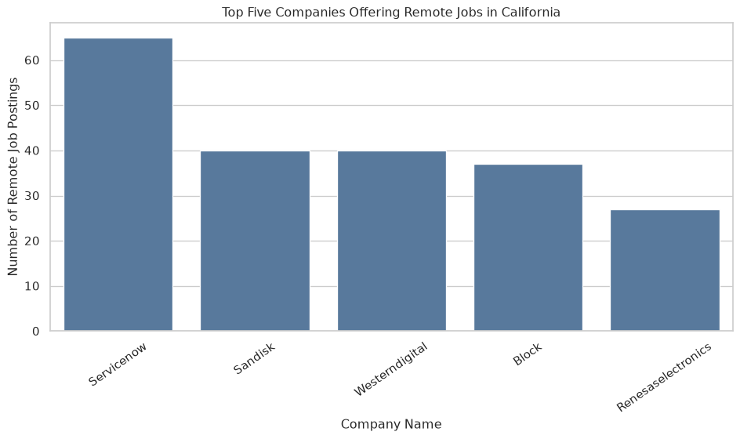
Insight. Servicenow ranked first with 65 remote California postings. It accounted for 31.1% of the postings represented by the five companies in this result, showing how concentrated remote hiring was among the leading employers.

5.3 Query 3: Monthly Job-Posting Trends in California
query3_df = spark.sql(
"""
WITH california_postings AS (
SELECT TO_DATE(j.posted, 'yyyy-MM-dd') AS posted_date
FROM job_postings_analysis AS j
INNER JOIN locations AS l
ON j.location_id = l.location_id
WHERE LOWER(TRIM(l.state_name)) = 'california'
)
SELECT
YEAR(posted_date) AS year,
MONTH(posted_date) AS month,
COUNT(*) AS job_count
FROM california_postings
WHERE posted_date IS NOT NULL
GROUP BY
YEAR(posted_date),
MONTH(posted_date)
ORDER BY year DESC, month DESC
"""
)
query3_pd = query3_df.toPandas()
display(query3_pd)
 | year | month | job_count
0 | 2026 | 7 | 1914
1 | 2026 | 6 | 12250
2 | 2026 | 5 | 427
3 | 2026 | 4 | 51
4 | 2026 | 3 | 27
5 | 2026 | 2 | 12
6 | 2026 | 1 | 4
if query3_pd.empty:
display(Markdown("**Visualization note:** No qualifying Query 3 rows were returned."))
else:
query3_plot_pd = query3_pd.sort_values(["year", "month"]).copy()
query3_plot_pd["year"] = query3_plot_pd["year"].astype(str)
plt.figure(figsize=(11, 6))
query3_axis = sns.lineplot(
data=query3_plot_pd,
x="month",
y="job_count",
hue="year",
marker="o",
linewidth=2,
)
query3_axis.set_title("Monthly Job-Posting Trends in California")
query3_axis.set_xlabel("Month")
query3_axis.set_ylabel("Number of Job Postings")
query3_axis.set_xticks(range(1, 13))
query3_axis.legend(title="Year")
plt.tight_layout()
plt.show()
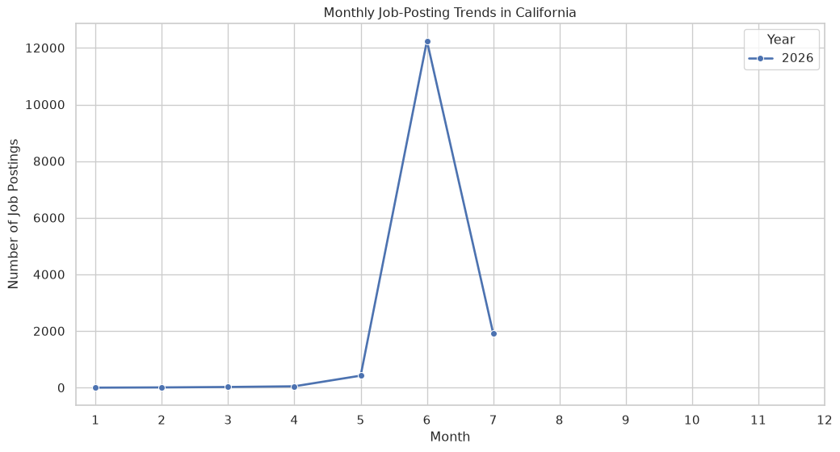
Insight. The highest monthly California volume occurred in 2026-06, with 12,250 postings. The lowest observed month was 2026-01, with 4 postings. The line chart makes the within-year fluctuations visible while keeping different years separate.

5.4 Query 4: Salary Comparisons Across Major US Metro Areas
query4_df = spark.sql(
"""
WITH selected_locations AS (
SELECT
l.location_id,
CASE CAST(l.msa AS STRING)
WHEN '14460' THEN 'Boston'
WHEN '47900' THEN 'Washington DC'
WHEN '35620' THEN 'New York'
WHEN '41860' THEN 'San Francisco'
WHEN '42660' THEN 'Seattle'
WHEN '31080' THEN 'Los Angeles'
WHEN '19100' THEN 'Dallas'
WHEN '26420' THEN 'Houston'
WHEN '12420' THEN 'Austin'
WHEN '34980' THEN 'Nashville'
WHEN '28140' THEN 'Kansas City'
WHEN '19740' THEN 'Denver'
END AS metro_area
FROM locations AS l
WHERE CAST(l.msa AS STRING) IN (
'14460', '47900', '35620', '41860',
'42660', '31080', '19100', '26420',
'12420', '34980', '28140', '19740'
)
)
SELECT /*+ BROADCAST(m) */
m.metro_area,
ROUND(AVG(j.salary), 2) AS average_salary,
COUNT(*) AS job_postings
FROM job_postings_analysis AS j
INNER JOIN selected_locations AS m
ON j.location_id = m.location_id
WHERE j.salary IS NOT NULL
AND j.salary > 0
AND m.metro_area IS NOT NULL
GROUP BY m.metro_area
ORDER BY average_salary DESC
"""
)
query4_pd = query4_df.toPandas()
display(query4_pd)
 | metro_area | average_salary | job_postings
if query4_pd.empty:
display(Markdown("**Visualization note:** No qualifying Query 4 rows were returned."))
else:
plt.figure(figsize=(11, 7))
query4_axis = sns.barplot(
data=query4_pd,
x="average_salary",
y="metro_area",
order=query4_pd["metro_area"].tolist(),
color="#4C78A8",
)
query4_axis.set_title("Average Salary Across Selected US Metro Areas")
query4_axis.set_xlabel("Average Salary ($)")
query4_axis.set_ylabel("Metro Area")
query4_axis.xaxis.set_major_formatter(StrMethodFormatter("${x:,.0f}"))
plt.tight_layout()
plt.show()
Visualization note: No qualifying Query 4 rows were returned.
Insight. No selected metro postings had usable positive salaries.

6. Conclusion
This workflow converts the wide job-postings source into a relational Spark SQL model and validates the primary-key and foreign-key relationships before analysis. The four queries then describe compensation within the technology sector, concentration in remote California hiring, changes in California posting activity over time, and geographic salary differences. All findings are limited to the job postings represented in the dataset, and salary findings are further limited to records with usable positive salary values.

7. Final Submission Checklist
- Replace the GitHub URL placeholder near the beginning of this report.
- Confirm that USE_SAMPLE = False and that all 17 Parquet files are found.
- Run all cells from top to bottom on the EC2 instance.
- Complete the generated research-survey workbook and enable its validation cell.
- Confirm that all four query tables, four charts, and four insights appear.
- Render the document with quarto render M02-A-jzhu116.qmd --to docx.
- Optionally render HTML with quarto render M02-A-jzhu116.qmd --to html.
- Commit the QMD, rendered Word document, and any required supporting files.
- Keep .env, Parquet files, optional CSV output, and research submissions out of GitHub.

