NAJDA STREET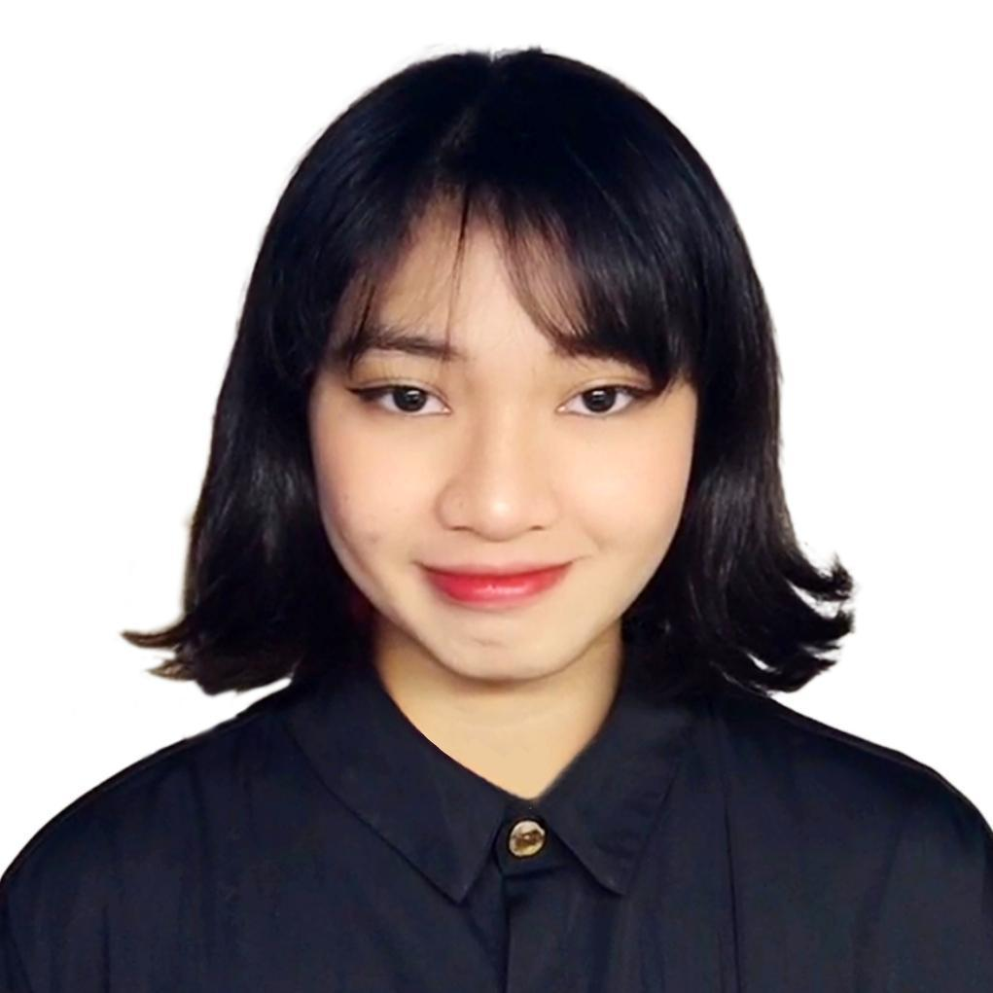

ABU DHABI CITY, UNITED ARAB EMIRATES

+971543207142

[januellemaxene@gmail.com](mailto:januellemaxene@gmail.com)

MAXENE JANUELLE GASPAY SALONA long, thin rectangle to divide sections of the document

VISA STATUS: **GOLDEN VISA** EXP: **AUGUST 11, 2032**

PASSPORT: P6993046C EXP: APR 25, 2034

# SUMMARY

Creative Computing graduate with practical experience in full-stack web development, machine learning, and digital forensics. Proficient in Python, JavaScript, responsive design, and version control. Quick to adapt, self-driven, and collaborative in fast-paced team environments. Holder of a UAE Golden Visa (student status), offering long-term residency and full-time work eligibility.

# EXPERIENCE

## Full-Stack Web Development Projects

Self-Initiated | 2022 – 2025

* Built and deployed personal projects using **HTML, CSS, JavaScript**, and entry-level **React**
* Managed hosting, domain setup, and version control via **Netlify, Vercel**, and **GitHub**
* Focused on responsive design and end-to-end UI implementation
* Currently refreshing skills and rebuilding projects

## Machine Learning Module

Bath Spa University | 2024 (4 months)

* Completed a supervised learning mini-project using **Python** and **scikit-learn**
* Gained foundational knowledge in datasets, model evaluation, and feature selection

## Cybersecurity & Forensics Lab

Bath Spa University | 2024 (4 months)

* Conducted basic forensic analysis using **Autopsy**
* Gained exposure to secure data handling and ethical computing principles

## Algorithms & C Programming

42 Abu Dhabi | 2023

* Developed logic and problem-solving skills using **C language**
* Solved algorithm challenges focused on recursion, sorting, and memory logic

# 

# ADDITIONAL EXPERIENCE

## Customer Support & Payment Handling – Vibes Event

**Part-Time | December 2024**

* Managed card payments and transactions efficiently during a high-traffic event
* Handled multiple customers simultaneously while maintaining professionalism under pressure
* Delivered quick and accurate service in a fast-paced event environment

## Retail Assistant – Children’s Shop

**Part-Time | 2025**

* Assisted with customer service, product arrangement, and sales in a child-focused retail setting
* Ensured a friendly and safe atmosphere for children and guardians
* Supported store operations including restocking and maintaining cleanliness

EDUCATION

## Bath Spa University – Ras Al Khaimah, UAE *— Bachelor of Science in Creative Computing*

**Completed 2025** | Graduation Ceremony Pending

* Focus Areas: Advanced Web Dev, Mobile Apps, Game Engines, AI & Machine Learning, Cybersecurity
* Strong emphasis on applied project work and real-world skills

## 42 Abu Dhabi

* Learned C programming fundamentals
* Completed logic-based and algorithmic challenges in a peer-learning environment

# TECHNICAL SKILLS

* **Languages:** JavaScript, HTML, CSS, Python (intermediate), C (basic)
* **Tools & Frameworks:** Git, GitHub, React (learning), Node.js (basics), Autopsy
* **Concepts:** Full-stack fundamentals, responsive design, ML basics, digital forensics

# SOFT SKILLS

Analytical Thinking, Problem Solving, Time Management, Team Collaboration, Adaptability, Clear Communication, Self-Directed Learning

# CERTIFICATIONS & SEMINARS

**Cybersecurity Awareness Seminar**

* *Future Training and Services Center – April 18, 2023 (Abu Dhabi)*