NAJDA STREET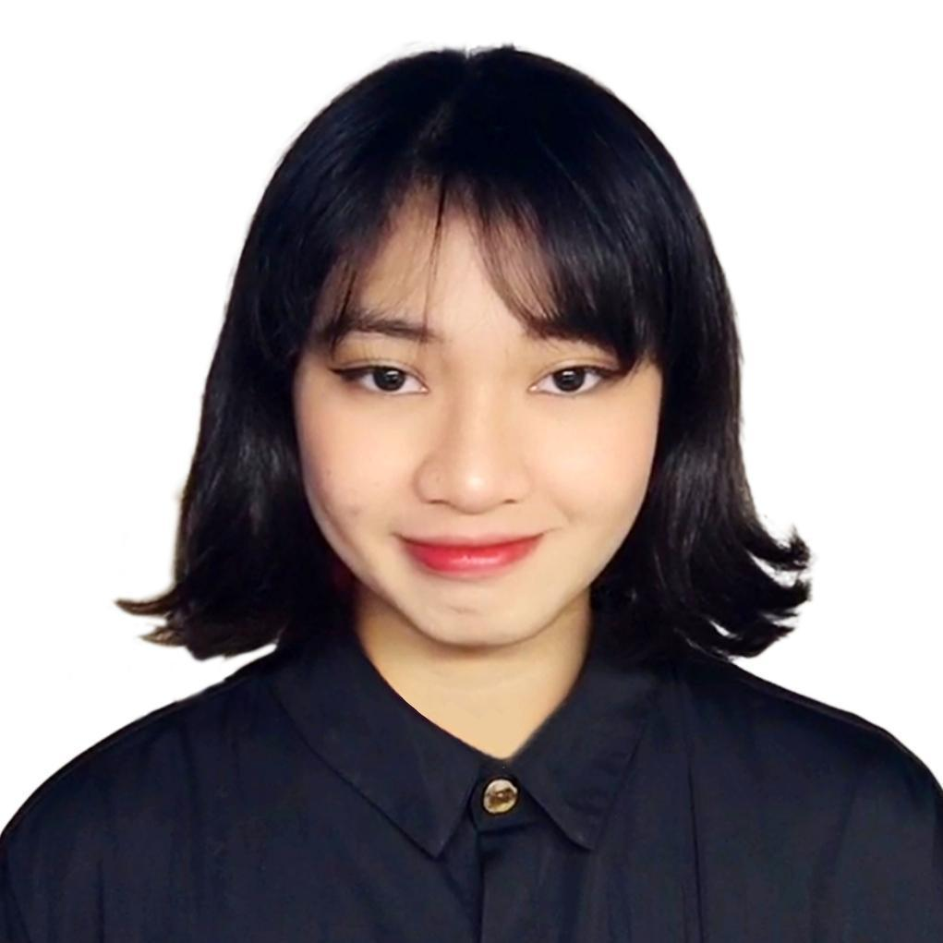

ABU DHABI CITY, UNITED ARAB EMIRATES

+971543207142

[januellemaxene@gmail.com](mailto:januellemaxene@gmail.com)

MAXENE JANUELLE GASPAY SALONA long, thin rectangle to divide sections of the document

VISA STATUS: **GOLDEN VISA** EXP: **AUGUST 11, 2032**

PASSPORT: P6993046C EXP: APR 25, 2034

# SUMMARY

Recent Creative Computing graduate with hands-on exposure to full-stack web development, basic machine learning concepts, and introductory digital forensics. Comfortable with HTML, CSS, JavaScript, and Python, and currently building confidence in tools like React and Git. Eager to learn, adaptable, and motivated to contribute to real-world projects. Holder of a UAE Golden Visa (student status), allowing long-term residency and full-time work eligibility.

# EXPERIENCE

## Self-Initiated Web Projects

Personal Learning & Practice | 2022 – 2025

* Created and maintained small web projects to apply and reinforce programming skills
* Used HTML, CSS, JavaScript, and beginner-level React for frontend interfaces
* Gained familiarity with deployment tools like Netlify and Vercel
* Practiced version control using Git and GitHub
* Currently revisiting and improving earlier projects to enhance structure and usability

## Machine Learning (Academic Module)

Bath Spa University | 2024 (4 months)

* Completed a guided mini-project using Python and scikit-learn
* Learned about basic model training, evaluation, and working with small datasets
* Gained an introduction to supervised learning and feature selection

## Cybersecurity & Digital Forensics (Academic Lab)

Bath Spa University | 2024 (4 months)

* Practiced basic forensic analysis techniques using tools like Autopsy
* Learned foundational concepts in secure data handling and ethical computing

## C Programming & Algorithms

42 Abu Dhabi | 2023 - Present

* Solved entry-level programming challenges to develop problem-solving skills
* Practiced core programming logic, memory management, and recursion in C

# EDUCATION

## Bath Spa University – Ras Al Khaimah, UAE *— Bachelor of Science in Creative Computing*

**Completed 2025** | Graduation Ceremony Pending

* Focus Areas: Advanced Web Dev, Mobile Apps, Game Engines, AI & Machine Learning, Cybersecurity
* Strong emphasis on applied project work and real-world skills

## 42 Abu Dhabi

* Learned C programming fundamentals
* Completed logic-based and algorithmic challenges in a peer-learning environment

# TECHNICAL SKILLS

* **Languages:** JavaScript, HTML, CSS, Python (beginner), C (basic)
* **Tools & Frameworks:** Git, GitHub, React (learning), Node.js (basics), Autopsy
* **Concepts:** Basic full-stack development principles, responsive design, ML basics, digital forensics

# SOFT SKILLS

* Willingness to learn and grow through feedback
* Able to manage time effectively in academic and project settings
* Comfortable working in peer-learning and group environments
* Enthusiastic about problem-solving and exploring new ideas
* Developing strong communication and collaboration skills

# CERTIFICATIONS & SEMINARS

**Cybersecurity Awareness Seminar**

* *Future Training and Services Center – April 18, 2023 (Abu Dhabi)*

# ADDITIONAL INFORMATION

* **Languages:** English, Filipino, Visayan