**Assessment Cover Sheet**

This Assessment Cover Sheet is only to be attached to

|  |  |  |  |  |  |  |
| --- | --- | --- | --- | --- | --- | --- |
| **ASSESSMENT DETAILS** | | | | | | |
| Unit title | | Data Structure and Pattern | Tutorial /Lab Group | 1 | | Office use only |
| Unit code | | COS30008 | Due date | 28 Oct 2022 | |  |
| Name of lecturer/tutor | | Dr. Mark Tee Kit Tsun | | | |  |
| Assignment title | | Problem Set 3 | | | | Faculty or school date stamp |
| **STUDENT(S) DETAILS** | | | | | | |
| Student Name(s) | | | | | Student ID Number(s) | |
| (1) | Alex Ngie Guan Ming | | | | 102765770 | |
| (2) |  | | | |  | |
| (3) |  | | | |  | |
| (4) |  | | | |  | |
| (5) |  | | | |  | |

hard copy submission of assessments.

|  |  |  |  |  |
| --- | --- | --- | --- | --- |
| **DECLARATION AND STATEMENT OF AUTHORSHIP** | | | | |
| 1. I/we have not impersonated, or allowed myself/ourselves to be impersonated by any person for the purposes of this assessment. 2. This assessment is my/our original work and no part of it has been copied from any other source except where due acknowledgement is made. 3. No part of this assessment has been written for me/us by any other person except where such collaboration has been authorised by the lecturer/tutor concerned. 4. I/we have not previously submitted this work for this or any other course/unit. 5. I/we give permission for my/our assessment response to be reproduced, communicated, compared and archived for plagiarism detection, benchmarking or educational purposes.   I/we understand that:   1. Plagiarism is the presentation of the work, idea or creation of another person as though it is your own. It is a form of cheating and is a very serious academic offence that may lead to exclusion from the University. Plagiarised material can be drawn from, and presented in, written, graphic and visual form, including electronic data and oral presentations. Plagiarism occurs when the origin of the material used is not appropriately cited. | | | |
| **Student signature/s**  I/we declare that I/we have read and understood the declaration and statement of authorship. | | | |
| (1) | Alex | (4) |  |
| (2) |  | (5) |  |
| (3) |  | (6) |  |

Further information relating to the penalties for plagiarism, which range from a formal caution to expulsion from the University is contained on the Current Students website at **https://www.swinburne.edu.my/current-students/manage-course/exams-results-assessment**

Copies of this form can be downloaded from the Student Forms web page at **https://www.swinburne.edu.my/current-students/manage-course/exams-results-assessment/how-to-submit-work.php**

Contents

Task 1 3

Implementation 3

Task 2 4

Implementation 4

Task 3 6

Implementation 6

Task 4 9

Implementation 9

Output 10

Task 5 13

Implementation 13

Output 17

# Task 1

## Implementation

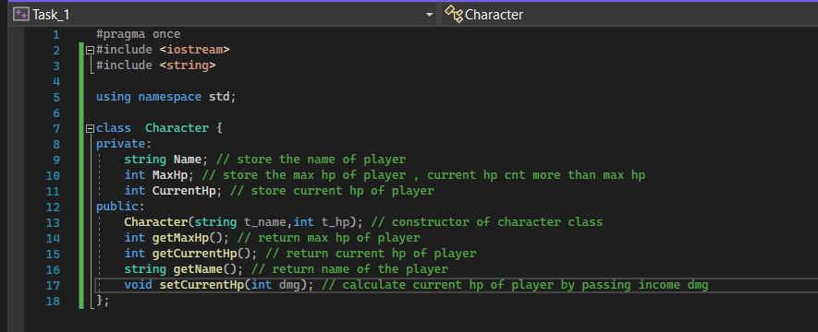

# Task 2

## Implementation

skillNode.h

SkillNode.cpp

# Task 3

## Implementation

Character.h

Character.cpp

Add

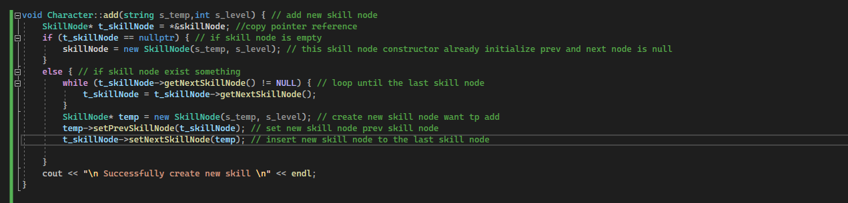

Remove

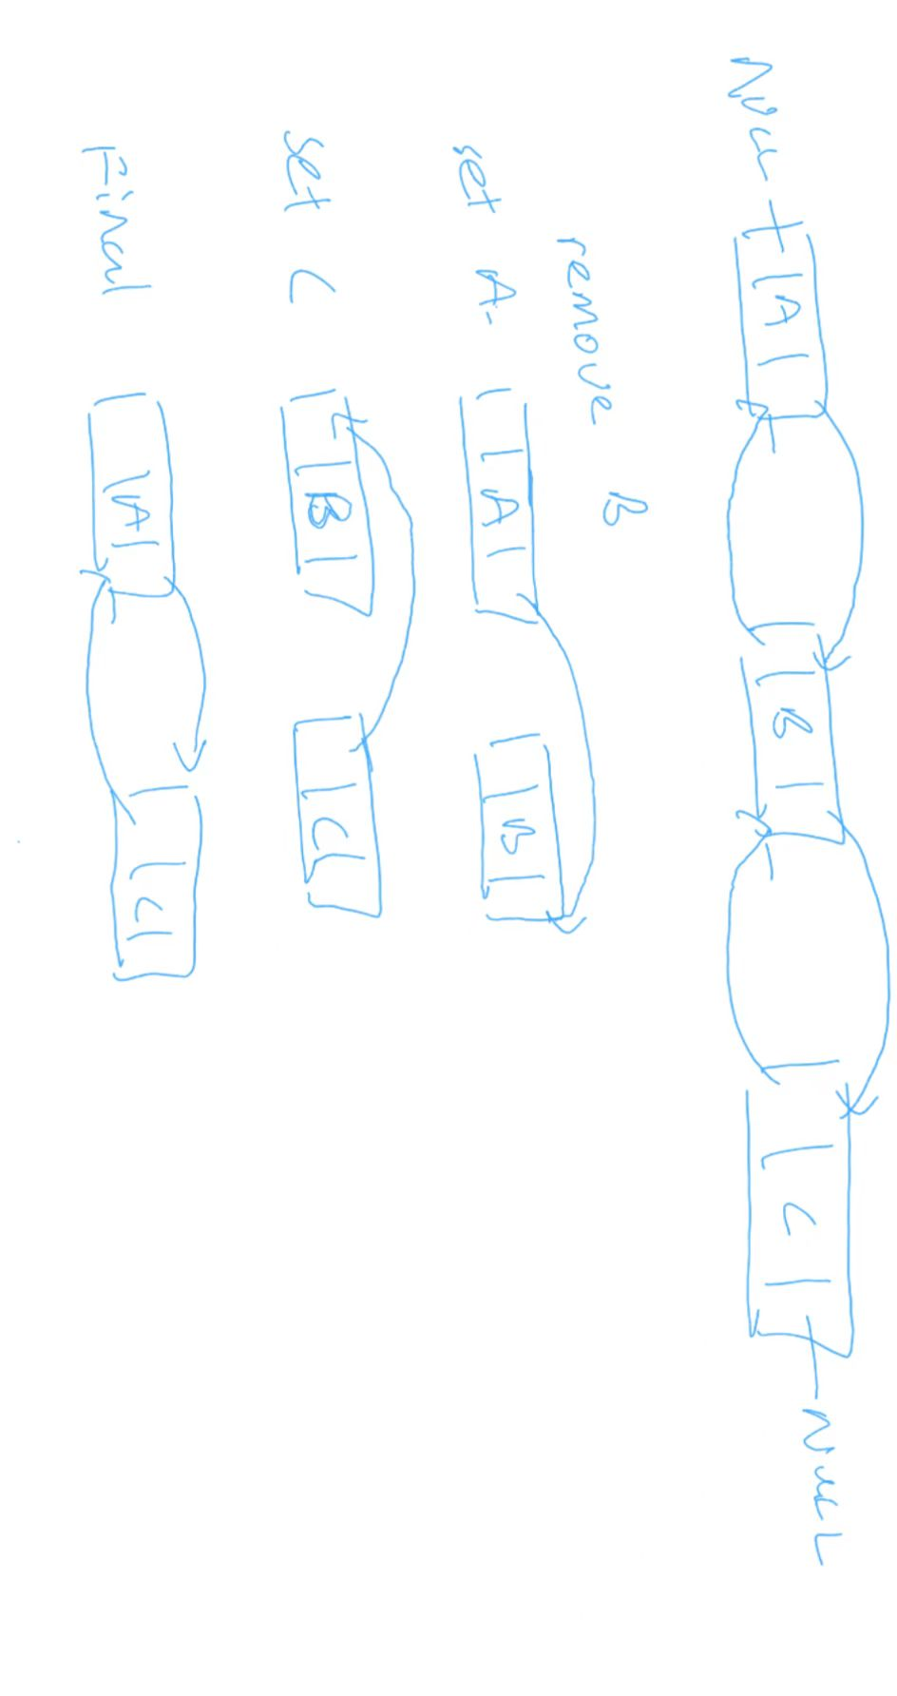

Modify

Find

Read

Other function created

# Task 4

## Implementation

Main.cpp

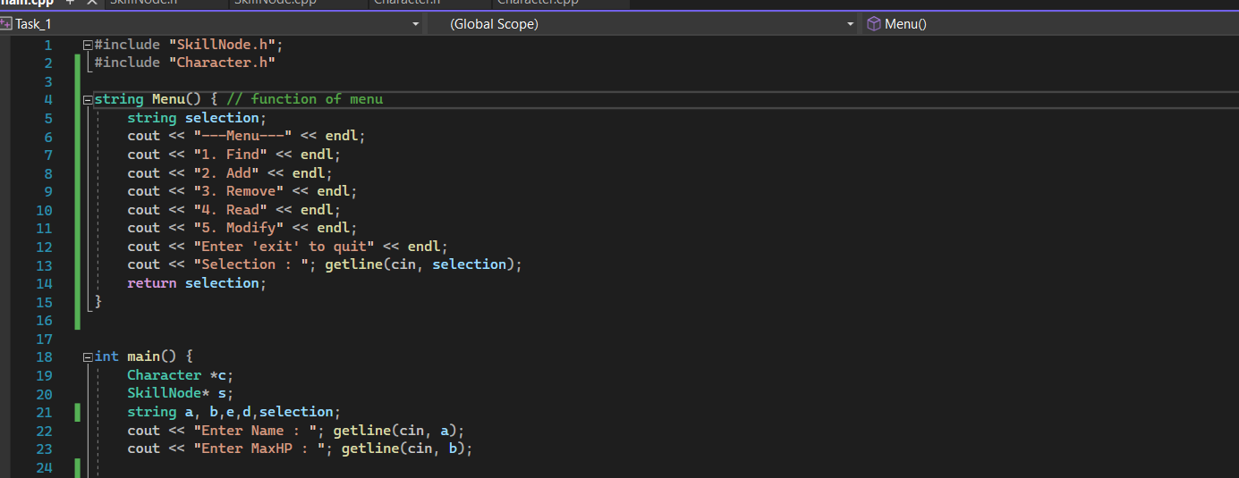

## Output

Find

Read and Add

Modify

Remove

# Task 5

## Implementation

Main.cpp

Character.h

Character.cpp

SkillList.h

SkillList.cpp

Add back

Add front / remove front

Remove back/ modify

Find / read

Print from tail/head

## Output

Insert front node

Insert back node

Remove head

Remove tail

Read

Print from tail/head

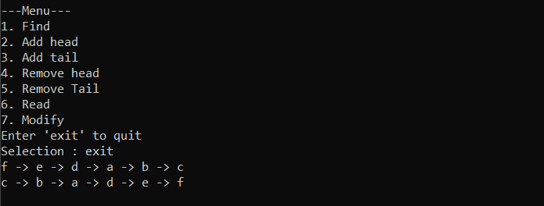

Modify

Find

