# Download node.js

<http://nodejs.org/download/>

# Install node.js

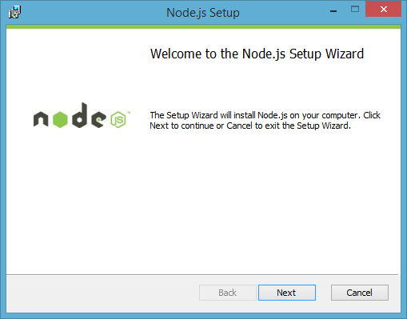

# Download Node.js Tools for Visual Studio (NTVS)

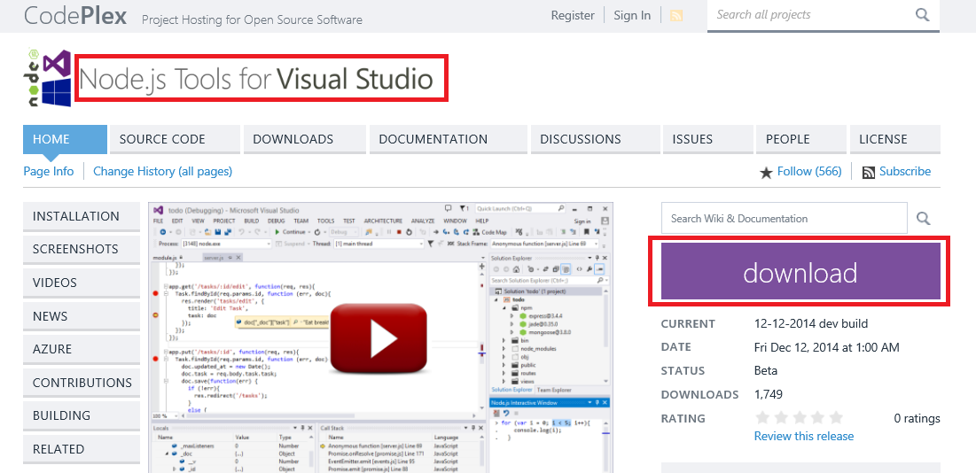

# Create new Node.js in Visual Studio

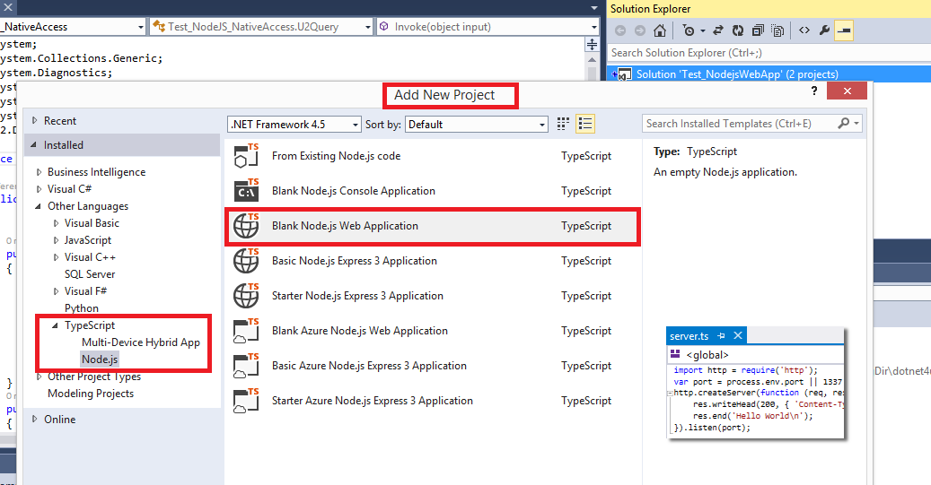

# Download Edge, Express and body-parse

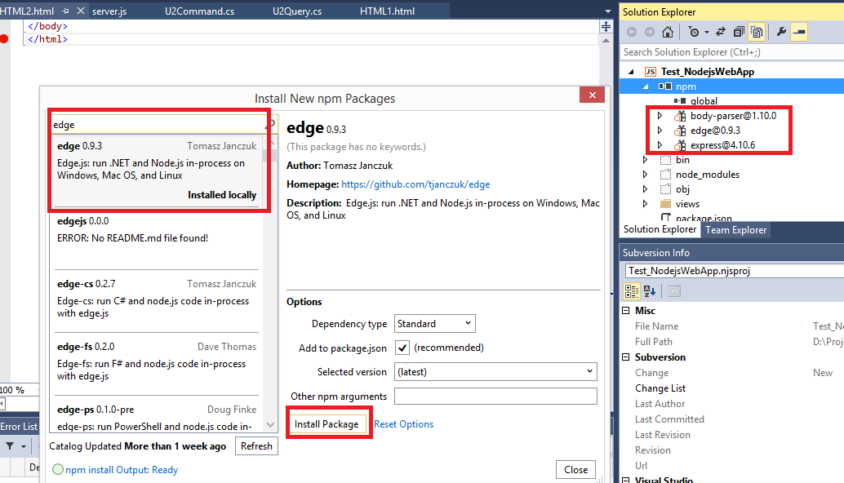

# Create C# Class Library Project

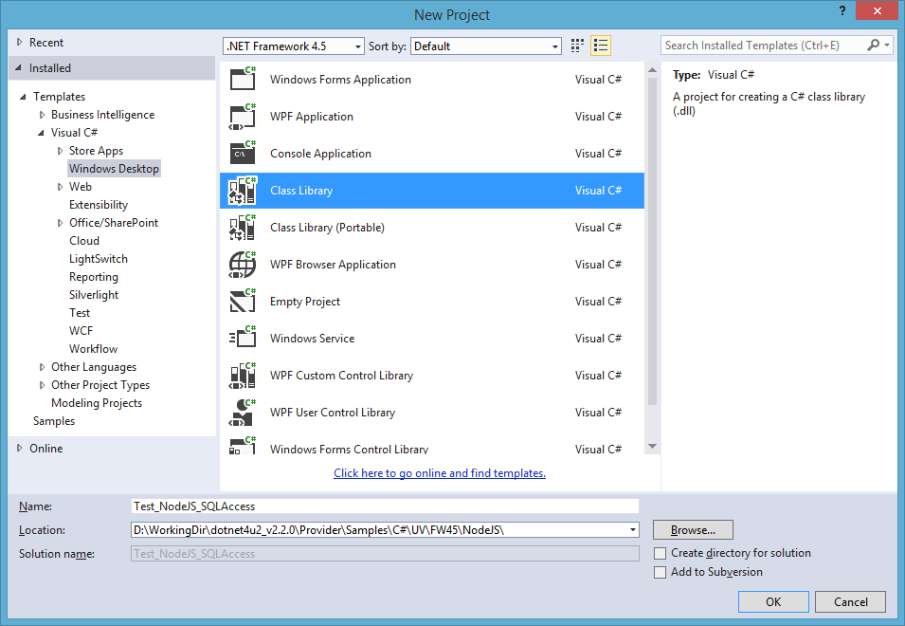

# Test_NodeJS_NativeAccess.dll

Output Test_NodeJS_NativeAccess.dll in Node.js parent directory (For Example: Test_NodejsWebApp directory)

# Specify Connection String

|  |
| --- |
| U2ConnectionStringBuilder l = new U2ConnectionStringBuilder();  l.UserID = "admin";  l.Password = "pass";  l.Server = "localhost";  l.Database = "HS.SALES";  l.ServerType = "universe";  l.Connect_Timeout = 360;  l.RpcServiceType = "uvcs";  l.AccessMode = "Native"; |

# Run Application

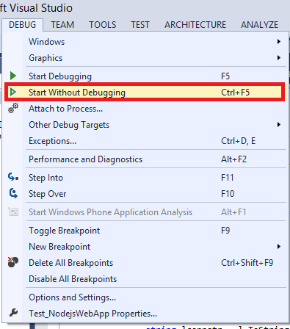

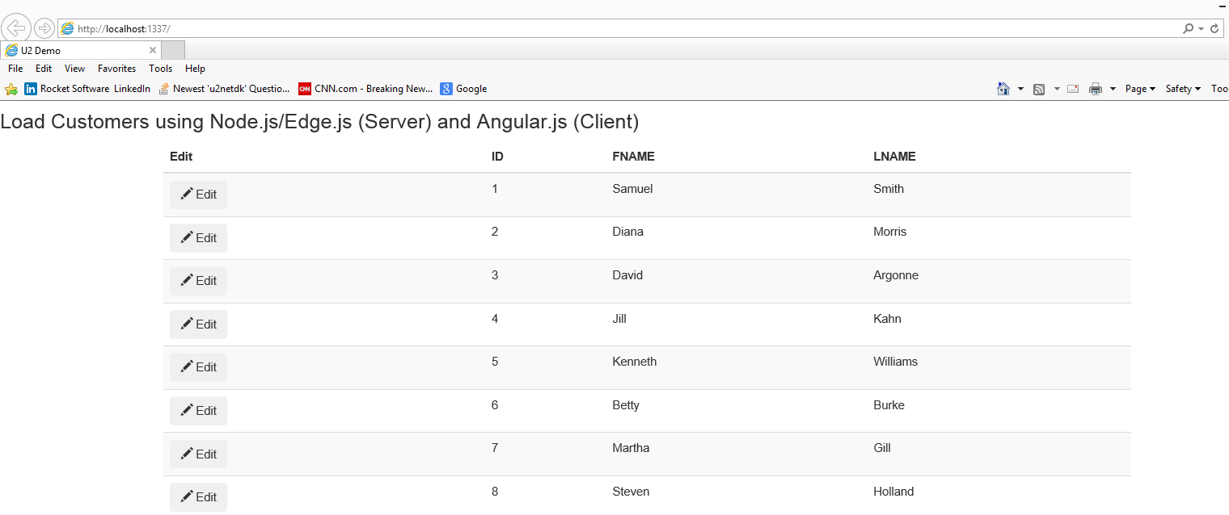

## Modify and Save

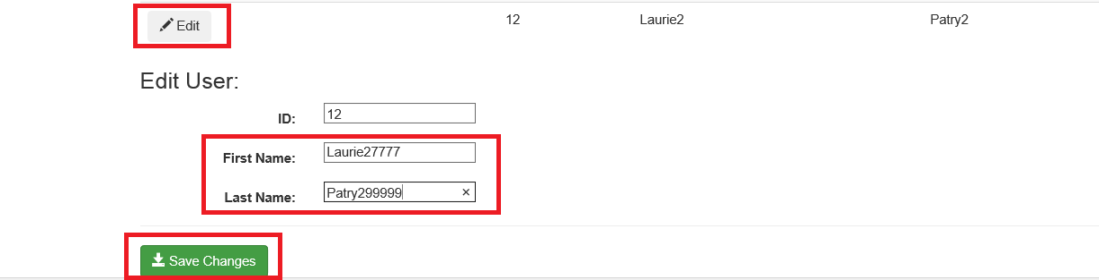

## Verify ‘Save Changes’

