John Zaiss

SWDV 691: Software Development Capstone

Joseph Gradecki

19 July 2020

# Re-Design: Database

# My Garden Web App

# Overview

The My Garden app is designed for the personal gardener who wants to manage their gardening experience. The data needed for this application will have many-to-many relationships and require normalization. One requirement that drives normalization is the need to support tags and to have a status for each plant.

To meet the database requirements of the My Garden Web App the best choice is a Relational Database Design. The specific choice for a relational database is MySQL.

# Entity-Relationship diagram

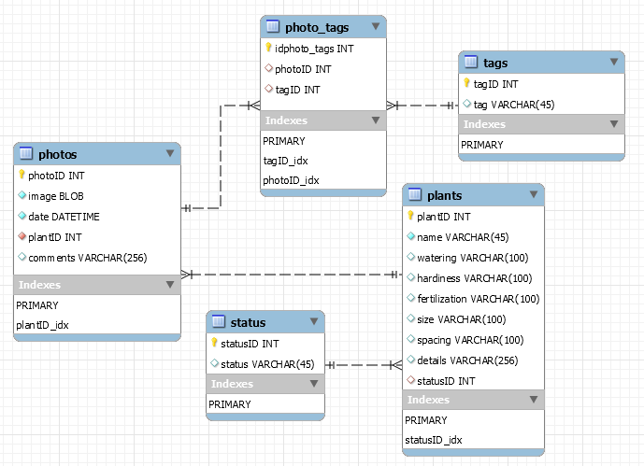

## Table Design

### Photos

The photos table is central to the app. The use cases for all personas require a photo of items in their garden. Each database entry starts with a photo.

**UPDATE: changed the primary key from imageID to photoID**

### Plants

The plants table contains records identifying each plant and the plantID column is a foreign key in the photos table linking the plant record to the photo. When additional photos of the same plant are taken to update the status the plantID for the record is added to the new photo creating a one to many relationship between a plant record and photos.

### Status

The status table is a list of statuses used in the plant record. A status can be used in planning for the garden.

### Tags

The tags table is used to store key words associated with each photo uploaded. Tags are used in keyword searches.

### Photo_tags

The photo_tags table is used to facilitate the many-to-many relationships between photos and tags.

**UPDATE: changed the foreign key index from imageID_idx to photoID_idx**