BAN 402 Phase 2: Product Failure Prediction
Janelle Zarate
July 22, 2026
Table of Contents
Logistic Regression Cross-Validation 19
Fit Logistic Regression on the Training Data 20
Logistic Regression ROC Curve 25
Logistic Regression Coefficients 26
Model 2: Classification Tree 27
Classification Tree Cross-Validation 28
Fit the Classification Tree 29
Classification Tree Predictions 29
Classification Tree Performance 30
Classification Tree Confusion Matrix 32
Classification Tree ROC Curve 33
Model 3: Random Forest 34
Random Forest Cross-Validation 35
Fit and Evaluate the Random Forest 35
Compare the Three Models 37
Comparison Chart 38
Select the Best Model 39
Kaggle Predictions 40

The purpose of this analysis is to develop and compare classification models that predict whether a product will fail. The analysis uses a training and testing split, along with five-fold cross-validation, to evaluate model performance.
#Loading Packages and Data
# Packages needed for the analysis
needed_packages <- c(
"tidyverse",
"janitor",
"forcats",
"mice",
"tidymodels",
"ranger",
"rpart",
"scales"
)
# Install any packages that are not already installed
packages_to_install = needed_packages[
!needed_packages %in% rownames(installed.packages())
]
if (length(packages_to_install) > 0) {
install.packages(packages_to_install)
}
# Load packages
library(tidyverse)
library(janitor)
library(forcats)
library(mice)
library(tidymodels)
library(ranger)
library(rpart)
library(scales)
# Make results reproducible
set.seed(402)
# File locations
train_path = "~/Downloads/train.csv"
test_path = "~/Downloads/test.csv"
sample_path = "~/Downloads/sample_submission.csv"
# Check that the required files exist
if (!file.exists(train_path)) {
stop("train.csv was not found in the Downloads folder.")
}
if (!file.exists(test_path)) {
stop("test.csv was not found in the Downloads folder.")
}
if (!file.exists(sample_path)) {
stop("sample_submission.csv was not found in the Downloads folder.")
}
# Import the files
train = read_csv(
train_path,
show_col_types = FALSE
) %>%
clean_names()
test = read_csv(
test_path,
show_col_types = FALSE
) %>%
clean_names()
sample_submission = read_csv(
sample_path,
show_col_types = FALSE
) %>%
clean_names()
#Review the Data
# Dataset dimensions
dim(train)
## [1] 26570 26
dim(test)
## [1] 20775 25
dim(sample_submission)
## [1] 20775 2
# Variable names
names(train)
## [1] "id" "product_code" "loading" "attribute_0"
## [5] "attribute_1" "attribute_2" "attribute_3" "measurement_0"
## [9] "measurement_1" "measurement_2" "measurement_3" "measurement_4"
## [13] "measurement_5" "measurement_6" "measurement_7" "measurement_8"
## [17] "measurement_9" "measurement_10" "measurement_11" "measurement_12"
## [21] "measurement_13" "measurement_14" "measurement_15" "measurement_16"
## [25] "measurement_17" "failure"
names(test)
## [1] "id" "product_code" "loading" "attribute_0"
## [5] "attribute_1" "attribute_2" "attribute_3" "measurement_0"
## [9] "measurement_1" "measurement_2" "measurement_3" "measurement_4"
## [13] "measurement_5" "measurement_6" "measurement_7" "measurement_8"
## [17] "measurement_9" "measurement_10" "measurement_11" "measurement_12"
## [21] "measurement_13" "measurement_14" "measurement_15" "measurement_16"
## [25] "measurement_17"
names(sample_submission)
## [1] "id" "failure"
# Dataset structure
glimpse(train)
## Rows: 26,570
## Columns: 26
## $ id <dbl> 0, 1, 2, 3, 4, 5, 6, 7, 8, 9, 10, 11, 12, 13, 14, 15, 1…
## $ product_code <chr> "A", "A", "A", "A", "A", "A", "A", "A", "A", "A", "A", …
## $ loading <dbl> 80.10, 84.89, 82.43, 101.07, 188.06, 75.35, 161.71, 177…
## $ attribute_0 <chr> "material_7", "material_7", "material_7", "material_7",…
## $ attribute_1 <chr> "material_8", "material_8", "material_8", "material_8",…
## $ attribute_2 <dbl> 9, 9, 9, 9, 9, 9, 9, 9, 9, 9, 9, 9, 9, 9, 9, 9, 9, 9, 9…
## $ attribute_3 <dbl> 5, 5, 5, 5, 5, 5, 5, 5, 5, 5, 5, 5, 5, 5, 5, 5, 5, 5, 5…
## $ measurement_0 <dbl> 7, 14, 12, 13, 9, 11, 12, 4, 9, 10, 10, 7, 9, 6, 10, 8,…
## $ measurement_1 <dbl> 8, 3, 1, 2, 2, 4, 2, 8, 6, 4, 3, 3, 0, 9, 4, 5, 5, 6, 6…
## $ measurement_2 <dbl> 4, 3, 5, 6, 8, 0, 4, 8, 5, 7, 6, 2, 6, 10, 10, 9, 6, 3,…
## $ measurement_3 <dbl> 18.040, 18.213, 18.057, 17.295, 19.346, 17.564, 17.303,…
## $ measurement_4 <dbl> 12.518, 11.540, 11.652, 11.188, 12.950, 13.721, 12.643,…
## $ measurement_5 <dbl> 15.748, 17.717, 16.738, 18.576, 16.990, 16.594, 17.476,…
## $ measurement_6 <dbl> 19.292, 17.893, 18.240, 18.339, 15.746, NA, 17.679, 15.…
## $ measurement_7 <dbl> 11.739, 12.748, 12.718, 12.583, 11.306, 11.592, 12.957,…
## $ measurement_8 <dbl> 20.155, 17.889, 18.288, 19.060, 18.093, 20.810, 17.916,…
## $ measurement_9 <dbl> 10.672, 12.448, 12.715, 12.471, 10.337, 10.622, 11.370,…
## $ measurement_10 <dbl> 15.859, 17.947, 15.607, 16.346, 17.082, 14.904, 17.714,…
## $ measurement_11 <dbl> 17.594, 17.915, NA, 18.377, 19.932, 19.107, 19.924, 20.…
## $ measurement_12 <dbl> 15.193, 11.755, 13.798, 10.020, 12.428, 13.327, 11.560,…
## $ measurement_13 <dbl> 15.029, 14.732, 16.711, 15.250, 16.182, 15.354, 16.653,…
## $ measurement_14 <dbl> NA, 15.425, 18.631, 15.562, 12.760, 19.251, 17.734, 16.…
## $ measurement_15 <dbl> 13.034, 14.395, 14.094, 16.154, 13.153, NA, NA, 15.176,…
## $ measurement_16 <dbl> 14.684, 15.631, 17.946, 17.172, 16.412, 17.625, 16.637,…
## $ measurement_17 <dbl> 764.100, 682.057, 663.376, 826.282, 579.885, 832.902, 6…
## $ failure <chr> "No", "No", "No", "No", "No", "No", "Yes", "Yes", "No",…
The training data contains the response variable failure. The test data contains the predictor variables but does not contain known failure outcomes.
#Convert Categorical Variables
# Convert categorical variables using as_factor()
train = train %>%
mutate(
failure = as_factor(failure),
product_code = as_factor(product_code),
attribute_0 = as_factor(attribute_0),
attribute_1 = as_factor(attribute_1)
)
test = test %>%
mutate(
product_code = as_factor(product_code),
attribute_0 = as_factor(attribute_0),
attribute_1 = as_factor(attribute_1)
)
# Place Yes first so failure is treated as the event
train = train %>%
mutate(
failure = fct_relevel(
failure,
"Yes"
)
)
# Check variable classes and levels
class(train$failure)
## [1] "factor"
class(train$product_code)
## [1] "factor"
class(train$attribute_0)
## [1] "factor"
class(train$attribute_1)
## [1] "factor"
levels(train$failure)
## [1] "Yes" "No"
levels(train$product_code)
## [1] "A" "B" "C" "D" "E"
levels(train$attribute_0)
## [1] "material_7" "material_5"
levels(train$attribute_1)
## [1] "material_8" "material_5" "material_6"
#Failure Distribution
failure_summary = train %>%
count(failure) %>%
mutate(
proportion = n / sum(n),
label = paste0(
comma(n),
"\n",
percent(proportion, accuracy = 0.1)
)
)
failure_summary
## # A tibble: 2 × 4
## failure n proportion label
## <fct> <int> <dbl> <chr>
## 1 Yes 5649 0.213 "5,649\n21.3%"
## 2 No 20921 0.787 "20,921\n78.7%"
ggplot(
failure_summary,
aes(
x = failure,
y = n,
fill = failure
)
) +
geom_col(
width = 0.65,
show.legend = FALSE
) +
geom_text(
aes(label = label),
vjust = -0.3,
size = 4
) +
labs(
title = "Product Failure Distribution",
subtitle = "Most tested products did not fail",
x = "Product outcome",
y = "Number of products"
) +
scale_y_continuous(
labels = comma,
expand = expansion(mult = c(0, 0.15))
) +
theme_minimal()
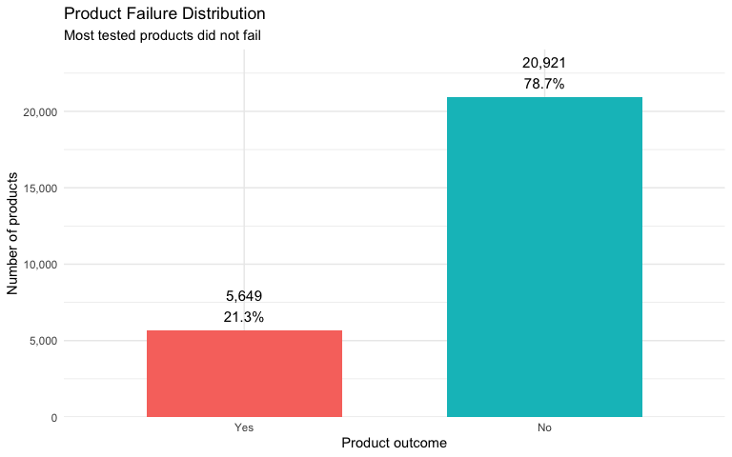
Most of the tested products did not fail, but the dataset contains enough failed products to compare patterns and models
#Visual Comparison of Failure Groups
#Boxplot
ggplot(
train,
aes(
x = failure,
y = loading,
fill = failure
)
) +
geom_boxplot(
na.rm = TRUE,
alpha = 0.75,
outlier.alpha = 0.20
) +
labs(
title = "Loading Values by Product Outcome",
subtitle = "Failed products tend to have higher Loading values",
x = "Product outcome",
y = "Loading"
) +
theme_minimal() +
theme(
legend.position = "none"
)
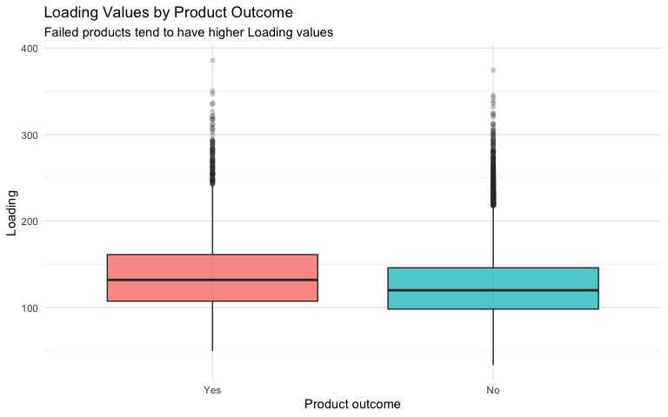
The center of the Loading distribution is higher for failed products. The groups still overlap, so Loading cannot perfectly separate the two outcomes by itself.
#Measurement 17 Boxplot
ggplot(
train,
aes(
x = failure,
y = measurement_17,
fill = failure
)
) +
geom_boxplot(
na.rm = TRUE,
alpha = 0.75,
outlier.alpha = 0.20
) +
labs(
title = "Measurement 17 by Product Outcome",
subtitle = "Measurement 17 shows some separation between outcomes",
x = "Product outcome",
y = "Measurement 17"
) +
theme_minimal() +
theme(
legend.position = "none"
)
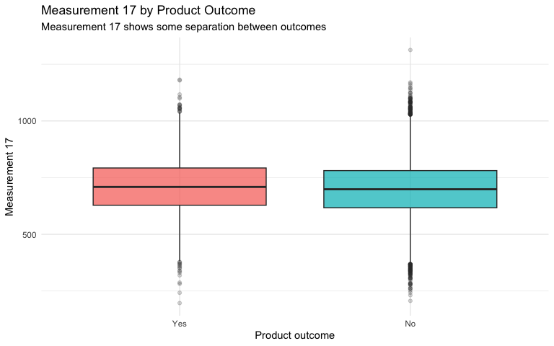
Measurement 17 shows a smaller difference between failed and non-failed products than Loading.
#Proportional Failure Chart
ggplot(
train,
aes(
x = product_code,
fill = failure
)
) +
geom_bar(
position = "fill"
) +
labs(
title = "Failure Proportions by Product Code",
subtitle = "Each bar represents all products in one product-code group",
x = "Product code",
y = "Proportion of products",
fill = "Product outcome"
) +
scale_y_continuous(
labels = percent
) +
theme_minimal()
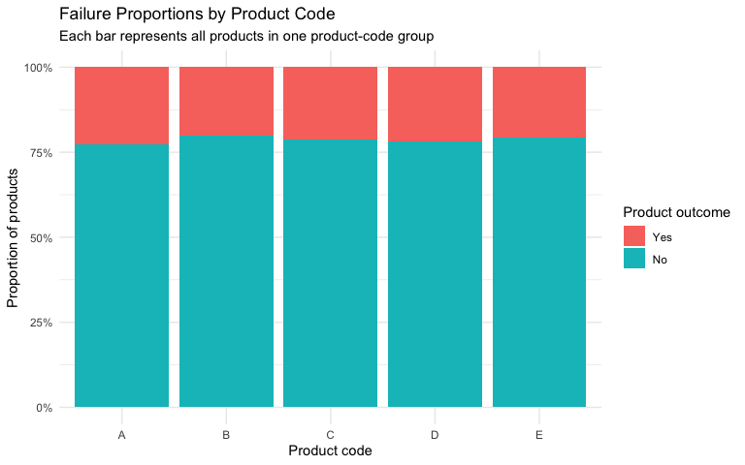
The proportions of failed and non-failed products vary slightly across product codes.
#Examine Missing Values
missing_before = tibble(
variable = names(train),
missing_count = colSums(is.na(train)),
missing_percent = round(
colSums(is.na(train)) / nrow(train) * 100,
1
)
) %>%
filter(missing_count > 0) %>%
arrange(desc(missing_count))
knitr::kable(
missing_before,
caption = "Missing Values Before Imputation"
)
Missing Values Before Imputation
variable | missing_count | missing_percent
measurement_17 | 2284 | 8.6
measurement_16 | 2110 | 7.9
measurement_15 | 2009 | 7.6
measurement_14 | 1874 | 7.1
measurement_13 | 1774 | 6.7
measurement_12 | 1601 | 6.0
measurement_11 | 1468 | 5.5
measurement_10 | 1300 | 4.9
measurement_9 | 1227 | 4.6
measurement_8 | 1048 | 3.9
measurement_7 | 937 | 3.5
measurement_6 | 796 | 3.0
measurement_5 | 676 | 2.5
measurement_4 | 538 | 2.0
measurement_3 | 381 | 1.4
loading | 250 | 0.9
ggplot(
missing_before,
aes(
x = reorder(variable, missing_count),
y = missing_count
)
) +
geom_col() +
geom_text(
aes(
label = paste0(
comma(missing_count),
" (",
missing_percent,
"%)"
)
),
hjust = -0.05,
size = 3
) +
coord_flip() +
labs(
title = "Missing Values Before Imputation",
subtitle = "Later measurements contain more missing observations",
x = NULL,
y = "Number of missing observations"
) +
scale_y_continuous(
labels = comma,
expand = expansion(mult = c(0, 0.25))
) +
theme_minimal()
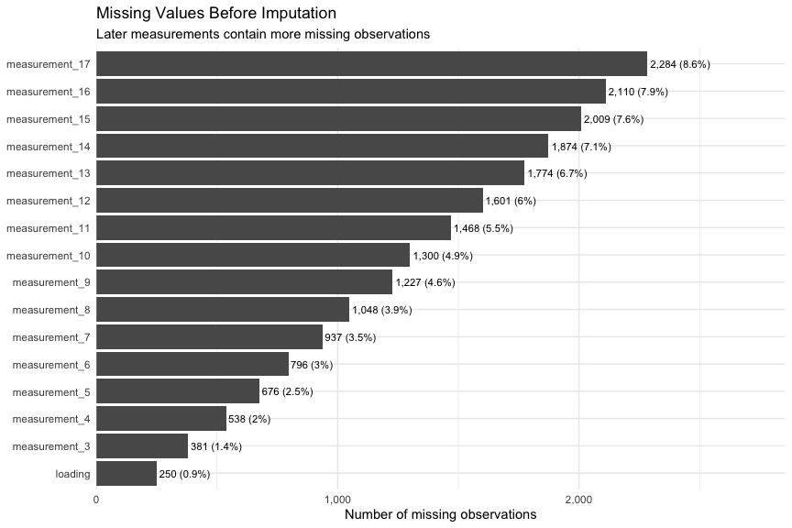
#Predictive Mean Matching Imputation
#Function for imputing missing numeric values
pmm_impute = function(data) {
#Return the original data if there are no missing values
if (sum(is.na(data)) == 0) {
return(data)
}
#initial mice settings
initial_setup = mice(
data,
maxit = 0,
printFlag = FALSE
)
methods = initial_setup$method
predictor_matrix = initial_setup$predictorMatrix
# Start with no imputation method
methods[] = ""
# Find numeric variables that contain missing values
numeric_variables = names(
data %>%
select(where(is.numeric))
)
numeric_missing = numeric_variables[
colSums(is.na(data[numeric_variables])) > 0
]
#predictive mean matching for numeric missing values
methods[numeric_missing] = "pmm"
#no impute or use the ID variable
if ("id" %in% names(data)) {
predictor_matrix[, "id"] = 0
predictor_matrix["id", ] = 0
}
# do not use failure when filling predictor values
if ("failure" %in% names(data)) {
predictor_matrix[, "failure"] = 0
predictor_matrix["failure", ] = 0
}
# Run the imputation
imputed_result = mice(
data,
method = methods,
predictor_matrix = predictor_matrix,
m = 1,
maxit = 5,
seed = 402,
print_flag = FALSE
)
# Return the completed dataset
complete(
imputed_result,
action = 1
) %>%
as_tibble()
}
# Apply predictive mean matching
train_imputed = pmm_impute(train)
##
## iter imp variable
## 1 1 loading* measurement_3* measurement_4* measurement_5* measurement_6* measurement_7* measurement_8* measurement_9* measurement_10* measurement_11* measurement_12* measurement_13* measurement_14 measurement_15* measurement_16* measurement_17*
## 2 1 loading measurement_3* measurement_4* measurement_5* measurement_6* measurement_7* measurement_8* measurement_9* measurement_10* measurement_11* measurement_12* measurement_13* measurement_14* measurement_15* measurement_16* measurement_17*
## 3 1 loading* measurement_3* measurement_4* measurement_5* measurement_6* measurement_7* measurement_8* measurement_9* measurement_10* measurement_11* measurement_12* measurement_13 measurement_14* measurement_15* measurement_16* measurement_17*
## 4 1 loading* measurement_3* measurement_4* measurement_5* measurement_6* measurement_7* measurement_8* measurement_9* measurement_10 measurement_11* measurement_12 measurement_13* measurement_14* measurement_15* measurement_16* measurement_17
## 5 1 loading* measurement_3* measurement_4* measurement_5* measurement_6* measurement_7* measurement_8* measurement_9* measurement_10* measurement_11* measurement_12* measurement_13* measurement_14* measurement_15* measurement_16* measurement_17*
## Warning: Number of logged events: 154
test_imputed = pmm_impute(test)
##
## iter imp variable
## 1 1 loading* measurement_3* measurement_4* measurement_5* measurement_6* measurement_7* measurement_8 measurement_9* measurement_10* measurement_11* measurement_12* measurement_13* measurement_14 measurement_15* measurement_16* measurement_17*
## 2 1 loading* measurement_3* measurement_4* measurement_5* measurement_6* measurement_7* measurement_8* measurement_9* measurement_10* measurement_11* measurement_12* measurement_13* measurement_14* measurement_15* measurement_16* measurement_17*
## 3 1 loading* measurement_3* measurement_4* measurement_5* measurement_6 measurement_7* measurement_8* measurement_9* measurement_10* measurement_11* measurement_12* measurement_13* measurement_14 measurement_15* measurement_16* measurement_17*
## 4 1 loading* measurement_3 measurement_4* measurement_5* measurement_6* measurement_7* measurement_8* measurement_9 measurement_10* measurement_11* measurement_12* measurement_13* measurement_14* measurement_15* measurement_16 measurement_17*
## 5 1 loading* measurement_3* measurement_4* measurement_5* measurement_6* measurement_7* measurement_8* measurement_9* measurement_10* measurement_11* measurement_12* measurement_13* measurement_14* measurement_15* measurement_16* measurement_17*
## Warning: Number of logged events: 153
# Check missing values after imputation
sum(is.na(train_imputed))
## [1] 0
sum(is.na(test_imputed))
## [1] 0
missing_comparison = tibble(
variable = names(train),
missing_before = colSums(is.na(train)),
missing_after = colSums(is.na(train_imputed))
) %>%
filter(
missing_before > 0 |
missing_after > 0
) %>%
arrange(desc(missing_before))
knitr::kable(
missing_comparison,
caption = "Missing Values Before and After Imputation"
)
Missing Values Before and After Imputation
variable | missing_before | missing_after
measurement_17 | 2284 | 0
measurement_16 | 2110 | 0
measurement_15 | 2009 | 0
measurement_14 | 1874 | 0
measurement_13 | 1774 | 0
measurement_12 | 1601 | 0
measurement_11 | 1468 | 0
measurement_10 | 1300 | 0
measurement_9 | 1227 | 0
measurement_8 | 1048 | 0
measurement_7 | 937 | 0
measurement_6 | 796 | 0
measurement_5 | 676 | 0
measurement_4 | 538 | 0
measurement_3 | 381 | 0
loading | 250 | 0
Predictive mean matching was used to replace missing numeric values with plausible values based on similar complete observations. The completed datasets are used for model development and prediction.
#Training and Testing Split
set.seed(402)
# Use 80% for training and 20% for testing
data_split = initial_split(
train_imputed,
prop = 0.80,
strata = failure
)
model_training = training(data_split)
model_testing = testing(data_split)
# Check dimensions
dim(model_training)
## [1] 21255 26
dim(model_testing)
## [1] 5315 26
training_distribution = model_training %>%
count(failure) %>%
mutate(
percent = n / sum(n),
dataset = "Training"
)
testing_distribution = model_testing %>%
count(failure) %>%
mutate(
percent = n / sum(n),
dataset = "Testing"
)
bind_rows(
training_distribution,
testing_distribution
) %>%
select(
dataset,
failure,
n,
percent
) %>%
knitr::kable(
digits = 3,
caption = "Failure Distribution in the Training and Testing Sets"
)
Failure Distribution in the Training and Testing Sets
dataset | failure | n | percent
Training | Yes | 4519 | 0.213
Training | No | 16736 | 0.787
Testing | Yes | 1130 | 0.213
Testing | No | 4185 | 0.787
#Five-Fold Cross-Validation
set.seed(402)
cv_folds <- vfold_cv(
model_training,
v = 5,
strata = failure
)
cv_folds
## # 5-fold cross-validation using stratification
## # A tibble: 5 × 2
## splits id
## <list> <chr>
## 1 <split [17003/4252]> Fold1
## 2 <split [17004/4251]> Fold2
## 3 <split [17004/4251]> Fold3
## 4 <split [17004/4251]> Fold4
## 5 <split [17005/4250]> Fold5
Five-fold cross-validation repeatedly evaluates a model across different portions of the training data. Later, fit_resamples() will calculate performance metrics across these folds without tuning model parameters. :contentReferenceoaicite:1
#Modeling Recipe
model_recipe = recipe(
failure ~ .,
data = model_training
) %>%
update_role(
id,
new_role = "ID"
) %>%
step_dummy(
all_nominal_predictors()
) %>%
step_zv(
all_predictors()
)
model_recipe
##
## ── Recipe ──────────────────────────────────────────────────────────────────────
##
## ── Inputs
## Number of variables by role
## outcome: 1
## predictor: 24
## ID: 1
##
## ── Operations
## • Dummy variables from: all_nominal_predictors()
## • Zero variance filter on: all_predictors()
excludes id as a predictor, converts categorical predictors into dummy variables, and removes predictors with no variation.
# Model 1: Logistic Regression
Logistic regression estimates the probability that a product will fail based on the available product attributes and measurements.
# Set up the logistic regression model
logistic_model <- logistic_reg() %>%
set_engine("glm") %>%
set_mode("classification")
# Combine the recipe and the model
logistic_workflow <- workflow() %>%
add_recipe(model_recipe) %>%
add_model(logistic_model)
logistic_workflow
## ══ Workflow ════════════════════════════════════════════════════════════════════
## Preprocessor: Recipe
## Model: logistic_reg()
##
## ── Preprocessor ────────────────────────────────────────────────────────────────
## 2 Recipe Steps
##
## • step_dummy()
## • step_zv()
##
## ── Model ───────────────────────────────────────────────────────────────────────
## Logistic Regression Model Specification (classification)
##
## Computational engine: glm

Logistic Regression Cross-Validation
# Metrics used to evaluate the model
model_metrics = metric_set(
roc_auc,
accuracy,
sens,
spec
)
set.seed(402)
# Evaluate logistic regression using five-fold cross-validation
logistic_cv = fit_resamples(
logistic_workflow,
resamples = cv_folds,
metrics = model_metrics,
control = control_resamples(
save_pred = TRUE
)
)
# Display average cross-validation results
logistic_cv_results = collect_metrics(
logistic_cv
)
knitr::kable(
logistic_cv_results,
digits = 3,
caption = "Logistic Regression Cross-Validation Results"
)
Logistic Regression Cross-Validation Results
.metric | .estimator | mean | n | std_err | .config
accuracy | binary | 0.787 | 5 | 0.000 | pre0_mod0_post0
roc_auc | binary | 0.606 | 5 | 0.007 | pre0_mod0_post0
sens | binary | 0.005 | 5 | 0.002 | pre0_mod0_post0
spec | binary | 0.998 | 5 | 0.000 | pre0_mod0_post0
The cross-validation results summarize how consistently logistic regression performed across five different sections of the training data.

Fit Logistic Regression on the Training Data
# Fit the model using the full model-training set
logistic_fit = fit(
logistic_workflow,
data = model_training
)
logistic_fit
## ══ Workflow [trained] ══════════════════════════════════════════════════════════
## Preprocessor: Recipe
## Model: logistic_reg()
##
## ── Preprocessor ────────────────────────────────────────────────────────────────
## 2 Recipe Steps
##
## • step_dummy()
## • step_zv()
##
## ── Model ───────────────────────────────────────────────────────────────────────
##
## Call: stats::glm(formula = ..y ~ ., family = stats::binomial, data = data)
##
## Coefficients:
## (Intercept) loading attribute_2
## -2.485222 -0.007367 -0.056660
## attribute_3 measurement_0 measurement_1
## -0.011352 -0.006713 0.001045
## measurement_2 measurement_3 measurement_4
## -0.016054 0.016296 0.062037
## measurement_5 measurement_6 measurement_7
## 0.128049 0.056939 0.054435
## measurement_8 measurement_9 measurement_10
## 0.126147 0.054701 0.008399
## measurement_11 measurement_12 measurement_13
## 0.016008 -0.008261 -0.044121
## measurement_14 measurement_15 measurement_16
## -0.006341 -0.005520 -0.003535
## measurement_17 product_code_B product_code_C
## -0.002807 0.255141 -0.077652
## product_code_D product_code_E attribute_0_material_5
## NA NA NA
## attribute_1_material_5 attribute_1_material_6
## NA NA
##
## Degrees of Freedom: 21254 Total (i.e. Null); 21231 Residual
## Null Deviance: 21990
## Residual Deviance: 21430 AIC: 21480
#Logistic Regression Predictions
# Create class and probability predictions for the training data
logistic_training_predictions = bind_cols(
model_training %>%
select(failure),
predict(
logistic_fit,
new_data = model_training,
type = "class"
),
predict(
logistic_fit,
new_data = model_training,
type = "prob"
)
)
# class and probability predictions for the testing data
logistic_testing_predictions <- bind_cols(
model_testing %>%
select(failure),
predict(
logistic_fit,
new_data = model_testing,
type = "class"
),
predict(
logistic_fit,
new_data = model_testing,
type = "prob"
)
)
head(logistic_testing_predictions)
## # A tibble: 6 × 4
## failure .pred_class .pred_Yes .pred_No
## <fct> <fct> <dbl> <dbl>
## 1 No No 0.172 0.828
## 2 No No 0.214 0.786
## 3 No No 0.103 0.897
## 4 No No 0.364 0.636
## 5 No No 0.401 0.599
## 6 No No 0.289 0.711
#Logistic Regression Performance
# Training performance
logistic_training_metrics = bind_rows(
accuracy(
logistic_training_predictions,
truth = failure,
estimate = .pred_class
),
roc_auc(
logistic_training_predictions,
truth = failure,
.pred_Yes
),
sens(
logistic_training_predictions,
truth = failure,
estimate = .pred_class
),
spec(
logistic_training_predictions,
truth = failure,
estimate = .pred_class
)
) %>%
mutate(
dataset = "Training"
)
# Testing performance
logistic_testing_metrics = bind_rows(
accuracy(
logistic_testing_predictions,
truth = failure,
estimate = .pred_class
),
roc_auc(
logistic_testing_predictions,
truth = failure,
.pred_Yes
),
sens(
logistic_testing_predictions,
truth = failure,
estimate = .pred_class
),
spec(
logistic_testing_predictions,
truth = failure,
estimate = .pred_class
)
) %>%
mutate(
dataset = "Testing"
)
# Combine the results
logistic_performance = bind_rows(
logistic_training_metrics,
logistic_testing_metrics
) %>%
select(
dataset,
metric = .metric,
estimate = .estimate
)
knitr::kable(
logistic_performance,
digits = 3,
caption = "Logistic Regression Training and Testing Performance"
)
Logistic Regression Training and Testing Performance
dataset | metric | estimate
Training | accuracy | 0.787
Training | roc_auc | 0.611
Training | sens | 0.005
Training | spec | 0.998
Testing | accuracy | 0.787
Testing | roc_auc | 0.613
Testing | sens | 0.004
Testing | spec | 0.999
testing results have a better estimate of how the model may perform on products it did not use during training
#Logistic Regression Confusion Matrix
logistic_confusion_matrix = conf_mat(
logistic_testing_predictions,
truth = failure,
estimate = .pred_class
)
logistic_confusion_matrix
## Truth
## Prediction Yes No
## Yes 5 5
## No 1125 4180
autoplot(
logistic_confusion_matrix,
type = "heatmap"
)
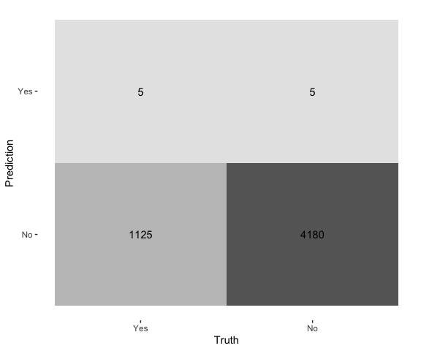

Logistic Regression ROC Curve
logistic_roc = roc_curve(
logistic_testing_predictions,
truth = failure,
.pred_Yes
)
autoplot(
logistic_roc
) +
labs(
title = "Logistic Regression ROC Curve",
subtitle = "Testing-set performance",
x = "False positive rate",
y = "True positive rate"
) +
theme_minimal()
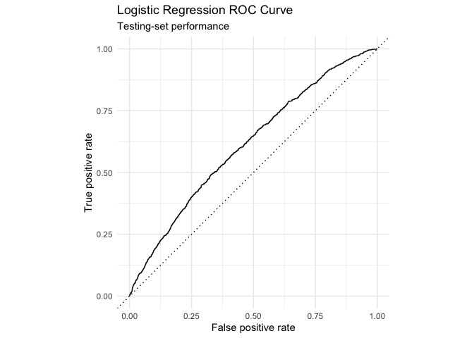

Logistic Regression Coefficients
# Extract the fitted glm model
logistic_engine = extract_fit_engine(
logistic_fit
)
# Display the model coefficients
logistic_coefficients = broom::tidy(
logistic_engine
) %>%
arrange(
p.value
)
knitr::kable(
head(logistic_coefficients, 15),
digits = 3,
caption = "Selected Logistic Regression Coefficients"
)
Selected Logistic Regression Coefficients
term | estimate | std.error | statistic | p.value
loading | -0.007 | 0.000 | -17.718 | 0.000
measurement_17 | -0.003 | 0.000 | -13.615 | 0.000
measurement_5 | 0.128 | 0.020 | 6.306 | 0.000
measurement_8 | 0.126 | 0.020 | 6.219 | 0.000
product_code_B | 0.255 | 0.067 | 3.810 | 0.000
measurement_4 | 0.062 | 0.018 | 3.503 | 0.000
measurement_6 | 0.057 | 0.017 | 3.381 | 0.001
measurement_7 | 0.054 | 0.017 | 3.256 | 0.001
measurement_9 | 0.055 | 0.018 | 3.120 | 0.002
measurement_2 | -0.016 | 0.005 | -2.990 | 0.003
measurement_13 | -0.044 | 0.015 | -2.962 | 0.003
(Intercept) | -2.485 | 1.064 | -2.336 | 0.020
attribute_2 | -0.057 | 0.024 | -2.325 | 0.020
measurement_0 | -0.007 | 0.005 | -1.484 | 0.138
measurement_11 | 0.016 | 0.011 | 1.398 | 0.162

Model 2: Classification Tree
A classification tree- dividing products into smaller groups based on their characteristics. It model creates a series of decision rules that lead to a predicted failure outcome.
# Set up the classification tree model
tree_model = decision_tree(
cost_complexity = 0.001,
tree_depth = 8,
min_n = 20
) %>%
set_engine("rpart") %>%
set_mode("classification")
# Combine the recipe and classification tree model
tree_workflow <- workflow() %>%
add_recipe(model_recipe) %>%
add_model(tree_model)
tree_workflow
## ══ Workflow ════════════════════════════════════════════════════════════════════
## Preprocessor: Recipe
## Model: decision_tree()
##
## ── Preprocessor ────────────────────────────────────────────────────────────────
## 2 Recipe Steps
##
## • step_dummy()
## • step_zv()
##
## ── Model ───────────────────────────────────────────────────────────────────────
## Decision Tree Model Specification (classification)
##
## Main Arguments:
## cost_complexity = 0.001
## tree_depth = 8
## min_n = 20
##
## Computational engine: rpart

Classification Tree Cross-Validation
set.seed(402)
# five-fold cross-validation
tree_cv = fit_resamples(
tree_workflow,
resamples = cv_folds,
metrics = model_metrics,
control = control_resamples(
save_pred = TRUE
)
)
tree_cv_results = collect_metrics(
tree_cv
)
knitr::kable(
tree_cv_results,
digits = 3,
caption = "Classification Tree Cross-Validation Results"
)
Classification Tree Cross-Validation Results
.metric | .estimator | mean | n | std_err | .config
accuracy | binary | 0.786 | 5 | 0.001 | pre0_mod0_post0
roc_auc | binary | 0.519 | 5 | 0.012 | pre0_mod0_post0
sens | binary | 0.008 | 5 | 0.005 | pre0_mod0_post0
spec | binary | 0.997 | 5 | 0.002 | pre0_mod0_post0
Cross-validation results show how consistently the classification tree performed across the five folds

Fit the Classification Tree
tree_fit = fit(
tree_workflow,
data = model_training
)
tree_fit
## ══ Workflow [trained] ══════════════════════════════════════════════════════════
## Preprocessor: Recipe
## Model: decision_tree()
##
## ── Preprocessor ────────────────────────────────────────────────────────────────
## 2 Recipe Steps
##
## • step_dummy()
## • step_zv()
##
## ── Model ───────────────────────────────────────────────────────────────────────
## n= 21255
##
## node), split, n, loss, yval, (yprob)
## * denotes terminal node
##
## 1) root 21255 4519 No (0.2126088 0.7873912) *

Classification Tree Predictions
# Training predictions
tree_training_predictions = bind_cols(
model_training %>%
select(failure),
predict(
tree_fit,
new_data = model_training,
type = "class"
),
predict(
tree_fit,
new_data = model_training,
type = "prob"
)
)
# Testing predictions
tree_testing_predictions = bind_cols(
model_testing %>%
select(failure),
predict(
tree_fit,
new_data = model_testing,
type = "class"
),
predict(
tree_fit,
new_data = model_testing,
type = "prob"
)
)
head(tree_testing_predictions)
## # A tibble: 6 × 4
## failure .pred_class .pred_Yes .pred_No
## <fct> <fct> <dbl> <dbl>
## 1 No No 0.213 0.787
## 2 No No 0.213 0.787
## 3 No No 0.213 0.787
## 4 No No 0.213 0.787
## 5 No No 0.213 0.787
## 6 No No 0.213 0.787

Classification Tree Performance
# Training metrics
tree_training_metrics = bind_rows(
accuracy(
tree_training_predictions,
truth = failure,
estimate = .pred_class
),
roc_auc(
tree_training_predictions,
truth = failure,
.pred_Yes
),
sens(
tree_training_predictions,
truth = failure,
estimate = .pred_class
),
spec(
tree_training_predictions,
truth = failure,
estimate = .pred_class
)
) %>%
mutate(
dataset = "Training"
)
# Testing metrics
tree_testing_metrics = bind_rows(
accuracy(
tree_testing_predictions,
truth = failure,
estimate = .pred_class
),
roc_auc(
tree_testing_predictions,
truth = failure,
.pred_Yes
),
sens(
tree_testing_predictions,
truth = failure,
estimate = .pred_class
),
spec(
tree_testing_predictions,
truth = failure,
estimate = .pred_class
)
) %>%
mutate(
dataset = "Testing"
)
# Combine training and testing results
tree_performance = bind_rows(
tree_training_metrics,
tree_testing_metrics
) %>%
select(
dataset,
metric = .metric,
estimate = .estimate
)
knitr::kable(
tree_performance,
digits = 3,
caption = "Classification Tree Training and Testing Performance"
)
Classification Tree Training and Testing Performance
dataset | metric | estimate
Training | accuracy | 0.787
Training | roc_auc | 0.500
Training | sens | 0.000
Training | spec | 1.000
Testing | accuracy | 0.787
Testing | roc_auc | 0.500
Testing | sens | 0.000
Testing | spec | 1.000

Classification Tree Confusion Matrix
tree_confusion_matrix = conf_mat(
tree_testing_predictions,
truth = failure,
estimate = .pred_class
)
tree_confusion_matrix
## Truth
## Prediction Yes No
## Yes 0 0
## No 1130 4185
autoplot(
tree_confusion_matrix,
type = "heatmap"
)
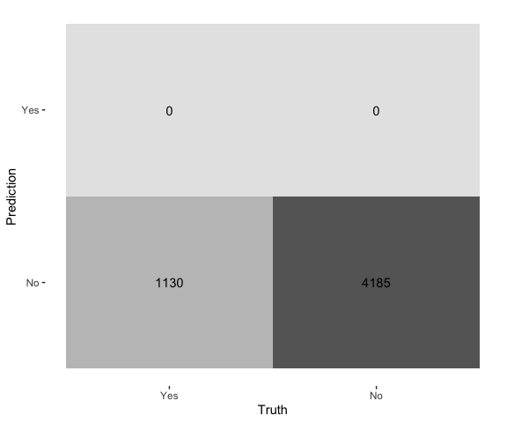

Classification Tree ROC Curve
tree_roc = roc_curve(
tree_testing_predictions,
truth = failure,
.pred_Yes
)
autoplot(
tree_roc
) +
labs(
title = "Classification Tree ROC Curve",
subtitle = "Testing-set performance",
x = "False positive rate",
y = "True positive rate"
) +
theme_minimal()
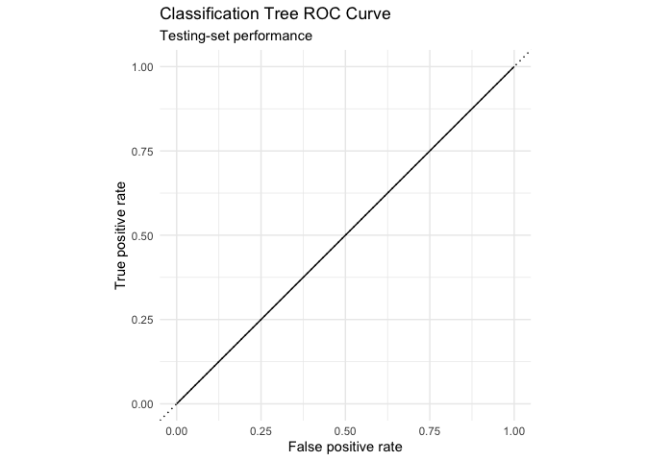
The ROC curve shows the classification tree’s ability to separate failed products from non-failed products across different probability cutoffs.

Model 3: Random Forest
A random forest combines many decision trees to make one final prediction. This can improve performance because the model considers several possible decision paths instead of relying on one tree.
#random forest model
forest_model = rand_forest(
trees = 500,
mtry = 8,
min_n = 10
) %>%
set_engine(
"ranger",
importance = "impurity",
probability = TRUE
) %>%
set_mode("classification")
# Combine the recipe and model
forest_workflow = workflow() %>%
add_recipe(model_recipe) %>%
add_model(forest_model)

Random Forest Cross-Validation
set.seed(402)
forest_cv = fit_resamples(
forest_workflow,
resamples = cv_folds,
metrics = model_metrics
)
forest_cv_results = collect_metrics(
forest_cv
)
knitr::kable(
forest_cv_results,
digits = 3,
caption = "Random Forest Cross-Validation Results"
)
Random Forest Cross-Validation Results
.metric | .estimator | mean | n | std_err | .config
accuracy | binary | 0.787 | 5 | 0.000 | pre0_mod0_post0
roc_auc | binary | 0.576 | 5 | 0.008 | pre0_mod0_post0
sens | binary | 0.002 | 5 | 0.001 | pre0_mod0_post0
spec | binary | 0.999 | 5 | 0.000 | pre0_mod0_post0

Fit and Evaluate the Random Forest
# Fit the random forest using the training set
forest_fit = fit(
forest_workflow,
data = model_training
)
# Make predictions for the testing set
forest_testing_predictions = bind_cols(
model_testing %>%
select(failure),
predict(
forest_fit,
new_data = model_testing,
type = "class"
),
predict(
forest_fit,
new_data = model_testing,
type = "prob"
)
)
# Calculate testing performance
forest_testing_metrics = bind_rows(
accuracy(
forest_testing_predictions,
truth = failure,
estimate = .pred_class
),
roc_auc(
forest_testing_predictions,
truth = failure,
.pred_Yes
),
sens(
forest_testing_predictions,
truth = failure,
estimate = .pred_class
),
spec(
forest_testing_predictions,
truth = failure,
estimate = .pred_class
)
) %>%
mutate(
dataset = "Testing"
) %>%
select(
dataset,
metric = .metric,
estimate = .estimate
)
knitr::kable(
forest_testing_metrics,
digits = 3,
caption = "Random Forest Testing Performance"
)
Random Forest Testing Performance
dataset | metric | estimate
Testing | accuracy | 0.788
Testing | roc_auc | 0.589
Testing | sens | 0.004
Testing | spec | 1.000

Compare the Three Models
#Results from models
logistic_test_results = logistic_performance %>%
filter(dataset == "Testing") %>%
mutate(model = "Logistic Regression")
tree_test_results = tree_performance %>%
filter(dataset == "Testing") %>%
mutate(model = "Classification Tree")
forest_test_results = forest_testing_metrics %>%
mutate(model = "Random Forest")
# Combine results
model_comparison = bind_rows(
logistic_test_results,
tree_test_results,
forest_test_results
) %>%
select(
model,
metric,
estimate
)
#summary table
model_comparison_table = model_comparison %>%
pivot_wider(
names_from = metric,
values_from = estimate
) %>%
arrange(
desc(roc_auc)
)
knitr::kable(
model_comparison_table,
digits = 3,
caption = "Testing Performance Comparison"
)
Testing Performance Comparison
model | accuracy | roc_auc | sens | spec
Logistic Regression | 0.787 | 0.613 | 0.004 | 0.999
Random Forest | 0.788 | 0.589 | 0.004 | 1.000
Classification Tree | 0.787 | 0.500 | 0.000 | 1.000
#ROC AUC is used as the main measure because it evaluates how well each model separates failed and non-failed products.

Comparison Chart
auc_chart = model_comparison %>%
filter(metric == "roc_auc") %>%
mutate(
model = reorder(
model,
estimate
)
)
ggplot(
auc_chart,
aes(
x = model,
y = estimate
)
) +
geom_col(
width = 0.65
) +
geom_text(
aes(
label = round(
estimate,
3
)
),
vjust = -0.4,
size = 4
) +
labs(
title = "Model Performance Comparison",
subtitle = "Testing ROC AUC for the three prediction methods",
x = "Model",
y = "ROC AUC"
) +
scale_y_continuous(
limits = c(0, 1),
expand = expansion(
mult = c(0, 0.08)
)
) +
theme_minimal()
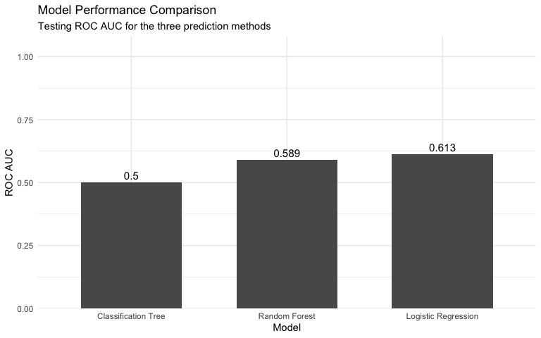

Select the Best Model
# model with the highest testing ROC AUC
best_model_name = model_comparison_table %>%
slice_max(
order_by = roc_auc,
n = 1,
with_ties = FALSE
) %>%
pull(model)
best_model_name
## [1] "Logistic Regression"
if (best_model_name == "Logistic Regression") {
final_workflow = logistic_workflow
}
if (best_model_name == "Classification Tree") {
final_workflow = tree_workflow
}
if (best_model_name == "Random Forest") {
final_workflow = forest_workflow
}
# Fit the selected model using all labeled training data
final_model = fit(
final_workflow,
data = train_imputed
)

Kaggle Predictions
kaggle_predictions = predict(
final_model,
new_data = test_imputed,
type = "class"
)
## Warning: Novel levels found in column "product_code": "F", "G", "H", and "I".
## ℹ The levels have been removed, and values have been coerced to <NA>.
## Warning: Novel level found in column "attribute_1": "material_7".
## ℹ The level has been removed, and values have been coerced to <NA>.
## Warning: ! There are new levels in `product_code`: NA.
## ℹ Consider using step_unknown() (`?recipes::step_unknown()`) before
## `step_dummy()` to handle missing values.
## Warning: ! There are new levels in `attribute_1`: NA.
## ℹ Consider using step_unknown() (`?recipes::step_unknown()`) before
## `step_dummy()` to handle missing values.
#sample submission format
submission = sample_submission %>%
mutate(
failure = as.character(kaggle_predictions$.pred_class)
)
dim(submission)
## [1] 20775 2
head(submission)
## # A tibble: 6 × 2
## id failure
## <dbl> <chr>
## 1 26570 <NA>
## 2 26571 <NA>
## 3 26572 <NA>
## 4 26573 <NA>
## 5 26574 <NA>
## 6 26575 <NA>
readr::write_csv(
submission,
"phase2_kaggle_submission.csv"
)
The logistic regression model achieved the highest testing ROC AUC (0.613).

