|  |  |
| --- | --- |
| **Pre-AP® Computer Science** | **Lab 05F**  **Practice/Perform Major Java Assignment** |
| **Looping with Graphics** | **50, 60, 70, 80, 90, 100 & 110 Point Versions** |
| **Assignment Purpose:**  The purpose of this program is to demonstrate knowledge of using control structures like **for** and **while** with graphics. | |

For this lab assignment you are provided with a grid of two rows by four columns. Each cell in the grid needs some graphics object to be drawn. It will be necessary to use methods of the *Expo* class to complete this assignment. The use of the grid is intentional. One cell will be done for you as an example. In the other 5 cells you will need to display some type of shape multiple times. Please realize that **A CONTROL STRUCTURE MUST BE USED!** For example, one cell has 14 concentric circles. You are **NOT** allowed to simply type 14 **Expo.drawCircle** commands. You need one **Expo.drawCircle** command inside a **for** loop that will make it repeat 14 times.

|  |  |
| --- | --- |
| **Lab05F Student Version** | **Do not copy this file, which is provided.** |
| **// Lab05Fst.java**  **// This is the student, starting version of Lab 05F which is divided into 8 cells.**  **// The first cell -- "Draw Red Horizontal Lines" -- is provided as an example.**  **// Students need to complete the other 7 cells on their own.**  **import java.awt.*;**  **import java.applet.*;**  **public class Lab05Fst extends Applet**  **{**  **public void paint(Graphics g)**  **{**  **// Draw Grid**  **Expo.drawLine(g,250,0,250,650);**  **Expo.drawLine(g,500,0,500,650);**  **Expo.drawLine(g,750,0,750,650);**  **Expo.drawLine(g,0,325,1000,325);**    **int x1, y1, x2, y2, x, y, r;**    **// Draw Red Horizontal Lines**  **Expo.setColor(g,Expo.red);**  **x1 = 0;**  **y1 = 5;**  **x2 = 250;**  **y2 = 5;**  **for (int k = 1; k <= 32; k++)**  **{**  **Expo.drawLine(g,x1,y1,x2,y2);**  **y1 += 10;**  **y2 += 10;**  **}**    **// Draw Blue Vertical Lines**    **// Draw Gray Diagonal Dots**    **// Draw Green Concentric Circles**    **// Draw Purple Concentric Ovals**  **// Draw Pink Concentric Arcs**    **// Draw Brown Concentric Rectangles**    **// Draw Gold Sphere**  **}**  **}** | |

**Current Output of Lab05Fst.java**

At the beginning, the output is a 4 by 2 grid, with the “Red Horizontal Lines” part done for you.

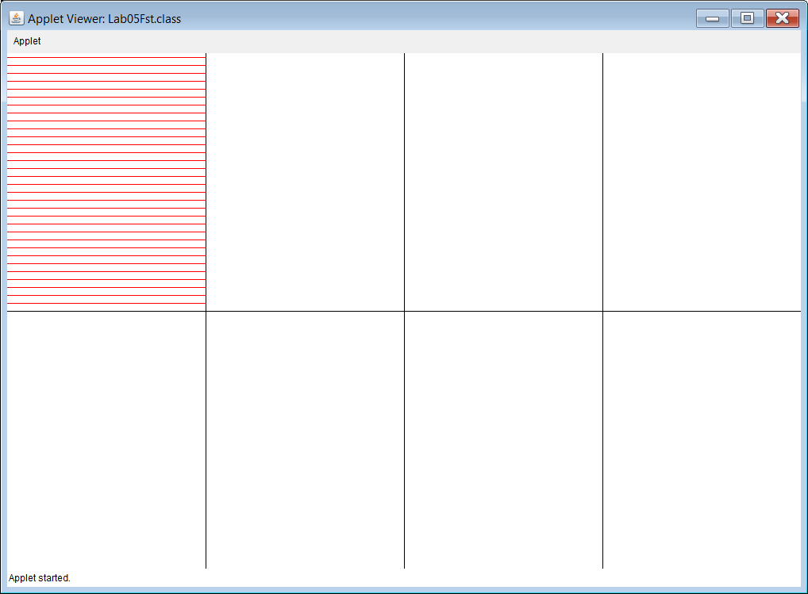

**50, 60, 70, 80, 90, 100 & 110-Point Version Specifics**

The 50-point version displays 2 of the cells below (Red Lines, and 1 other one).

The 60-point version displays 3 of the cells below (Red Lines, and 2 others).

The 70-point version displays 4 of the cells below (Red Lines, and 3 others).

The 80-point version displays 5 of the cells below (Red Lines, and 4 others).

The 90-point version displays 6 of the cells below (Red Lines, and 5 others).

The 100-point version displays 7 of the cells below (Red Lines, and 6 others).

The 110-point version displays ALL 8 cell below.

**110-Point Version Output**

