|  |  |  |
| --- | --- | --- |
| **Pre-AP® Computer Science** | | **Lab 07B**  **Open Ended Java Assignment** |
| **The OOP Graphics Project** | **0, 80, 90, 100 and 110 Point Versions** | |
| **Assignment Purpose:**  This program requires knowledge of class methods and reviews graphics. | | |

You need to create an original graphics program similar to the output below.

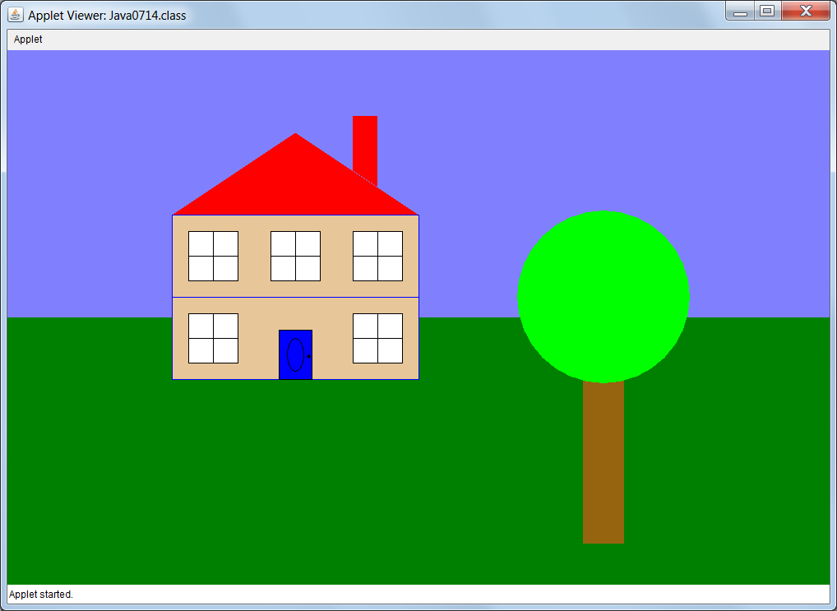

NOTE: You may NOT draw this or any other house!

Your graphics program must be something original that YOU created. The program should consist of several methods (no less than 4) similar to program examples **Java0709.java**, **Java0710.java**, **Java0711.java**, **Java0714.java** or **Java0715.java**. Your graphics program must show a considerable amount of effort and of course be also be school appropriate!

**80 Point Version**

The **paint** method calls methods that are all in the same class similar to program **Java0709.java**.

In addition to the **paint** method, there needs to be at least 3 user-defined methods.

**90 Point Version**

The **paint** method calls methods from a separate class similar to **Java0710.java**.

There need to be a minimum of 3 user-defined methods in this user-defined class.

**100 Point Version**

The **paint** method calls methods from at least 2 separate classes similar to programs **Java0711.java** and **Java0714.java**.

Each of these user-defined classes requires at least 3 user-defined methods in each class.

The grouping of the methods in each class needs to be both logical and practical.

NOTE: While you are not allowed to draw a House, you may have a **Tree** class or a **Background** class in your program; however, the **Tree** and **Background** classes in the textbook are very simplistic. For this assignment your classes need to have more methods and be considerable more complicated than a rectangle and a circle.

**110 Point Version**

The 110 Point Version requires everything from the 100 point version but requires that every class is saved in its own file similar to all of the files in the **Java0715** folder.

**0 Point Version**

You will earn a 0 on this major project if any of the following are true:

* Your program has all of the graphics commands in the **paint** method similar to **Java0708.java**.
* Your program is not school appropriate.
* Your program is a house
* Your program does not show sufficient effort.