Joshua Zeilmann

303 – Introduction to Web Publishing

Search Engine Optimization Assignment

**SEO Analysis & Recommendations for Eastern Mountain Sport GPS Watches**

1. **Keyword Research – 3 Recommended Keywords (Cr)**
   1. **The 3 keywords/ phrases I think will drive the most traffic:**
      1. GPS sports watch
      2. Garmin Forerunner
      3. Suunto Ambit
   2. **Explanation of Choice**
      1. **GPS Sports Watch**: This is the keyword focus given to me by my client. My research on this keyword phrase leads me to believe that this keyword is not very efficient because it is too broad. Google Keyword Planner says “GPS Sports Watch” has a score of 3600 which is low in comparison to my other two keywords. This keyword will be usefull because both sites sell GPS Sports Watches.

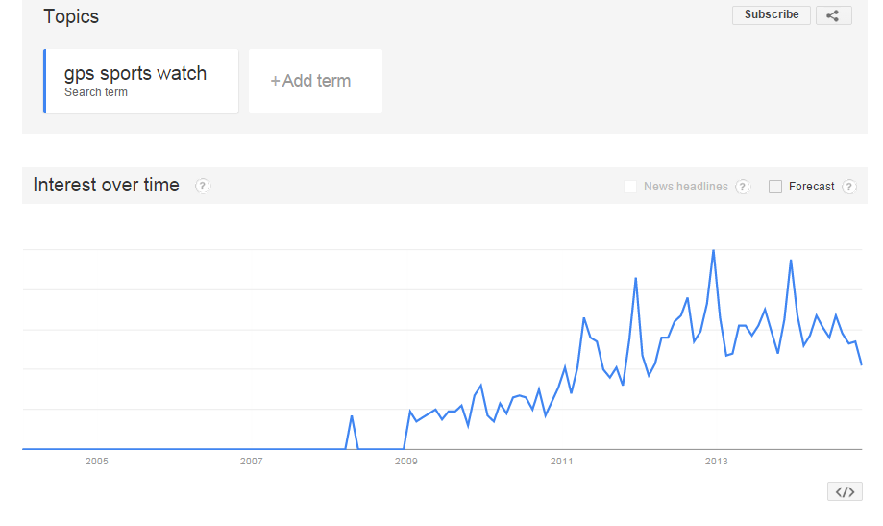

* + 1. 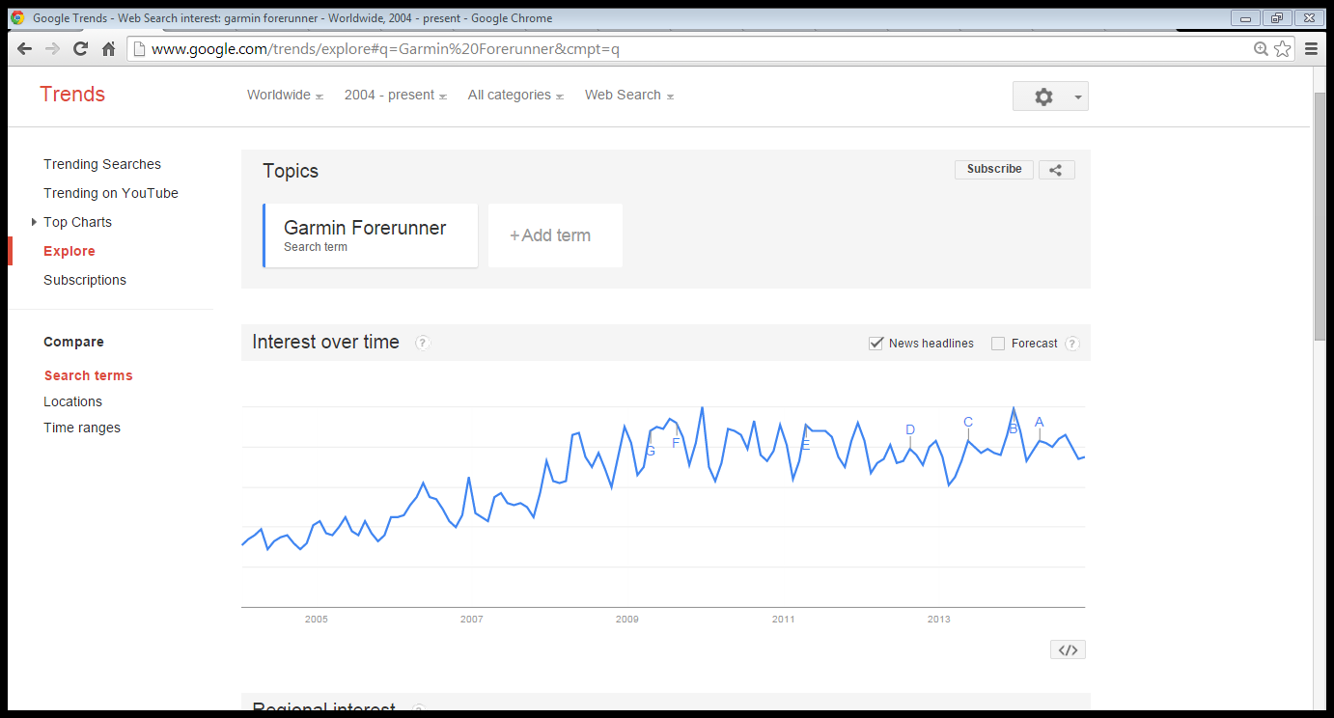 **Garmin Forerunner**: This is the second keyword focus that I chose for the client. I chose this keyword because I noticed that the Garmin Forerunner line of GPS watches was very prevalent on EMS.com. Google Keyword Planner gave this keyword a score of 201000, which is the highest of the three keywords.
    2. **Suunto Ambit**: This is the third keyword focus I chose for my client. I decided on this keyword because after viewing the product page for GPS watches I noticed that this was the second most prevalent brand of GPS watches on EMS.com. Google Keyword Planner gave this keyword a score of 74000, which is the second highest score of my three keywords.

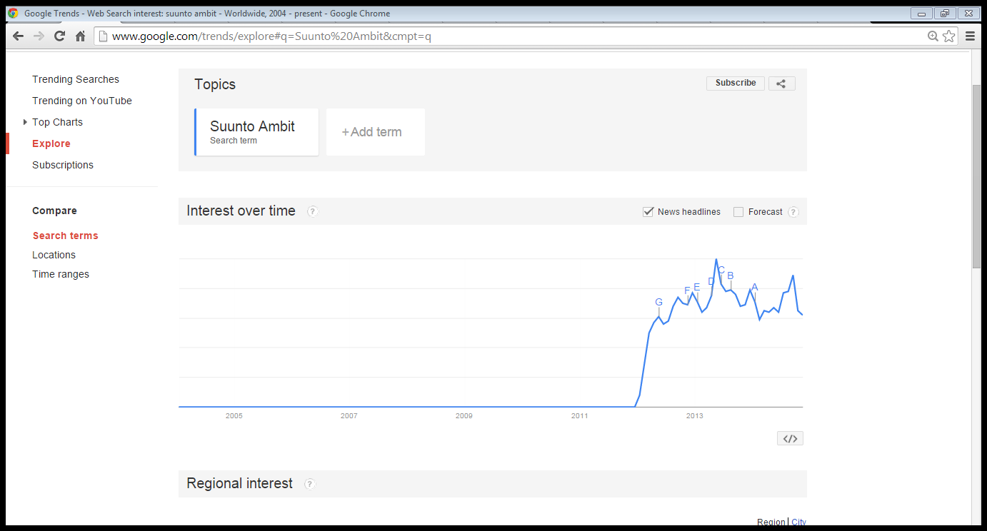

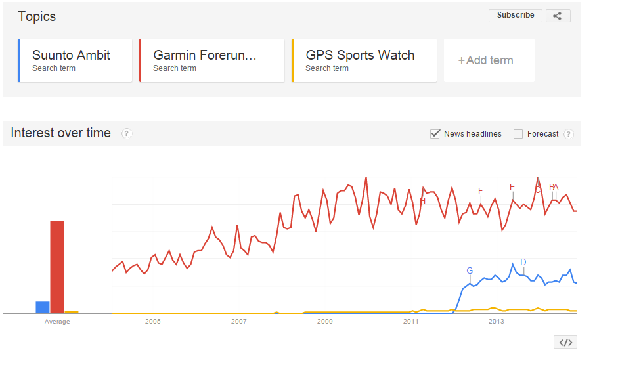

1. **Current Traffic**
   1. **EMS.com Monthly Unique Visitors:** 243,125
   2. **RoadRunnerSports.com Monthly Unique Visitors:** 371, 773
   3. **Analysis:** After reviewing both [www.EMS.com](http://www.EMS.com) and [www.RoadRunnerSports.com](http://www.RoadRunnerSports.com) I noticed several unique details about both. Although EMS.com had fewer unique visitors, I noticed they had a greater variant in the number of unique visitors over the 13 months shown. Unlike RoadRunnerSports.com that had a higher level of unique visitors but a very even chart throughout the month. I also noticed that both website had different “peak” months in their charts, EMS.com being in December and RoadRunnerSports.com being in October.
2. **Content Analysis:** **Quality**
   1. **Overall Quality (Cq, Vt, Va)**
      1. **EMS.com Score**: [8.5]
      2. **RoadRunnerSports.com Score**: [8]
      3. **Analysis:** When deciding on an overall quality score for both of the websites there were multiple guidelines and criteria I used to decide on an appropriate score. Some of the first things I looked at fell into the category of Quality (Cq), I looked at how well the site was written and the quality of the content available on the website. When looking at the content on Eastern Mountains website (EMS.com), I noticed they had a wide array of outdoor products ranging from camping gear, biking gear, climbing equipment, men/ female apparel and outdoor gear of all types. I noticed the every one of the 12 categories on the navigation bar on the above the fold page had 8 -10 sub category. When looking at Road Runner Sport’s navigation bar, I noticed that their content is more specifically targeted to running and runners. They had they content arrange in a similar fashion as Ems.com by having 8 categories on the navigation bar with several sub categories. I noticed no misspelling or typos on either of the websites and the wording seemed well written.

The second criteria I looked at in these websites would fall into the category of Thin (Vt), which asks, is the content “thin” or “shallow” and/or lacking substance. I would say that Eastern Mountain has a better depth of content for their products. After clicking on a “Garmin Forerunner 620” on the website it immediately showed me the price, several product images, a product video, available colors and reviews. Upon scrolling down more I discovered a full description with features/ benefits, technical specs, and country of origin. When viewing a similar watch on Road Runner Sport’s I noticed that the site offered the price, product images/videos, colors, and a review section even though there were no reviews for this particular product. I also noticed that the description section seemed to be a little lighter. Road Runner Sport’s had about the same amount of features/benefits as Eastern Mountain did for their product. Both website gave users the ability to share their products on Facebook and Twitter, and Road Runner Sports also has Google +, and Pinterest. Both websites also have recommendations for similar products that they think the user would be interested in. One thing I saw on Road Runner Sports that Eastern Mountain didn’t have was a pop up for a “Fit Expert” in which you could either text or video chat live with a person to find the perfect fit for your product.

When reviewing the websites for Ads (Va), I noticed that both websites did a good job of keeping Ads to a minimal on their website especially “above the fold”. The few Ads I did see on the websites were ads to their own products on the website. Another thing I tested on the website was to check whether the content was original or not. I copied a description of a watch from [www.EMS.com](http://www.EMS.com) into a website that checks for the uniqueness of the content called, <http://www.plagium.com/>. I found out that this same description was found on 3 other sites even though EMS.com got the highest ranking.

* + 1. **Recommendation for improvement:** After reviewing [www.EMS.com](http://www.EMS.com) for the criteria listed above there is several recommendation I could make to help improve the overall content of the website. The first change I would make would for Eastern Mountain to offer more options for users to share their content. Although they have the ability to share via Facebook and Twitter they lack the ability of sharing through Pinterest and Google+. Another recommendation I would make towards the publishers of [www.EMS.com](http://www.EMS.com) is to make sure that their content is original and unique to their site only. Another thing I noticed on the Road Runner Sports that would be a nice addition to Eastern Mountain’s website was the help pop-up which offered the ability to chat live via text or video with a real person. I feel like adding this will add some real value in their content.
  1. **Engaging Content (Ce):**
     1. **EMS.com Score:** [7]
     2. **RoadRunnerSports.com Score:** [8]
     3. **Analysis:**  I believe both sites did a good job of “engaging” users as describe under the Engage (Ce) Category. I first looked at the time spent on both sites, EMS.com had an average time spent on site of 3:30 which is up 37% from the previous 3 months. RoadRunnerSports.com had an average time spent on site of 3:35, which is down 4% from the previous 4 months. So according to this information, on average user spent 5 more seconds on roadrunnersports.com than on ems.com even though roadrunnersports.com is down 3%. The second thing I looked at was the bounce rates of both websites and how they compared to each other. EMS.com had a bounce rate of 38.50% (Up 19%) vs RoadRunnerSports.com bounce rate of 38.40%. (Up 7%), both of which are average bounce rates. Another thing that both these sites did to improve their (Ce) score was giving users the ability to comment/ discuss/ review the products. I like how RoadRunnerSports.com gave users the ability to magnify the product, this intrigued me by giving me ability to see every little crack and crevice of the product. Also being able to add products to a shopping cart with actually having to purchase them first is a nice feature that both sites offer.
     4. **Recommendations for improvement:** Although I felt both sites did a good job of engaging the user into the website I feel that there are still some recommendations for improvement that could be made toward EMS.com. The first recommendation I would make would be to give users the ability to view the product on themselves by possibly uploading a picture of themselves or just giving the user the ability to be more in touch with the product. Another thing that I noticed EMS.com was missing was the ability to magnify on the pictures available. I feel that this gives users a better understanding of what they are buying.
  2. **Social Signals (Sr, Ss):**
     1. **EMS.com Score:** [6]
     2. **RoadRunnerSports.com Score:** [7]
     3. **Analysis:** When deciding on a Social Signal score for the two website there were two criteria that I took into consideration. First being Social Reputation (Sr), I started off by examining the Facebook accounts of both websites. Although they both had Facebook Accounts, Road Runner Sports’ update their account multiple times a day and EMS did it maybe once or twice a week. Also RRS had 99k likes where EMS only had 49k likes on Facebook. I also noticed that both companies had a strong presence on Twitter as well. Both tweeted and replied to people multiple times a day, although Road Runner Sports had 16k followers to EMS 12k followers. I then examined both companies presence on Pinterest. Eastern Mountain Sports had 44 boards, 4000 pins, and 2,132 followers on their Pinterest site. While Road Runner Sports only had 10 boards, 400 pins, and 396 followers. The fourth social media medium that I chose to examine was Youtube. Eastern Mountain Sport’s Youtube channel had 1,673 subscribers and Road Runner Sports had only 311 subscribers. Also Eastern Mountain Sport’s has and continues to upload more videos. Eastern Mountain Sport’s allows for user to share products on both Facebook and Twitter, Road Runner Sports allow users to share product via Facebook, Twitter, Pinterest, and Google+.
     4. **Recommendations for Improvement:** I have several recommendation towards Eastern Mountain that could possibly improve their Social Signals rating. The first would be to allow user to share through more mediums than just Facebook and Twitter. The second recommendation would be for Eastern Mountain to increase their presence on Facebook by posting more and getting more likes towards their page.

1. **HTML: Current Keyword Location Analysis (Ht, Hd, Hh)**
   1. **Title Tags**
      1. **EMS.com Product Page**: <title>GARMIN Forerunner 620 Bundle with HRM, Black/Blue - Eastern Mountain Sports</title>
      2. **RoadRunnerSports.com Product Page:** <title>Wenger Roadster Watches at Road Runner Sports</title>
      3. 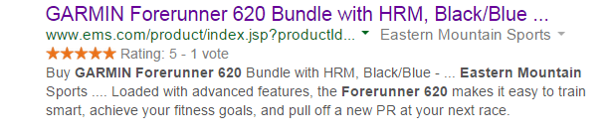
      4. **Explanation:** I chose these specific pages to analyze because they were the first product pages that appeared when you typed “GPS Sports Watch” in the search tool. Both Title tags tell the name of the website and the specific product name which is very important. It is important to have these keywords in the title tag because tells both users and search engines what the topic of a particular page is.
      5. **Recommendations for improvements:** I believe that both companies did a good job of creating a proper Title Tag because it says the keyword and the name of the website, so I don’t have any recommendations.
   2. **Description meta tags**
      1. **EMS.com Product Page:** <meta name="description" content="Buy GARMIN Forerunner 620 Bundle with HRM, Black/Blue - " /
      2. **RoadRunnerSports.com Product Page:** <meta name="description" content="Wenger Roadster Watches - Wenger&reg; Roadster :: The Roadster is not your casual driving watch. It&#39;s your cross-country road trip, African safari, dinner with the in-laws, meet the new CEO, &quot;I can take on the world&quot; watch. In other words, it&#39;s your new essential timepiece. Wenger&reg; has proven once again that style and adventure can go hand in hand; that your wristwatch can tell others just how fearless you are. With the Roadster on your wrist you&#39;re ready for action, so buckle up and make every second count. This web exclusive item ships separately within the continental U.S. only. You can count on this item to ship in 3-5 business days! "
      3. 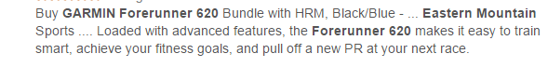
      4. **Explanation:** I found both of Meta tags in the page source on the “GPS Sports Watch” product page of both EMS.com and RoadrunnerSports.com. I chose these pages because they are the most relevant to the keywords I chose. These Meta tags are important because they describe what is actually on the page. The Meta tag gives the publisher an opportunity to suggest how their page appears in search listings.
      5. **Recommendations for Improvement:** I would recommend for EMS.com to make their meta tag more descriptive than just saying “ Buy the Garmin Forerunner”. The Meta tag can be uses as a selling point for the product, so EMS.com could maybe add some information about their product that would attract people to their site and thus purchase their product.
   3. **IMG names and ALT text**
      1.  <img src="http://ems.imageg.net/images/gLogo.gif" width="634" height="57" id="brand**" alt="Eastern Mountain Sports"**
      2. 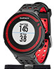 <img src="http://ems.imageg.net/graphics/product_images/pEMS1-17014442t100.jpg**" alt="GARMIN Forerunner 220 Bundle with HRM, Black/Red"**
      3. 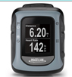 <img src="http://ems.imageg.net/graphics/product_images/pEMS1-13259534t100.jpg" **alt="MAGELLAN Switch Watch with HRM"**
      4. 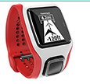 <img src="http://ems.imageg.net/graphics/product_images/pEMS1-16958105t100.jpg**" alt="MAGELLAN Echo Watch, Blue" /></a>**
      5. 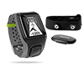 <imgsrc="http://ems.imageg.net/graphics/product_images/pEMS1-16834088t100.jpg" **alt="TOMTOM Multi-Sport GPS Watch with HRM" />**
      6. 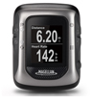 <imgsrc="http://ems.imageg.net/graphics/product_images/pEMS1-13259533t100.jpg" **alt="MAGELLAN Switch Up Watch with HRM" />**
      7.  <imgsrc="http://ems.imageg.net/images/shipping_info/prdDomesticShipButton.png**" alt="Domestic Ship Only"/>**
      8. 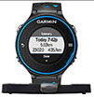 <img src="http://ems.imageg.net/graphics/product_images/pEMS1-17014439t100.jpg**" alt="GARMIN Forerunner 620 Bundle with HRM, Black/Blue - Eastern Mountain Sports"**
   4. **Explanation:** I chose this page to examine for Image Names and Alt Text because I felt that this page was most relevant with the keywords I have been using. I chose to use the Garmin Forerunner 620, which is the same page I have used in the previous two sections. The Alt texts of these images are used to tell a computer, than cannot actually see the image, what the image file contains. The more descriptive the Alt text the easier it is for a computer/ bot to figure out what the picture really is. Also in some of these image names they give the dimensions of the Ad/Picture and a URL link to the image.
   5. **Recommendations for Improvement:** I would recommend for Eastern Mountain to make their Alt Text more descriptive. Because the better the description, the better google can do their job of linking others to your site.
2. **Architecture (As, Au, Am)**
   1. **Speed (As)**
      1. **EMS.com Score: [**6.5]
      2. **RoadRunnerSports.com Score:** [5.5]
      3. **Explanation:** After review the product page of “Garmin Forerunner 620” on EMS.com and the “Weagner Roadster” on Roadrunnersports.com, I came to several conclusions about the speed of both pages. EMS.com has a “First View” load time of 5.212 secs. While Roadrunnersports.com has a “First View” load time of 4.464 secs. The second item I looked at was the “Repeat View” load time of both sites. EMS.com has a score of 2.782 secs and Roadrunnersports.com has a score of 2.4 secs. Both first view load speeds fall above the national average load time of 3.5 secs. The main file that is slowing down this page is <http://ems.imageg.net/images/video-button.jpg>. The main category of request that is slowing down these pages are images first, followed by HTML.
      4. [**http://www.ems.com/product/index.jsp?productId=24782126**](http://www.ems.com/product/index.jsp?productId=24782126)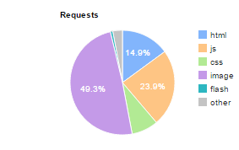
      5. http://www.roadrunnersports.com/rrs/products/WNW112/wenger-roadster/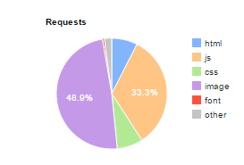
      6. **Recommendations for Improvement**
   2. **URL (Au)**
      1. **EMS.com Score:** [5]
      2. **RoadRunnerSports.com Score:** [8]
      3. **Explanation:** I began examining the URL of these sites by clicking through different categories and products to see how the pages appeared in the URL. Beginning with EMS.com I notice that their URL structure was very messy and unorganized. After I clicked on the “Men’s Apparel” category the URL appeared as <http://www.ems.com/category/>. But when I click on “Men’s Apparel on Roadrunnersports.com, the URL appeared as <http://www.roadrunnersports.com/rrs/mensapparel/>, which uses the words “men’s apparel”. Having these words in the URL makes this website easier for Googles bot to read and “crawl” the website. Another thing that RoadRunnerSports.com does right that EMS.com doesn’t is when they click on sub categories or even specific products, the actually wording of the product/ category appears in the URL. This is a huge problem for EMS.com because google will not be able to accurately know what’s on their website or how to accurately direct traffic towards their site.
      4. **Recommendations for Improvement:** A recommendation I would make towards the URL of EMS.com would be to add more descriptive words in their URL and take out more of the random numbers and symbols. At the same time publishers should keep in mind to keep the URL short but descriptive at the same time.
   3. **Mobile (Am)**
      1. **EMS.com Score:** [8.5]
      2. **RoadRunnerSports.com Score:** [8]
      3. **Explanation:** Both of these websites had a pretty good mobile set up according to the Google SEO Starter Guide. The main thing that both of these sites did right was designing a completely mobile version of their sites that run very efficiently. Both mobiles sites were very intuitive and easy to use, giving users the ability to make purchased and add products to the shopping cart. Neither of these websites had responsive design on their pages.
      4. **Recommendations for Improvement:** One thing that publishers could consider for EMS.com would be testing out a responsive design to see how it runs. Although responsive design isn’t always the best options for SEO, Google does look to see a site employs responsive design. I believe that if it doesn’t significantly slow down the sitethen you should use responsive design.
3. **Links (Ln, Lq)**
   1. **Link Number (Ln)T**
      1. **EMS.com No. of Referring Domains:** [4,473]
      2. **RoadRunnerSports.com No. of Referring Domains:** [3,992]
   2. **Link Quality (Lq)**
      1. **EMS.com No. of Referring Domains:** [7]
      2. **RoadRunnerSports.com No. of Referring Domains:** [7]
      3. **Explanation:** The reason I gave both of these websites 7 on a scale of 1-10 was because of the quality of the TLDs of the sites that link to these sites. Most of them are .com and each has 1 .org. Although these are not restricted domains they still are in a higher level category as another domains.
4. **Keyword Performance on SERPs for Recommended Keywords**
   1. **Ranking of Recommended Keywords on EMS.com**

|  |  |  |  |
| --- | --- | --- | --- |
| **Keyword** | **Google** | **Bing** | **Yahoo!** |
| **GPS Sports watch** | No | No | No |
| **Garmin Forerunner** | No | No | No |
| **Suunto Ambit** | No | No | No |

* 1. **Ranking of Recommended Keywords on RoadRunnerSports.com**

|  |  |  |  |
| --- | --- | --- | --- |
| **Keyword** | **Google** | **Bing** | **Yahoo!** |
| **GPS Sports Watch** | 5 | 8 | 6 |
| **Garmin Forerunner** | 39 | No | No |
| **Suunto Ambit** | No | No | No |

* 1. **Explanation:** I believe these two graphs say a lot about the problems EMS.com has with being noticed on search engine results pages. The Garmin Forerunner and the Sunnto Ambit are the two most popular GPS watches on EMS.com, but yet it’s not found on any on the search engines. RoadRunnerSports.com was somehow noticed to be in 39 place for google, which is weird because the top 10 is what really matters. The Suunto Ambit was not found in the search engines for either of the two sites even though EMS.com offers many Suunto Ambit models. RoadRunnerSports.com had pretty good rating for the keyword “GPS Sports Watch”, better than any of the other keywords for both websites.

1. **Conclusion and Priority Recommendations**
   1. After reviewing EMS.com for many attribute that are described in The Periodic Table of SEO Success Factors, I noticed that there were several categories in particular the I feel would make significant improvements to the SEO of Eastern Mountain’s website. The first improvement I would make would fall into the category of Cf (Fresh). I would recommend for the publishers to make sure all of their content is up to date and original. I noticed on a few of their product pages, the description of the product was sometimes found on multiples sites. The second recommendation I would make towards Eastern Mountain would fall into Social Signals (Sr,Ss). Although Eastern Mountain can be found on basically all forms of social media, I feel that their presence on Facebook and Twitter is lacking and needs to be improved. The third improvement I would recommend Eastern Mountain to make put more of a description into their Meta tags so that google can better understand the content on their page. This will also get user a better description of what their website has to offer when viewing SERP. Another major improvement that Eastern Mountain should make towards their website is the URL structure. The URL structure of their website is extremely poor and unorganized. It would be much better if they used short, descriptive, and unique phrases in their URL. The final recommendation I would make would be to work on trying to get in a higher ranking on the keywords used. Considering these products are sold on their sites, it’s a shame to see there not found on SERPs. I do believe after the previous recommendations are made Eastern Mountain’s traffic will greatly increase.