CS171 Project Progress Report: Forward Search

Name: Jessica Zeng (ID# 57314018)

Zephyr Yao (ID# 56627634)

Date: February 13, 2016

1 Target

We have added forward search algorithm as a consistency checking strategy for the Monster Sudoku project. Our project is implemented in Java, and complied with JDK1.7.

2 Progress

On the basis of the Sudoku file reader, backtracking search algorithm, we have implemented a forward search algorithm to eliminate the number of expanded nodes. The sudoku file reader enables forward checking algorithm when it sees “FC” token. As a sudoku problem is transformed into constrain satisfaction problem, backtracking search algorithm attempts to assign a value to an unassigned variable. At this stage, there is no heuristic function to determine the order of value assigned.

Our forward checking algorithm takes the last-assigned variable as a parameter. The algorithm gets a list of its neighbor variables, and tests constraint on each neighbor variable. Since Sudoku game’s constrain is not allowing two (constrain) neighbor to have the same value, when a variable is assigned, the algorithm remove the assigned value from all its neighbor using the provided function, *removeValueFromDomain*. If a variable has no legal value, the algorithm returns false to indicate the assignment is not consistent. Otherwise, the algorithm returns true.

Forward search algorithm uses bookkeeping method. If as assignment fails, *Solve* function will change domains back.

3 Problems and Questions

We had a problem with “assignment” flag of a variable. *Variable* class’s function *isAssigned* returns true if a variable’s domain contains unique value. However, Forward-checking sometimes eliminates certain variable’s domain to unique value, but still, the variable is not assigned. We introduced another flag “allocated” for *Variable* class.

4 Results and Extra Credit  
 We completed forward search algorithm. Forward search algorithm updates neighbor variables’ domain, using bookkeeping method.

We implemented Arc-3 Checking as an extra work.

Appendix

1 Sudoku file reader

We added token reader, which determines consistency-checking strategy.

2 Forward checking algorithm

Forward checking algorithm takes the last assigned variable as a parameter, and return true if the assignment is consistent, otherwise false.

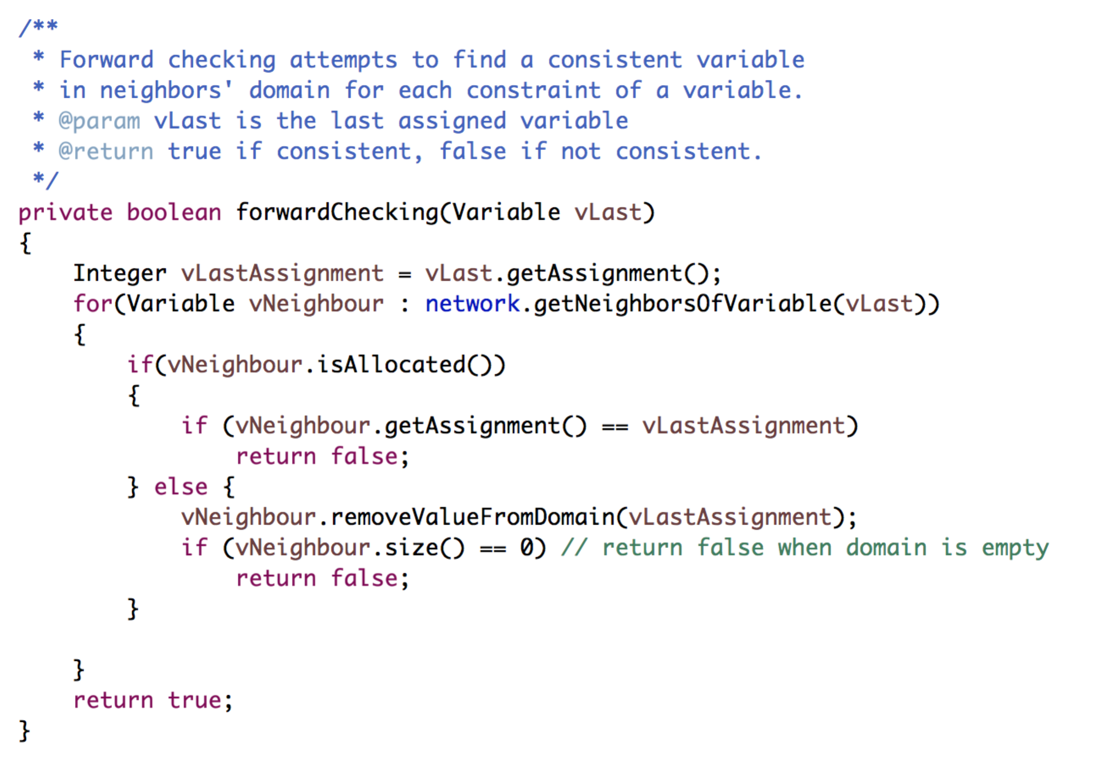

3 We implemented Arc-3 Checking algorithm (Extra work). Same as Forward-Checking, it takes the last assigned variable as a parameter, and return true if the assignment is consistent, otherwise false.