
JAN ZERNISCH
Freelance Software Engineer
(+49) 177 6889291 · jan@jzernisch.com

ABOUT ME
🙋‍♂️ My name is Jan and I am a passionate software developer with a mathematical background. In the past I have worked with a wide variety of technologies, but now have a focus on backend development in Python.
I am currently particularly interested in topics such as software architecture, Domain Driven Design and Machine Learning and am a big fan of Test Driven Development (TDD).
I also worked as an agile coach and as an interim product owner for a while, which often helps me to think across roles and adopt non-technical perspectives.

EXPERIENCE
 | Vonovia SE
 | October 2024 – present

🤖 IoT Plattform (Backend Development)
This project is subject to a strict NDA.
Technologies: Python · FastAPI

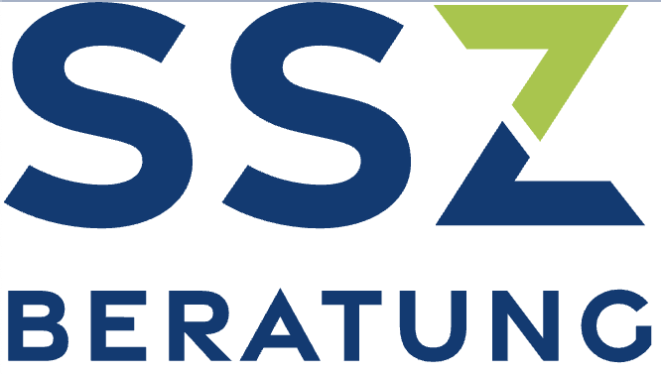 | SSZ GmbH
 | February 2024 – present

🔮 Workforce Management/Forecasting (Architecture Consulting)
This project is subject to a strict NDA.
Technologies: Python · AWS

 | Albatros Group GmbH
 | May 2024 – September 2024

🏙️ Smart City/Critical Infrastructure (Architecture Consulting & Backend Development)
Realization of a product that, among other things, to be used to monitor critical infrastructure using real-time image recognition methods. The particular aim here was to design a scalable architecture that meets the performance requirements.
Technologies: FAST API · OpenCV · Docker · Redis Streams

 | node.energy GmbH
 | March 2023 – September 2024

🍃 opti.node - GreenTech SaaS (Backend & API-Development)
opti.node is a B2B SaaS software that helps operators of renewable energy systems meet their regulatory obligations and implement digital business models. The regulations in this domain are very complex in Germany, which is reflected in the highly complex business logic of the software. To do justice to this, domain driven design concepts were used.
Technologies: Python · Django REST-Framework · Domain Driven Design · PostgreSQL · Docker · Github Actions · Microsoft Azure · Microsoft Graph API · openpyxl · Excel · pandas

 | PwC Deutschland GmbH, Düsseldorf
 | March 2020 – September 2022

🤖 Chatbot Platform (Frontend & Backend Development)
An internal chatbot platform was developed that makes it possible to deploy a new chatbot for a given context with minimal effort. For PwC Germany, the platform serves 12,000+ users via various channels (various messenger services, email or ticket systems). The platform also offered a user interface for administering the chatbot (AI training, performance evaluation).
Technologies: Python · RASA · Flask/Flask-RESTX · Django · pandas · React JS · TypeScript · SQLAlchemy · Alembic · PostgreSQL · Docker · Kubernetes · Gitlab CI/CD

⛰️ Agile Transformation (Agile Coaching)
As a member of the “Team Zero” transformation team, which reported directly to the CIO, I supported the Technology & Transformation department through organizational development and agile coaching. The aim was to align the organization based on value streams and to promote business agility. We helped to set up and set up cross-functional teams, coached them and the leadership, introduced OKRs at all levels and organized the work on Kanban Flight Levels.

 | Valtech Mobility GmbH, Düsseldorf
 | Januar 2019 – Februar 2020

🚙 “Project e.GO Mobile” (Agile Coach & Interim Product Owner)
The connected car backend, a mobile app and a web application for service workshops was developed for the Aachen-based e-car manufacturer e.GO. In addition to coaching the development team at Valtech Mobility GmbH, the successful cooperation of various other service providers involved had to be coordinated.

 | InVision AG, Düsseldorf
 | July 2011 – December 2018
InVision offers the product injixo, a leading SaaS workforce management solution for contact centers, which almost completely automates the very complex personnel planning process that is customary there. Here I was involved in various sub-projects, including:

🔮 Automatic forecasting of call volumes in contact centers (frontend & backend development)
The core component of injixo is injixo Forecast, which, based on historical call data using machine learning methods, can precisely and fully automatically predict call volumes, on which optimal staffing is then calculated, which on the one hand takes service level agreements into account and on the other hand ensures them that employees are not overloaded.
Technologies: Ruby · Sinatra · Rails · Python · Flask · Numpy/Pandas · Tensorflow · R · React JS · PostgreSQL · Redis · RabbitMQ · Docker · Kubernetes · Jenkins · Github

🏖️ Automated handling of vacation requests (frontend & backend development)
Development of a solution for the automated acceptance and rejection of vacation requests in contact centers, based on heuristically calculated shift schedules.
Technologies: Ruby · Rails · PostgreSQL · Go · Backbone JS · Ember JS · RabbitMQ · Docker · Kubernetes · Jenkins · Github

🧮 Algorithms for call center forecasting (R&D, backend development)
Design of algorithms for forecasting, which later flowed into the first version of injixo Forecast.
Technologies: Ruby · C · C++ · ALGLIB

 | Institute for Discrete Mathematics, Bonn
 | April 2009 – October 2010

💻 VLSI - Very Large Scale Integration (R&D, backend development)
Conception and implementation of algorithms for the design of VLSI microchips, in particular for the "port assignment problem", which involves arranging the ports of a chip component after "placement" (determining the component positions) in such a way that that the component can be optimally wired during the subsequent "routing". The project was created as part of a cooperation between the University of Bonn and IBM.
Technologies: C · C++ · CPLEX · SCIP · Tcl

EDUCATION

👨‍🎓 Rheinische Friedrich-Wilhelms-Universität, Bonn – Mathematics, Diploma
October 2003 – January 2011
- Mathematics, minoring in Computer Science
- Grade : "sehr gut" (excellent)

👨‍🎓Coursera, Stanford Online/Deeplearning.AI – Machine Learning Specialization
January 2023 – February 2023
- Supervised Machine Learning: Regression and Classification
- Advanced Learning Algorithms
- Unsupervised Learning, Recommenders, Reinforcement Learning

