Problem 1 Output:

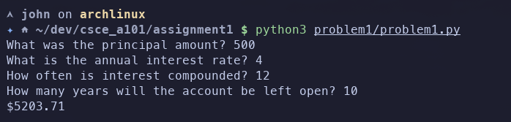

Problem 2A Output:

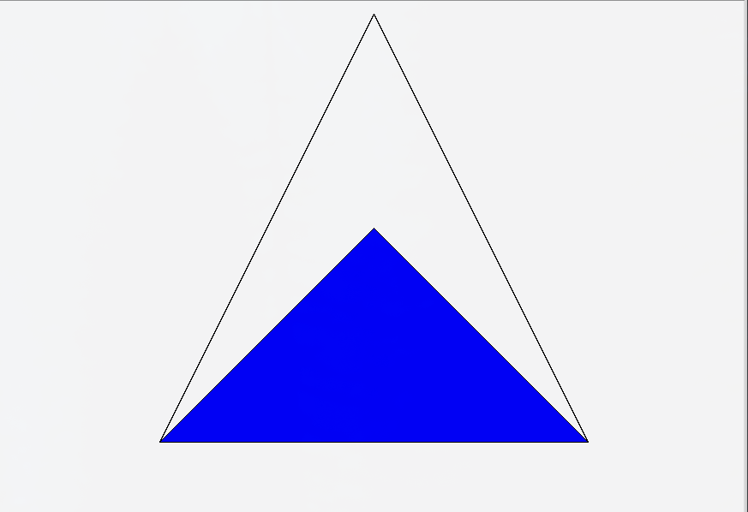

Problem 2B Output:

