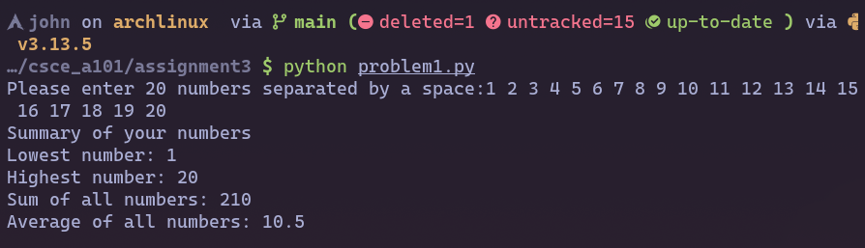Problem 1 Output:

Problem 2 Output:

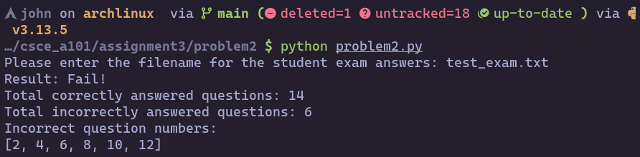

Problem 3 Output:

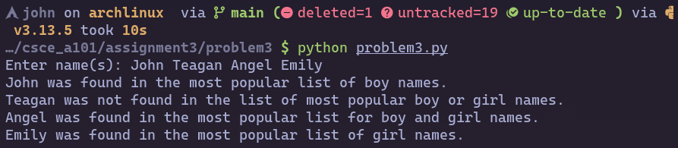

Problem 4 Output:

