Reproducibility Report
Project: Contraceptive Use & Sociodemographic Factors
Prepared by: Jing Zhang (replicator)
Report date: 2025-10-24

Executive Verdict
Verdict: Full reproduction with minor issues. All described outputs (weighted descriptive tabulations, one logistic model, and three figures) were reproduced. A minor command mismatch was corrected (using 'svy:' prefix for weighted tabulations). No remaining discrepancies were observed in the reproduced outputs.

Replicator Environment
Software: Stata (survey capabilities via 'svy:' prefix; linearized VCE). Operating System and exact Stata build not recorded in the provided log. Weights specified via 'svyset [pw=wght_per]'. No strata or PSU specified in the run.

Survey Design Declaration
Design: Probability weights only. The analysis used 'svyset [pw=wght_per]'. If PSU/strata variables exist in the underlying dataset, adding them is recommended for accurate variance estimation; otherwise, the weight-only design is acceptable.

Methods & Replication Steps
1) Loaded raw data and applied variable cleaning: set special codes to missing; created binary 'contr_used1'; recode 'imp_reg1'.
2) Applied survey weights: svyset [pw=wght_per].
3) Produced weighted descriptive tabulations using 'svy: tabulate' / 'svy: mean' / 'svy: proportion'.
4) Estimated a logistic regression of contraception use on the importance of religion, education, age group, urban/rural, sex, and marital status.
5) Exported three figures (PNG) corresponding to the descriptive visualizations.

Outputs Reproduced
A) Weighted descriptive tabulations for sex, marital status, age groups, urban/rural, education, contraception use, and importance of religion (SEs via linearized VCE).
B) Logistic regression: contr_used1 ~ imp_reg1 + highest_edu + agegr5 + i.cityvsrural + i.sex + i.marstat (pweights).
C) Figures:
- Average Importance of Religion by Sex
- Proportion Using Contraception (Past 12 Months), by age group
- Education Level by Urban/Rural

Code-to-Output Mapping
Output (Table/Figure) | Generating Command / Script Block | Status
Descriptive tabs (sex, marstat, agegr5, cityvsrural, education, contr_used1, imp_reg1) | svy: tabulate var, percent se | svy: proportion / svy: mean | Reproduced
Logistic model (contr_used1) | svy: logit contr_used1 imp_reg1 highest_edu agegr5 i.cityvsrural i.sex i.marstat | Reproduced
Figure 1: Avg. Importance of Religion by Sex | graph bar (mean) imp_reg1, over(sex) [pw=wght_per] | Reproduced
Figure 2: Contraception Use by Age Group | graph bar (mean) contr_used1, over(agegr5) [pw=wght_per] | Reproduced
Figure 3: Education Level by Urban/Rural | graph bar (mean) highest_edu, over(cityvsrural) [pw=wght_per] | Reproduced

Embedded Figures (as reproduced)
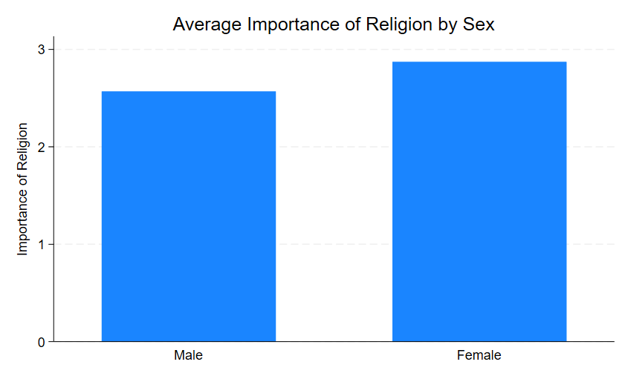
Zhang-Replication-1.png
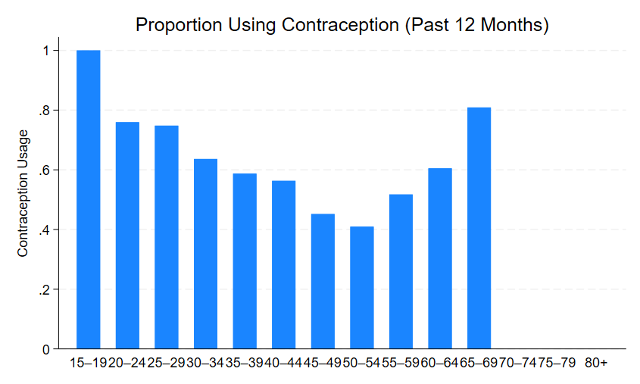
Zhang-Replication-2.png
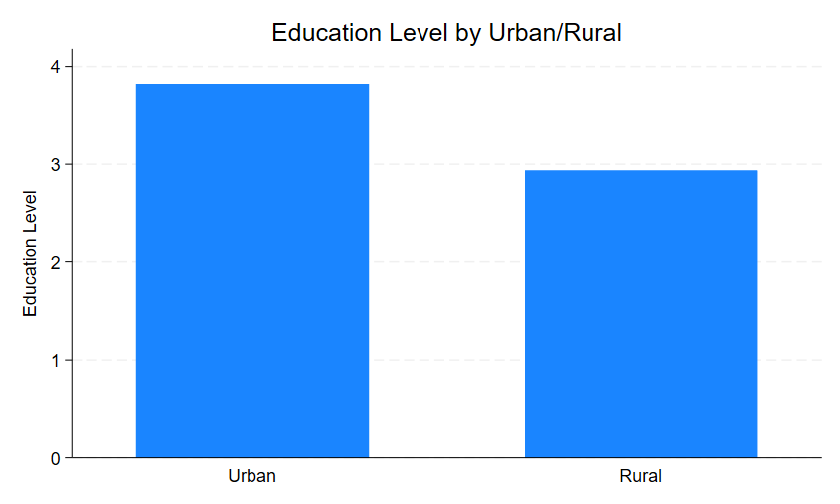
Zhang-Replication-3.png

Final Classification
Full reproduction with minor issues (command usage corrected).

Jing Zhang’s replication codes

import delimited "\\smb-isl01.fsu.edu\citrix\JZ22\Desktop\gss-12M0025-E-2017-c-31_F1.csv", clear
log using "\\smb-isl01.fsu.edu\citrix\JZ22\Documents\Zhang-Replication.log", replace

rename fi_500 contr_used
rename rlr_110 imp_reg
rename ehg3_01b highest_edu
rename luc_rst cityvsrural

keep contr_used imp_reg highest_edu agegr5 cityvsrural sex marstat wght_per

recode contr_used (6/9=.)
recode imp_reg (7/9=.)
recode cityvsrural (3=.)
tab sex

tab highest_edu
recode highest_edu (97/99=.)
tab marstat
recode marstat (97/98=.)

gen contr_used1=.
replace contr_used1=1 if contr_used==1
replace contr_used1=0 if contr_used==2
label define contr_used1 1 "Yes" 0 "No"
label values contr_used1 contr_used1

gen imp_reg1=5-imp_reg

label define imp_reg1 1 "Not at all important" 2 "Not very important" 3 "Somewhat important" 4 "Very important"
label values imp_reg1 imp_reg1

label define sex 1 "Male" 2 "Female"
label values sex sex

label define marstat 1 "Married" 2 "Common-law" 3 "Widowed" 4 "Separated" 5 "Divorced" 6 "Single, never married"
label values marstat marstat

label define highest_edu 1 "Less than high school" 2 "High school diploma / equivalency" 3 "Trade certificate or diploma" 4 "College/CEGEP or non-university diploma" 5 "University certificate/diploma below bachelor" 6 "Bachelor's degree" 7 "University degree above bachelor"
label values highest_edu highest_edu

label define agegr5 1 "15–19" 2 "20–24" 3 "25–29" 4 "30–34" 5 "35–39" 6 "40–44" 7 "45–49" 8 "50–54" 9 "55–59" 10 "60–64" 11 "65–69" 12 "70–74" 13 "75–79" 14 "80+"
label values agegr5 agegr5

label define cityvsrural 1 "Urban" 2 "Rural"
label values cityvsrural cityvsrural
svyset [pw=wght_per]

svy: tab sex, percent se
svy: tab marstat, percent se
svy: tab agegr5, percent se
svy: tab cityvsrural, percent se
svy: tab highest_edu, percent se
svy: tab contr_used1, percent se
svy: tab imp_reg1, percent se

logit contr_used1 imp_reg1 highest_edu agegr5 i.cityvsrural i.sex i.marstat [pw=wght_per]

graph bar (mean) imp_reg1 [pw=wght_per], over(sex) ///
title("Average Importance of Religion by Sex") ///
ytitle("Importance of Religion")

graph bar (mean) contr_used1 [pw=wght_per], over(agegr5) ///
title("Proportion Using Contraception (Past 12 Months)") ///
ytitle("Contraception Usage")

graph bar (mean) highest_edu [pw=wght_per], over(cityvsrural) ///
title("Education Level by Urban/Rural") ///
ytitle("Education Level")

log close

